Seismic analyses of the Double Closure Plate Sub-Plate for the ITER Electron Cyclotron Upper Launcher during the Vacuum Vessel baking scenario

Avelino Mas Sánchez^{a*}, René Chavanª, Mario Gagliardi^{b}, Timothy Goodmanª, Gabriella Saibene^{b}, Phillip Santos Silvaª, Matteo Vagnoniª

ª Ecole Polytechnique Fédérale de Lausanne (EPFL), Swiss Plasma Center (SPC), CH-1015 Lausanne, Switzerland
^{b} Fusion for Energy, Josep Pla 2, Torres Diagonal Litoral B3, E-08019 Barcelona, Spain

The Double Closure Plate Sub-Plate (DCPSP) was introduced in the Electron Cyclotron Upper Launcher (EC UL) design in order to minimize the openings exposing the interior of the Port Plug (PP) to the port cell; avoiding thus the near environment activation in case of maintenance or intervention on the In-Vessel (IV) components. The load combination Vacuum Vessel (VV) baking + Seismic level 2 is considered as one of the most relevant accidental events in terms of structural conformity affecting the DCPSP. The modal analysis of the DCPSP shows that the natural frequencies are far from the peaks of the ITER reference spectra at the PP flange. Therefore, the feasibility of analyzing the seismic event by using a static method, as a replacement of the Response Spectrum approach, is also investigated. Next, the results due to the seismic event are combined with those produced by loads on the DCPSP that occur during the VV baking scenario. The comparison of the categorized stresses and the allowable design limits showed that the mechanical integrity of the DCPSP is preserved during this load combination.

Keywords: ITER, ECH, Upper Launcher, Waveguide Feedthrough, Seismic analysis

1. Introduction
Four EC ULs [1] will be used in ITER to counteract magneto-hydrodynamic plasma instabilities by injecting up to 20 MW of mm-wave power at 170 GHz. The power will be transmitted through the eight Ex-Vessel (EV) waveguide assemblies of each EC UL to the IV waveguides. The power exiting the IV waveguides, housed by the PP, will be directed via quasi-optical mirrors to specific plasma locations.
The DCPSP [2] is the component that defines the border between EV and IV components. The DCPSP consists of the mechanical coupling, by bolted connection, between two stainless steel 316L(N)-IG sub-assemblies called the In-vessel Waveguides (IV-WG) CPSP and the Thermal Isolation (TI) CPSP. The primary functions of the DCPSP are to provide transmission line feedthroughs, support and alignment of the attached waveguides, neutron and gamma radiation shielding and tritium/vacuum containment. These components are categorized with the most stringent ITER classifications in terms of safety and vacuum (SIC-1 (Safety Important Component 1) and VQC1A (Vacuum Quality Class 1A), respectively).
The seismic event taking place during the VV baking scenario was identified as one of the most stringent load combinations for the DCPSP [3]. This load combination is analyzed using the commercial software ANSYS Workbench 18.1 [4].
2. Seismic analyses
2.1 Model description
The Response Spectrum (RS) approach was used for the seismic analyses of the DCPSP. The results coming from these analyses were compared with those obtained from the static structural approach. This study aims to assess the feasibility of using the static approach for the combination with the rest of the loads taking place during the VV baking scenario.
A modal analysis was initially performed in order to obtain the natural frequencies and natural modes of the structure. Three distinct RS simulations (according to the three directions of the acceleration: radial (x), toroidal (y) and vertical (z)) were then carried out using the modal analysis as an input. Three additional static structural simulations were performed to compare these results with the ones obtained with the RS method. The same geometry, mesh, contacts and material properties are shared by all the aforementioned simulations.
The geometry considered for these analyses includes both IV-WG CPSP and TI CPSP as well as their couplings with the interface components, namely EV Waveguides and Closure Plate (Fig. 1). Bonded contacts are defined between the abovementioned components. This geometry is meshed with element size of 12 mm uniformly defined in the entire domain. The overall number of nodes considered in the numerical model is 1410869 whereas the number of elements is 878630.
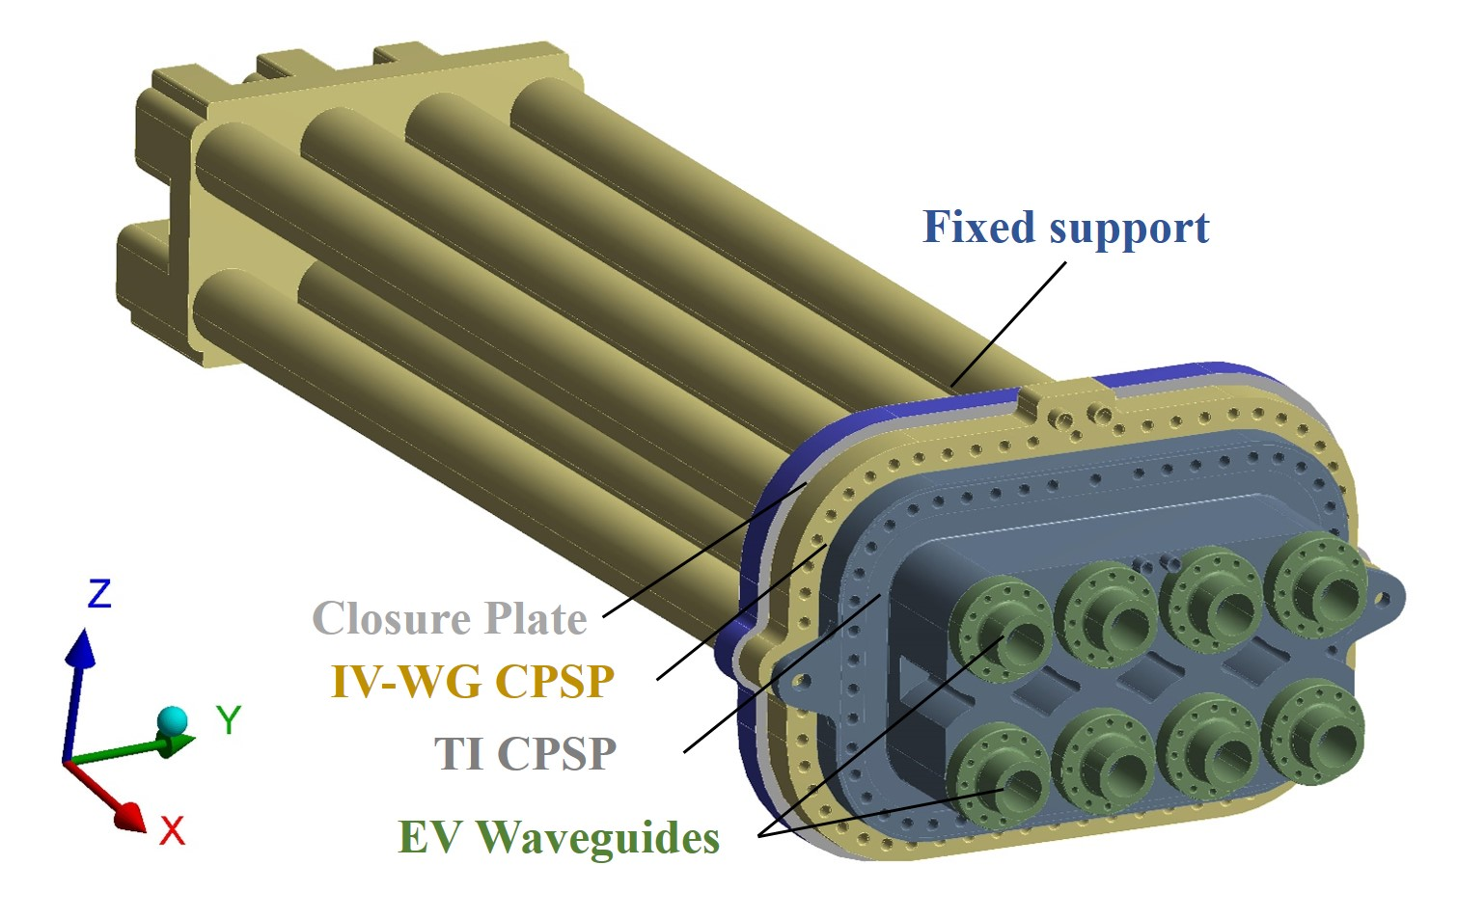
Fig. 1. Geometrical model for the DCPSP seismic analyses.
The material properties of stainless steel 316L(N)-IG [5] were applied to the Closure Plate, IV-WGs CPSP and TI CPSP while aluminum alloy EN AW-6061-T6 properties [6] were considered for the EV Waveguides. Linear material properties were taken into account and both materials were defined with a constant damping value of 0.04 [7].
The RS analysis is a linear-dynamic analysis that quantifies the contribution from each natural mode of vibration to indicate the likely maximum seismic response of a structure assumed to behave elastically. The DCPSP is bolted to the Closure Plate, which in turn is bolted to the Upper Plug Flange, leaving the IV Waveguides in a cantilevered configuration inside the plug. For this reason, the Floor Repose Spectrum (FRS) for the Seismic level 2 (SL-2) at the Upper Plug Flange [8] was selected for the RS analyses of the DCPSP (Fig. 2) and applied on the Closure Plate boundaries (fixed support in the simulation).
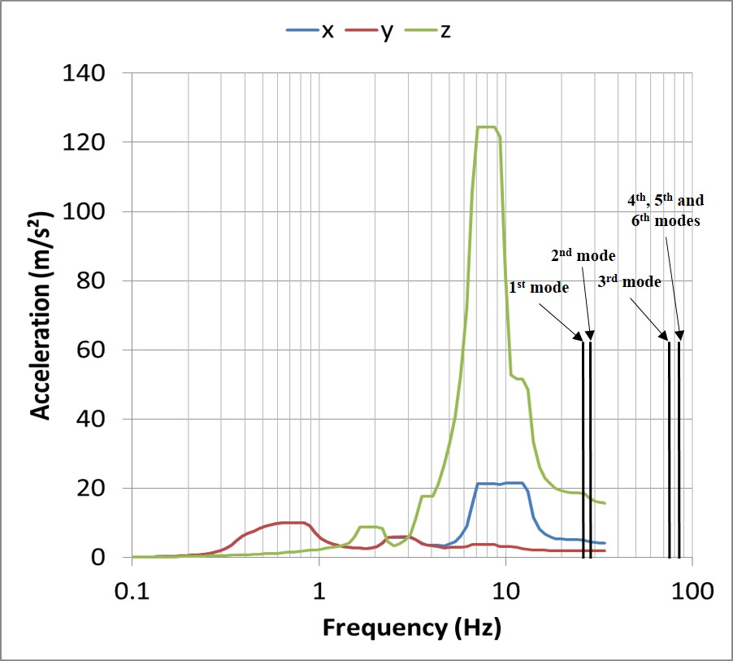
Fig. 2. FRS at the Upper Plug Flange [8]. The first six DCPSP natural frequencies are also reported.
The cut-off frequency (f_{ZPA}) is the last frequency point of the FRS, whose acceleration is named Zero Period Acceleration (ZPA). Beyond this frequency (33 Hz, [9]), the structure is considered perfectly rigid and therefore its natural frequency is infinity (the natural period is zero). This means that the DCPSP will oscillate in unison with the Upper Plug Flange and at an acceleration equal to the ZPA. The ZPA values relative to the FRS at the Upper Plug Flange are 4.08 m/s², 1.95 m/s² and 15.71 m/s² [8] according to the radial, toroidal and vertical directions. Engineering factors of 1.25 and 1.5 [7] were applied to the selected FRS (and ZPA values) in order to cover the uncertainties existing in [8]. The Complete Quadratic Combination (CQC) method is used for the modal combination in the RS analysis as specified in [9].
Regarding the static method, three independent static structural simulations were performed with acceleration values of 7.65 m/s², 3.65 m/s² and 29.45 m/s² (ZPA acceleration multiplied by the engineering factors) according to the radial, toroidal and vertical directions, respectively.
2.2 Results
Since the DCPSP is cantilevered inside the Port Plug, the first and second modes correspond to the vertical (26.8 Hz) and toroidal (28.8 Hz) bending of the IV Waveguides, respectively (Fig. 3). The third mode takes place for a much higher frequency (74.3 Hz) and corresponds to the torsion of the structure. The following modes correspond to independent IV Waveguide vibrations.
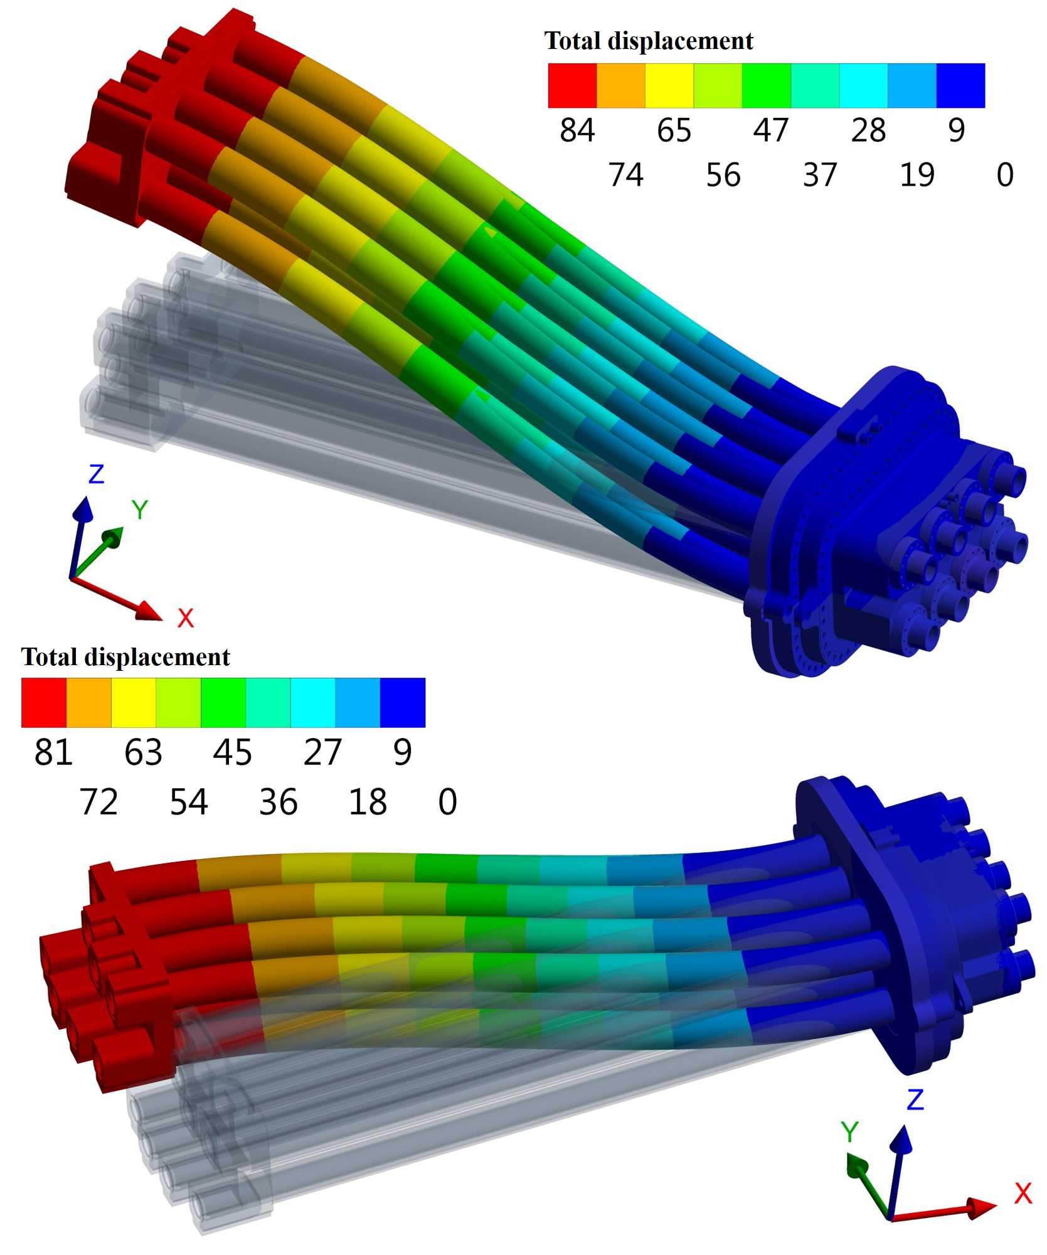
Fig. 3. First (top) and second (bottom) natural modes of the DCPSP.
Only the two first modes are below the f_{ZPA}. The RS analysis was then performed by using these two modes and including the missing mass associated to the higher order modes. The obtained natural frequencies are far from the FRS peaks (Fig. 2), which take place around 10 Hz, so no resonance condition occurs for the DCPSP.
The results from the RS analyses according to the three directions of the acceleration shall be combined in order to obtain the final results. The Newmark’s rule [9] was considered for the spatial combination of the results. This rule assumes that when the maximum response according to one direction of the excitation occurs, the responses according to the other two directions are 40% of the maximum. For a given variable R, the Newmark’s rule is defined as:
$R=max\left(±R_{x}±{0.4R}_{y}±{0.4R}_{z}; ±0.4R_{x}±R_{y}±{0.4R}_{z}; ±0.4R_{x}±{0.4R}_{y}±R_{z}\right)$ (1)
Where R_{x}, R_{y} and R_{z} are the responses of the system due to the excitation in the radial, toroidal and vertical directions, respectively. The Newmark’s rule is also considered for the spatial combination of the results coming from the static simulations.
The results obtained from both approaches show a good agreement for each one of the analyzed magnitudes. However, the maximum directional displacements and stress components are slightly higher for the RS method (Table 1). This can be explained considering the fact that the first two natural frequencies of the DCPSP are still below the f_{ZPA}. The largest directional displacement takes place along the Z axis since the seismic excitation in this direction is the highest. The highest stresses occur at the connection of the IV waveguides with the plates located at both ends.
Table 1. Maximum directional displacements (U) and stress components (S) obtained from the RS and static approaches, and ratio between them.
Magnitude | RS approach | Static approach | Ratio
U_{x} (mm) | ±0.34 | ±0.29 | 1.17
U_{y} (mm) | ±0.14 | ±0.13 | 1.03
U_{z} (mm) | ±1.47 | ±1.26 | 1.16
S_{x} (MPa) | ±28.71 | ±26.18 | 1.09
S_{y} (MPa) | ±16.16 | ±15.93 | 1.01
S_{z} (MPa) | ±13.97 | ±11.36 | 1.23
S_{xy} (MPa) | ±5.64 | ±5.53 | 1.01
S_{yz} (MPa) | ±8.33 | ±9.13 | 1.02
S_{xz} (MPa) | ±9.45 | ±8.69 | 1.08
The advantage of using the static method for the combination with the rest of the loads taking place during the VV baking scenario is that the seismic excitation can be directly introduced to the analysis setup as an additional time step. In addition, the RS method does not allow nonlinear properties, such as gasket material models, frictional contacts, or large deformations, which are used for the analysis of the VV baking scenario. For these reasons, the static method accelerations multiplied by a dynamic amplification factor of 1.25 (conservative value, higher than all the ratios reported in Table 1) was used for the assessment of the seismic event taking place during the VV baking scenario.
3. Thermo-mechanical analyses
3.1 Model description
A static thermo-mechanical analysis was performed to assess the DCPSP mechanical integrity (plastic collapse and ratcheting) against the loads due to the seismic event occurring during the VV baking scenario. Geometry, mesh, contacts and material properties considered in this analysis are identical to the ones described in [2].
The analysis setup is divided into 8 sequential load steps as described in Table 2. The seismic excitation according to the Y axis is not considered due to the symmetric conditions defined in the numerical model. This is an acceptable assumption since the acceleration along the Y axis is much lower than the accelerations along the X axis and Z axis. The Newmark’s rule [9] is not applied in this case, to be conservative. The sign for the acceleration components is assigned to produce the highest deflection of the IV Waveguides; positive values along the X axis and negative values along the Z axis.

Table 2. Load steps. Coupling 1, 2 and 3 correspond to the couplings Closure Plate – IV-WG CPSP (59 bolts), IV-WG CPSP – TI CPSP (51 bolts) and TI CPSP – EV Waveguides (51 bolts per coupling), respectively. The coolant pressure relative to the Primary Heat Transfer System (4 MPa) and Component Cooling Water System (0.85 MPa) is applied to the IV-WGs CPSP and TI CPSP cooling circuits [7], respectively. The external forces and moments obtained from the First Confinement system [3] are applied on the EV waveguides boundaries.
Load step | Pre-tension coupling 1 (kN/bolt) | Pre-tension coupling 2 (kN/bolt) | Pre-tension coupling 3 (kN/bolt) | Gravity (m/s²) | Coolant  pressure (MPa) | Seismic  Excitation  [x, y, z]  (m/s²) | Baking temp. (°C) | Forces  [x, y, z] (kN) | Moments [x, y, z] (Nm)
1 | 48 | Open | Open | - | - | - | - | - | -
2 | Lock | 48 | Open | - | - | - | - | - | -
3 | Lock | Lock | 14 | - | - | - | - | - | -
4 | Lock | Lock | Lock | 9.8 | - | - | - | - | -
5 | Lock | Lock | Lock | 9.8 | 4, 0.85 | - | - | - | -
6 | Lock | Lock | Lock | 9.8 | 4, 0.85 | 9.56, 0, 36.82 | - | - | -
7 | Lock | Lock | Lock | 9.8 | 4, 0.85 | 9.56, 0, 36.82 | Fig.4 | - | -
8 | Lock | Lock | Lock | 9.8 | 4, 0.85 | 9.56, 0, 36.82 | Fig.4 | 3, 0, 1 | 0, 1000, 0

3.2 Results
Fig 5 shows the stress intensity (Tresca) field of the most highly stressed section, located in the IV-WG CPSP flange. The stress on this section is classified, in order to be compared to the allowable design limits. The stress classification is based on Primary (P) and secondary stresses (Q), which are related with the equilibrium equations and compatibility equations, respectively. In addition, the primary stress must be linearized along the so-called Stress Classification Lines (SCL), to obtain the generalized membrane stress (P_{m}) (or localized membrane stress (P_{L}) – if close to discontinuities), the bending (P_{B}) and peak stress (F).
The ASME code [10] was selected for the design validation by analysis of the DCPSP. The allowable values in correspondence to the selected design criteria are given in Table 3. The design stress intensity S_{m} was obtained by the 2/3 of the minimum yield stress at the baking temperature of 240°C and it amounted to 90 MPa [5]. The VV Baking + SL-2 scenario is categorized as Category IV [7], which for SIC-1 components corresponds to ASME Level D. The stress intensity factor k for ASME Level D is 2 [10]. The comparison between the categorized stress obtained and the allowable design limits shows that the DCPSP design is capable (in terms of plastic collapse and ratcheting) of withstanding the expected loads due to the SL-2 seismic event occurring during the VV baking scenario.
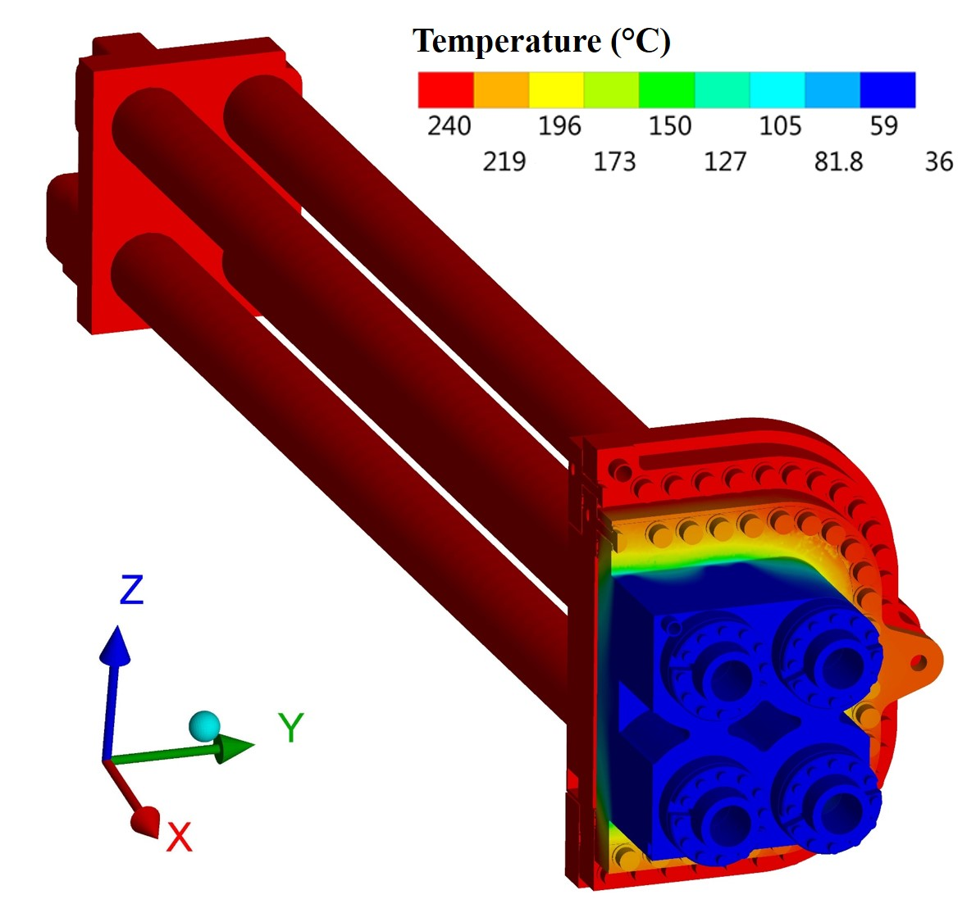
Fig. 4. DCPSP temperature distribution during the VV baking event.
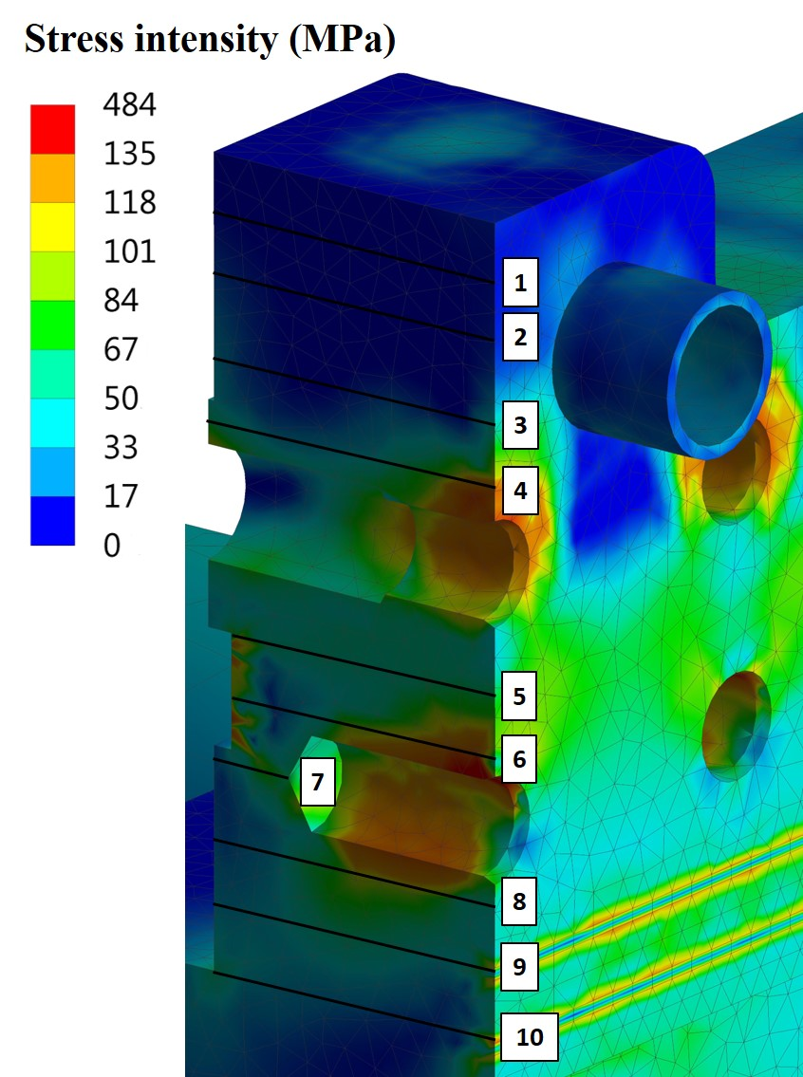
Fig. 5. Stress intensity of the most stressed region (IV-WG CPSP mid-plane bolting area).
Table 3. Stress verification. Values in MPa.
Design Criteria | 1 | 2 | 3 | 4 | 5 | 6 | 7 | 8 | 9 | 10 | Limit
P_{m} | - | - | - | - | - | - | - | - | - | - | k S_{m} = 180 MPa
P_{L} | 1.1 | 1.7 | 8.7 | 27.7 | 57.6 | 45.6 | 41.3 | 52.6 | 30.6 | 27.9 | 1.5k S_{m} = 270 MPa
P_{m} (P_{L})+ P_{B} | 2.5 | 3.8 | 19.9 | 64.5 | 63.4 | 90.5 | 74.3 | 93.8 | 60.8 | 64.1 | 1.5kS_{m} = 270 MPa
P_{m} (P_{L})+ P_{B} + Q | 7.6 | 12.0 | 28.1 | 123.4 | 70.7 | 187.8 | 90.9 | 120.9 | 52.0 | 43.9 | 3kS_{m} = 540 MPa

4. Conclusions
An analysis strategy, based on the static approach, was developed in order to assess the DCPSP mechanical integrity against the loads occurring during the VV Baking + SL-2 load combination (accidental event).
The modal analysis of the DCPSP shows that only the first two natural frequencies are below the f_{ZPA}, but are far from the FRS peaks. This explains the good agreement between the results obtained from the RS and static approaches. Nevertheless, a dynamic amplification factor of 1.25, which multiplies the static accelerations, was introduced in order to take into account the slightly higher values produced with the RS method.
The thermo-mechanical analysis of the DCPSP seismic event occurring during the VV baking scenario produces categorized stresses lower than the allowable limits defined in ASME [10] according the load category and component safety classification.
Additional analyses covering all the rest of the applicable load combinations shall be carried out in order to fully validate the DCPSP design [7].
Acknowledgments
This work was supported in part by the Swiss National Science Foundation. This work was carried out within the framework of the ECHUL consortium, partially supported by the F4E grant F4E-GRT-615. The views and opinions expressed herein do not necessarily reflect those of the European Commission or the ITER Organization.
References
- D. Strauss, et al., Progress of the ECRH upper launcher design for ITER, Fusion Eng. Des. 89 (2014) 1669–1673
- A. Mas Sánchez, et al., Design status of the double Closure Plate Sub-Plate concept for the ITER Electron Cyclotron Upper Launcher, Fusion Eng. Des. 136 (2018) 503-508
- A. Mas Sánchez, et al., Mechanical analyses of the ITER electron cyclotron upper launcher first confinement system, Fusion Eng. Des. In Press, 123 (2017) 458–462
- http://www.ansys.com/
- V. Barabash, et al., ITER MPH - AA04 316L(N)-IG – Annealed, ITER_D_222W67 v2.0
- D. Rasmussen, Deviation Request for Addition of Aluminum Alloy Grades to the ITER Material Properties Handbook, ITER_D_G8XR8D v1.1
- N. Casal, EC UL Sub-System Load Specification [SSLS-52.UL], F4E_D_25QD28 v5.0
- G. Mazzone, Global Tokamak Seismic Report, IT-ER_D_33W3P4 v2.1
- F. Rueda, Guidelines for seismic design, analysis and qualification of complex industrial and nuclear facilities against seismic hazard, F4E_D_26R65J v2.0
- 2010 ASME Boiler & Pressure Vessel Code, Section III, Division 1, Subsection NC – Class 2 Components.

