Design status of the double Closure Plate Sub-Plate concept for the ITER Electron Cyclotron Upper Launcher
Avelino Mas Sánchezª, René Chavanª, Mario Gagliardi^{b}, Timothy Goodmanª, Jean-Daniel Landisª, Gabriella Saibene^{b}, Florian Ramseyerª, Phillip Santos Silvaª, Matteo Vagnoniª

ªEcole Polytechnique Fédérale de Lausanne (EPFL), Swiss Plasma Center (SPC), CH-1015 Lausanne, Switzerland ^{b}Fusion for Energy, Josep Pla 2, Torres Diagonal Litoral B3, E-08019 Barcelona, Spain

The Closure Plate Sub-Plate (CPSP), which defines the border between ex-vessel and in-vessel components of the Electron Cyclotron Upper Launcher (EC UL), bundles the waveguides into a sub-assembly which can be manipulated separately from the UL Port Plug (PP). The primary CPSP functions are to provide transmission line feedthroughs, support and alignment of the attached waveguides, neutron and gamma shielding, and Tritium/vacuum containment. The double CPSP concept, which is divided into In-vessel Waveguides CPSP and Thermal Isolation CPSP, was recently introduced in order to minimize the openings that expose the interior of the plug, to avoid the near environment activation in case of maintenance or intervention on the in-vessel components.
This paper reports the most recent status of the CPSP as well as the analyses carried out to validate the design for normal operation. The fluid-dynamic analyses show that the power dissipated due to mm-wave transmission can be properly removed with an acceptable mass flow producing admissible values of pressure drop and temperature rise in the cooling systems. The results obtained in the thermo-mechanical simulation, validated using the ASME code, shows that the CPSP design is capable of withstanding the expected loads taking place during normal operation.

Keywords: ITER, ECH, Upper Launcher, Closure Plate

1. Introduction
Four Electron Cyclotron Upper Launchers (EC UL) [1] will be used at ITER to counteract magneto-hydrodynamic plasma instabilities by injecting up to 20 MW of mm-wave power at 170 GHz. This mm-wave power will be transmitted through eight ex-vessel waveguide assemblies for each EC UL to the in-vessel waveguides. The power exiting the in-vessel waveguides inside the PP will be directed, by quasi-optical mirrors, to specific plasma locations.
The so-called Closure Plate Sub-Plate (CPSP) is the assembly that defines the border between ex-vessel and in-vessel components (Fig. 1). The CPSP bundles (both ex-vessel (EV) and in-vessel (IV)) waveguides (WGs) and waveguide feedthroughs into a subassembly that can be manipulated separately from the EC UL PP. The double CPSP concept was recently introduced to allow the independent removal of the first leg of ex-vessel waveguides as one group, while leaving the in-vessel waveguides in place in order to minimize the openings that expose the interior of the plug to the port cell; thereby, reducing the near environment activation. This approach also simplifies the cooling of IV and EV components, facilitating their connection to separate cooling systems.
The primary design loads for the CPSP are the bolt pre-tension required to properly compress the double metallic seals. External forces and moments derived from the imposed vacuum vessel displacement and waveguide thermal expansion, cooling pressure and thermal loads resulting from mm-wave transmission losses and stray radiation also contribute to the CPSP deformation.
2. Design description
The CPSP assembly consists of the mechanical coupling by bolted connection between two stainless steel 316L(N)-IG sub-assemblies called the In-vessel Waveguides (IV-WG) CPSP and the Thermal Isolation (TI) CPSP. These components are categorized with the most stringent ITER classifications in terms of safety and vacuum (SIC-1 (Safety Important Component 1) and VQC1A (Vacuum Quality Class 1A), respectively). Therefore, the flange coupling shall contain two concentric metallic seals with two ports for real-time leak monitoring of the seals’ interspace [2].
The IV-WG CPSP (Fig. 2) is also fastened in a cantilevered position to the Closure Plate via a bolted connection. A double metallic seal with two monitoring ports is required for this coupling as well. The Primary Heat Transfer System (PHTS; the system defined for the in-vessel component cooling), which is only accessible from the Port Cell side, shall be connected to cool the IV WGs. For this reason, the IV-WG CPSP is manufactured out of two plates with internal channels (both front and back plates) and concentric shells welded together in order to enclose the cooling water around the IV WGs. The internal cooling channels in the front plate force us to modify the bolt spacing at this region. All the welded connections are designed to use the full penetration butt welds required in [2]. The cylindrical internal surface of the IV WGs (also made of 316L(N)-IG) shall be corrugated and copper coated in order to reduce the Ohmic losses that occur during power transmission. This assembly (as well as the TI CPSP) is installed using two two-stepped guiding pins, one at each side, to ensure proper alignment.
The ITER vacuum vessel together with the in-vessel components will be baked 500 times during the ITER lifetime by PHTS water at 240°C [3]. During the vacuum vessel warm-up (48 hours) and cool-down (24 hours), the eight aluminum alloy EN AW-6061-T6 EV waveguides shall be protected so that they do not reach inadmissible temperatures. The TI CPSP (Fig. 3) will be actively cooled by the Component Cooling Water System (CCWS-1; the system defined for cooling the ex-vessel SIC-1 components), via cooling channels machined using the deep-drilling technique. The cooling channels are covered by full-penetration welded caps. Each EV-WG is connected to corrugated, copper-coated, waveguide feedthroughs by double-metallic-seal bolted couplings.

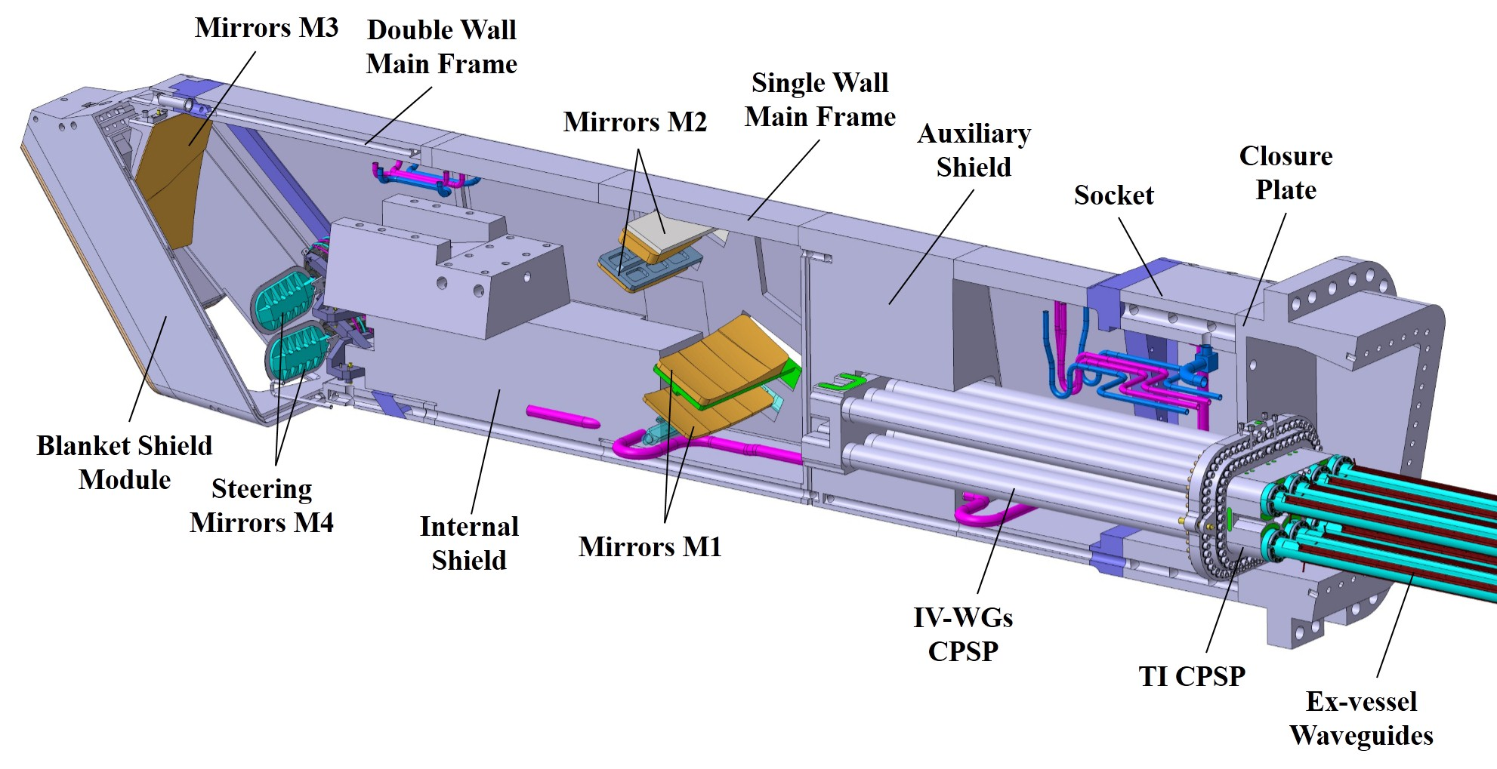
Fig. 1. ITER Electron Cyclotron Upper Launcher.

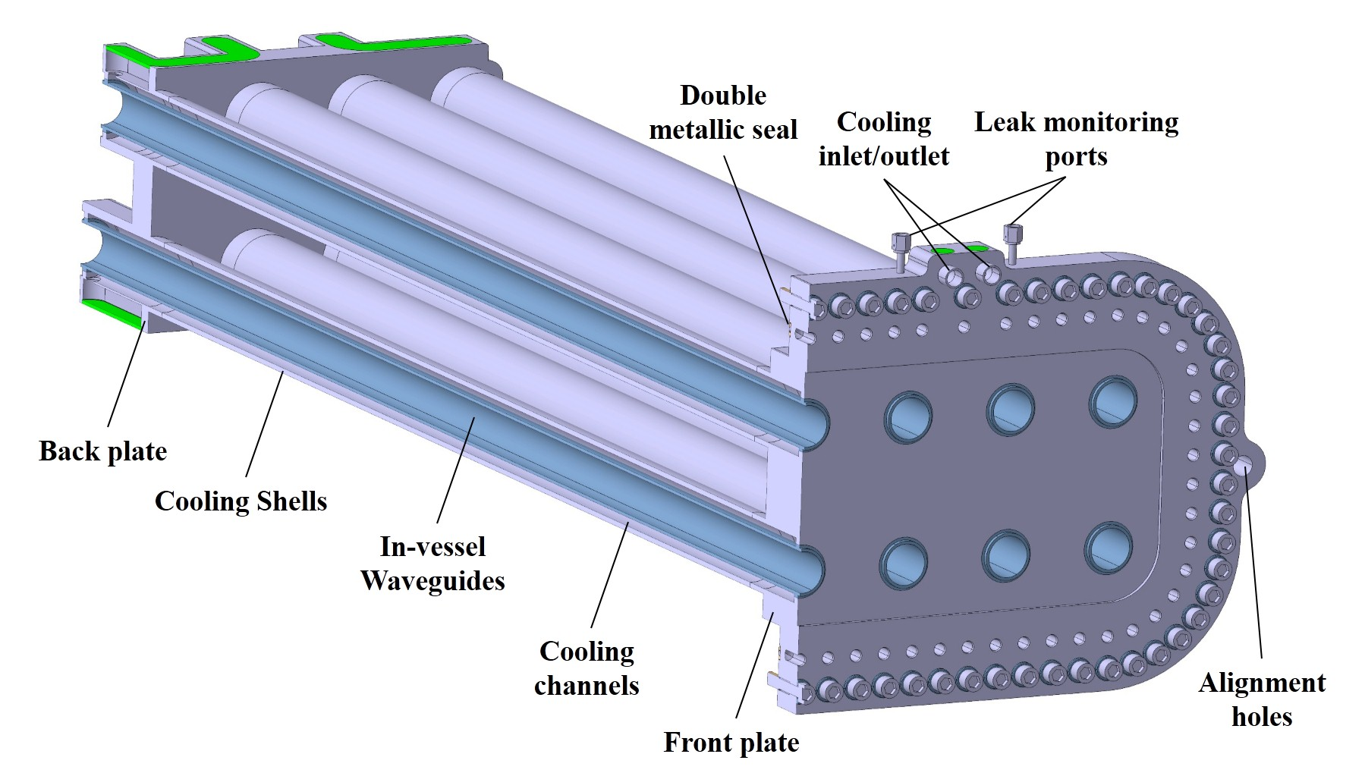
Fig. 2. In-vessel Waveguides CPSP

3. Numerical analyses
3.1 Fluid-dynamic analyses
These analyses aim to characterize the flow pattern and heat transfer taking place in both the IV-WG CPSP and the TI CPSP. The results from these simulations allow the estimation of the required mass flow rate to ensure an acceptable temperature rise during normal mm-wave operation while simultaneously maintaining an admissible pressure drop. Two, independent, fluid-dynamic simulations for each sub-assembly are performed in ANSYS Workbench 18.0 CFX [4]. The temperature-dependent material properties used for these analyses are obtained from [5] for 316L(N)-IG. The default properties included in the CFX software are used for water. The turbulence model used for both simulations is the Shear Stress Model (SST) with a mesh refinement that leads to y+=1 near the walls.
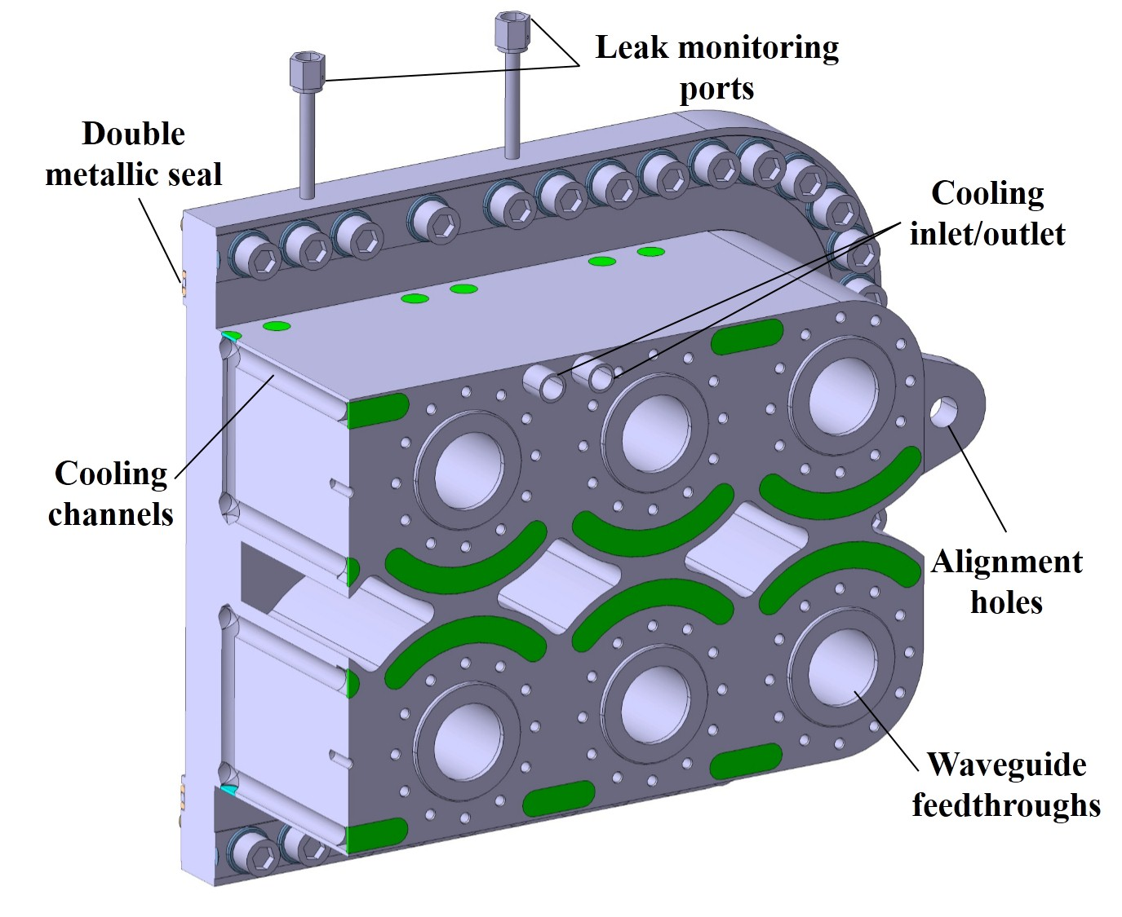
Fig. 3. Thermal Isolation CPSP
3.1.1 IV-WG CPSP analysis
The selected mass flow rate for the IV-WG CPSP cooling is 0.8 kg/s; this represents 9.5% of the total PHTS flow rate available for one launcher. The inlet temperature and pressure in the simulation are 75°C and 4 MPa, respectively [3]. The heat flux into each internal IV WG surface is defined by the following expression:
$q^{''}(W/m^{2})= 4000 + 14260 e^{-z/1.102}$,
where 4000 $(W/m^{2})$ is the uniform power deposition due to the ohmic losses during mm-wave transmission and $14260 (W/m^{2}) e^{-z/1.102(m)}$ is the heat flux associated with stray radiation, where z (m) is the WG axial direction with the origin of the coordinates at the end of the longest WG (positive values along the WGs away from the plasma). This expression results in an overall power to the ensemble of 24.5 kW when all waveguides are powered. In addition, the IV-WG CPSP surface that is in contact with the Closure Plate is set to a uniform temperature of 100°C (Vacuum Vessel temperature during normal operation [3]); this adds 2 kW of thermal heating power to the system. The average Reynolds number through the WG channels is 8500.
The simulation shows that the highest temperature values occur at the WG ends (where the highest power deposition takes place), reaching 104°C (Fig. 4). The outlet temperature for the water is 82.9°C (7.9°C temperature rise) which is much smaller than the maximum allowed outlet temperature for the PHTS circuit (126°C [3]). The pressure drop across the system is 0.23 MPa, which is an admissible value compared with the maximum allowed pressure drop for the PHTS circuit (1.35 MPa [3]).
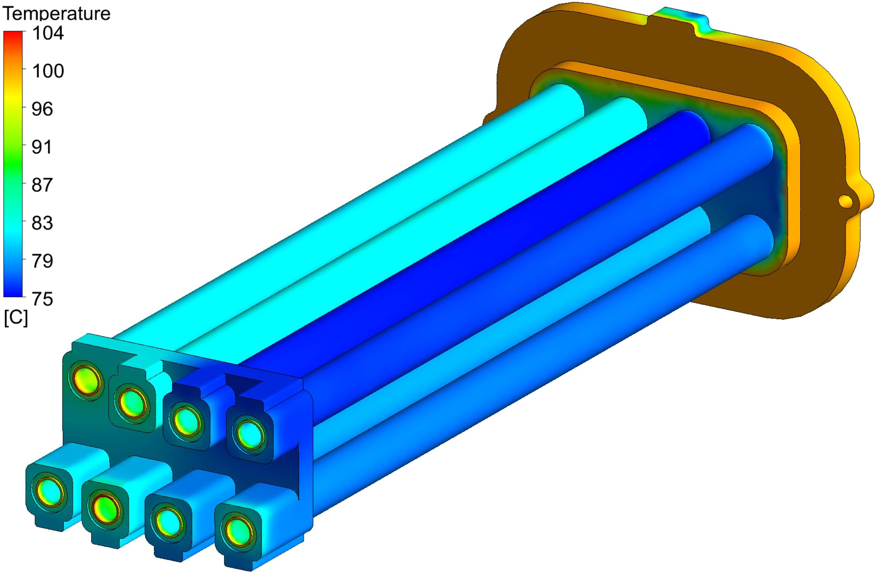
Fig. 4. Temperature field for the IV-WG CPSP for normal operation
3.1.2 TI CPSP analysis
The selected mass flow rate for the TI CPSP cooling is 0.2 kg/s, which represents 4.7% of the total CCWS-1 flow rate available for one launcher. The inlet temperature and pressure in the simulation are set to 34°C and 0.85 MPa, respectively [3]. The heat flux to the waveguide feedthroughs’ surfaces due to Ohmic losses is 4300$\frac{W}{m^{2}}$ , which amounts to 1.06 kW in total: the stray radiation here is negligible. The TI CPSP surface in contact to the IV-WG CPSP is set to a uniform temperature of 100°C (maximum temperature obtained on this face from the IV-WG CPSP analysis) adding 878 W. The average Reynolds number through the cooling channels is 19000.
This analysis shows that the highest temperature obtained on the surfaces in contact to the aluminum EV-WGs only reaches 59°C (Fig. 5). The outlet temperature for the water is 36.3°C (2.3°C temperature rise), which is much smaller than maximum allowed outlet temperature for the CCWS-1 circuit (51°C [3]). The pressure drop across the system is 0.04 MPa, which is an admissible value compared with the maximum allowed pressure drop for the CCWS-1 circuit (0.5 MPa [3]).
This sub-system is also simulated for a vacuum-vessel baking event, with the same cooling parameters. In this case a uniform temperature of 240°C (inlet temperature of the PHTS water during baking [3]) is imposed on the surface in contact to the IV-WG CPSP, this provides 3.4 kW of heating power to the system. Thermal radiation is considered on the surface facing the IV-WG CPSP; this results in an additional 180 W. The simulations’ results show that the highest temperature obtained on the surfaces in contact with the aluminum EV-WG only reaches 51°C. This value is smaller than 75°C, the value below which creep effects for aluminum alloy EN AW-6061-T6 are considered negligible [6]. The outlet temperature for the water is 38.3 °C.
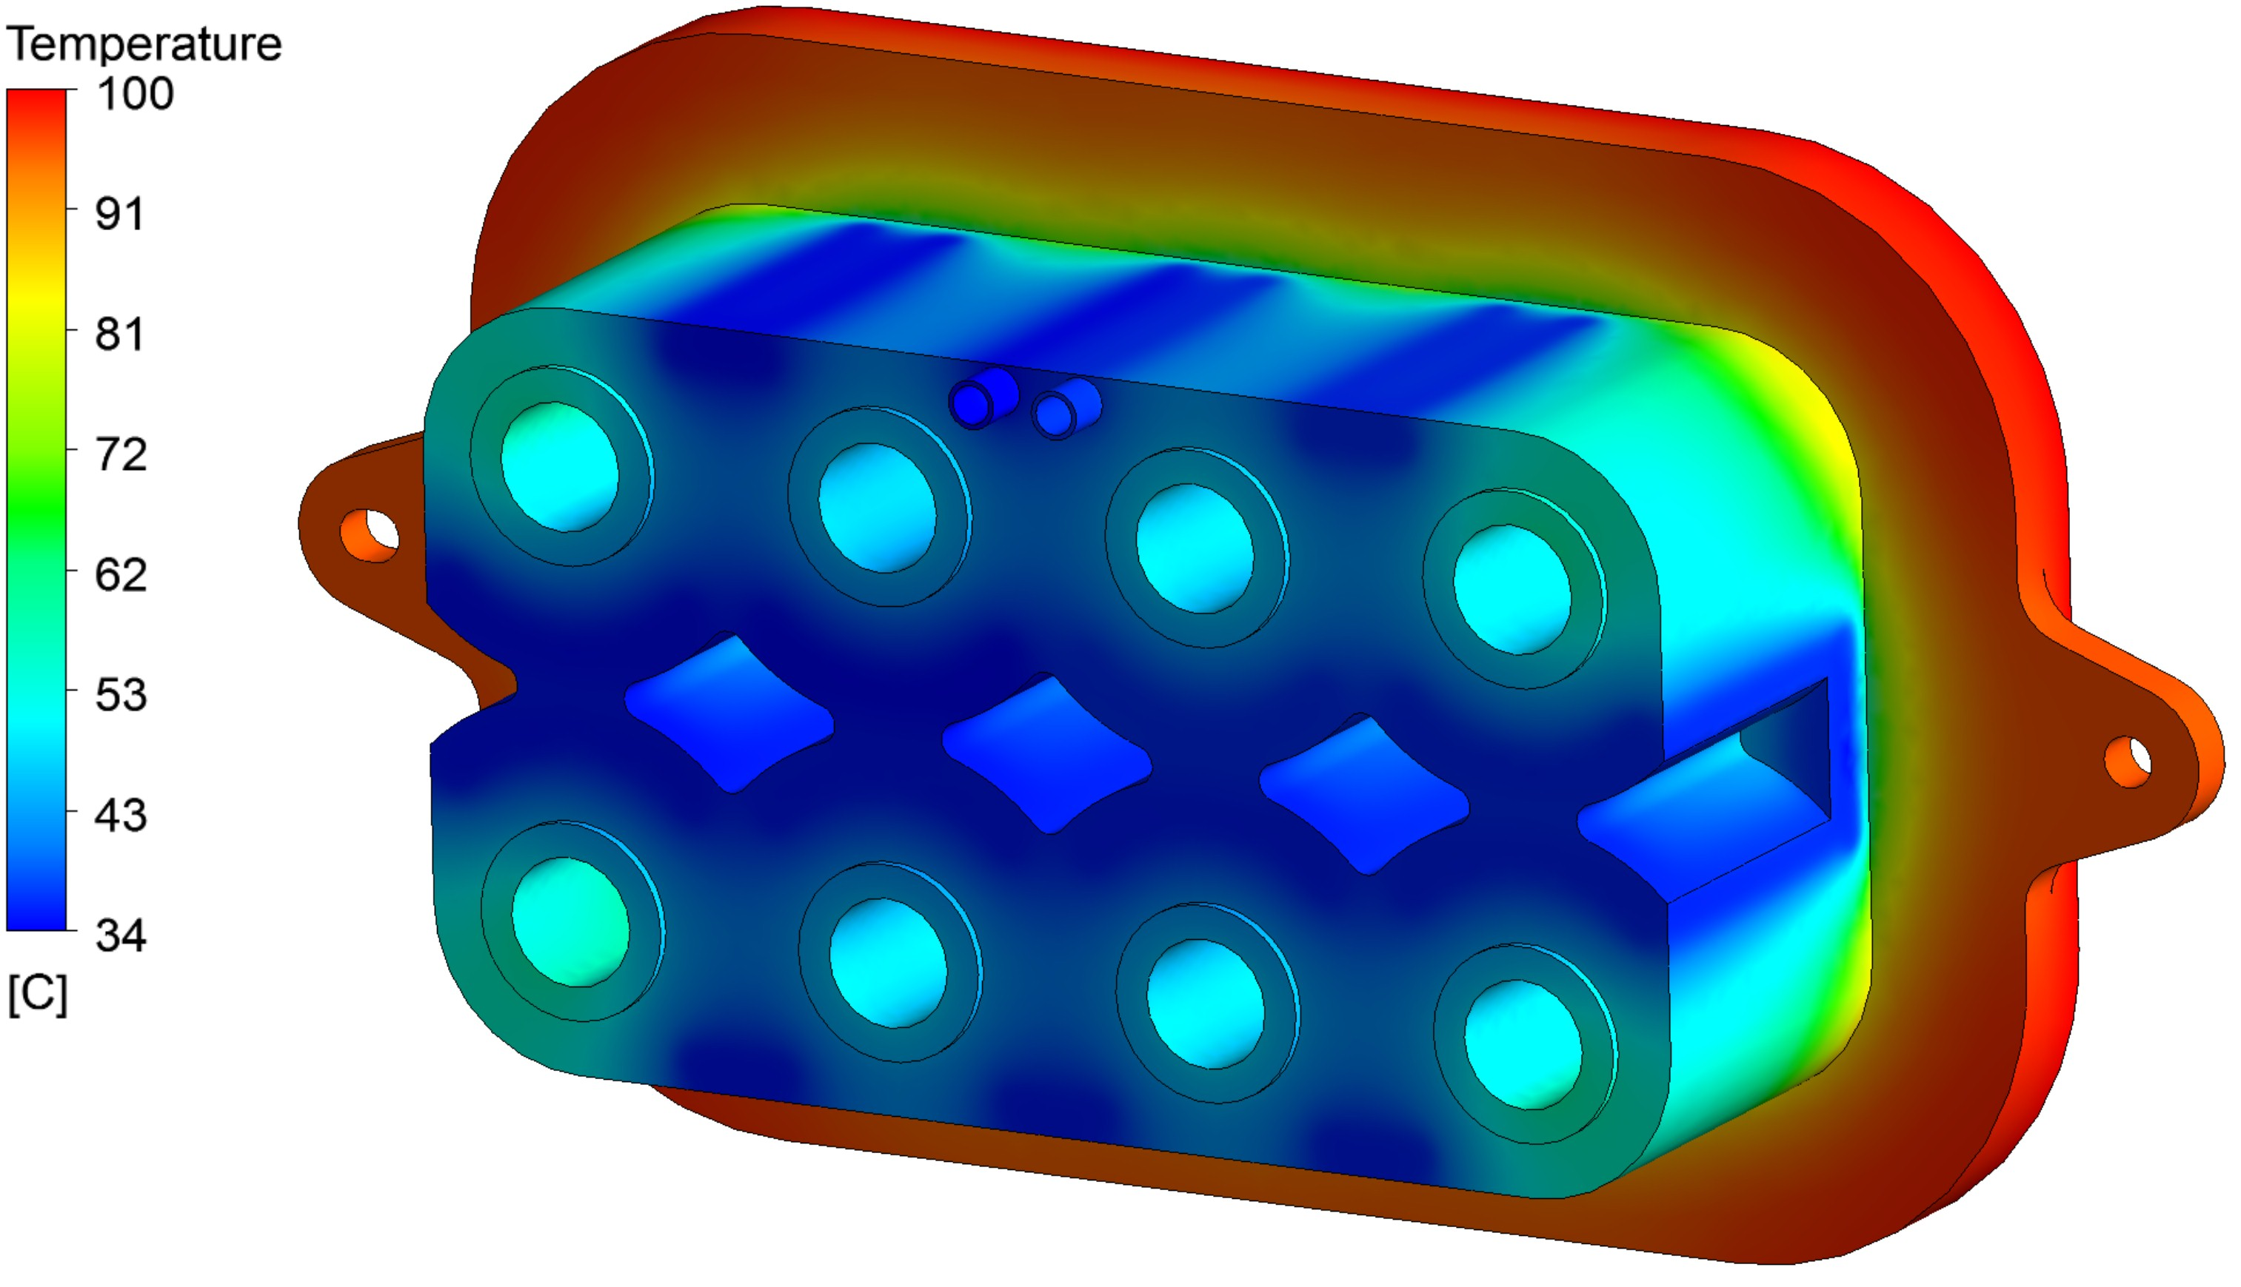
Fig. 5. Temperature field for the TI CPSP for normal operation

3.2 Thermo-mechanical analyses
A thermo-mechanical analysis is performed in ANSYS Workbench 18.0 Static Structural [4] in order to assess the CPSP assembly integrity during normal operation. The numerical model (Fig. 6) covers the entire CPSP assembly including the attached EV-WG and a segment of the Closure Plate, which is fixed in space. Symmetry conditions are used to reduce the computational cost of the simulation. The metallic seals are modelled as prismatic rings with square cross sections of 1.8 and 1 mm width (estimated contact surface after compression) and 4.8 and 2.6 mm height (seal cross section diameter before compression) for couplings 1-2 and coupling 3, respectively (Fig. 6). An initial separation between faces (0.8 mm for couplings 1-2 and 0.47 mm for coupling 3, seal compression recommended by the supplier) is defined as the starting state of the model in order to properly simulate the bolt pre-tensioning process. The seal properties definition and the loading strategy used in this simulation are the ones developed in [7].

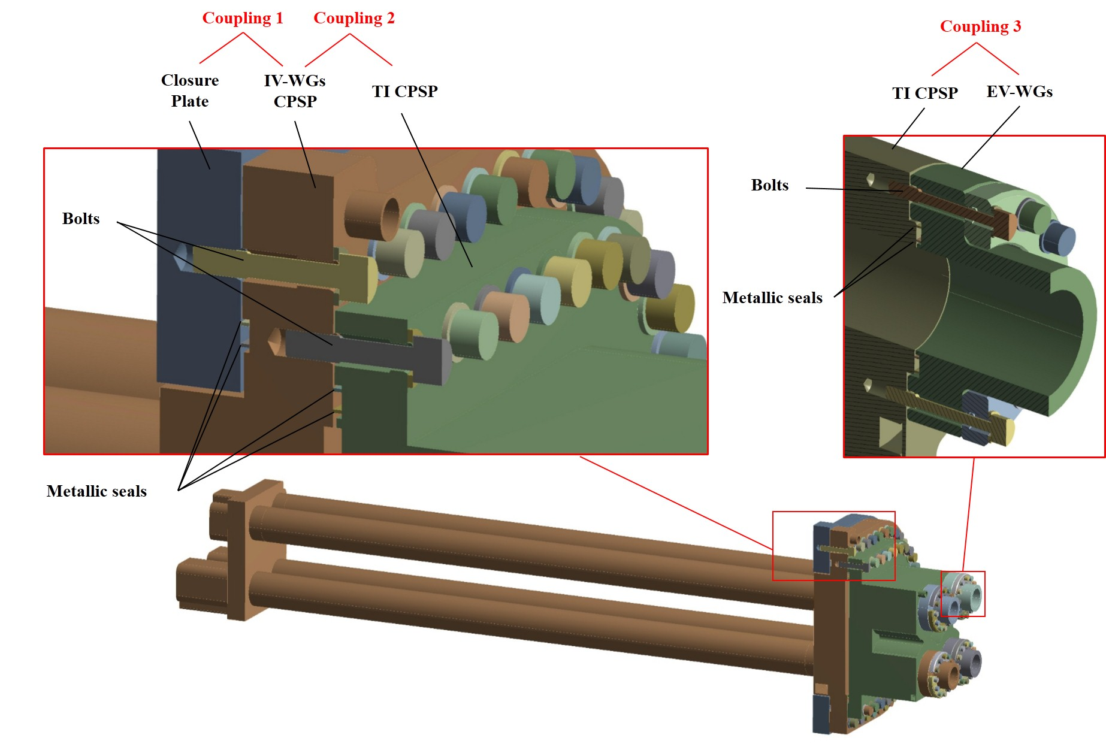
Fig. 6. Numerical model for the CPSP assembly mechanical analysis

The temperature-dependent material properties used in this analysis are obtained from [5], [8] and [9] for 316L(N)-IG (Closure Plate, IV-WG CPSP and TI CPSP), Inconel 718 (bolting), and Aluminum Alloy 6061-T6 (EV-WGs), respectively. Linear behavior is assumed for 316L(N)-IG, Inconel 718, and Aluminum Alloy 6061-T6 in this simulation. Non-linear hysteresis curves provided by the suppliers (Technetics [10] for the couplings 1-2 and HTMS [11] for coupling 3) are introduced to simulate the seal behaviors.
The analysis setup is divided into 7 sequential load steps (Table 1). This strategy not only aims to facilitate the convergence of the numerical problem, but also to assess the independent contribution of each load step. The pre-tension load applied is 48 kN for couplings 1-2 bolts (59 bolts for Coupling 1, 51 bolts for Coupling 2) and 14 kN for coupling 3 bolts (12 bolts each). The inlet pressure described in Sec. 3.1 is applied on the surfaces in contact with the cooling water. A prior thermal simulation with ANSYS Workbench 18.0 Steady-State Thermal [4], where the temperature fields from Sec. 3.1 were used as inputs, is performed in order to obtain the temperature distribution in the components not considered in the two previous fluid-dynamic simulations (Sec. 3.1). In addition, the external loads coming from the vacuum vessel displacement and waveguide thermal expansion are applied to the attached EV-WGs. An axial force of 65 kN and a bending moment of 100 Nm (values obtained from the overall simulation of the EC UL First Confinement System during normal operation [12]) are applied to the EV-WG borders.

Table 1. Load steps.
Load step | Pre-tension coupling 1 (kN) | Pre-tension coupling 2 (kN) | Pre-tension coupling 3 (kN) | Gravity (m/s) | PHTS  cooling  pressure (MPa) | CCWS-1 cooling pressure (MPa) | Temp. field (°C) | Axial  Force (kN) | Bending Moment (Nm)
1 | 48 | Open | Open | - | - | - | - | - | -
2 | Lock | 48 | Open | - | - | - | - | - | -
3 | Lock | Lock | 14 | - | - | - | - | - | -
4 | Lock | Lock | Lock | ON | - | - | - | - | -
5 | Lock | Lock | Lock | ON | 4 | 0.85 | - | - | -
6 | Lock | Lock | Lock | ON | 4 | 0.85 | ON | - | -
7 | Lock | Lock | Lock | ON | 4 | 0.85 | ON | 65 | 100

Fig. 7 shows the stress intensity (Tresca) field of the most highly stressed section, located in the TI CPSP flange. The stress on this section must be classified, in order to be compared to the allowable design limits. The stress classification is based on Primary (P) and secondary stresses (Q), which are related with the equilibrium equations and compatibility equations, respectively. In addition, the primary stress must be linearized along the so-called Stress Classification Lines (SCL) (Fig. 7), to obtain the generalized membrane stress (P_{m}) (or localized membrane stress (P_{L}) if close to discontinuities), as well as the bending (P_{B}) stress.
The ASME code [13] is selected for the validation by analysis of the CPSP assembly design. The allowable values for each type of stress (P_{m} or P_{L}, P_{L}+P_{B} and P_{L}+P_{B}+Q) are derived from the design stress intensity (S_{m}), which is 2/3 of the minimum yield stress (172 MPa) at working temperature (100°C) [5]. According to [13] the verifications to be performed for normal operation (ASME Level A) are:
P_{m} < S_{m} = 114.6 MPa; P_{L} < 1.5S_{m} = 172 MPa; P_{L}+P_{B} < 1.5S_{m} = 172 MPa; P_{L}+P_{B}+Q < 3S_{m}= 344 MPa;
Table 2 summarizes the verifications performed for each SCL. P_{m} is not assessed because the presence of discontinuities on the selected section. Only the first five load steps (bolt pre-tension, inner pressure and gravity) are considered for the evaluation of primary stresses. For secondary stresses the full set of load steps is evaluated (including thermal loads and loads coming from imposed displacements).

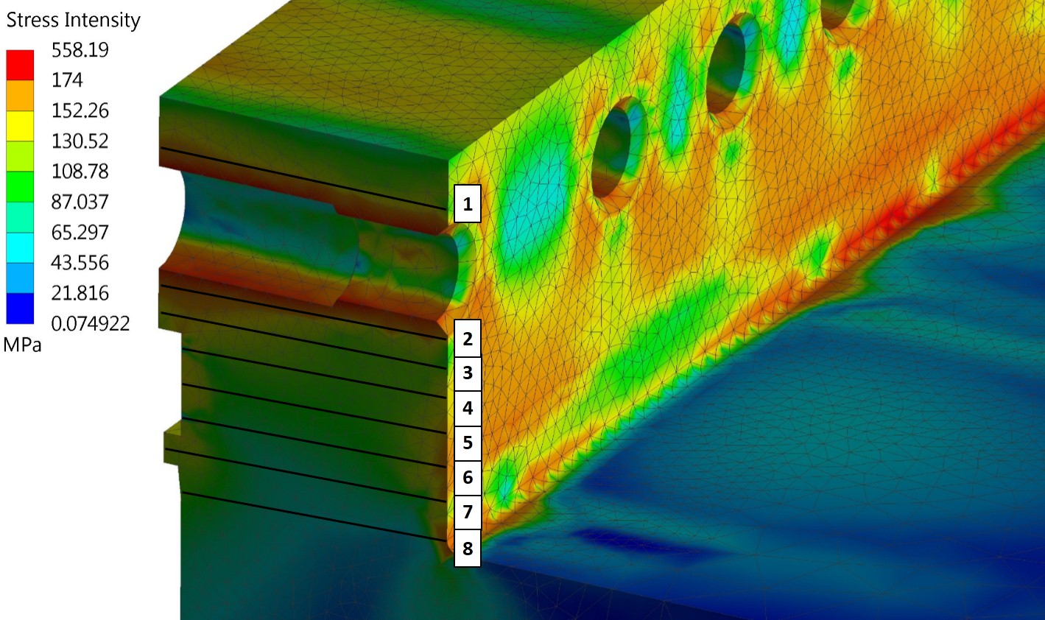
Fig. 7. Stress intensity of the most stressed region (TI CPSP) after the full set of load steps
Table 2. Stress verification (MPa).
SCL | 1 | 2 | 3 | 4 | 5 | 6 | 7 | 8 | Limit
P_{m} | - | - | - | - | - | - | - | - | 114.6
P_{L} | 34.1 | 40.2 | 43.7 | 43.3 | 22.3 | 25.4 | 7.1 | 6.1 | 172
P_{L}+P_{B} | 70.0 | 102.7 | 77.9 | 51.7 | 55.5 | 35.6 | 48.1 | 47.3 | 172
P_{L}+P_{B}+Q | 200.0 | 239.3 | 146.0 | 116.8 | 128.7 | 123.3 | 135.1 | 111.7 | 344

4. Conclusions
A design concept of double CPSP for the ITER EC UL, capable of fulfilling the requirements in terms of safety, vacuum tightness, space restriction and mm-wave transmission, has been developed by SPC (Swiss Plasma Center) in the framework of the F4E grant F4E-GRT-615.
The fluid-dynamic analyses show that the power dissipated in both IV-WG CPSP and TI CPSP during normal operation can be properly removed with an acceptable mass flow, resulting in an admissible contribution to their respective cooling systems in terms of pressure drop and temperature rise. The simulation for the baking event indicates that the TI CPSP properly thermally isolates the Aluminum Alloy 6061-T6 EV-WGs, maintaining their contact surfaces at allowable temperatures.
The comparison between the classified stress from the thermo-mechanical analysis and the allowable design limits according ASME code [13] shows that the CPSP assembly design is capable of withstanding the expected loads taking place during normal operation.
Additional analyses shall be performed in order to validate the CPSP assembly design against the full range of load combinations expected to take place throughout the system life-cycle [3].
Acknowledgments
This work was supported in part by the Swiss National Science Foundation. This work was carried out within the framework of the ECHUL consortium, partially supported by the F4E grant F4E-GRT-615. The views and opinions expressed herein do not necessarily reflect those of the European Commission or the ITER Organization.
References
- D. Strauss, et al., Progress of the ECRH upper launcher design for ITER, Fusion Eng. Des. 89 (2014) 1669–1673
- R. Pearce, ITER Vacuum Handbook, ITER_D_2EZ9UM v2.3
- N. Casal, EC UL Sub-System Load Specification [SSLS-52.UL], F4E_D_25QD28 v5.0
- http://www.ansys.com/
- V. Barabash, et al., ITER MPH - AA04 316L(N)-IG – Annealed, ITER_D_222W67 v2.0
- RCC-MRx, Section III, Tome 1, Subsection Z, Appendix A.3.2.A
- A. Mas Sánchez, et al., Mechanical analyses of the waveguide flange coupling for the first confinement system of the ITER electron cyclotron upper launcher, Fusion Eng. Des. 109-111, Part A, (2016) 532-538
- V. Barabash, et al., ITER MPH - AD02 Alloy 718, ITER_D_222XFT v2.0
- D. Rasmussen, Deviation Request for Addition of Aluminum Alloy Grades to the ITER Material Properties Handbook, ITER_D_G8XR8D v1.1.
- http://www.techneticsgroup.com.
- http://www.htms.com/.
- A. Mas Sánchez, et al., Mechanical analyses of the ITER electron cyclotron upper launcher first confinement system, Fusion Eng. Des. In Press, Corrected Proof (2017)
- 2010 ASME Boiler & Pressure Vessel Code, Section III, Division 1, Subsection NC – Class 2 Components.

