Supporting Information
Colloid transport and distribution in the hyporheic zone
Guangqiu Jin¹, Zhongtian Zhang¹, Hongwu Tang^{1,}#, Yang Xiaoquan^{3,1}, Ling Li², D. A. Barry⁴
¹ State Key Laboratory of Hydrology-Water Resources and Hydraulic Engineering, Hohai University, Nanjing, China
Emails: jingq@hhu.edu.cn, zhongtian_zhang@163.com, hwtang@hhu.edu.cn
² School of Engineering, Westlake University, Hangzhou, China
Email: liling@westlake.edu.cn
³ Guiyang Aluminum & Magnesium Engineering & Research Institute Co., Ltd, Guiyang, 550081, China
Email: mnmn520530@126.com
⁴ Laboratoire de technologie écologique, Institut d’ingénierie de l’environnement, Faculté de l’environnement naturel, architectural et construit (ENAC), Ecole Polytechnique Fédérale de Lausanne (EPFL), Station 2, 1015 Lausanne, Switzerland
Email: andrew.barry@epfl.ch

S1 Determination of the detachment rate coefficient k_{det}
The detachment rate coefficient (k_{det}) can be calculated based on the following equation (Israelachvili, 1992),
(S1)
where β is the hysteresis loss factor; ΔG_{min} (J) is the primary minimum of interaction energy; μ (Pa s) is the fluid viscosity; d_{p} (μm) is the colloid radius; and K_{interaction} (J μm⁻²) is the elastic interaction constant. Using Equation (S1), k_{det} is determined to be 4.86×10⁻⁹ s⁻¹, far less than k₁ =2.4×10⁻³ s⁻¹. Therefore, the effect of detachment can be neglected. Note that values of coefficients involved in Equation (S1) were based on the study of Israelachvili [1992] and Bergendahl [2000].

S2 Variations of sand bed properties due to colloid retention and retention mass calculation
In this study, retained colloids would not change the porosity and hydraulic conductivity significantly, as the total mass of the colloids released to the system during the experiments and simulations is very small and would not impose significant effects on the porosity and hydraulic conductivity. According to the reference of Zheng. et al. [2014], the variation of porosity and hydraulic conductivity could be calculated as follows
(S2)
(S3)
where θ is porosity, θ₀ is the initial porosity, S_{c} (kg m⁻³) is the retention concentration, (kg m⁻³) is the density of colloid particles, K (m s⁻¹) is the hydraulic conductivity, and K₀ (m s⁻¹) is the initial hydraulic conductivity.
We calculated the maximum changes of θ and K as being 0.427% and 0.114%, respectively. They are indeed insignificant changes. Therefore, we assumed in the study that the porosity and hydraulic conductivity are constants during the experiment and simulations. The average θ changing rate is 0.0275%, which is much smaller.
In terms of the calculation of retention mass for experiment, we sampled and measured the concentration of retained colloids in a number sections (91 for the experiment) that divided the measured bedform. With these data, we made a contour map of the retained colloid concentration distribution. Integration of the concentration over the area (multiplied by the width) gave an estimate of the amount of trapped colloid particles within the bedform. Similar concentration distributions were measured for the measured bedforms in one case. An averaged amount of trapped colloid particles was calculated based on results from all measured bedforms. This averaged amount was multiplied by the bedform number to give the total amount of trapped colloids in the whole bed. For the simulation result, the trapped mass of colloids was also estimated from integration of the concentration over the area at last time (the time we stopped the experiment), then times the result with bedform numbers. Finally, almost all colloids were retained – 98.5% of colloid particles initially put to the stream water retained in the bed according to measurements and 99.9% retained as predicted by the model simulation.
S3 Determination of settling velocity v_{s}
As the colloid concentration in pore water is small (Figs. 3 & 6), we considered the other two more important phrases in determining the coefficient of correlation between model predictions and data for the purpose of model calibration. Table S1 compares the average correlation coefficients (R) among the different simulated cases, in 2 parts: 1) concentration variation in overlying water; 2) retention mass per unit height in bedforms. In this table, row 2, 3 & 4 show the correlations for cases with different settling velocities and same retention rate coefficient. The highest average R value for the best fit of model with data was obtained when v_{s}=2×10⁻⁵ m s⁻¹. This value was used for simulating the flume experiment. Row 6, 7 & 8 show the correlations for cases with different retention rate coefficients and same settling velocity. k₁ = 2.4×10⁻³ s⁻¹ gave the highest average R value, consistent with the value from the column experiment (Section 3.3).
The reason why we do not apply Stokes’ settling velocity as the colloid settling velocity is that Stokes’ settling velocity is for settling of single spherical particle, which tends to be smaller than the particle group settling velocity. We used the Stokes settling velocity formula to find the range of the real settling velocity and calibrated the model over this range. The Stokes settling velocity, however, was found to be too small.
S4 Steps of sand washing and measurement methods of porosity and hydraulic conductivity
The sand washing followed a five-step procedure, through which most salt and fine particles can be removed: (1) Washed four times with deionized water to remove impurities. Each washing cycle took approximately 45 min. (2) Washed in a hydrochloric acid solution (pH=3.5) for approximately 12 h to remove adsorbed metals on sand particles. (3) Washed twice again using deionized water for 45 min each time. (4) Washed in a solution (pH=10.5) of sodium hydroxide for approximately 12 h to remove clays, dust and organic coatings. (5) Finally washed four times with deionized water (45 min each time). The sand was then stored in a bin with deionized water [Jin et al., 2010].
Water evaporation method is the way to measure porosity of sand bed. Measuring the total volume of the sand V₀ (m³), then the mass of saturated sample m₁ (kg) and the mass of dried sample m₂ (kg) should be measured. The porosity can be calculated:
(S4)
where ρ (kg m⁻³) is the density of water.
The constant-head method is a typical method to measure the hydraulic conductivity of sand. The mechanism of this method is based on Darcy’s Law. This procedure allows water to move through the sand under a steady state head condition while the quantity (volume) of water flowing through the sand specimen is measured over a period of time. By knowing the quantity V (m³) of water measured, length L (m) of specimen, cross-sectional area A of the specimen, time t (s) required for the quantity of water V to be discharged, and head H (m), the hydraulic conductivity can be calculated:
(S5)

Tables
Table S1 Coefficients of correlation between the experimental and simulation results of colloid concentrations in overlying water and of retained mass in the bed per unit height for different values of retention rate coefficient and settling velocity tested in the model calibration.
Settling velocity changing  k₁=2.4×10⁻³ s⁻¹ | v_{s} (m s⁻¹) | 0 | 1×10⁻⁵ | 2×10⁻⁵ | 3×10⁻⁵ | 4×10⁻⁵
 | R in overlying water | 0.9755 | 0.9867 | 0.9854 | 0.976 | 0.9621
 | R in bedform | 0.8828 | 0.9629 | 0.9953 | 0.9971 | 0.9744
 | Average R | 0.9292 | 0.9748 | 0.9904 | 0.9866 | 0.9683
Retention rate coefficient changing  v_{s}=2×10⁻⁵ m s⁻¹ | k₁ (s⁻¹) |  | 1.4×10⁻³ | 2.4×10⁻³ | 3.4×10⁻³
 | R in overlying water |  | 0.9855 | 0.9854 | 0.9853
 | R in bedform |  | 0.9647 | 0.9953 | 0.9633
 | Average R |  | 0.9751 | 0.9904 | 0.9743

Figures

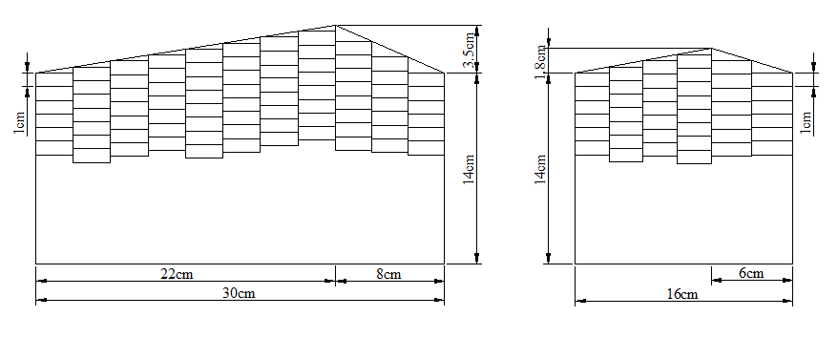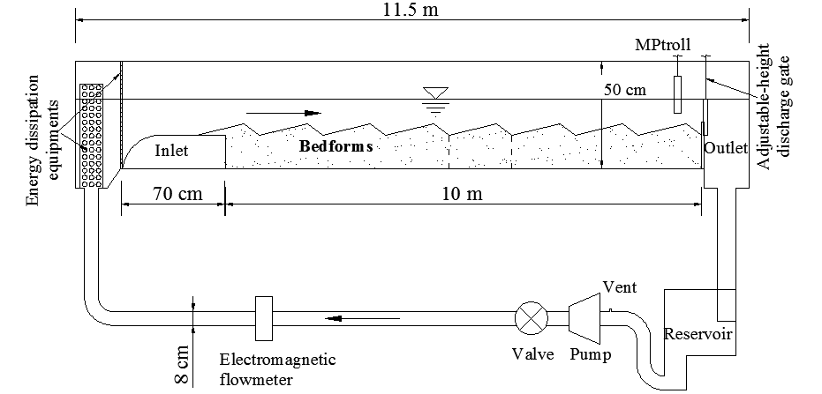
(a)
(b)
Fig. S1 (a) Experimental set-up based on a closed, recirculating sand flume. (b) Sampling sections in the streambed over one bedform at the end of the experiment.

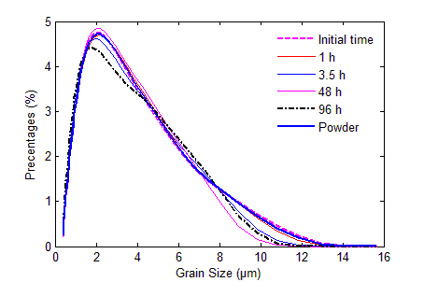

Fig. S2 Colloid size distribution after the NaCl treatment.

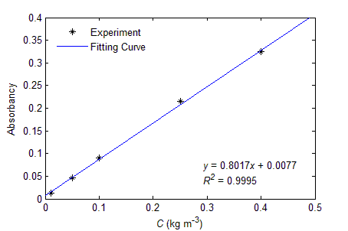

Fig. S3 Relationship between colloid concentration and absorbance.

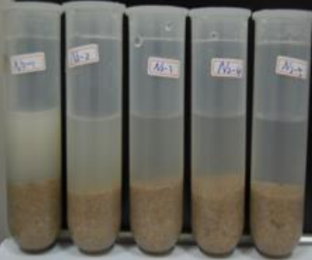
(a)
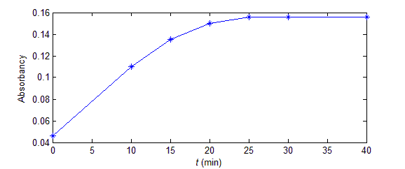

(b)

Fig. S4 (a) Sediment samples for different depths after treatment by ultrasonic vibration. Samples in experiment, for depths of 1 cm, 2 cm, 3 cm, 4 cm and 5 cm from left to right. Retained colloids are released after the treatment by the ultrasonic vibration. The more turbid the solution is, the higher mass fraction of the retained colloid mass is. (b) Effects of ultrasonic vibration on detaching colloids from sands over time. Influence of the ultrasonic vibration reached the steady state after the elapsed time of 25 min.

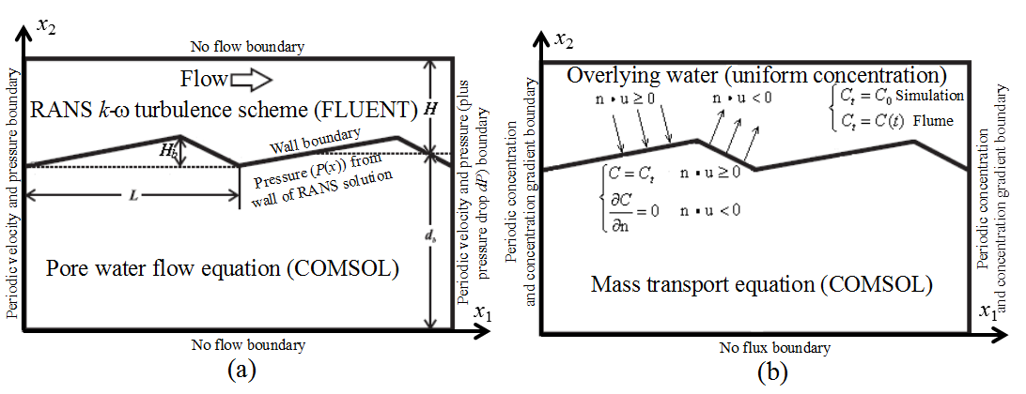

Fig. S5 (a) Schematic of model domain and boundaries for water flow. L, H, H_{b} and d_{b} are bedform length, average water depth of overlying water, bedform height and average depth of streambed, respectively. (b) Schematic of model domain and boundaries for colloid transport. Where n is the unit vector normal to the interface (pointing inward), u is the colloidal particles flow velocity vector =u_{i} - v_{s} , and C_{t} (kg m⁻³) is the colloid concentration in the overlying water at time t. It should be noted that the overlying water in our experiments was found to be relatively well mixed and hence a spatially uniform concentration was assumed along the long flume. However, C_{t} varied with time as a result of the mass exchange between the overlying water and the bed

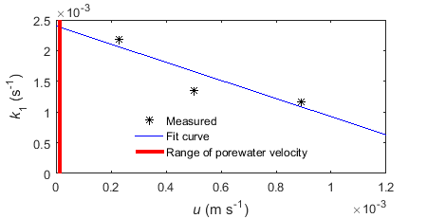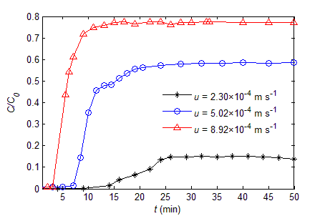
(a)
(b)
Fig. S6 (a) Breakthrough curves of colloid transport through the column with different velocities. (b) Fitted curve for obtaining the retention rate coefficient. The range of pore water flow velocity is from 1×10⁻⁵ to 2×10⁻⁵ m s⁻¹, indicated by the red belt. In the middle of the belt, the k₁ value is around 2.4×10⁻³ s⁻¹.

Fig. S7 Colloid concentration distribution in the pore water at the peak time (t = 2000 s). The unit of contour map is kg m⁻³.

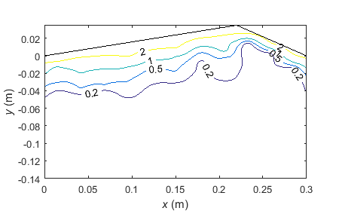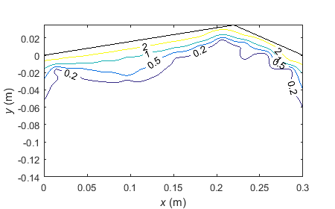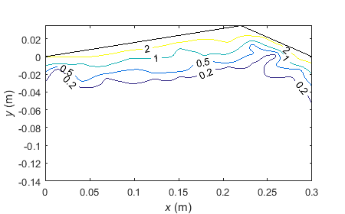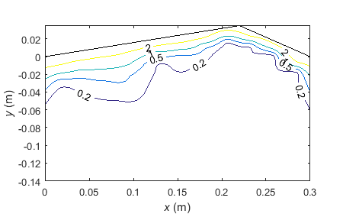
(a)
(c)
(d)
(b)
Fig. S8 Measured results of experiment, there were 32 bedforms in total: measurements were made at bedforms 2, 16, 17 and 31 from left to right. (a) bedform 2; (b) bedform 16; (c) bedform 17, used in main text; (d) bedform 31;

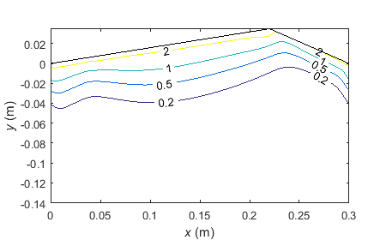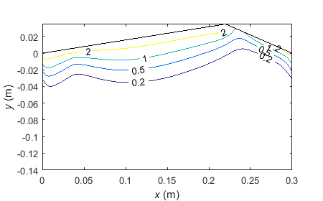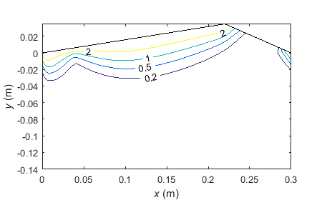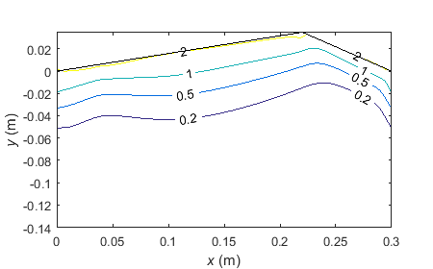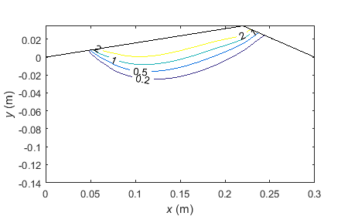
(a)
(b)
(c)
(d)
(e)
Fig. S9 Simulated results of retention mass distribution in the bedform, k₁=2.4×10⁻³ s⁻¹: (a) v_{s}=0×10⁻⁵ m s⁻¹ ; (b) v_{s}=1×10⁻⁵ m s⁻¹ ; (c) v_{s}=2×10⁻⁵ m s⁻¹ for the simulation of flume experiment; (d) v_{s}=3×10⁻⁵ m s⁻¹ ; (e) v_{s}=4×10⁻⁵ m s⁻¹ .

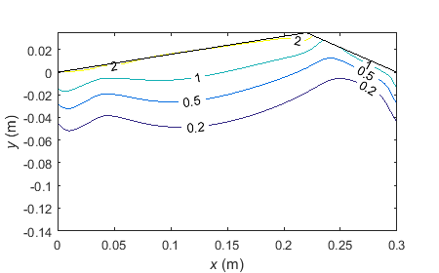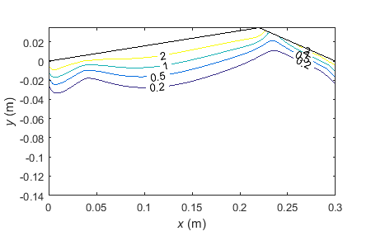
(a)
(b)
(c)
Fig. S10 Simulated results of retention mass distribution in the bedform, v_{s}=2×10⁻⁵ m s⁻¹: (a) k₁=1.4×10⁻³ s⁻¹; (b) k₁=2.4×10⁻³ s⁻¹ for the simulation of flume experiment; (c) k₁=3.4×10⁻³ s⁻¹.

References
Bergendahl, J., & Grasso, D. (2000). Prediction of colloid detachment in a model porous media: hydrodynamics. Chemical Engineering Science, 55(9), 1523-1532.
Israelachvili, J. N. (1992). In Intermolecular and surface forces (2nd ed.), London: Academic Press.
Jin, G., H. Tang, B. Gibbes, L. Li, and D. Barry (2010). Transport of nonsorbing solutes in a streambed with periodic bedforms, Advances in water resources, 33(11), 1402–1416.
Zheng, X. L., Shan, B. B., Chen, L., Sun, Y. W., & Zhang, S. H. (2014). Attachment–detachment dynamics of suspended particle in porous media: Experiment and modeling. Journal of Hydrology, 511, 199-204.

# Author to whom all correspondence should be addressed. Tel: +86 (25) 8378-6662. Fax: +86 (25) 8373-5375

