Ductile adhesively-bonded timber joints – Part 1: Experimental investigation

Myrsini Angelidi, Anastasios P. Vassilopoulos, Thomas Keller
Composite Construction Laboratory (CCLab),
Ecole Polytechnique Fédérale de Lausanne (EPFL),
Station 16, CH-1015 Lausanne, Switzerland.

Abstract

In the field of timber load-bearing structures, adhesive bonding is a promising joining technique that may increase the structural stiffness and capacity of timber joints and structures. The use of ductile adhesives may furthermore allow designing ductile joints, which can compensate for the material ductility that timber lacks. To demonstrate the potential of this approach, adhesively-bonded double-lap timber joints were manufactured using a ductile acrylic adhesive and then subjected to axial tension and compression loading. The load-displacement responses were measured and compared to those of the same joint configuration for which a brittle epoxy adhesive was used. The effect of the different adhesives on the joint capacity and ductility has been studied and quantified. Strain field measurements using the Digital Image Correlation (DIC) technique and a quadratic strain interaction criterion provided a better understanding of the mechanical behavior of the two different joint types.

Keywords: acrylics, adhesive, ductility, epoxy, joint, spruce, timber

1. Introduction

Joints are the most critical elements in the majority of timber structures; basically they can be designed as mechanical or adhesively-bonded joints. Although bonded joints may be sensitive to environmental conditions such as elevated temperatures and humidity, they can exhibit higher efficiency than doweled joints due to a more uniform stress distribution [1, 2]; in the latter, high stress concentrations occur around the mechanical fasteners and the cross section is reduced [3]. In addition to this higher capacity of bonded joints, the stiffness is increased, the weight-to-strength ratio reduced, and fatigue strength and durability are improved, the latter due to the sealing by the adhesive [4]. Many different types of adhesives may be used, depending on the targeted application [5].

One of the most important requirements for load-bearing structures, especially in earthquake design, is ductility, i.e. the ability of a material or structure to sustain inelastic deformation prior to failure, without loss of resistance. The energy generated by the seismic action or any impact is dissipated and large deformations prior to failure provide sufficient warning [6]. In redundant systems, the internal forces may be redistributed and the structural safety thus increased. The provision of ductility is however made difficult when using brittle materials, such as fiber-reinforced polymers (FRPs) or wood. To overcome this difficulty in the field of FRP materials, ductile adhesives were proposed [7] and used [2] for developing ductile joints, thus compensating for the lacking material ductility [2].

The basic definition of ductility is expressed as the ratio between the total and yield deformations of a material or structural component [8]. However, ductile behavior cannot be derived based only on an observed non-linear load-displacement response. In an elastically buckling component, for example, the ascending non-linear loading and descending unloading paths overlap and no (permanent) yield deformation or related ductility are developed. Therefore, extended energy-based definitions of ductility, taking into account the inelastic energy dissipated during loading, were introduced. The total area under the load-displacement curve corresponds to the total energy, E_{tot}, which is composed of the elastic energy, E_{el}, which is released while unloading and the dissipated inelastic energy, E_{inel}, represented by the area between the loading and unloading paths respectively [9, 10]. Such energy-based definitions usually consider different ratios of these energies: i.e. E_{inel}/E_{tot} [11, 12] or E_{tot}/E_{el} [13].

Ductile adhesive joints to implement ductility in FRP composite structures have already been developed, as mentioned above. A systematic and comprehensive investigation of the application of such ductile adhesives for timber-timber joints, however, has not yet been performed; only an experimental study concerning their load capacity has been carried out [14]. The aim of this work is thus to design such ductile adhesive timber joints and compare their performance, if subjected to axial tension and compression loading, with similar joints comprising a brittle adhesive. Stiffness, capacity, failure modes and load transfer mechanisms based on strain field measurements are compared in detail and ductility is quantified. The comparison is based on experimental results obtained from large-scale joint investigations. The corresponding numerical modeling is subsequently developed and presented in Part 2 of this paper [15].

2. Experimental set-up

2.1 Specimens and materials

The experimental program included 19 large-scale, adhesively-bonded dog-bone-shaped double-lap timber joint specimens, as shown in Fig. 1. Norway spruce (Picea abies) was used, as it is one of the most widely used types of wood for structural applications in the timber industry. The wooden adherends were cut from spruce wood logs, avoiding any obvious defects or knots. For the assembling of these adherends, two kinds of structural adhesives were used and two series of joints were manufactured: a reference series using a brittle epoxy adhesive, SikaDur330, and a series using a ductile acrylic adhesive, SikaFast5221NT; both adhesives were obtained from Sika AG, Switzerland [16, 17]. The ductile behavior of this acrylic adhesive has already been investigated and quantified in a preceding work [18]. The basic mechanical properties of the materials used for the joints are summarized in Table 1. It has to be noted that the properties of the acrylic adhesive were highly strain rate-dependent, as shown in a preceding work [19].

The detailed specimen geometry, which resulted from preliminary studies to optimize the joint capacity [22], is shown in Figs. 1 and 2; the total length and width were 970 and 50 mm, the overlap length was 160 mm and the thickness of the adhesive layer was 2 and 3 mm, for epoxy- and acrylic-adhesive joints (denominated ‘’epoxy joints’’ and ‘’acrylic joints’’ in the following) respectively. In the latter case, subsequently to preliminary experiments exhibiting adhesion failure, a 0.5-mm (on average) layer of epoxy of SikaDur330 was added between the wood and acrylic adhesive to improve adhesion. The acrylic adhesive was applied on the cured epoxy adhesive. Before applying any adhesive, the joint surfaces were carefully smoothened with sandpaper and cleaned with acetone. The joints were fabricated under ambient laboratory conditions (21 ± 3°C and 38 ± 10% relative humidity) and stored in a conditioning room (20 ± 2°C and 60 ± 3% relative humidity) for at least one week to obtain a) a uniform moisture content (12%, as measured in [23]), and b) full cure of the adhesives (according to [18]).

2.2 Experimental procedure and instrumentation

The experimental program included both axial tensile and compressive experiments since the adhesive tensile and compression behavior was found to be different [18]. The joint specimens were loaded up to failure at a displacement rate of 2 mm/min. In the acrylic joint specimens an unloading-reloading cycle, at the same displacement rates, was implemented in the plateau region of the load-displacement response.

A universal Schenk machine of 600-kN capacity was used. Teeth-shaped steel plates were installed to prevent grip failure and specimen slip. The machine’s load-cell and two linear variable displacement transducers (LVDTs), symmetrically placed on both sides of the specimens with a gauge length of 330 mm, were used to measure the load and displacements applied to the joints respectively, see Fig. 2. In the following, average values of the two LVDT measurements divided by two are reported as “displacement”, assumed to correspond to the displacements of one of the two joints per specimen. The accuracy of the LVDT measurements was ±0.02mm and that of the load cell ±0.6%, which for 65kN corresponded to ±0.4kN.

In four epoxy and three acrylic joints in tension, the full 3D displacement fields were measured on one specimen side, using a Digital Image Correlation (DIC) system provided by Correlated Solutions Inc. [24], and the corresponding strain fields were derived. One LVDT was left in place on the opposite side. The DIC surface was sanded and painted white and a random pattern of black speckles of similar size was then sprayed onto it, allowing the DIC to track their relative displacements during the experiment, see Fig. 2. The accuracy of these measurements depended on the surface roughness and was significantly lower for the adhesive joints, i.e. ±0.01mm for displacements and correspondingly ± 0.001 for strains in that case.

In total, 11 specimens (five epoxy and six acrylic) were examined in tension and eight in compression (four and four for each adhesive). The specimens were labeled according to the adhesive (E for epoxy or A for acrylic), type of loading (T for tension or C for compression) and specimen number, e.g. AT_2 denotes the second (2) acrylic (A) joint in tension (T).

3. Results and discussion

3.1 Failure modes and load-displacement responses

Different failure modes were observed in tension and compression for the two types of joints, as summarized in Tables 2 and 3 and shown in Figs. 3 and 4. All epoxy joints failed in the wood of the inner adherend (adherend failure), except for two of them in compression, which buckled during loading. The initiation of failure in tension occurred just below the adhesive layer at one overlap end, while in compression initiation was at mid-height at the edge of the inner adherend. A mixed failure mode was observed in the acrylic joints in tension; failure occurred partially in the wood (adherend failure) and partially in the epoxy-acrylic adhesive interface (adhesive failure) on one joint side (i.e. in one overlap) while on the other side failure occurred in the wood. In compression, failure occurred completely in the adhesive interface (adhesive failure) on one side and in the wood on the other side.

Typical load-displacement curves are shown in Fig. 5. The responses were linear for the epoxy joints up to failure but highly non-linear for the acrylic joints. The unloading-reloading cycle of the acrylic joints was performed between 50 and 55 kN, after clearly entering the post-yield part of the load-displacement curve (‘’plateau’’ region).

3.2 Displacement and strain distributions

The different joint behaviors could be further analyzed through the DIC mapping of the surfaces. The full-field displacements and strains were extracted for both types of joints at the same load level of 40 kN, which approximately corresponded to the average ultimate load of the epoxy joints (see Table 2). The acrylic joints already entered the non-linear range at this load, as shown in Fig. 5. The axial displacement behavior of both joint types is compared in Fig. 6. The origin of the axes (0) is defined in the center of the mapped path. The acrylic joints exhibited much larger displacements (e.g. AT_5, 0.60 mm) compared to the epoxy joints (e.g. ET_3, 0.20 mm). In the latter, the displacements were almost uniformly distributed across the joint. In the former, however, most of the displacements (within 70-80%) occurred in the adhesive layer, and the elongation of the wood was comparably small.

The shear strains, ε_{xy}, at one extracted path per joint in the adhesive mid-plane are shown in Fig. 7. The strains in the wood were similar in both joint types. In the adhesive layer, the strains in the epoxy were much lower than those in the acrylic layer due to the higher E-modulus. However, their distribution along the overlap length was not uniform and exhibited high peaks at the edges. The distribution in the acrylic layer, in contrast, was uniform along the length. These differences were much less obvious in the through-thickness strains, ε_{yy}, as shown in Fig. 8. These strains resulted from the joint eccentricity, which was the same in both joint types. Accordingly, the strain distributions were similar, exhibiting on one side a tensile and on the other side a compressive peak.

The differences in the two joint behaviors were also clearly represented in the two principal strain distributions, ε₁ (tension, Fig. 9) and ε₂ (compression, Fig. 10) and their angles, the latter shown for α₁ at two different load levels, 10 kN and 40 kN (Figs. 11 and 12). Along the adhesive layers, both principal strains varied in the epoxy joints, while they were almost uniformly distributed in the acrylic joints with the exception of small peaks at the edges. The angle of the principal strain ε₁, α₁, in the epoxy layer varied between 15 and 40° (20° on average) with respect to the loading axis (which is 0°) and independent of the load level. The angle α₁ in the acrylic joints was almost identical along the length (45° on average) and also independent of the load level.

3.3 Mechanical characterization

Based on the Swiss code for timber structures [25] and the load-displacement curves shown in Fig. 5, the joints were characterized as described in Fig. 13. The main mechanical properties included the initial stiffness, K₁, the yield load and displacement, F_{y} and d_{y}, and the ultimate load and displacement, F_{u} and d_{u}, where failure occurred. The full set of the calculated properties is included in Tables 2 and 3.

The results showed that the epoxy joints exhibited a significantly stiffer initial behavior in tension and compression than the acrylic joints, while the latter exhibited a much higher displacement at failure in tension. In compression, the full displacement capacity could not be developed due to the premature adhesion failure in the interface, as mentioned in Section 3.1. The acrylic joints in tension exhibited much higher ultimate loads (+59% on average) than the epoxy joints in tension, although the former exhibited a mixed and not an adherend failure mode as the latter did. This result could be clearly attributed to the much more uniform strain distributions in the acrylic joints caused by the non-linear behavior. Similar results were obtained using flexible adhesives for glulam [26]. The epoxy joints, in contrast, exhibited much higher strain peaks, as shown above, which limited the ultimate loads. Improving the bond of the acrylic joints to also produce a pure adherend failure would further increase their ultimate loads. In compression, the epoxy joints reached similarly high ultimate loads to the acrylic joints in tension. This result could be attributed to the different location of failure initiation than in tension, as described above, which was mainly caused by the change of sign of the through-thickness strains from compression to tension (peel) at the inner adherend edge. If premature interface failure could have been prevented, the acrylic joints in compression, which exhibited much lower ultimate loads, would certainly have exhibited at least the same values as the epoxy joints since the strain distributions were again more uniform.

3.4 Joint ductility

The deformation- and energy-based ductility indexes, μ_{d} and μ_{e}, as mentioned above, were calculated for the acrylic joints, as follows:

$μ_{d}=\frac{d_{u}}{d_{y}}$ (1)
$μ_{e}=\frac{1}{2}∙\left(\frac{E_{tot}}{E_{el}}+1\right)$ (2)

The energy-based index was selected according to [13] and the corresponding total energy, E_{tot}, and elastic energy, E_{el}, were determined as shown in Fig. 14. A difficulty in calculating this index was that the unloading path required just an instant before failure could not be experimentally captured due to the scatter of the ultimate loads, see Tables 2 and 3. Unloading was thus performed earlier, as described above, and the unloading stiffness, K₂, as defined in Fig. 14, was calculated. Since later unloading led to further degradation of the unloading stiffness, a logarithmic relationship between the stiffness ratio K₂/K₁ and the displacement at unloading, d_{un}, could then be established, see Fig. 15. Based on this relationship, the stiffnesses of the unloading paths an instant before failure, K₂’, i.e. at d_{un} = d_{u}, were estimated and μ_{e} was calculated based on these values, as shown in Tables 4 and 5. This procedure also allowed the ductility indexes of the joints for which no cycles were performed to be estimated.

The relationship between the displacement- and energy-based ductility indexes was linear, as shown in Fig. 16, implying that similar conclusions can be drawn from both methods. The much lower values of the prematurely failed specimens in compression also fitted into this result. The two indexes were further exponentially related to the ultimate displacement, as shown for the energy-based index in Fig. 17.

The displacement-based indexes in tension, 7.30 on average, were much higher than values given in timber codes for high ductility, e.g. [25], where high ductility is assigned to values of μ_{d} >3.0. Considering the energy-based definition, the tension values, 3.49 on average, are also high compared to other materials (excluding metals), e.g. compared to 2.5 for glass-fiber-reinforced polymer (GFRP) bridge decks, adhesively bonded onto steel girders [27], or prestressed concrete beams with unbonded FRP tendons subjected to bending, whose calculated ductility index was in the range of 2-5 [28].

3.5 Ultimate load prediction

Since strains and not stresses were measured, a quadratic strain interaction criterion, based on the Norris failure criterion for wood [29], was applied to predict the ultimate loads of those joints that failed in the wood (epoxy joints in tension) or exhibited mixed failure mode (acrylic joints). The strain-based formulation was selected as follows, considering the orthotropic nature of wood:
$\frac{{ε_{xx}}^{2}}{X^{2}}+\frac{{ε_{yy}}^{2}}{Y^{2}}+\frac{{ε_{xy}}^{2}}{S^{2}}-\frac{{│ε}_{xx}∙ε_{yy}│}{X∙Y}≤1$ (3)

where the numerators of the fractions represent the measured tensile, ε_{xx}, through-thickness, ε_{yy}, and shear strains, ε_{xy}, while the denominators indicate the corresponding failure strains, which were obtained from literature (see Table 6). In compression, they were assumed to be the elastic strain limits [21], as no ultimate failure occurred. The shear failure strain was derived from the corresponding elastic strength limit (10MPa) and the G-modulus for the xy-plane (690 MPa) [20], since no other data on shear was available.

The criterion was applied to the measured strain distributions, as shown in Figs 18 and 19 for an epoxy and an acrylic joint, in each case just before and after the peak load. In the epoxy case (specimen ET_3), values reaching or exceeding 1.0 were obtained just before the peak load at the location where failure initiation in the wood was observed, i.e. at the overlap end in the inner adherend just below the adhesive. Since the joint only partially failed at the peak load, extended areas developed along the crack zone where the criterion also reached or exceeded the 1.0-value. In the case of the acrylic joint (AT_5), the DIC targets on the outer adherends were lost before the peak load. Again, values ≥ 1.0 were obtained at the location where failure initiated at the overlap end below the adhesive. Several further zones of values ≥ 1.0 developed – however, they were located on the adhesive layers, which exhibited much higher strains than the wood (see above) and where the criterion was thus not applicable. After the peak load and complete separation of the joint, the targets on the left side of the crack were also lost. The remaining specimens showed similar results, i.e. locations of crack initiation and ultimate load levels were well predicted in most cases.

4. Conclusions

Bonded double-lap timber joints have been experimentally studied in tension and compression, using two different structural adhesives; a brittle epoxy and a ductile acrylic adhesive. The main conclusions of this study can be summarized as follows:
- Epoxy-bonded joints exhibited a stiff linear load-displacement response up to brittle failure. Failure occurred in the inner adherend while the location of failure initiation in tension and compression was different and significantly influenced the ultimate load, i.e. ultimate loads in compression were much higher than in tension.
- Acrylic-bonded joints showed a highly non-linear and ductile load-displacement response in tension. The ultimate loads were much higher than those of the epoxy joints. In compression, they exhibited a premature adhesion failure.
- The much higher ultimate loads of the acrylic joints could be attributed to the much more uniform strain distributions along the overlap length caused by the nonlinearity and concentration of the deformations in the adhesive layers. Although this effect is well-known, detailed experimental verifications are rare and were not yet performed for timber joints.
- The angles of principal strains along the adhesive layers were independent of the load level in both joint types. The angles were however much less uniform and smaller in the epoxy joints (20° on average, with respect to the loading axis) than in the acrylic joints (45° on average).
- Displacement- and energy-based ductility indexes were derived for the ductile acrylic joints in tension. The joints exhibited high ductility compared to other materials and structural components.
- The application of a strain-based quadratic failure criterion for wood allowed the locations of failure initiation to be identified and estimation of the ultimate loads of the joints, which exhibited failure in the wood or mixed failure mode.
In Part 2 of this paper, numerical models will be developed to describe the different behaviors of the two joint types. In the modelling of the acrylic joints, in particular, the high strain rate dependency of the adhesive properties will be taken into account and further discussed through parametric studies.

Acknowledgements

The authors wish to acknowledge the funding of this work by the National Research Program NRP 66 of the Swiss National Science Foundation (Grant No. 406640-136680).

References

- Tannert, T., Vallée, T., & Hehl, S. Temperature dependent strength of adhesively bonded timber joints. In Proceedings of the International Conference on Wood Adhesives (pp. 76-80), (2009, September).
- De Castro J.: “System ductility and redundancy of FRP structures with ductile adhesively-bonded joints”, EPFL PhD Thesis no 3214, Lausanne (2005).
- Lehmann M., Vallée T., Tannert T., Brunner M. “Adhesively bonded joints composed of wooden load-bearing elements”, 12th International Conference on Fracture (2009), ICF-12, p: 2741-2749, Ottawa, ON.
- Tannert T., Vallée T., Hehl S. “Experimental and numerical investigations on adhesively bonded hardwood joints”, International Journal of Adhesion and Adhesives (2012), Vol. 37, p: 65-69
- Banea M. D., da Silva L. F. M. “Mechanical characterization of flexible adhesives”, Journal of Adhesion, Vol. 85, Issue: 4-5, p:261-285 (2009).
- Keller T, De Castro J. “System ductility and redundancy of FRP beam structures with ductile adhesive joints”, Composites Part B: Engineering, Vol. 36, Issue 8, p:586-596 (2005).
- Hart-Smith, L. J. Adhesive-bonded double-lap joints. National Aeronautics and Space Administration (NASA), (1973).
- Park R., Pauley T. “Reinforced Concrete Structures”, John Wiley and Sons, New York, United States of America (1975).
- Baker JF, Horne MR., Heyman J. “Plastic behavior and design, the steel skeleton”, vol.2, UK: Cambridge University Press (1956).
- Yanes-Armas S., de Castro J., Keller T. Energy dissipation and recovery in web-flange junctions of pultruded GFRP decks. Composite Structures (2016), 148:168-180.
- Grace NF., Soliman A., Abdel-Sayed G., Saleh K. Behavior and ductility of simple and continuous FRP reinforced beams. J Compos Constr (1998), 2(4):186–94.
- De Lorenzis L., Galati D., La Tegola A. Stiffness and ductility of fibre-reinforced polymer-strengthened reinforced concrete members. Proc. ICE-Struct. Build. (2004), 157(1):31–51.
- Naaman A.E., Jeong S.M. Structural ductility of concrete beams prestressed with FRP tendons, Nonmetallic (FRP) reinforcement for concrete structures, Proc. of the second international RILEM symposium (FRPRCS-2) (1995): 379-386.
- Vallée T, Tannert T, Hehl S. “Ductile adhesively bonded timber joints”, International conference on wood adhesives, Session 4B: 315-318 (2009).
- Angelidi M., Keller T. Ductile adhesively-bonded timber joints – Part 2: Strain rate effect. Construction and Building Materials, (2018) (under review).
- Sika AG. SikaDur-330: 2-part epoxy impregnation resin. (2006).
- Sika AG. SikaFast5221 NT: Fast-curing 2-component structural adhesive. Zurich (2013).
- Angelidi M., Vassilopoulos A. P., Keller T. Ductility, recovery and strain rate dependency of an acrylic structural adhesive. Construction and Building Materials, 2017; 140:184-193.
- Angelidi M., Vassilopoulos A. P., Keller T. Displacement rate and structural effects on Poisson ratio of a ductile structural adhesive under tension and compression. International Journal of Adhesion and Adhesives, 2017; 78: 13-22.
- Dinwoodie J. M. Timber - a review of the structure‐mechanical property relationship. Journal of Microscopy, 104(1), 3-32. (1975).
- Zhong W., Rusinek A., Jankowiak T., Huang X., & Farid, A. B. E. D. Experimental and Numerical Investigation on Compression Orthotropic Properties of Spruce Wood in Axial and Transverse Loading Directions. Engineering Transactions, 62(4), 381-401, (2015).
- Angelidi M. Ductility and strain rate-dependency of adhesively-bonded timber joints. EPFL PhD Thesis no 7838, Lausanne (2017).
- Farajzadeh Moshtaghin, A., Franke, S., Vassilopoulos, A. P., & Keller, T. Spatial variability in longitudinal elastic modulus of clear timber. Euromech Colloquium 556, Dresden, Germany (2015).
- Correlated Solutions Inc. (2010). Vic-3D Manual. Columbia, SC., Sutton, Michael A, Orteu, Jean Jose, & Schreier, Hubert. (2009). Image correlation for shape, motion and deformation measurements: basic concepts, theory and applications: Springer Science & Business Media.
- SIA. "265–Timber structures." Swiss Standards Association (2003).
- Brunner M., Lehmann M., Kraft S., Fankhauser U., & Richter K. Super glulam: A flexible adhesive layer boosts the bending resistance of glulam. (2010).
- Keller T., Gürtler H. Composite action and adhesive bond between FRP bridge decks and main girders. Journal of Composites for Construction (2005), 9(4): 360-368.
- Jo B. W., Tae G. H., Kwon B. Y. Ductility evaluation of prestressed concrete beams with CFRP tendons. Journal of reinforced plastics and composites (2004), 23(8): 843-859
- Norris C. B. Strength of orthotropic materials subjected to combined stresses, Madison: U.S. Department of Agriculture, 1962.

TABLES

- Basic material mechanical properties

Material | Mechanical properties
 | Tensile  E-modulus (MPa) | Compressive E-modulus  (MPa) | Poisson ratio  (-) | Density  (kg/m³)
Epoxy | 4500 [3] | 3000 [3] | 0.37 [3] | 1300 [16]
Acrylics* | 105 [18] | 21 [18] | 0.48 [18] | 1200 [17]
Spruce  (// fibers) | 11600 [20] | 11330 [21] | ³0.4 [20] | 440**
*values obtained at a strain rate of 0.17 min⁻¹
**measured

Table 2: Experimental results for joints in tension (*specimens monitored with the DIC)

Specimen | Initial stiffness  K₁ (kN/mm) | Yield  load  F_{y} (kN) | Yield displacement  d_{y} (mm) | Ultimate load  F_{u} (kN) | Ultimate  displacement  d_{u} (mm) | Failure mode
ET_1 | 131.34 | - | - | 32.21 | 0.24 | adherend
ET_2* | 172.00 | - | - | 29.16 | 0.17 | adherend
ET_3* | 231.99 | - | - | 47.07 | 0.19 | adherend
ET_4* | 187.07 | - | - | 43.50 | 0.24 | adherend
ET_5* | 197.61 | - | - | 33.68 | 0.17 | adherend
AV  ±SD | 184.00  ±32.91 | - | - | 37.12  ±6.91 | 0.20  ±0.03
AT_1 | 126.03 | 39.00 | 0.33 | 56.58 | 3.04 | mixed
AT_2 | 119.54 | 45.57 | 0.44 | 65.11 | 2.96 | mixed
AT_3 | 99.42 | 41.00 | 0.47 | 61.64 | 2.95 | mixed
AT_4* | 129.74 | 37.72 | 0.34 | 53.63 | 1.86 | mixed
AT_5* | 139.38 | 40.76 | 0.32 | 65.80 | 3.47 | adherend
AT_6* | 98.59 | 40.00 | 0.42 | 55.64 | 2.46 | mixed
AV  ±SD | 118.78  ±15.17 | 40.68  ±2.45 | 0.39  ±0.06 | 59.73  ±4.71 | 2.79  ±0.51

Table 3: Experimental results for joints in compression

Specimen | Initial stiffness  K₁ (kN/mm) | Yield  load  F_{y} (kN) | Yield displacement  d_{y} (mm) | Ultimate load  F_{u} (kN) | Ultimate displacement  d_{u} (mm) | Failure mode
EC_1 | 118.75 | - | - | 53.93 | 0.49 | adherend
EC_2 | 149.25 | - | - | 60.25 | 0.43 | adherend
EC_3 | 128.30 | - | - | 64.89 | 0.55 | buckling
EC_4 | 138.63 | - | - | 63.20 | 0.54 | buckling
AV  ±SD | 133.73  ± 28.75 | - | - | 60.57  ±4.18 | 0.50  ±0.05
AC_1 | 99.27 | 28.79 | 0.29 | 32.23 | 0.50 | adhesion
AC_2 | 92.64 | 32.42 | 0.35 | 34.73 | 0.57 | adhesion
AC_3 | 111.21 | 37.00 | 0.34 | 40.55 | 0.53 | adhesion
AC_4 | 128.25 | 40.40 | 0.32 | 44.55 | 0.54 | adhesion
AV  ±SD | 107.84  ± 13.53 | 34.65  ±4.41 | 0.33  ±0.02 | 38.02  ±4.83 | 0.54  ±0.03

Table 4: Displacement- and energy-based ductility indexes of acrylic joints in tension

Specimen | Load at unloading  F_{un} (kN) | Displacement  at unloading  d_{un} (mm) | Unloading stiffness  (kN/mm) |  | Total energy  E_{tot} (J) | Elastic energy  E_{el} (J) | Displacement  -based  ductility  μ_{d} (-) | Energy-based ductility  μ_{e} (-)
 |  |  | Experimental  K₂ | Estimated  K₂’
AT_1 | 50.05 | 1.19 | 95.88 | 79.04 | 144.24 | 20.25 | 9.24 | 4.06
AT_2 | - | - | - | 75.65 | 154.61 | 28.02 | 6.73 | 3.26
AT_3 | 55.11 | 1.60 | 79.75 | 62.99 | 155.18 | 30.16 | 6.41 | 3.07
AT_4 | - | - | - | 94.88 | 78.46 | 15.16 | 5.47 | 3.09
AT_5 | 52.06 | 0.86 | 126.36 | 83.51 | 226.43 | 25.92 | 10.63 | 4.87
AT_6 | 49.74 | 1.36 | 80.49 | 66.26 | 98.40 | 23.36 | 5.33 | 2.61
AV  ±SD | 51.74  ±2.14 | 1.25  ±0.27 | 95.62  ±18.88 | 77.06  ±10.64 | 142.89  ±47.26 | 23.81  ±5.00 | 7.30  ±1.97 | 3.49  ±0.75

Table 5: Displacement- and energy-based ductility indexes of acrylic joints in compression

Specimen | Load at unloading  F_{un} (kN) | Displacement  at unloading  d_{un} (mm) | Unloading stiffness  (kN/mm) |  | Total energy  E_{tot} (J) | Elastic energy  E_{el} (J) | Displacement  -based  ductility  μ_{d} (-) | Energy-based ductility  μ_{e} (-)
 |  |  | Experimental  K₂ | Estimated  K₂’
AC_1 | - | - | - | 100.25 | 9.90 | 5.18 | 1.72 | 1.46
AC_2 | - | - | - | 90.98 | 12.36 | 6.63 | 1.64 | 1.43
AC_3 | 34.07 | 0.33 | 134.13 | 110.93 | 13.40 | 7.41 | 1.83 | 1.40
AC_4 | 35.28 | 0.38 | 122.93 | 127.42 | 15.70 | 7.79 | 1.68 | 1.51
AV  ±SD | 34.68  ±0.61 | 0.35  ±0.02 | 128.53  ±5.60 | 107.39  ±13.55 | 12.84  ±2.08 | 6.75  ±1.00 | 1.72  ±0.07 | 1.45  ±0.04

Table 6: Failure strains for spruce

Failure strain // fibers, X (-) |  | Failure strain ⊥ fibers, Y (-) |  | Shear, S (-)
Tension | Compression | Tension | Compression
0.010 [20] | 0.070 [21] | 0.010 [20] | 0.040 [21] | 0.014 [21]

FIGURES
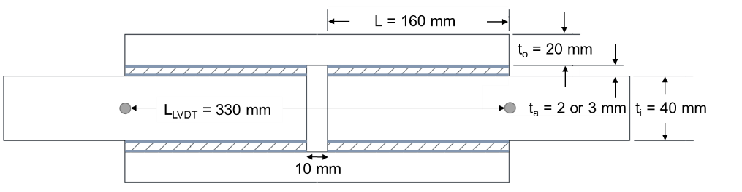
- Geometry of double-lap joint

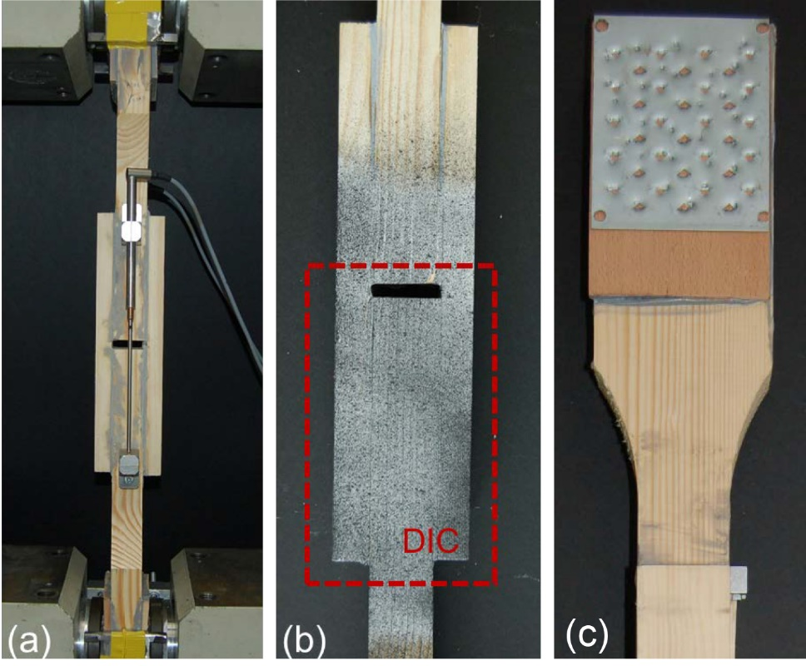
(c)

- Experimental set-up for tension and compression using (a) LVDTs, (b) DIC system (c) clamping part of dog-bone-shaped specimens with beech timber and perforated aluminium plates

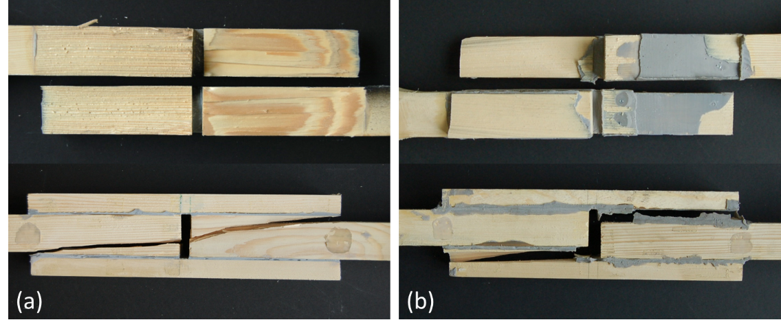
- Failure modes in tension: (a) adherend failure for epoxy joints (ET_3) and (b) mixed failure for acrylic joints (AT_1), plan and side views
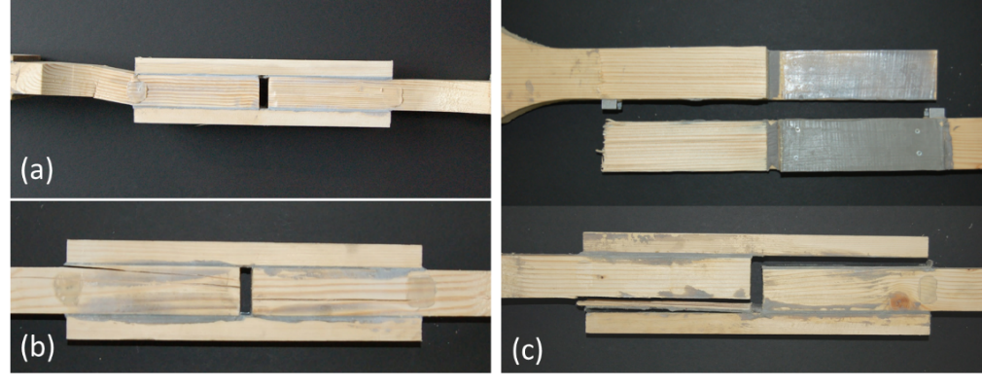
- Failure modes in compression: (a) buckling (EC_4) and (b) adherend failure for epoxy joints (EC_1) and (c) adhesion failure for acrylic joints (AC_2)

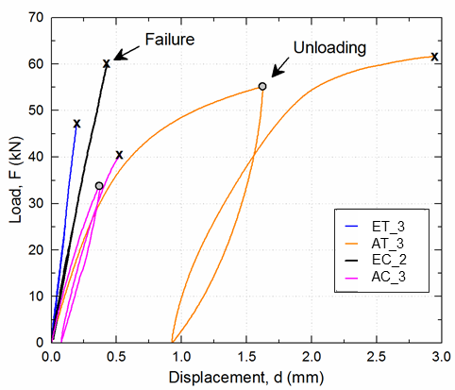
- Typical load-displacement responses of epoxy and acrylic joints in tension and compression
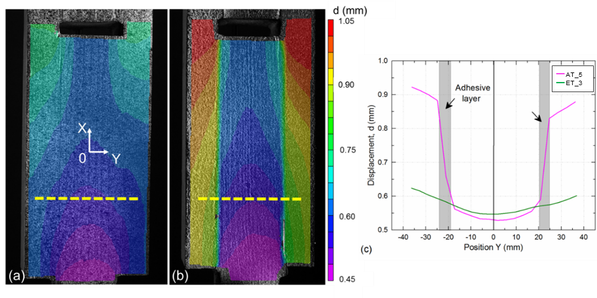
- Axial displacement distribution at 40 kN of (a) epoxy (ET_3) and (b) acrylic joint (AT_5) and (c) comparison at selected path (X = -33mm)

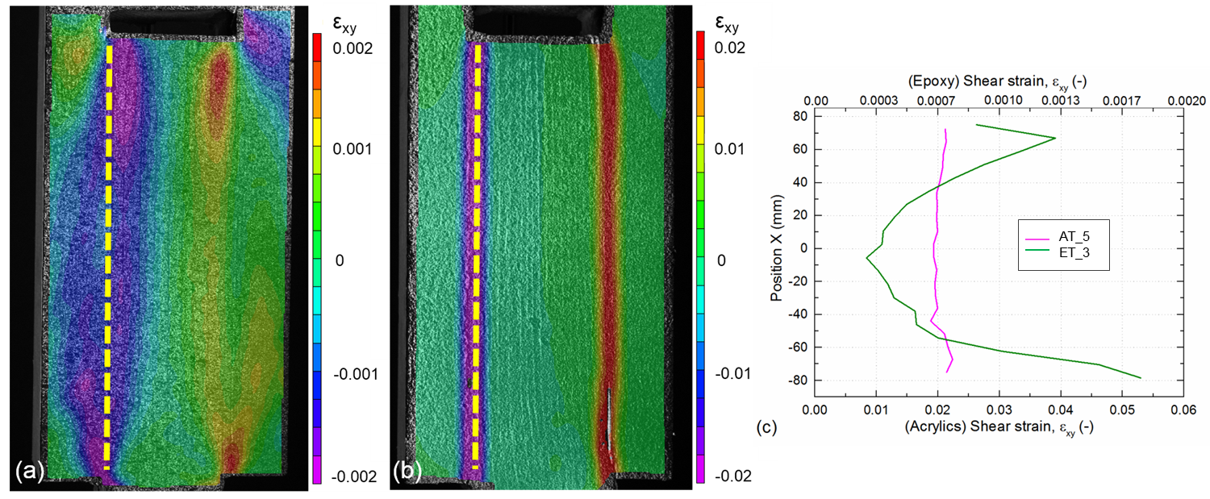
- Shear strain distribution at 40 kN for (a) epoxy (ET_3) and (b) acrylic joint (AT_5) and (c) comparison at selected path (adhesive mid-plane)

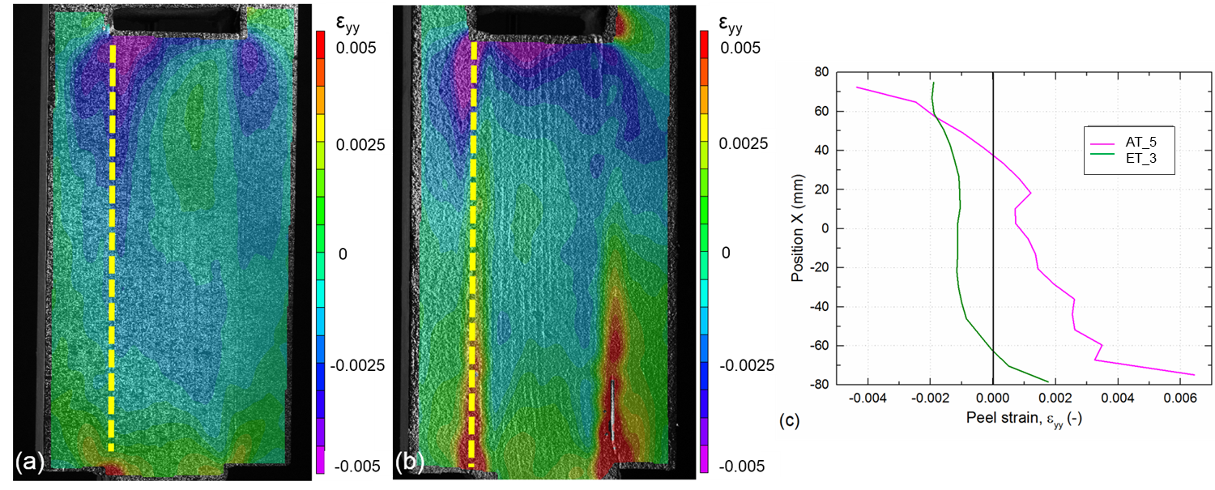
- Through-thickness strain distribution at 40 kN for (a) epoxy (ET_3) and (b) acrylic joint (AT_5) and (c) comparison at selected path (adhesive mid-plain)

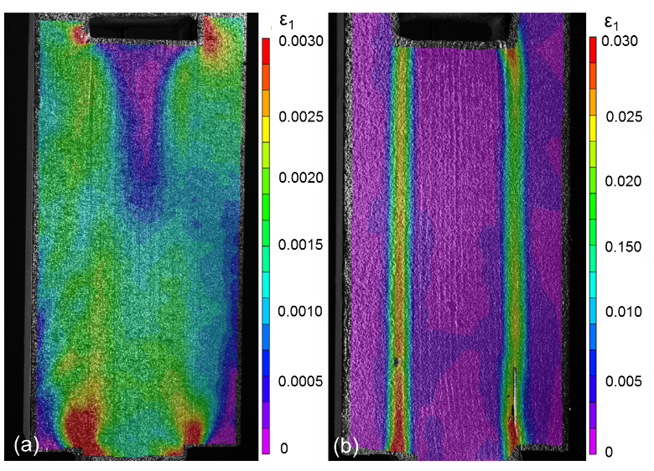
- Principal strain distribution (ε₁) at 40 kN for (a) epoxy (ET_3) and (b) acrylic joint (AT_5)
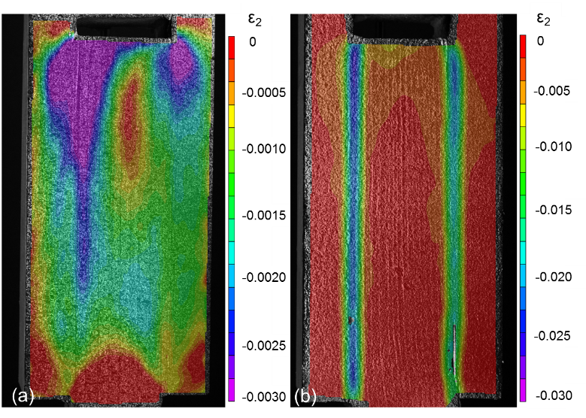
- Principal strain distribution (ε₂) at 40 kN for (a) epoxy (ET_3) and (b) acrylic joint (AT_5)
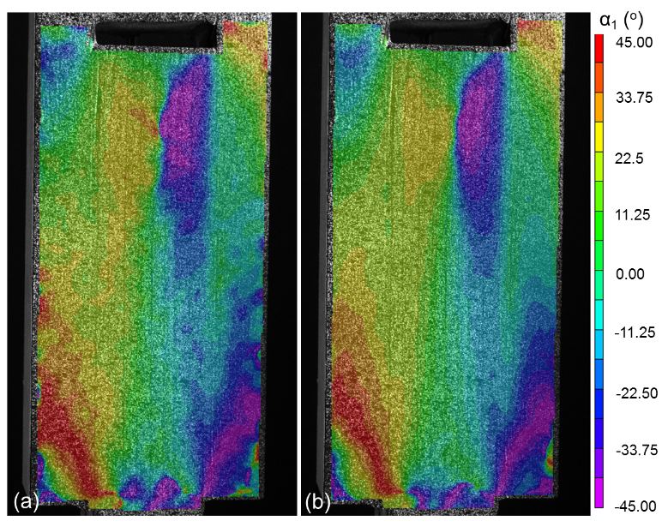
- Principal strain angle distribution (α₁), (a) for epoxy (ET_3) at 10kN and (b) at 40kN (0°=parallel to loading axis)

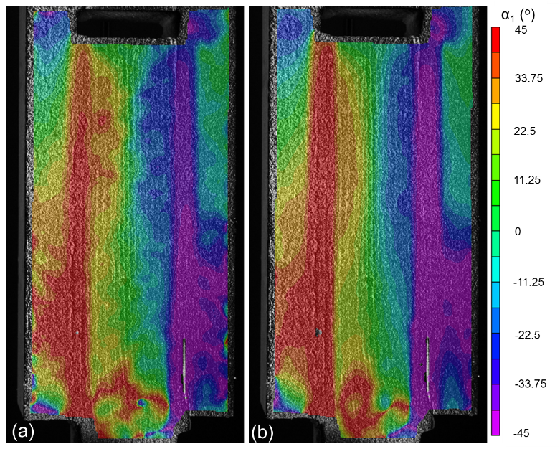
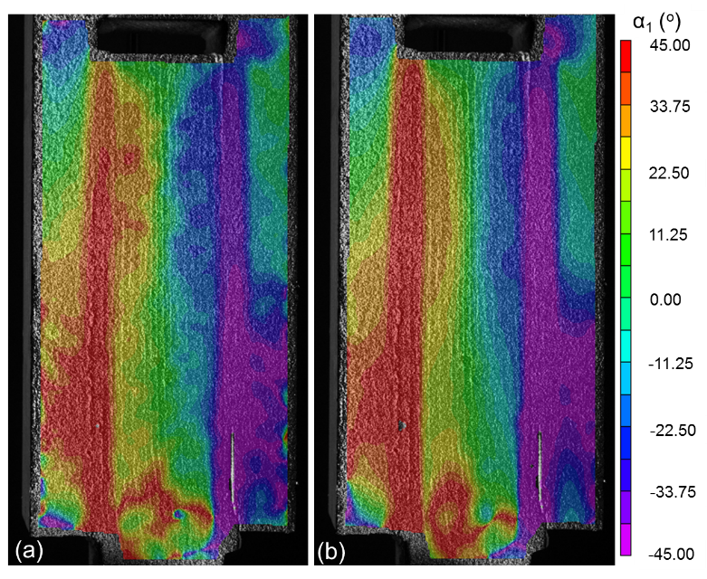

- Principal strain angle (α₁), (a) for acrylic joint (AT_5) at 10kN and (d) at 40kN (0°=parallel to loading axis)

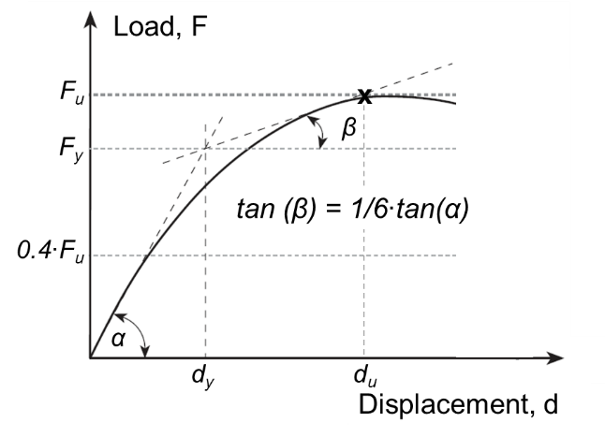
- Definition of stiffness and ductility properties according to [23]

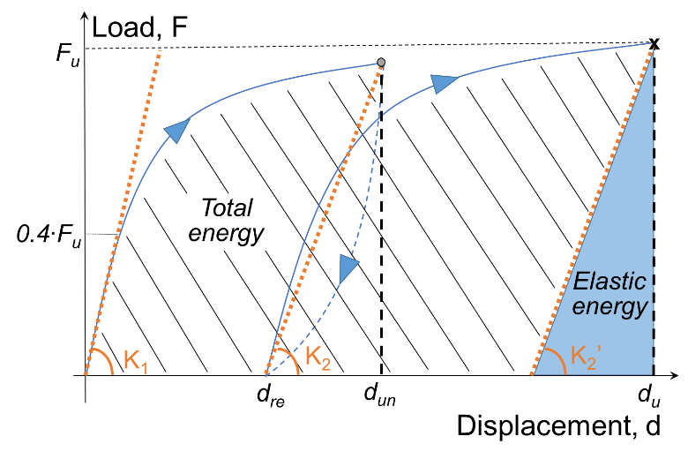
- Definition of total and elastic energy

- Relationship between stiffness ratio K₂/K₁ and displacement at unloading, d_{un}
(R² = 0.766)

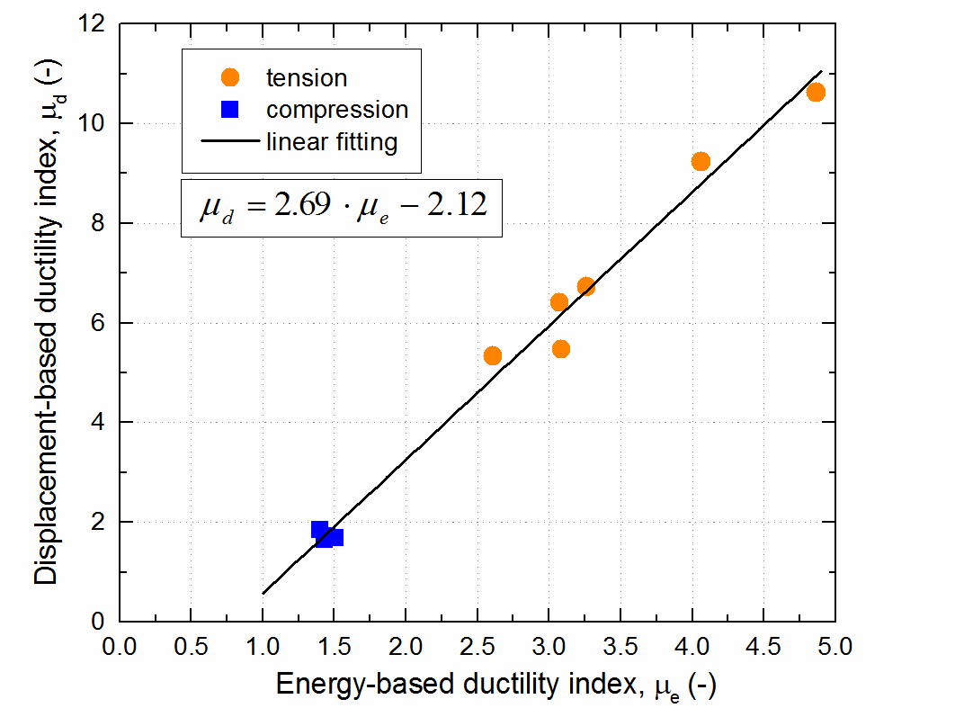

- Relationship between energy- and displacement-based ductility index
(R² = 0.988)

- Relationship between energy-based ductility index and ultimate displacement
(R² = 0.930)
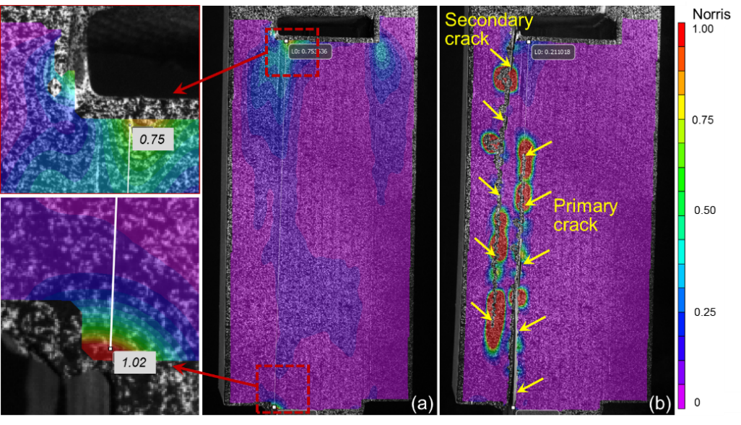
- Failure criterion (a) just before and (b) after peak load (joint partially failed), for epoxy joint (ET_3)
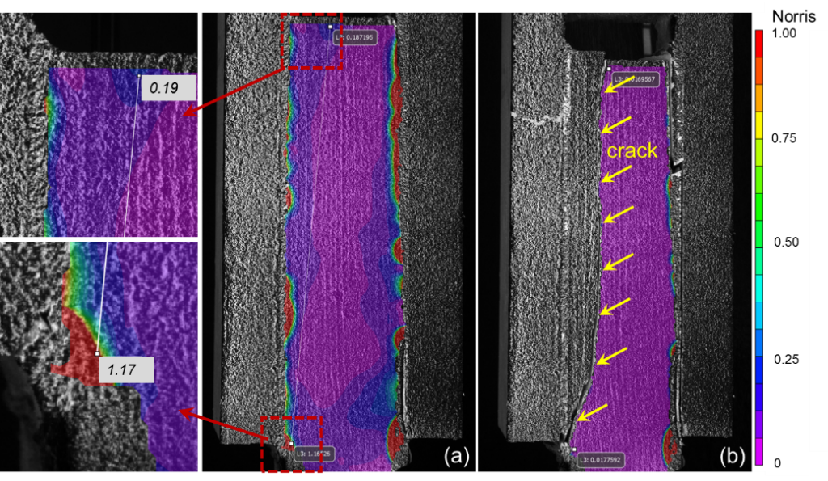
- Failure criterion (a) just before and (b) after peak load (joint completely failed), for acrylic joint (AT_5)

