**Improving surface heat flux estimation for a large lake through model optimization and two-point calibration: The case of Lake Geneva**

**Supplemental Information**

Abolfazl Irani Rahaghia,*, Ulrich Lemmina, Andrea Cimatoribusa, Damien Bouffardb,c, Michael Rifflerd,e, Stefan Wunderled, David Andrew Barrya

a Ecological Engineering Laboratory (ECOL), Environmental Engineering Institute (IIE), Faculty of Architecture, Civil and Environmental Engineering (ENAC), Ecole Polytechnique Fédérale de Lausanne (EPFL), CH-1015 Lausanne, Switzerland

b Physics of Aquatic Systems Laboratory (APHYS), Margaretha Kamprad Chair, Environmental Engineering Institute (IIE), Faculty of Architecture, Civil and Environmental Engineering (ENAC), Ecole Polytechnique Fédérale de Lausanne (EPFL), CH-1015 Lausanne, Switzerland

c Aquatic Physics Group, Department of Surface Waters Research and Management, Eidgenössische Anstalt für Wasserversorgung, Abwasserreinigung und Gewässerschutz (EAWAG), CH-6047 Kastanienbaum, Switzerland

d Institute of Geography and Oeschger Centre for Climate Change Research, Faculty of Science, University of Bern, CH-3012 Bern, Switzerland

e Geoville Information Systems GmbH, Innsbruck, Austria

* Corresponding author: [abolfazl.iranirahaghi@epfl.ch](mailto:abolfazl.iranirahaghi@epfl.ch)

Email addresses: [ulrich.lemmin@epfl.ch](mailto:ulrich.lemmin@epfl.ch) (U. Lemmin), [andrea.cimatoribus@epfl.ch](mailto:andrea.cimatoribus@epfl.ch) (A. Cimatoribus), [damien.bouffard@eawag.ch](mailto:damien.bouffard@eawag.ch) (D. Bouffard), [mriffler@gmx.at](mailto:mriffler@gmx.at) (M. Riffler), [stefan.wunderle@giub.unibe.ch](mailto:stefan.wunderle@giub.unibe.ch) (S. Wunderle), [andrew.barry@epfl.ch](mailto:andrew.barry@epfl.ch) (D.A. Barry)

***Contribution of lateral (horizontal) advection to the water column energy balance***

We used a 3D numerical model of Lake Geneva to calculate the effect of horizontal advection on the energy content of the water column, particularly at the SHL2 and GE3 locations. The MITgcm code (Marshall et al. 1997) was applied to solve the Navier-Stokes equations under the Boussinesq and hydrostatic approximations. The 3D velocity and temperature fields were solved by the model with a finite-volume approach. Since salinity plays a minor role in determining the density of Lake Geneva, a constant value of 0.05 p.s.u. was assumed. COSMO-2 hourly meteorological patterns provided the surface forcing. The model also includes the Rhône River discharge (*Rhône-in* Fig. 1) and temperature data provided by Swiss Federal Office for the Environment ([FOEN](https://www.bafu.admin.ch/bafu/en/home.html), last accessed 5 July 2018) and the Rhône River outflow (*Rhône-out* Fig. 1) for water mass balance. A grid with a horizontal resolution of 173 m to 260 m, and 35 depth layers (ranging in thickness from 0.5 m at the top to 37 m at the bottom) was generated. A detailed description of the model and its calibration for Lake Geneva is given by (Cimatoribus et al. 2018).

We performed the modeling from January to October 2010. The model was initialized from rest on 16 November 2009 at 12:00, using the measured temperature profile SHL2 as the initial condition. The model spin up finished by April 2010, and the simulation was run until the end of October 2010. Here, we present the results for the six-month period May to October 2010. The measured temperature profiles up to 70-m depth at SHL2 and GE3 and the model results at these locations (Figs. S1 and S2) are in good agreement.

At each grid cell, the 6-h average advective temperature fluxes, *Fad,x*, *Fad,y*, and *Fad,z* [oCm3s‑1], were recorded. The horizontal advective temperature fluxes at each cell were then calculated following MITgcm guidelines ([MITgcm](http://mitgcm.org/download/daily_snapshot/MITgcm/doc/Heat_Salt_Budget_MITgcm.pdf), last accessed 5 July 2018). These fluxes were integrated over the entire column and multiplied by to determine the rate of horizontal thermal energy transfer [W] into the water column. To compare this with the SurHF estimations [W per m2 of the surface], the values were averaged over ~1 km2 (satellite pixel resolution), and then multiplied by (surface area/lateral area) to obtain *Qad*[Wm-2] (hereinafter m2 refers to m2 of the lake surface). Mean monthly absolute values were less than 10 Wm-2 (results not shown). We also computed the horizontal diffusive fluxes at each grid cell. As expected, they are much lower than the horizontal advective fluxes and thus were neglected in this analysis.

To determine the contribution of advective heat flux, *Qad*, to the lake heat content (Eq. 3), the heat content variation due to *Qad* was compared with the heat content variation resulting from the estimated SurHF, *QN*, for the numerical simulation period. The 6-h advective fluxes were used for *Qad*, and the hourly results for *QN*. Results (Fig. S3) indicate that the heat content variation resulting from the advective heat fluxes remains nearly constant in time and is negligible compared to the net SurHF for the spatiotemporal scales of this study. Oscillations in *Qad,* more clearly seen for GE3, indicate that large-scale mixing and homogenization are more significant than unidirectional transport.

The standard deviation for the time series of water column heat content due to advective heat fluxes, i.e., the standard deviation of *∆Gad*, was also calculated over the entire lake. Figure S4 shows the map of this statistic for the simulation period. It can be seen that the contribution of the advective heat fluxes is important for near-shore regions, whereas it is negligible for the central region of the lake where stations SHL2 and GE3 are located (for station location see Fig. 1).

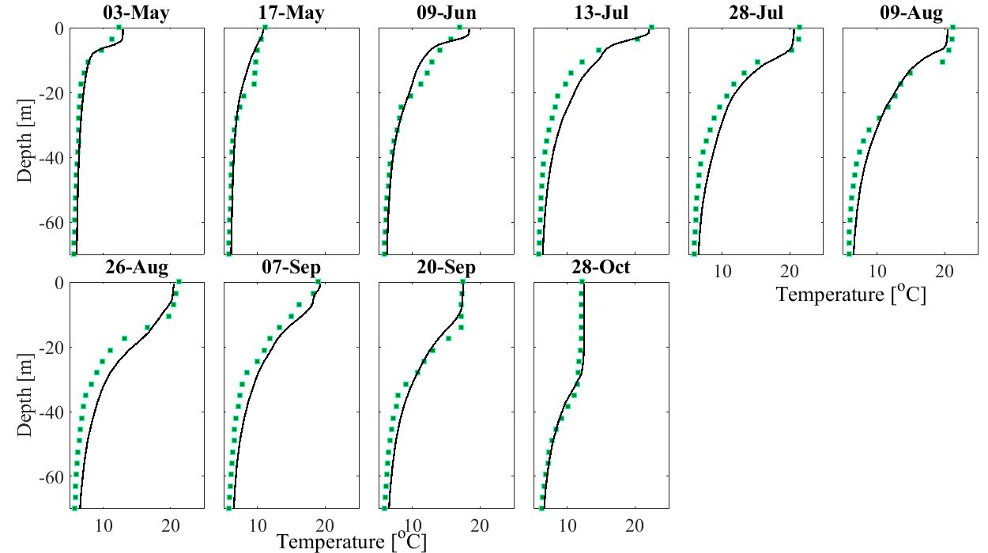

Fig. S1. Comparison of measured temperature profiles at SHL2 (for station location see Fig. 1) with the MITgcm model results for May to October 2010. The water depth is ~309 m at this point. However, for visualization purposes, only the first 70 m are shown (results for deeper depths are similar).

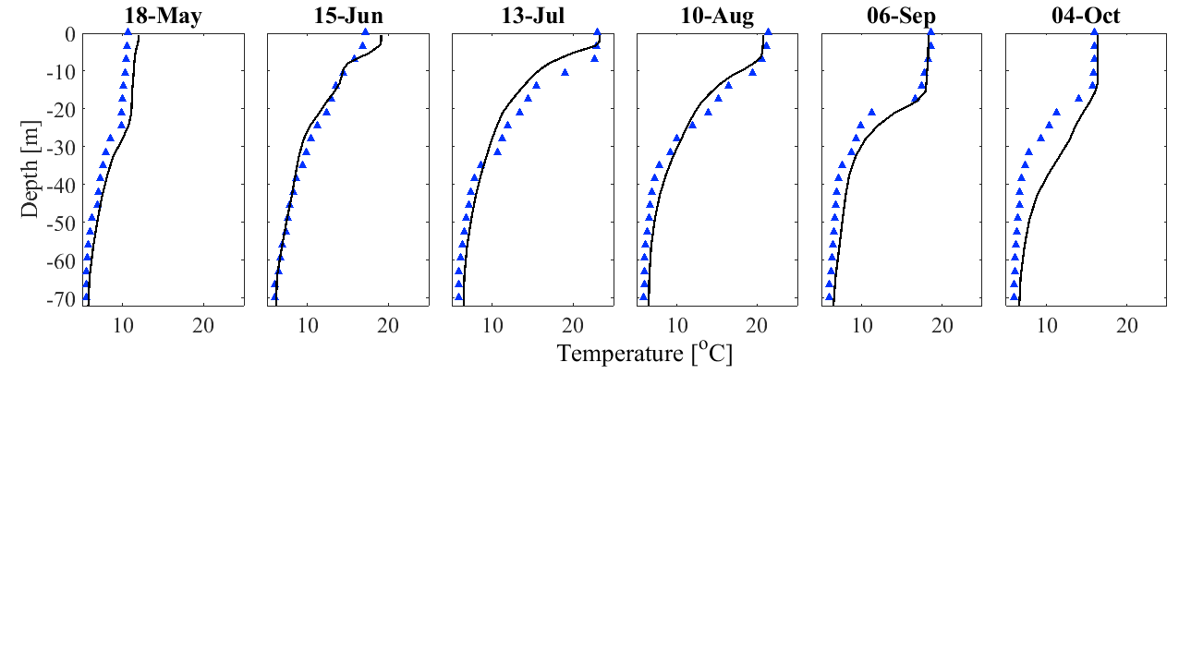

Fig. S2. Comparison of measured temperature profiles at GE3 (for station location see Fig. 1) with the MITgcm model results for May to October 2010.

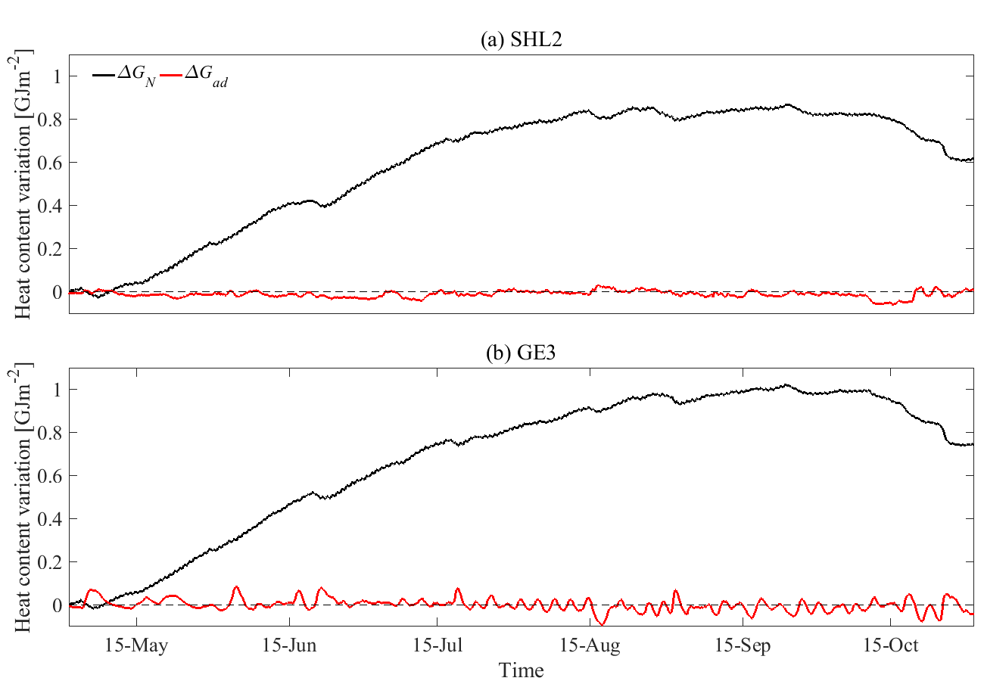

Fig. S3. Comparison of cumulative heat content variation due to (i) the net SurHF (*∆GN* obtained from bulk modeling) and (ii) to lateral advection (*∆Gad* determined from 3D numerical modeling) at (a) SHL2 and (b) GE3 for the period May to October 2010.

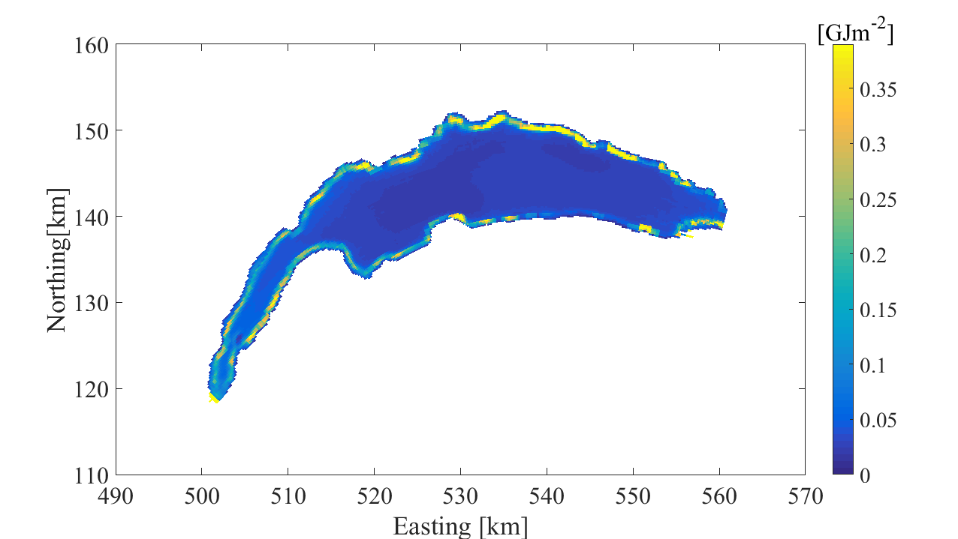

Fig. S4. Spatial pattern of the standard deviation of the water column energy content variation, [GJm-2], due to horizontal advective energy fluxes (*Qad*, [Wm-2]) for the period May to October 2010. In order to compare it with the energy content variation due to SurHF, the range of the color bar is equal to the standard deviation of Δ*GN* at SHL2 and GE3 (black lines in Fig. S3). The Swiss coordinate system with km length-based units was used.

|  |
| --- |
|  |

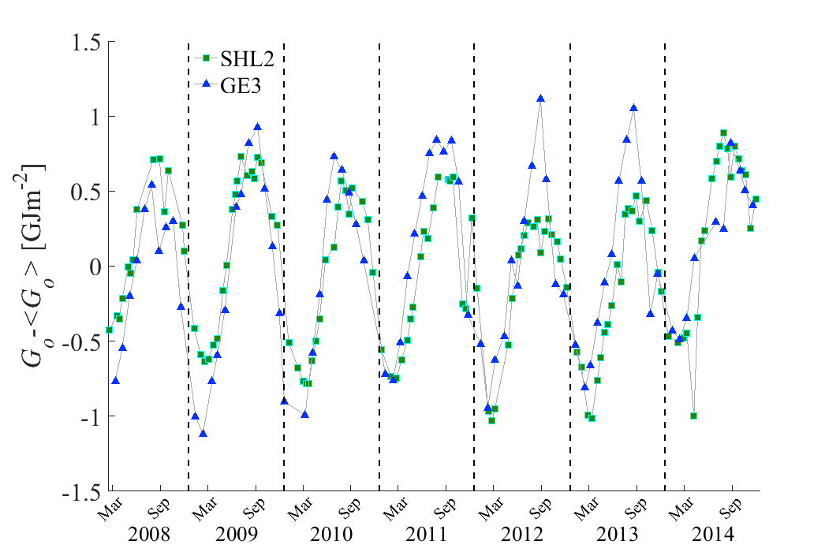

Fig. S5. Temporal evolution of lake heat content variation (the mean value is subtracted) using the measured temperature profiles at SHL2 (green squares) and GE3 (blue triangles).

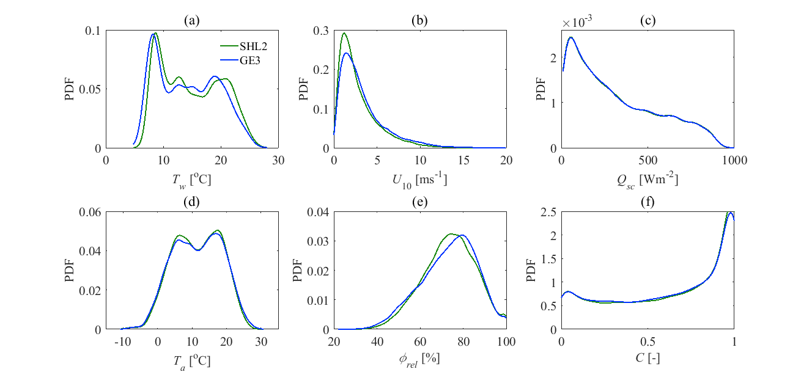

Fig. S6. Probability Density Functions (PDFs) for hourly input data at SHL2 and GE3. (a) Lake Surface Water Temperature (LSWT), *Tw*, (b) wind speed, *U*10, (c) global radiation, *Qsc*, (d) air temperature, *Ta*, (e) relative humidity, , and (f) cloudiness, *C*.

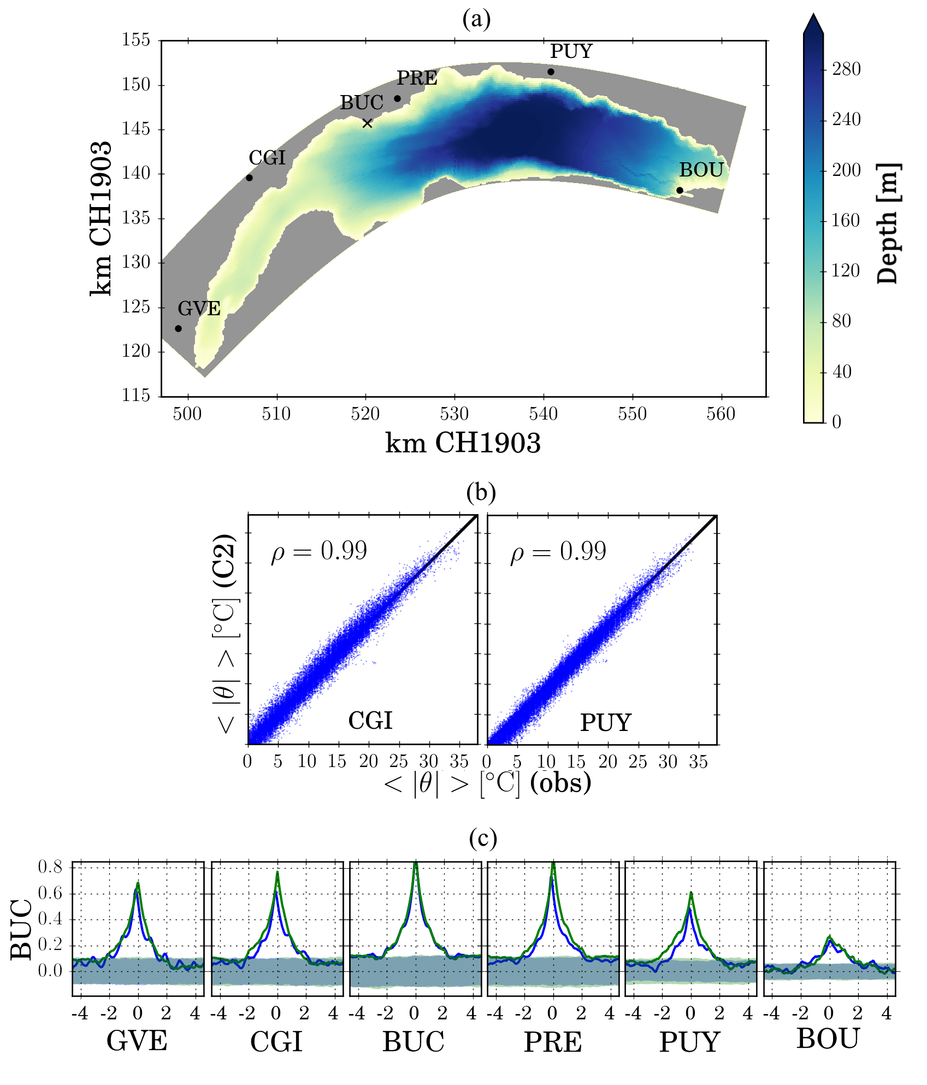

Fig. S7. (a) Location of meteorological stations on the Swiss side of Lake Geneva operated by MeteoSwiss (black circles; GVE: Geneva airport, CGI: Changins, PRE: Saint-Prex, PUY: Pully, and BOU: Bouveret), and our station 100 m offshore (black cross; BUC: Buchillon). The color bar shows the lake bathymetry, (b) Correlation coefficient, *ρ*, between hourly averaged () in situ air temperature (obs) and COSMO-2 outputs (C2) at Changins and Pully for 2013, and (c) Cross-correlation (including autocorrelation) values between BUC and the other stations for in situ measurements (blue lines) and COSMO-2 outputs (green lines). The values on the abscissa of (c) have units of h.

***Selected Surface Heat Flux (SurHF) models***

*Radiation*

Tables S1 and S2 summarize formulas and coefficient values used for estimating the radiative SurHF components, *Qsn*, *Qan* and *Qbr*, Eqs. S1 to S4 in Table S1, respectively. Part of the incident solar radiation is reflected at the water surface, denoted by the albedo coefficient, *rs,* which is divided into direct and diffusive parts. Several empirical formulas exist for the determination of the atmospheric long-wave radiation, *Qan*. Here, we considered two concepts that represent the relevant physics and provide widely used formulas. In Eq. S2b, *Ccloud* is a calibration factor that depends on the cloud type. Factor *Can*is another calibration factor that corrects the so-called leading coefficient proposed by Brutsaert (1975), i.e., 1.24 in Eq. S2b. This means that *εan* can physically reach a maximum value of unity under completely covered skies, i.e., *C =* 1 where *C* is cloudiness. The parameter *εan*2 was calculated employing the improved methods of Crawford and Duchon (1999). They added a seasonal adjustment, *Clt*, in Table S1-Eq. S3b, to the leading coefficient, *Clc*. According to their analysis, this time-variable atmospheric emissivity better represents the monthly mean bias and root mean square errors of the observations.

Table S1. Bulk models used to calculate radiative Surface Heat Flux (SurHF) components.

|  |  |  |  |
| --- | --- | --- | --- |
| Cogley (1979); Fink et al. (2014) |  | | (S1a) |
|  | | (S1b) |
|  | | (S1c) |
| Stefan-Boltzmann law |  | (S2a) | |
| Brutsaert (1975) |  | | (S2b) |
| Stefan-Boltzmann law |  | | (S3a) |
| Crawford and Duchon (1999) |  | | (S3b) |
| Stefan-Boltzmann law |  | | (S4) |

Table S2. Definition and values/formulas of the symbols used in Table S1.

|  |  |  |
| --- | --- | --- |
| Definitions | | Value |
| *C* | Cloudiness | From COSMO-2 |
| *Can* | Calibration factor | - |
| *Ccloud* | Calibration factor | - |
| *Clc* | Calibration factor | - |
| *Clt* | Calibration factor | - |
| *ea* | Water vapor pressure [hPa] |  |
| *Fdiff* | Solar radiation diffusive fraction | - |
| *Fdir* | Solar radiation direct fraction | - |
| *Qsc* | Global radiation [Wm-2] | From COSMO-2 |
| *rs,diff* | Diffusive albedo a | 0.066 |
| *rs,dir* | Direct albedo b | From Cogley (1979) |
| *Ta* | Air temperature [°C] | From COSMO-2 |
| *tm* | Numerical month | e.g., 15 January = 1 |
| *Tw* | Lake surface water temperature [°C] | From satellite imagery |
| *εa* | Atmospheric emissivity | - |
| *εw* | Water surface emissivity c | 0.972 |
|  | Relative humidity | From COSMO-2 |
|  | Stefan-Boltzmann constant [Wm-2°C-4] | 5.6710-8 |

a Burt (1954); Fink et al. (2014)

b In the present study, the modified mean monthly direct albedo for 46o latitude(Cogley 1979) was used. For the SurHF calculation, hourly values were estimated by applying the Piecewise Cubic Hermite polynomials interpolation method (Fritsch and Carlson 1980). The effects of other atmospheric conditions, e.g., air pollution, and solar zenith angle on the direct/diffusive fraction are neglected. The daily variation of *Qsn* is mainly due to *Qsc*, which is taken into account.

cDavies et al. (1971) and Sweers (1976) recommended a value of *εw* = 0.972, which was used by Livingstone and Imboden (1989) and Fink et al. (2014), whereas Octavio (1977) suggested *εw* = 0.956. We applied the first value, i.e., 0.972, following previous studies in Switzerland.

*Sensible and latent heat fluxes*

Due to the similarity between sensible, *Qco*, and latent, *Qev*, heat fluxes, they are often calculated with formulas having a similar form. To estimate them, three different pairs of equations, Eqs. S5 to S7 in Table S3, were selected, representing different concepts. The level of complexity in these formulas increases from Eq. S5 to Eq. S7. Table S4 shows the definition and values of the parameters in those equations.

Murakami’s formulation, Eq. S5a, corresponds to the turbulent bulk latent heat flux formula without the influence of free convection, following a constant Dalton number. A constant Bowen ratio in Eq. S5b, *Cb*, was used to estimate the sensible heat flux with values of the latent heat flux, *Qev*1. The factor *Cb* is proportional to air pressure even though an average value is usually employed. Equation S6 takes into account the contribution of free convection to the sensible and latent heat flux calculations. Here, *Ce,r*and *Ch,r* are the Dalton and Stanton numbers, respectively, both of which are calibrated. In a more sophisticated approach, the turbulent SurHF is calculated by applying the bulk parameterization algorithms based on similarity theory and empirical relationships, Eq. S7. This formulation relates the surface layer data to surface momentum and heat fluxes. More information is given in the section, “Details of the model calibration procedure.”

Table S3. Selected bulk models for sensible and latent surface heat fluxes.

|  |  |  |
| --- | --- | --- |
| Murakami et al. (1985); |  | (S5a) |
| Bowen (1926) a |  | (S5b) |
| Ryan et al. (1974); Gill (1982) |  | (S6a) |
|  | (S6b) |
|  | (S6c) |
|  | (S6d) |
|  | (S6e) |
|  | (S6f) |
|  | (S6g) |
|  | (S6h) |
|  | (S6i) |
| Monin-Obukhov similarity theory (Monin and Obukhov 1954) |  | (S7a) |
|  | (S7b) |
|  | (S7c) |
|  | (S7d) |
|  | (S7e) |

a Assuming an analogy between heat exchange and mass transfer, the convective heat flux can be related to the evaporative flux through the Bowen ratio, .

| Table S4. Definition and values/formulas of the symbols used in Table S3 (continued). | | |
| --- | --- | --- |
| Definitions | | Value |
| *Cb* | Calibration factor (Bowen coefficient) [hPa°C-1] | -  . |
| *Ce* | Calibration factor (Dalton number) | - |
| *Cfr.conv.* | The free convection coefficient a | 0.14 |
| *Cd* | Momentum transfer coefficient | - |
| *Ch* | Calibration factor (Stanton number) | - |
| *Cmur* | Calibration factor | - |
| *Cp,a* | Specific heat capacity of air [Jkg-1°C-1] | 1004 |
| *Da* | Air molecular diffusivity [m2s-1] |  |
| *es* | Saturated water vapor pressure [hPa] b |  |
| *G* | Gravitational acceleration [ms-2] | 9.81 |
| *ks* | Transfer coefficient | - |
| *Lv* | Latent heat of vaporization [Jkg-1] |  |
| *Lw* | Monin-Obukhov length | - |
| *Patm* | Air pressure [hPa] | From COSMO-2 |
| Pr | Prandtl number | 0.7 |
| *qa* | Actual air specific humidity  [kgkg-1 dry air] |  |
| *qs* | Saturated air specific humidity  [kgkg-1 dry air] |  |
| *qz* | Specific humidity at height *zq*  [kgkg-1 dry air] | - |
| *q\** | Scaling humidity [kgkg-1 dry air] |  |
| *Rdry* | Dry air gas constant [Jkg-1°C-1] | 287.05 |
| *Rvap* | Water vapor gas constant [Jkg-1°C-1] | 461.495 |
| *SL* | Lake surface area [m2] | 5.8108 |
| *Tz* | Air temperature at height *zt* [°C] | - |
| *Tv* | Virtual air temperature [K] |  |
| *T\** | Scaling temperature [°C] | - |
| *U*10 | Wind speed at 10 m above the free surface [m s-1] | From COSMO-2 |
| *uz* | Wind speed at height *zu* [ms-1] | - |
| *u\** | Air friction velocity [ms-1] | - |
| *zq* | Height of humidity data [m] | From COSMO-2 |
| *zt* | Height of air temperature data [m] | From COSMO-2 |
| *zu* | Height of wind speed data [m] | From COSMO-2 |
|  | Von Karman constant | 0.41 |
|  | Air viscosity [m2s-1] | 1.610-5 |
|  | Actual air density [kgm-3] | - |
|  | Average air density [kgm-3] | - |
|  | Saturated air density [kgm-3] | - |
|  | Water density [kgm-3] | (Read et al. 2011) |
|  | Air density at height *z* [kgm-3] |  |
|  | Air-water momentum flux [Nm-2] | - |
|  | Stability parameter | - |

a Estimated by Ryan et al. (1974).

b Estimated with the Magnus formula (WMO 2008).

***Details of the model calibration procedure***

In Tables 1 and S3, the level of complexity in the turbulent heat flux models increases from (*Qev* + *Qco*)1 to (*Qev* + *Qco*)3. The calculations in the first two formulas are not complicated. The model, (*Qev* + *Qco*)3, uses the bulk parameterization algorithms based on the similarity theory and empirical relationships (Eq. S7, Table S3). Two components must be defined in this algorithm: the turbulence stability functions, *fm*, *fe* and *fh*, and the roughness lengths for wind, temperature and humidity (*z*0, *z*0*t* and *z*0*q*, respectively). The differential equations for *fm*, *fe* and *fh* (Eq. S7d) are integrated between the roughness lengths and the measurement heights to obtain the wind, temperature and specific humidity gradients in the atmospheric boundary layer, and the corresponding drag, humidity and temperature bulk transfer coefficients, *Cd,m*, *Ce,m*and *Ch,m*, respectively, to calculate the turbulent surface fluxes. The Monin-Obukhov similarity theory (Monin and Obukhov 1954) was used for the turbulence stability functions, which depend on the atmospheric stability parameter,(Eq. S7e). We employed expressions that are mainly used over other water bodies (e.g., Zeng et al. 1998; Woolway et al. 2015):

|  |  |
| --- | --- |
|  | (S8) |

|  |  |
| --- | --- |
|  | (S9) |

The empirical parameterization of two roughness lengths was investigated in order to reduce the calibration factors for the calculation of (*Qev* + *Qco*)3. The roughness momentum length, *z*0, was calculated using (Smith 1988):

|  |  |
| --- | --- |
|  | (S10) |

where *Cm*1, the Charnock constant (Charnock 1955), and *Cm*2 are calibration factors. The functional form of Brutsaert (1982) was applied for the roughness lengths of humidity, *z*0*q*, and temperature, *z*0*t*:

|  |  |
| --- | --- |
|  | (S11) |

where *Cq*1 and *Cq*2 are calibration factors, and ${\text{Re}}_{\text{*}}\text{ = }{\text{u}}_{\text{*}}{\text{z}}_{\text{0}}\text{/}{\text{v}}_{\text{a}}$ is the roughness Reynolds number. Zeng et al. (1998), employing the bulk parameterization in Eqs. S10 and S11 with some other algorithms, obtained the following values: *Cm*1= 0.013, *Cm*2= 0.11, *Cq*1= -2.67 and *Cq*2= 2.57. These four calibration factors were based on the data of the Tropical Ocean-Global Atmosphere Coupled-Ocean Atmosphere Response (TOGA COARE) experiment (Fairall et al. 1996) and define the variation of drag, humidity and temperature bulk transfer coefficients as a function of meteorological parameters, especially wind speed. A sensitivity analysis of these calibration factors reveals that the shape of humidity and temperature transfer coefficients are mainly controlled by *Cm*2 and *Cq*1 (Fig. S8). These results illustrate that *Cm*2 affects the low wind speed regime (up to 5 ms-1) while *Cq*1 controls higher wind speeds (over 5 ms-1). Rearranging Eq. S10 indicates that *Cm*2is equal to a constant Re* as the wind speed approaches zero. In addition to other meteorological parameters and LSWT, the wind speed distribution also changes at SHL2 and GE3 (Figs. 2b and S6b). In this study, we assumed *Cm*1= 0.013 and *Cq*2= 2.57 and calibrated *Cm*2 and *Cq*1 through an optimization procedure.

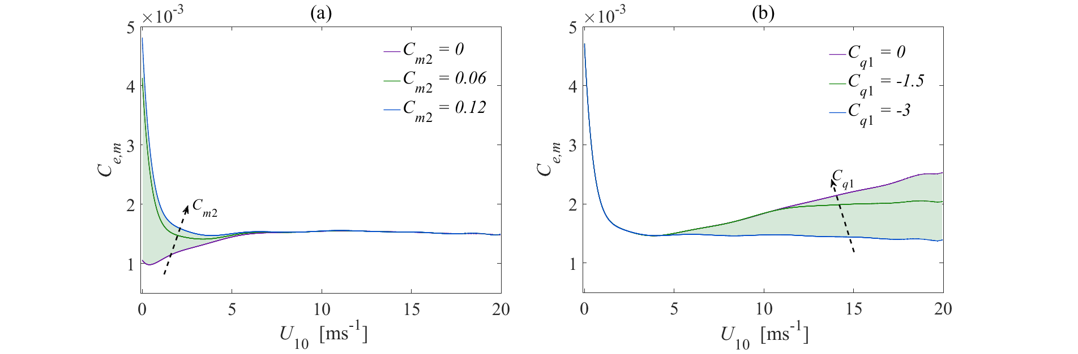

Fig. S8. Sensitivity of humidity bulk transfer coefficient, *Ce,m*, to the calibration factors given in the legend: (a) *Cm*2, and (b) *Cq*1. Dashed arrows indicate the change in values as given in the legend.

The Generalized Likelihood Uncertainty Estimation (GLUE) methodology employed for the optimization requires values within a certain range for each calibration parameter. These were based on literature values (Table S5). For each of the six net SurHF models, there are four calibration factors: viz., *Ccloud* /*Can* or *Clc* /*Clt* for the atmospheric radiation component, and *Cmur*/*Cb* or *Ce,r*/*Ch,r* or *Cm*2/*Cq*1for the turbulent (sensible and latent) heat fluxes. The Monte Carlo approach (105 realizations) using uniform random sampling across the parameter ranges was implemented as the sampling strategy.

For the calibration, the following five-step procedure was carried out for each SurHF model: (i) the meteorological data including *U*10, *Ta,**, Qsc*, *C*, *Patm* from the COSMO-2 model and *Tw* from AVHRR satellite images were extracted at the SHL2 and GE3 locations (Fig. 1), (ii) the net SurHF model and its corresponding calibration factors, [(*Can* / *Ccloud*) | (*Clc* / *Clt*)] and [(*Cmur* / *Cb*) | (*Ch,r* / *Ce,r*) | (*Cm*2 / *Cq*1)], were chosen, (iii) *QN* and *Gm* were calculated at the two locations for different Monte Carlo model realizations, (iv) the measured temperature profiles at SHL2 and GE3 were taken from the CIPEL data set and *Go* was calculated, and (v) model performance was ranked based on Eq. 6.

The data set was divided into two parts: The period March 2008 to 7 July 2011 was used for calibration, and August 2011 to December 2014 for validation.

Table S5. Literature values for the selected calibration factors.

|  |  |  |  |
| --- | --- | --- | --- |
| **Calibration factors** | **Reported values** | **References** | **Selected range for GLUE methodology** |
| *Can* | 1.09, 0.943, 1.05 | Livingstone and Imboden (1989), Herrero and Polo (2012), Fink et al. (2014) | [0.8, 1.3] |
| *Ccloud* | 0.17, 0.42, 0.17 | Livingstone and Imboden (1989), Herrero and Polo (2012), Fink et al. (2014) | [0.04, 0.45] |
| *Clc* | 1.22 | Crawford and Duchon (1999) | [0.8, 1.3] |
| *Clt* | 0.06 | Crawford and Duchon (1999) | [0.02, 0.2] |
| *Cmur* | 1.210‑7 | Murakami et al. (1985) | [510-8, 210-7] |
| *Cb* | 0.65, 0.6, 0.62 | Sweers (1976), Livingstone and Imboden (1989), Fink et al. (2014) | [0.58, 0.7] |
| *Ce,r* | 2.110-3 | Wahl and Peeters (2014) | [10-4, 510-2] |
| *Ch,r* | 1.4510-3 | Wahl and Peeters (2014) | [10-4, 510-2] |
| *Cm*2 | 0.11 | Zeng et al. (1998) | [0, 0.12]a |
| *Cq*1 | -2.67 | Zeng et al. (1998) | [-3, 0]a |

a See the sensitivity analysis above for details of the range selection.

***Error analysis***

*Calibration uncertainty*

To investigate the calibration uncertainties, dot plots of RMSE for each of the four calibration parameters, *Can*, *Ccloud*, *Cq*1 and *Cm*2, in a narrowed range of low RMSE values are shown in Fig. S9; RMSE can reach up to > 5 GJm-2. These plots present the RMSE results of the GLUE methodology based on the Monte Carlo approach outlined in the section, “*Details of the model calibration procedure”* above. The results reveal a convergence to a minimum (optimum) RMSE value (0.28 GJm-2; red dots in Fig. S9) for all parameters with a small (negligible) variation in the neighborhood of the optimum values of *Can*, *Ccloud*, *Cq*1 and *Cm*2, as indicated by the scatter of black circles below the horizontal red line (RMSE < 0.3 GJm-2) in each panel. Note that the minimum RMSE value is the same in all four panels, since the calibration and optimization for the four parameters was carried out jointly for this parameter set.

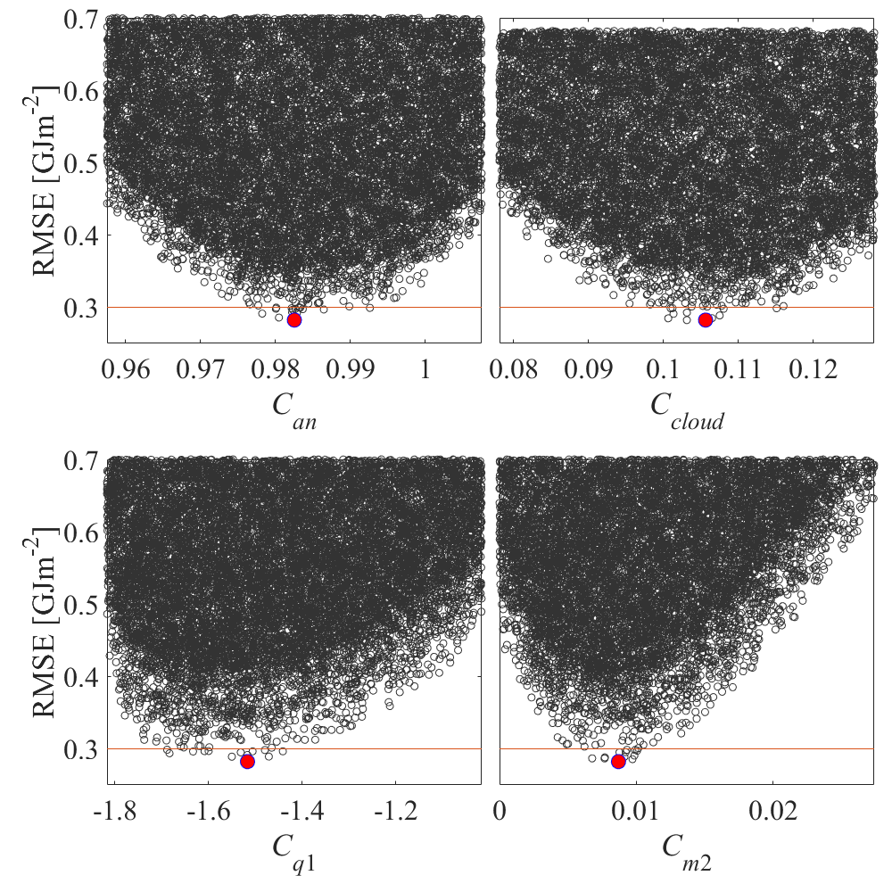

Fig. S9. Dot plots of RMSE for the four calibration parameters: *Can* (top-left panel), *Ccloud* (top-right panel), *Cq*1 (bottom-left panel), and *Cm*2 (bottom-right panel) in a narrowed range. Red dots indicate the optimal values (0.28 GJm-2), and the thin horizontal red lines, a threshold of 0.3 GJm-2 that is within 10% of the minimal RMSE values.

*Uncertainty of the observed heat content values*

To estimate the uncertainty of the measured heat content, we modified Eq. 1 by considering noise in the measured temperature profiles:

|  |  |
| --- | --- |
|  | (S12) |

where is the error (noise) in the temperature profile measurements. This term induces an error of in the total heat content estimates of the water column:

|  |  |
| --- | --- |
|  | (S13) |

To determine the importance of the induced uncertainty, we consider the worst case scenario for the absolute value of : a constant bias in the whole water column at SHL2, the deepest point in the lake. Therefore, the maximum error can be estimated as:

|  |  |
| --- | --- |
|  | (S14) |

Assuming constant values of ~ 1000 kgm-3, ~ 4200 Jkg-1°C-1 and *H* ~ 309 m, we obtain:

|  |  |
| --- | --- |
|  | (S15) |

The *Commission Internationale pour la Protection des Eaux du Léman* ([CIPEL](http://www.cipel.org/en/links_en/lake-geneva/)) water temperature profiles were collected for Lake Geneva with an RBR XR-620 CTD profiler (or similar) with an accuracy of ±0.002 °C. Therefore, the maximum error in the estimates of the water column heat content is ~ ±2.6×106 Jm-2 or ~ ±0.0026 GJm-2. Compared to the minimum RMSE (0.28 GJm-2 in Fig. S9), this value is negligible.

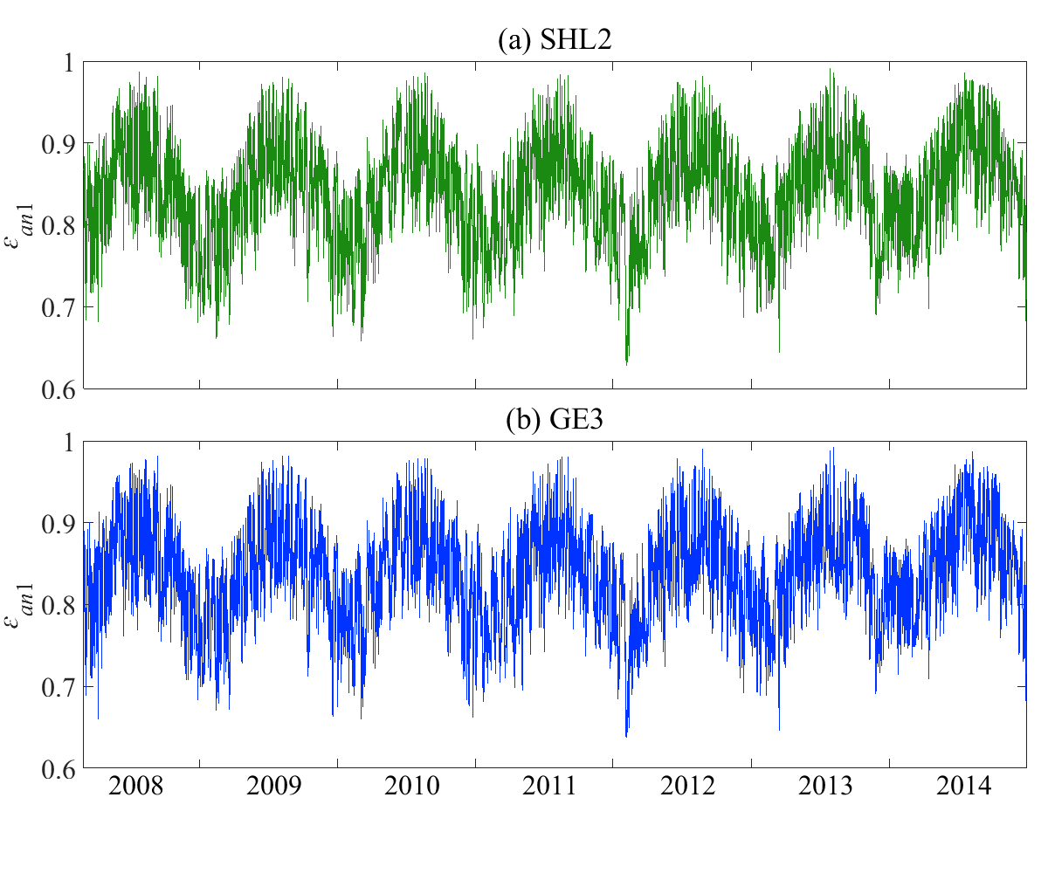

Fig. S10. Time series of calibrated atmospheric emissivity (*εan*1 ; see Eq. S2b) values (hourly results) at (a) SHL2, and (b) GE3 calculated with optimal coefficients *Can, opt* and *Ccloud, opt*. Note that the calibrated emissivity varies between 0.6 and 1, whereas the uncalibrated emissivity exceeded physically unrealistic values of 1.

**References**

Bowen, I. S. 1926. The ratio of heat losses by conduction and by evaporation from any water surface. Phys. Rev. **27:** 779-787. doi: 10.1103/Physrev.27.779.

Brutsaert, W. 1975. Derivable formula for long-wave radiation from clear skies. Water Resour. Res. **11:** 742-744. doi: 10.1029/Wr011i005p00742.

Brutsaert, W. 1982. Evaporation into the atmosphere: Theory, history and applications. Springer Netherlands. doi: 10.1007/978-94-017-1497-6.

Burt, W. V. 1954. Albedo over wind-roughened water. J. Meteorol. **11:** 283-290. doi: 10.1175/1520-0469(1954)011<0283:Aowrw>2.0.Co;2.

Charnock, H. 1955. Wind stress on a water surface. Q. J. Roy. Meteor. Soc. **81:** 639-640. doi: 10.1002/qj.49708135027.

Cimatoribus, A. A., U. Lemmin, D. Bouffard, and D. A. Barry. 2018. Nonlinear dynamics of the near-shore boundary layer of a large lake (Lake Geneva). J. Geophys. Res.: Oceans **123:** 1016-1031. doi: 10.1002/2017JC013531.

Cogley, J. G. 1979. Albedo of water as a function of latitude. Mon. Weather Rev. **107:** 775-781. doi: 10.1175/1520-0493(1979)107<0775:Taowaa>2.0.Co;2.

Crawford, T. M., and C. E. Duchon. 1999. An improved parameterization for estimating effective atmospheric emissivity for use in calculating daytime downwelling longwave radiation. J. Appl. Meteorol. **38:** 474-480. doi: 10.1175/1520-0450(1999)038<0474:Aipfee>2.0.Co;2.

Davies, J. A., P. J. Robinson, and M. Nunez. 1971. Field determinations of surface emissivity and temperature for Lake Ontario. J. Appl. Meteorol. **10:** 811-819. doi: 10.1175/1520-0450(1971)010<0811:FDOSEA>2.0.CO;2.

Fairall, C. W., E. F. Bradley, D. P. Rogers, J. B. Edson, and G. S. Young. 1996. Bulk parameterization of air-sea fluxes for Tropical Ocean Global Atmosphere Coupled Ocean Atmosphere Response Experiment. J. Geophys. Res.: Oceans **101:** 3747-3764. doi: 10.1029/95jc03205.

Fink, G., M. Schmid, B. Wahl, T. Wolf, and A. Wüest. 2014. Heat flux modifications related to climate-induced warming of large European lakes. Water Resour. Res. **50:** 2072-2085. doi: 10.1002/2013wr014448.

Fritsch, F. N., and R. E. Carlson. 1980. Monotone piecewise cubic interpolation. Siam. J. Numer. Anal. **17:** 238-246. doi: 10.1137/0717021.

Gill, A. E. 1982. Atmosphere-ocean dynamics. Academic Press. San Diego, USA. doi: 10.1002/qj.49711046322.

Herrero, J., and M. J. Polo. 2012. Parameterization of atmospheric longwave emissivity in a mountainous site for all sky conditions. Hydrol. Earth Syst. Sci. **16:** 3139-3147. doi: 10.5194/hess-16-3139-2012.

Livingstone, D. M., and D. M. Imboden. 1989. Annual heat balance and equilibrium temperature of Lake Aegeri, Switzerland. Aquat. Sci. **51:** 351-369. doi: 10.1007/Bf00877177.

Marshall, J., A. Adcroft, C. Hill, L. Perelman, and C. Heisey. 1997. A finite-volume, incompressible Navier Stokes model for studies of the ocean on parallel computers. J. Geophys. Res.: Oceans **102:** 5753-5766. doi: 10.1029/96jc02775.

Monin, A. S., and A. M. Obukhov. 1954. Basic laws of turbulent mixing in the ground layer of the atmosphere. Tr. Akad. Nauk SSSR Geofiz. Inst. **24:** 163-187.

Murakami, M., Y. Oonishi, and H. Kunishi. 1985. A numerical simulation of the distribution of water temperature and salinity in the Seto Inland Sea. J. Oceanogr. Soc. Jpn. **41:** 213-224. doi: 10.1007/BF02109271.

Octavio, K. A. H. 1977. Vertical heat transport mechanisms in lakes and reservoirs. Ralph M. Parsons Laboratory for Water Resources and Hydrodynamics. Mass. Inst. Tech., Cambridge, Massachusetts, USA. <http://hdl.handle.net/1721.1/52844> (last accessed 5 July 2018).

Read, J. S., D. P. Hamilton, I. D. Jones, K. Muraoka, L. A. Winslow, R. Kroiss, C. H. Wu, and E. Gaiser. 2011. Derivation of lake mixing and stratification indices from high-resolution lake buoy data. Environ. Model. Softw. **26:** 1325-1336. doi: 10.1016/j.envsoft.2011.05.006.

Ryan, P. J., D. R. F. Harleman, and K. D. Stolzenbach. 1974. Surface heat loss from cooling ponds. Water Resour. Res. **10:** 930-938. doi: 10.1029/Wr010i005p00930.

Smith, S. D. 1988. Coefficients for sea-surface wind stress, heat flux, and wind profiles as a function of wind speed and temperature. J. Geophys. Res.: Oceans **93:** 15467-15472. doi: 10.1029/Jc093ic12p15467.

Sweers, H. E. 1976. Nomogram to estimate heat exchange coefficient at air-water interface as a function of wind speed and temperature: Critical survey of some literature. J. Hydrol. **30:** 375-401. doi: 10.1016/0022-1694(76)90120-7.

Wahl, B., and F. Peeters. 2014. Effect of climatic changes on stratification and deep-water renewal in Lake Constance assessed by sensitivity studies with a 3D hydrodynamic model. Limnol. Oceanogr. **59:** 1035-1052. doi: 10.4319/lo.2014.59.3.1035.

WMO. 2008. Guide to meteorological instruments and methods of observation. World Meteorological Organization. <http://www.wmo.int/pages/prog/gcos/documents/gruanmanuals/CIMO/CIMO_Guide-7th_Edition-2008.pdf> (last accessed 5 July 2018).

Woolway, R. I., I. D. Jones, D. P. Hamilton, S. C. Maberly, K. Muraoka, J. S. Read, R. L. Smyth, and L. A. Winslow. 2015. Automated calculation of surface energy fluxes with high-frequency lake buoy data. Environ. Model. Softw. **70:** 191-198. doi: 10.1016/j.envsoft.2015.04.013.

Zeng, X. B., M. Zhao, and R. E. Dickinson. 1998. Intercomparison of bulk aerodynamic algorithms for the computation of sea surface fluxes using TOGA COARE and TAO data. J. Clim. **11:** 2628-2644. doi: 10.1175/1520-0442(1998)011<2628:Iobaaf>2.0.Co;2.