MOF-derived cobalt phosphide/carbon nanocubes for selective hydrogenation of nitroarenes to anilines
Shuliang Yang,^{[a]} Li Peng,^{[a]} Emad Oveisi,^{[b]} Safak Bulut,^{[a]} Daniel T. Sun,^{[a]} Mehrdad Asgari,^{[a]} Olga Trukhina,^{[a]} and Wendy L. Queen*^{[a]}
[a] Dr. S. Yang, Dr. L. Peng, Dr. S. Bulut, D. Sun, M. Asgari, Dr. O. Trukhina, Prof. Dr. W. Queen
Institute of Chemical Sciences and Engineering
École Polytechnique Fédérale de Lausanne (EPFL)
EPFL-ISIC-Valais, Sion, 1950 (Switzerland)
E-mail: wendy.queen@epfl.ch
[b] Dr. E. Oveisi
Interdiciplinary Center for Electron Microscopy, École Polytechnique Fédérale de Lausanne (EPFL), CH-1015 Lausanne, Switzerland.
Supporting information for this article is given via a link at the end of the document.

Abstract: Selective hydrogenation of nitroarenes to anilines is an important organic transformation. More than 4 million tons of aniline and its derivatives are produced every year to meet the needs of the agricultural, biological and pharmaceutical industries. Given the magnitude of the production process, chemists are continuously working towards designing cheaper and more efficient catalysts. In this work, cobalt phosphide/carbon nanocubes are designed and their catalytic activity is studied for this important conversion. A high surface area metal-organic framework (MOF), ZIF-67, is infused with red phosphorous, and then pyrolysis promotes the facile production of the phosphide-based catalysts. The resulting composite, consisting of Co₂P@CN_{x} nanocubes, is shown to exhibit excellent catalytic performance in the selective hydrogenation of nitroarenes to anilines. To the best of our knowledge, this is the first report showing catalytic activity of a cobalt phosphide in nitroarenes hydrogenation.
As a relatively new class of porous materials, metal-organic frameworks (MOFs), have moved to the forefront of materials research because of their unprecedented internal surface areas, tunable topologies, and designable pore surfaces.^{[1]} These properties endow MOFs with great promise in applications coupled to catalysis, gas adsorption/separation, chemical sensing and so on.^{[2]} For example, the organic ligands in MOFs, promote the formation of frameworks that have highly dispersed metal ions and clusters.^{[3]} Further, these ligands can be pre-designed to afford additional coordination sites for metals.^{[4]} These structural features can aid the formation of MOFs and MOF-derived materials with very small and highly dispersed nanoparticles, clusters, and even single atoms as catalytically active sites. Hence, compared to other classes of porous materials, MOF-based catalysts can offer higher activities that are comparable to their homogeneous counterparts. For example, Li et al recently reported that calcination of a Zn/Co bimetallic MOF, which offers N-coordinated metal ions, promotes the formation of a MOF-derived catalyst containing individual Co-N_{x} active sites. This material’s performance is superior to commercially available Pt/C catalysts used in oxygen reduction reaction.^{[5]} Further, Beller et al showed that the calcination of a Co-1,4-diazabicyclo[2.2.2]octane (DABCO)-terephthalic acid (TPA) MOF provides an efficient catalyst for the general synthesis of a large variety of amines under industrially viable and scalable conditions.^{[6]} These successful studies have sparked our interest in screening MOF-derived catalysts for activity in the reduction of nitroarenes to anilines.
Transition-metal compounds, such as chalcogenides, phosphides and carbides have received much attention during the past few years because of their robust stability, corrosion resistance, high melting points, good mechanical properties and low cost.^{[7]} Among them, cobalt phosphides (Co_{x}P) have already found applicability in electrocatalysis. Several Co_{x}P-based materials are shown to be highly active, stable and cost effective options for hydrogen evolution, oxygen evolution and water splitting reactions.^{[8]} While these materials have exhibited impressive performance in electrocatalysis, to the best of our knowledge, there is no report using Co_{x}P for the hydrogenation of nitroarenes to anilines. In this work, a simply pyrolysis of ZIF-67 MOF nanocubes combined with red phosphorous precursor, is shown to promote the formation of Co₂P@CN_{x} composite. Gratifyingly, the resulting novel Co₂P@CN_{x} nanocubes show excellent activity and selectivity for selective hydrogenation of nitroarenes to anilines. This reaction is found to take place at significantly lower temperatures (60 °C) when compared to other Co and Fe-based catalysts (>110 °C);^{[9]} this implies that the phosphide has very high activity for this hydrogenation reaction. Further, this material is significantly cheaper than commercially employed Pd-based materials,^{[10]} making it a viable selection for this and other hydrogenation reactions.

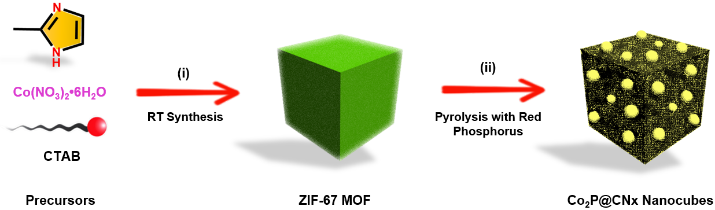
Scheme 1. Graphical presentation for the synthesis of Co₂P@CNx nanocubes.

The preparation process of Co₂P@CN_{x} nanocubes is displayed in Scheme 1. Firstly, with the help of a capping agent, cetyltrimethylammonium bromide (CTAB), uniform ZIF-67 nanocubes are prepared. The adsorption of CTAB on the hydrophobic surfaces slows the growth rate of the crystal facets and hence promotes uniform nanocube formation.^{[11]} After mixing the as-prepared ZIF-67 nanocubes with red phosphorus, a simple calcination treatment yields a porous Co₂P@CN_{x} composite. Compared to previous methods for the preparation of Co₂P, such as the treatment of trioctylphosphine at elevated temperature (ca. 300 ºC) in high-boiling organic solvents,^{[12]} the method developed here is simple and convenient. Further, this method yields a homogeneous Co₂P phase, all while avoiding
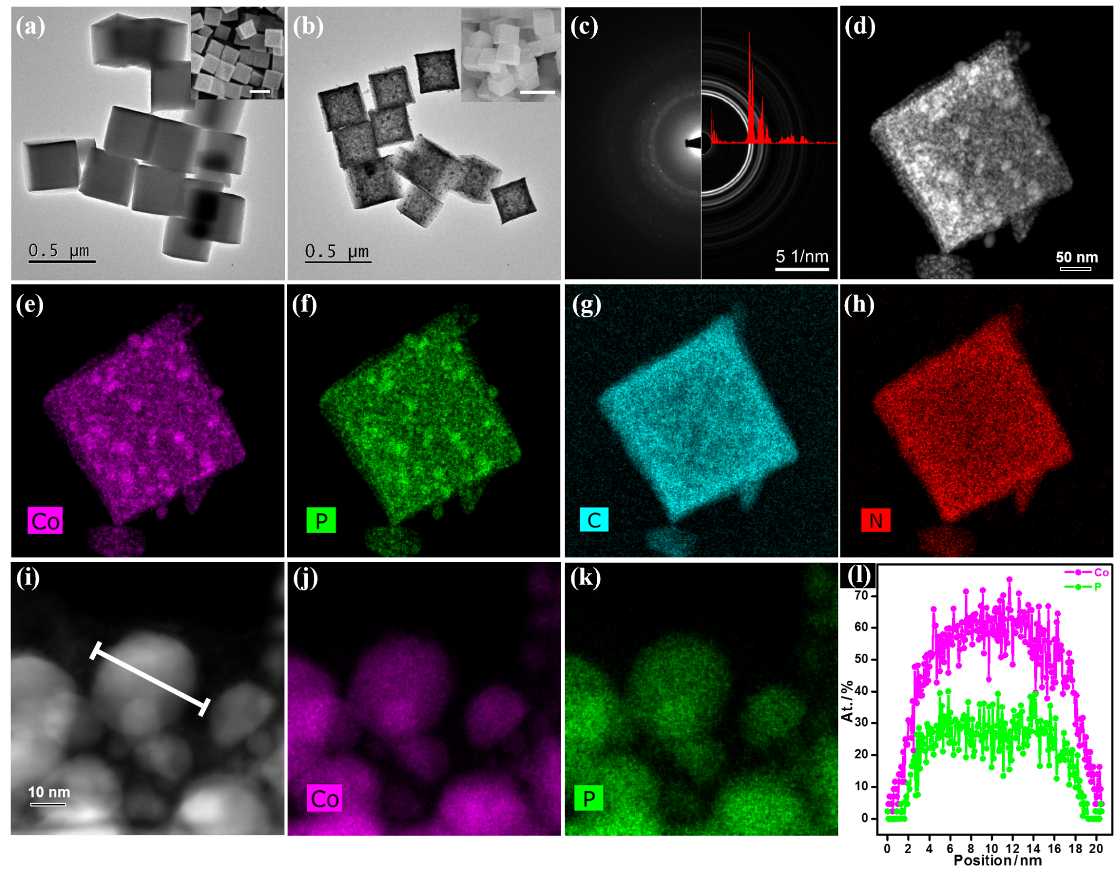
Figure 1. Bright-field TEM images of the ZIF-67 (a) and Co₂P@CN_{x} nanocubes (b). SEM images are shown in the inset (scale bar, 500 nm). Selected area electron diffraction pattern of Co₂P@CN_{x} nanocubes along with simulated diffraction pattern of Co₂P (c). HAADF-STEM image of a Co₂P@CN_{x} nanocube (d) and corresponding EDX elemental maps of Co (e), P (f), C (g), N (h). HAADF-STEM image of Co₂P nanoparticles (i) and corresponding EDX elemental maps of Co (j), P (k). STEM-EDX line scan profile (l) of Co and P elements across a single Co₂P nanoparticle that is marked in image (i).

the formation of toxic PH₃, which occurs when using NaH₂PO₂ as the phosphorus source.^{[13]}
The morphology of the materials acquired in each step was characterized by scanning electron microscopy (SEM) and transmission electron microscopy (TEM). From the TEM and SEM images (Figures 1a and S1), it was found that the prepared ZIF-67 cubes had smooth surfaces and an average size of ca. 400 nm. The X-ray diffraction (XRD) pattern of ZIF-67 cubes matched well with the simulated pattern of ZIF-67 (Figure S2). Next, the Co₂P@CN_{x} composite was prepared through a phosphorization step using red phosphorus as the phosphorus source. TEM and SEM images displayed that the cube morphology was well maintained with an average size of ca. 260 nm post calcination (Figures 1b and S3). The size shrinkage is ascribed to the thermal treatment during the phosphorization process. Meanwhile, TEM revealed many small nanoparticles anchored inside the resulting composite (Figures S3c-3d). The XRD pattern of Co₂P@CN_{x} was consistent with the simulated pattern of Co₂P, indicating the successful formation of Co₂P phase (Figure S4b). The observed peak broadening in the diffraction pattern is due to the formation of small Co₂P nanoparticles. Further, reciprocal plane spacing, determined via the selected area electron diffraction pattern (SAEDP, Figure 1c) and the fast Fourier transform (FFT, Figure S5) of the high-resolution TEM (HR-TEM) images, fitted well with the predicted spacing of the Co₂P structure. All of the above-mentioned data confirm the successful preparation of Co₂P@CN_{x} composites consisting of many small Co₂P nanoparticles inside nitrogen-doped carbon matrix.
Thermal treatment of the ZIF nanocubes under varying conditions was also explored, and it was discovered that Co₂P was formed at temperatures between 700 and 900 ºC (Figures S4a and S4c). High-angle annular dark-field scanning TEM (HAADF-STEM) imaging coupled with energy dispersive X-ray spectroscopy (STEM-EDX) displayed that the formed Co₂P nanoparticles were uniformly distributed inside the nanocube matrix (Figures 1d-1f). Further, it is noted that C and N are also uniformly distributed throughout the nanocubes (Figures 1g-1h and S6). The presence of oxygen species results from adsorbed atmospheric oxygen and, hence slight surface oxidation of the particles during the preparation process. The STEM-EDX line scan profiles measured across a single nanoparticle reveals that P is distributed uniformly inside the Co₂P nanoparticles with the expected Co:P ratio of ≃2:1 atom%, which is consistent with the expected chemical formula of Co₂P (Figures 1i-1l). It should be noted that without the introduction of red phosphorus, the formation of metallic cobalt nanoparticles was instead observed in the doped carbon matrix (Figure S7).
To further explore the species of the Co₂P@CN_{x} nanocubes, X-ray photoelectron spectroscopy (XPS) was adopted to further characterize the element species inside the Co₂P@CN_{x} nanocubes. XPS analysis revealed that the Co₂P@CN_{x} composites consisted of C, O, N, P and Co with atomic ratio of 67.91, 7.03, 7.53, 7.22 and 10.32 atom%, corresponding to 32.60 wt% of Co. As a surface characterization method, XPS results matched well with the ICP-OES result which showed 33.40 wt% Co after digestion of the bulk catalyst. This also implies that the Co₂P nanoparticles were distributed uniformly throughout the composites. Analysis of the XPS data shows three peaks, with binding energies equal to 402.1, 400.8 and 398.8 eV, which are indicative of quaternary nitrogen, pyridine nitrogen and pyrrole nitrogen, respectively (Figure 2b). This result is in agreement with those of other carbonized ZIF structures using 2-methylimidazole (2-MeIM) as an organic linker.^{[14]} High-resolution XPS data also revealed ionized cobalt in the Co₂P@CN_{x} nanocubes (Figure 2c). The binding energy of reduced Co located at 778.6 eV, corresponding to Co 2p_{3/2} spin orbit peak that is higher than metallic Co (777.6 eV) and lower than Co²⁺ (780.1 eV); this implies there is a reduced valence state of Co between 0 and 2 (Co^{δ+}, 0 < δ < 2) compared to the original ZIF-67.^{[15]} The binding energy of phosphorus in Co₂P@CN_{x} located at 129.7 eV, is lower than elemental phosphorus (130.1 eV), implying a partially negative charge (P^{δ-}, -1 < δ < 0, Figure 2d).^{[16]} Meanwhile, a peak located at 133.0 eV represents some partially oxidized phosphate species, which likely forms from air exposure during the preparation process.^{[17]}
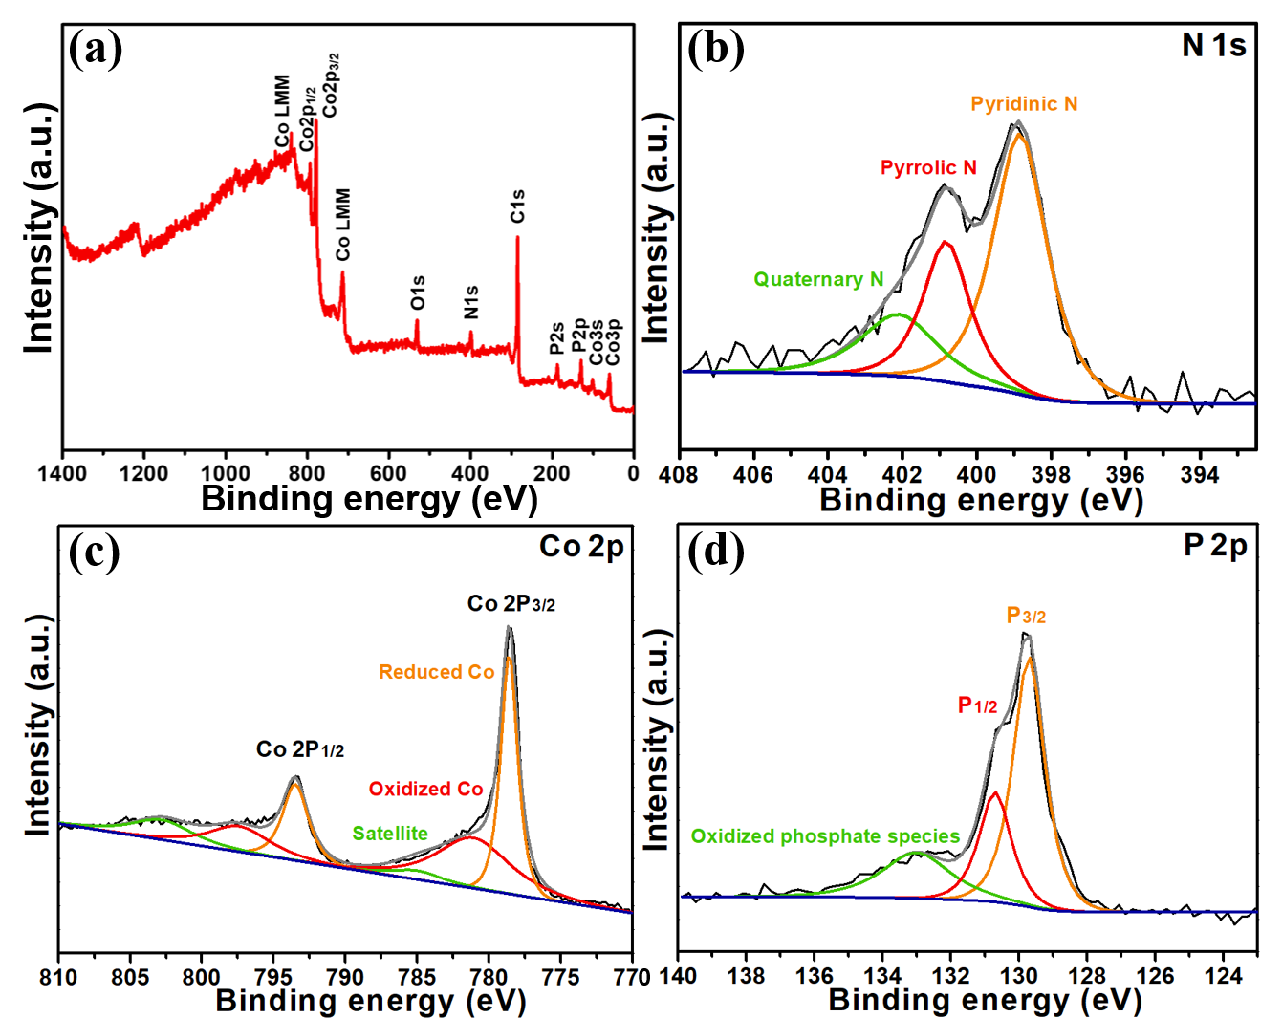
Figure 2. Full spectrum (a) and high-resolution XPS spectra of N 1s (b), Co 2p (c) and P 2p (d) of Co₂P@CN_{x} nanocubes prepared at 800 ºC.

The porosity of Co₂P@CN_{x} was probed via N₂ adsorption measurements taken at 77 K. Before pyrolysis, the ZIF-67 nanocubes display a typical type-I curve, indicative of micropores as expected from the ZIF-67 structure (Figure S8). However, the calcined Co₂P@CN_{x} nanocubes show a typical type-IV isotherm with a distinct hysteresis loop after calcination, indicative of newly formed mesopores in the Co₂P@CN_{x} composite (Figure S9a). Meanwhile, the BET surface area decreases from 1648 to 383 m² g⁻¹ from the ZIF to the composite, respectively. The decreased surface area results from the collapse of well-organized micropores upon ligand decomposition and cobalt reduction during the pyrolysis treatment. Further, the pore size distribution, obtained using the Barrett-Joyner-Halenda (BJH) method, indicates that there are irregular mesopores inside the Co₂P@CN_{x} (Figure S9b). A Raman spectrum of Co₂P@CN_{x}, used to determine that I_{D}/I_{G} is equal to 0.99, reveals the coexistence of both defects and sp²-bonded graphitic sheets inside the nitrogen doped carbon matrix (Figure S10).
Co-based catalysts have found wide applications in both electrochemically and thermally driven catalysis.^{[9a, 18]} For example, Beller et al recently reported an interesting work using a Co-MOF derived composite for the synthesis of a wide array of amines.^{[6]} Considering the importance of amines in the modern chemical industry, we decided to explore the hydrogenation of nitroarenes to anilines as a proof of concept application for the new Co₂P@CN_{x} composite.
First, control experiments were developed to show that the hydrogenation of nitroarenes to anilines could not be achieved without a catalyst or in the presence of the original ZIF-67 structure (Table S1, entries 1-2). After pyrolysis, the ZIF-67 derived Co/CN_{x} does catalyze this reaction; however, the selectivity is found to be lower than the reactions carried out in the presence of Co₂P@CN_{x} nanocubes (78% to 95%, Table S1, entries 3-4). Further, efforts to optimize the pyrolysis temperature reveal that Co₂P@CN_{x} prepared at 800 ºC has optimized activity when compared to the samples prepared at 700 ºC or 900 ºC (Table S1, entries 4-6). When the reaction time is prolonged to 6 h, >99% nitrobenzene conversion with >99% selectivity for aniline is obtained (Table S1, entry 7). While further efforts were made to make the reaction conditions more mild, through the use of less solvent (2 mL), a single solvent (EtOH), and lower pressures (2.0 MPa H₂), none of these reactions reached 99% conversion after 6 hours reaction time (Table S1, entries 8-10). It should be noted that for the optimized reaction conditions, a hot extraction experiment was conducted at 1 hour, and no further nitrobenzene conversion occurred; this confirms that the catalysis is indeed exclusively heterogeneous in nature (Figure S11).
With the conditions optimized, the substrates scope was extended to a series of other nitro compounds with different functional groups (Table 1). It is shown that both electron donating and electron withdrawing groups could provide the desired aniline derivatives with high conversion and excellent selectivity (entries 1-5) even though the electron-donating group slightly slowed the catalytic reaction (entry 2). Moreover, reaction with sterically hindered 1,3-dimethyl-2-nitrobenzene achieved >99% conversion and >99% selectivity when the reaction time was prolonged to 12 h (entry 6). The Pd-catalysts that are currently employed in industry have several disadvantages that are overcome with the use of the Co₂P@CN_{x} composite developed here. For instance, often hydrodehalogenation reactions occur when halogen substituted nitroarenes were employed as substrates in the presence of Pd-catalysts;^{[19]} when using Co₂P@CN_{x} nanocubes as the catalyst, all chlorine, bromine and iodine substituted substrates, no matter the position of the substituent group (located in the ortho-, meta- or para- position), underwent hydrogenation with excellent selectivity and no dehalogenation by-products were detected (entries 7-10). Moreover, nitroarenes with strongly coordinating functional groups such as cyano, quinoline N, or amino groups, are known to poison Pd-catalysts through coordination with the Pd active sites; however, these same substrates readily formed the corresponding amino derivatives with high activity and selectivity using Co₂P@CN_{x} (entries 11-13) as the catalyst.^{[20]}

Table 1. Hydrogenation reactions of substituted nitroarenes with Co₂P/CN_{x} as the catalyst.^{[a]}
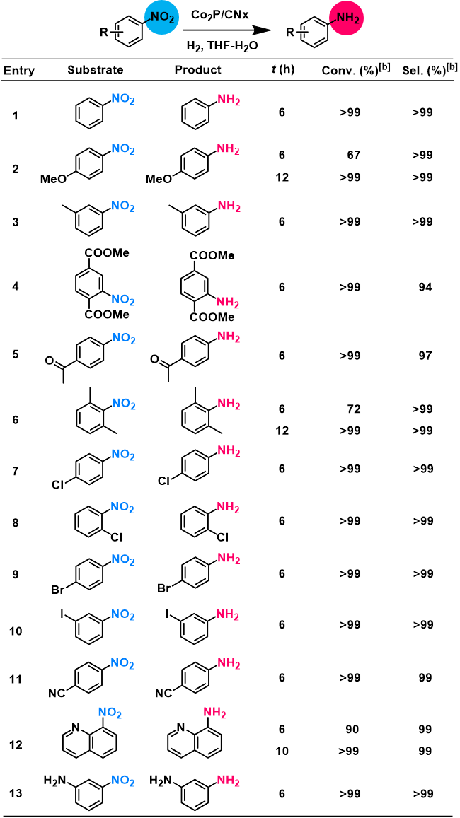
[a] Unless otherwise mentioned, reaction conditions: subtrate (0.5 mmol), Co₂P@CN_{x} (10 mg), solvent (4 mL, V_{H2O}:V_{THF} = 1:1), 5.0 MPa H₂, 60 ºC, 6 h. [b] Determined by GC using mesitylene as internal standard.
In addition to facile separation from products, heterogeneous catalysts, must offer stability and recyclability to achieve a true cost advantage over their homogeneous counterparts. To explore these characteristics, nitrobenzene was chosen as the model substrate and the reaction time was shortened from 6 h to 1 h to test the stability. It was found that there is slight activity loss between cycle 1 and 5 (Figure S12). While ICP-OES analysis showed a slight decrease in the Co content in Co₂P@CN_{x} from 33.40 wt% in the original sample to 29.47 wt% after cycle 5, the XRD pattern of the recovered catalyst did not change when compared to that of the fresh one (Figure S13). Furthermore, the morphology was well maintained after 5 runs from the TEM and SEM images (Figure S12). XPS analysis also confirms that the nature of the Co, P, N, O, and C species didn’t change with cycling (Figure S14). Thus, the slight activity loss is attributed to a small amount of cobalt leaching during the reaction process and also an unavoidable sample loss during the recycle procedures.
In summary, this work reveals that a novel Co₂P@CN_{x} composite can be easily prepared using red-phosphorous infused ZIF-67 nanocubes as precursors. To date, many reports are focused on developing new methods for the preparation of cobalt phosphide-based materials, due to their strong applicability in electrocatalysis. As such, this discovery provides a new, interesting platform for the development of nano-structured Co₂P. Additionally, the newly formed composite is shown to have excellent activity, selectivity, stability, and recyclability for the thermally driven hydrogenation of a variety of nitroarenes to aniline and its derivatives. Given the newly demonstrated catalytic activity combined with high efficiency, the work presented here unveils the potential applicability of cobalt phosphide-based materials in a variety of other traditional catalytic processes.
Acknowledgements
This work was supported by the Swiss National Science Foundation under grant PYAPP2_160581. M.A. is financially supported by the Swiss Commission for Technology and Innovation (CTI). O.T. is financially supported by the National Center for Competence in Research (NCCR) “Materials' Revolution: Computational Design and Discovery of Novel Materials (MARVEL)” of the Swiss National Science Foundation (SNSF) and EPFL Fellows co-funded by Marie Skłodowska-Curie. The authors thank Dr. Pascal Schouwink and Dr. Natalia Gasilova for help with XRD and MS analysis, respectively.
Keywords: metal-organic framework • cobalt phosphide • non-noble metal • heterogeneous catalysis • nitroarene hydrogenation
[1] a) H. Furukawa, K. E. Cordova, M. O'Keeffe, O. M. Yaghi, Science 2013, 341, 1230444-1230444; b) S. Kitagawa, R. Kitaura, S.-i. Noro, Angew. Chem. Int. Ed. 2004, 43, 2334-2375; c) D. J. Xiao, E. D. Bloch, J. A. Mason, W. L. Queen, M. R. Hudson, N. Planas, J. Borycz, A. L. Dzubak, P. Verma, K. Lee, F. Bonino, V. Crocellà, J. Yano, S. Bordiga, D. G. Truhlar, L. Gagliardi, C. M. Brown, J. R. Long, Nat. Chem. 2014, 6, 590-595; d) J. E. Mondloch, M. J. Katz, W. C. Isley Iii, P. Ghosh, P. Liao, W. Bury, G. W. Wagner, M. G. Hall, J. B. DeCoste, G. W. Peterson, R. Q. Snurr, C. J. Cramer, J. T. Hupp, O. K. Farha, Nat. Mater. 2015, 14, 512-516; e) D. Feng, K. Wang, J. Su, T.-F. Liu, J. Park, Z. Wei, M. Bosch, A. Yakovenko, X. Zou, H.-C. Zhou, Angew. Chem. Int. Ed. 2014, 54, 149-154; f) C. Wang, Z. Xie, K. E. deKrafft, W. Lin, J. Am. Chem. Soc. 2011, 133, 13445-13454; f) G. Férey, C. Serre, C. Mellot-Draznieks, F. Millange, S. Surblé, J. Dutour, I. Margiolaki, Angew. Chem. Int. Ed. 2004, 43, 6296-6301.
[2] a) J. Lee, O. K. Farha, J. Roberts, K. A. Scheidt, S. T. Nguyen, J. T. Hupp, Chem. Soc. Rev. 2009, 38, 1450-1459; b) J. Yang, F. Zhang, H. Lu, X. Hong, H. Jiang, Y. Wu, Y. Li, Angew. Chem. Int. Ed. 2015, 54, 10889-10893; c) L. Peng, J. Zhang, Z. Xue, B. Han, X. Sang, C. Liu, G. Yang, Nat. Commun. 2014, 5, 5465; d) Y. Liu, J. H. Pan, N. Wang, F. Steinbach, X. Liu, J. Caro, Angew. Chem. Int. Ed. 2015, 54, 3028-3032; e) W.-w. Zhan, Q. Kuang, J.-z. Zhou, X.-j. Kong, Z.-x. Xie, L.-s. Zheng, J. Am. Chem. Soc. 2013, 135, 1926-1933; f) Q.-L. Zhu, J. Li, Q. Xu, J. Am. Chem. Soc. 2013, 135, 10210-10213; g) M. H. Beyzavi, R. C. Klet, S. Tussupbayev, J. Borycz, N. A. Vermeulen, C. J. Cramer, J. F. Stoddart, J. T. Hupp, O. K. Farha, J. Am. Chem. Soc. 2014, 136, 15861-15864. h) X. Kang, Q. Zhu, X. Sun, J. Hu, J. Zhang, Z. Liu, B. Han, Chem. Sci. 2016, 7, 266-273.
[3] L. Peng, M. Asgari, P. Mieville, P. Schouwink, S. Bulut, D. T. Sun, Z. Zhou, P. Pattison, W. van Beek, W. L. Queen, ACS Appl. Mater. Interfaces 2017, 9, 23957-23966.
[4] a) L. Chen, H. Chen, R. Luque, Y. Li, Chem. Sci. 2014, 5, 3708-3714; b) K. Shen, X. Chen, J. Chen, Y. Li, ACS Catal. 2016, 6, 5887-5903.
[5] P. Yin, T. Yao, Y. Wu, L. Zheng, Y. Lin, W. Liu, H. Ju, J. Zhu, X. Hong, Z. Deng, G. Zhou, S. Wei, Y. Li, Angew. Chem. Int. Ed. 2016, 55, 10800-10805.
[6] R. V. Jagadeesh, K. Murugesan, A. S. Alshammari, H. Neumann, M.-M. Pohl, J. Radnik, M. Beller, Science 2017, DOI: 10.1126/science.aan6245.
[7] a) M. Liu, J. Li, ACS Appl. Mater. Interfaces 2016, 8, 2158-2165; b) S. Zheng, X. Li, B. Yan, Q. Hu, Y. Xu, X. Xiao, H. Xue, H. Pang, Adv. Energy Mater. 2017, 7, 1602733.
[8] a) Q. Liu, J. Tian, W. Cui, P. Jiang, N. Cheng, A. M. Asiri, X. Sun, Angew. Chem. Int. Ed. 2014, 53, 6710-6714; b) J. Tian, N. Cheng, Q. Liu, W. Xing, X. Sun, Angew. Chem. Int. Ed. 2015, 54, 5493-5497.
[9] a) B. Sahoo, D. Formenti, C. Topf, S. Bachmann, M. Scalone, K. Junge, M. Beller, ChemSusChem 2017, 10, 3035-3039; b) R. V. Jagadeesh, A. E. Surkus, H. Junge, M. M. Pohl, J. Radnik, J. Rabeah, H. Huan, V. Schunemann, A. Bruckner, M. Beller, Science 2013, 342, 1073-1076; c) P. Zhou, L. Jiang, F. Wang, K. Deng, K. Lv, Z. Zhang, Sci. Adv. 2017, 3, e1601945.
[10] a) S. Gao, M. Cao, W. Li, R. Cao, J. Mater. Chem. A 2014, 2, 12185-12193; b) F. Zhang, J. Jin, X. Zhong, S. Li, J. Niu, R. Li, J. Ma, Green Chem. 2011, 13, 1238-1243; c) S. S. Lee, S. N. Riduan, N. Erathodiyil, J. Lim, J. L. Cheong, J. Cha, Y. Han, J. Y. Ying, Chem. Eur. J. 2012, 18, 7394-7403.
[11] a) H. Hu, Bu Y. Guan, X. W. Lou, Chem 2016, 1, 102-113; b) Y. Pan, D. Heryadi, F. Zhou, L. Zhao, G. Lestari, H. Su, Z. Lai, CrystEngComm 2011, 13, 6937-6940.
[12] a) Y. Shi, B. Zhang, Chem. Soc. Rev. 2016, 45, 1529-1541; b) C. Qian, F. Kim, L. Ma, F. Tsui, P. Yang, J. Liu, J. Am. Chem. Soc. 2004, 126, 1195-1198; c) J. Park, B. Koo, Y. Hwang, C. Bae, K. An, J.-G. Park, H. M. Park, T. Hyeon, Angew. Chem. Int. Ed. 2004, 43, 2282-2285.
[13] Y. V. Kaneti, S. Dutta, M. S. A. Hossain, M. J. A. Shiddiky, K.-L. Tung, F.-K. Shieh, C.-K. Tsung, K. C. W. Wu, Y. Yamauchi, Adv. Mater. 2017, 29, 1700213.
[14] J. Song, C. Zhu, B. Z. Xu, S. Fu, M. H. Engelhard, R. Ye, D. Du, S. P. Beckman, Y. Lin, Adv. Energy Mater. 2017, 7, 1601555.
[15] a) M. Pramanik, S. Tominaka, Z.-L. Wang, T. Takei, Y. Yamauchi, Angew. Chem. Int. Ed. 2017, 56, 13508-13512; b) K. Cao, L. Jiao, Y. Liu, H. Liu, Y. Wang, H. Yuan, Adv. Funct. Mater. 2015, 25, 1082-1089.
[16] H. Wang, W. Wang, Y. Y. Xu, M. Asif, H. Liu, B. Y. Xia, J. Mater. Chem. A 2017, 5, 17563-17569.
[17] a) S. Cobo, J. Heidkamp, P.-A. Jacques, J. Fize, V. Fourmond, L. Guetaz, B. Jousselme, V. Ivanova, H. Dau, S. Palacin, M. Fontecave, V. Artero, Nat. Mater. 2012, 11, 802-807; b) Z. Huang, Z. Chen, Z. Chen, C. Lv, M. G. Humphrey, C. Zhang, Nano Energy 2014, 9, 373-382.
[18] a) F. A. Westerhaus, R. V. Jagadeesh, G. Wienhöfer, M.-M. Pohl, J. Radnik, A.-E. Surkus, J. Rabeah, K. Junge, H. Junge, M. Nielsen, A. Brückner, M. Beller, Nat. Chem. 2013, 5, 537-543; b) P. Zhou, Z. Zhang, ChemSusChem 2017, 10, 1892-1897; c) R. Wu, D. P. Wang, K. Zhou, N. Srikanth, J. Wei, Z. Chen, J. Mater. Chem. A 2016, 4, 13742-13745; d) Y.-X. Zhou, Y.-Z. Chen, L. Cao, J. Lu, H.-L. Jiang, Chem. Commun. 2015, 51, 8292-8295; e) P. He, X.-Y. Yu, X. W. Lou, Angew. Chem. Int. Ed. 2017, 56, 3897-3900; f) Z. Li, A. W. Peters, V. Bernales, M. A. Ortuño, N. M. Schweitzer, M. R. DeStefano, L. C. Gallington, A. E. Platero-Prats, K. W. Chapman, C. J. Cramer, L. Gagliardi, J. T. Hupp, O. K. Farha, ACS Cent. Sci. 2017, 3, 31-38; g) B. Sahoo, A.-E. Surkus, M.-M. Pohl, J. Radnik, M. Schneider, S. Bachmann, M. Scalone, K. Junge, M. Beller, Angew. Chem. Int. Ed. 2017, 56, 11242-11247.
[19] a) H. Yang, T. Zhou, W. Zhang, Angew. Chem. Int. Ed. 2013, 52, 7455-7459; b) E. M. Zahran, N. M. Bedford, M. A. Nguyen, Y.-J. Chang, B. S. Guiton, R. R. Naik, L. G. Bachas, M. R. Knecht, J. Am. Chem. Soc. 2014, 136, 32-35.
[20] a) T. Schulz, C. Torborg, B. Schäffner, J. Huang, A. Zapf, R. Kadyrov, A. Börner, M. Beller, Angew. Chem. Int. Ed. 2009, 48, 918-921; b) S. Yang, C. Cao, L. Peng, J. Zhang, B. Han, W. Song, Chem. Commun. 2016, 52, 3627-3630; c) H. Lindlar, R. Dubuis, Org. Synth. 1966, 46, 89; d) Y. Yabe, T. Yamada, S. Nagata, Y. Sawama, Y. Monguchi, H. Sajiki, Adv. Synth. Catal. 2012, 354, 1264-1268; e) K. R. Campos, D. Cai, M. Journet, J. J. Kowal, R. D. Larsen, P. J. Reider, J. Org. Chem. 2001, 66, 3634-3635.

COMMUNICATION
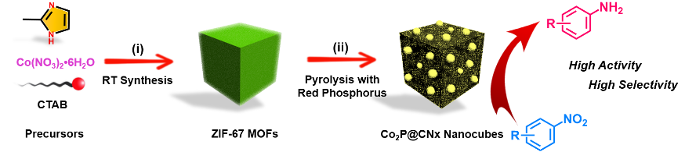  A novel Co₂P@CN_{x} composite can be easily prepared using red-phosphorous infused ZIF-67 nanocubes as precursors. For the first time, the newly formed cobalt phosphide composite is shown to have excellent activity, selectivity, stability, and recyclability for the thermally driven hydrogenation of a variety of nitroarenes to anilines. |  | Shuliang Yang, Li Peng, Emad Oveisi, Safak Bulut, Daniel T. Sun, Mehrdad Asgari, Olga Trukhina, and Wendy L. Queen*  Page No. – Page No.  MOF-derived cobalt phosphide/carbon nanocubes for selective hydrogenation of nitroarenes to anilines

