Supporting Information

Direct electrochemical cycling
Polyaniline supported on carbon paper (PANI/CP) was electrochemically cycled with different oxidation potentials to determine the onset potential for oxidative degradation. Specifically, the PANI/CP was oxidized at various potentials from 0.600 V to 0.8 V vs Ag/AgCl (0.050 V steps), always followed by a reduction at 0.400 V vs Ag/AgCl. Oxidative degradation results in an irreversible charge transfer during oxidation, which in turn should lower the coulombic efficiency for each cycle. The coulombic efficiency for different oxidation potentials is plotted in Figure S 1 below:
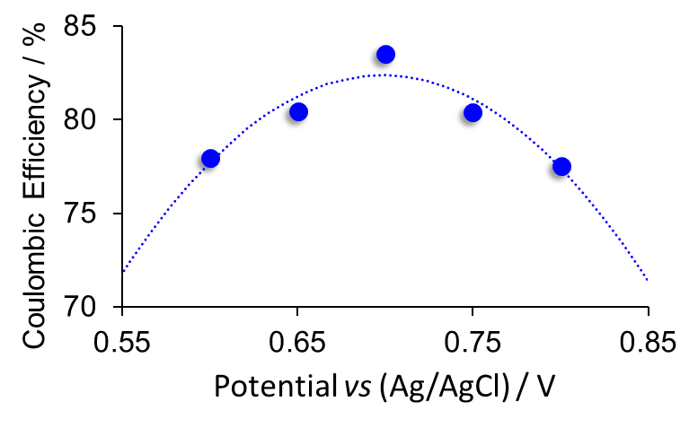
Figure S 1. Coulombic efficiency as a function of oxidation potential for PANI/CP.
The gradual decrease of coulombic efficiency after ca. 0.700 V vs Ag/AgCl indicates the onset of oxidative degradation. This is consistent with CV results presented in Figure 3 of the manuscript.
Also presented here is a typical potentiostatic cycle for PANI in the chosen potential ranges for Fe(III/II) and V(IV/III). This data is equivalent to Figure 4 in the manuscript, but is plotted as I vs t for clarity.
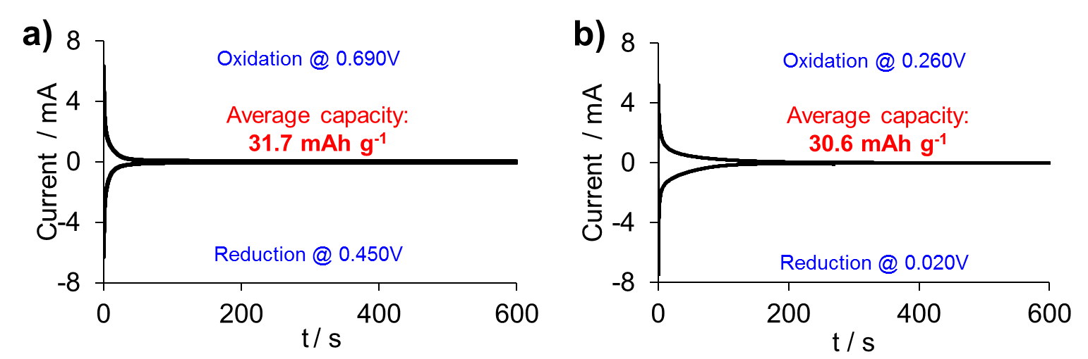
Figure S 2. Potentiostatic cycling of PANI in 1 M HCl, in the potential range corresponding to a) Fe(III/II) and b) V(IV/III).

Indirect chemical cycling – V(IV/III)
Polyaniline supported on carbon paper (PANI/CP) was indirectly chemically cycled in solutions of V³⁺ and VO²⁺, as described in the manuscript. The specific capacity over 25 cycles is plotted in Figure S 1 below:
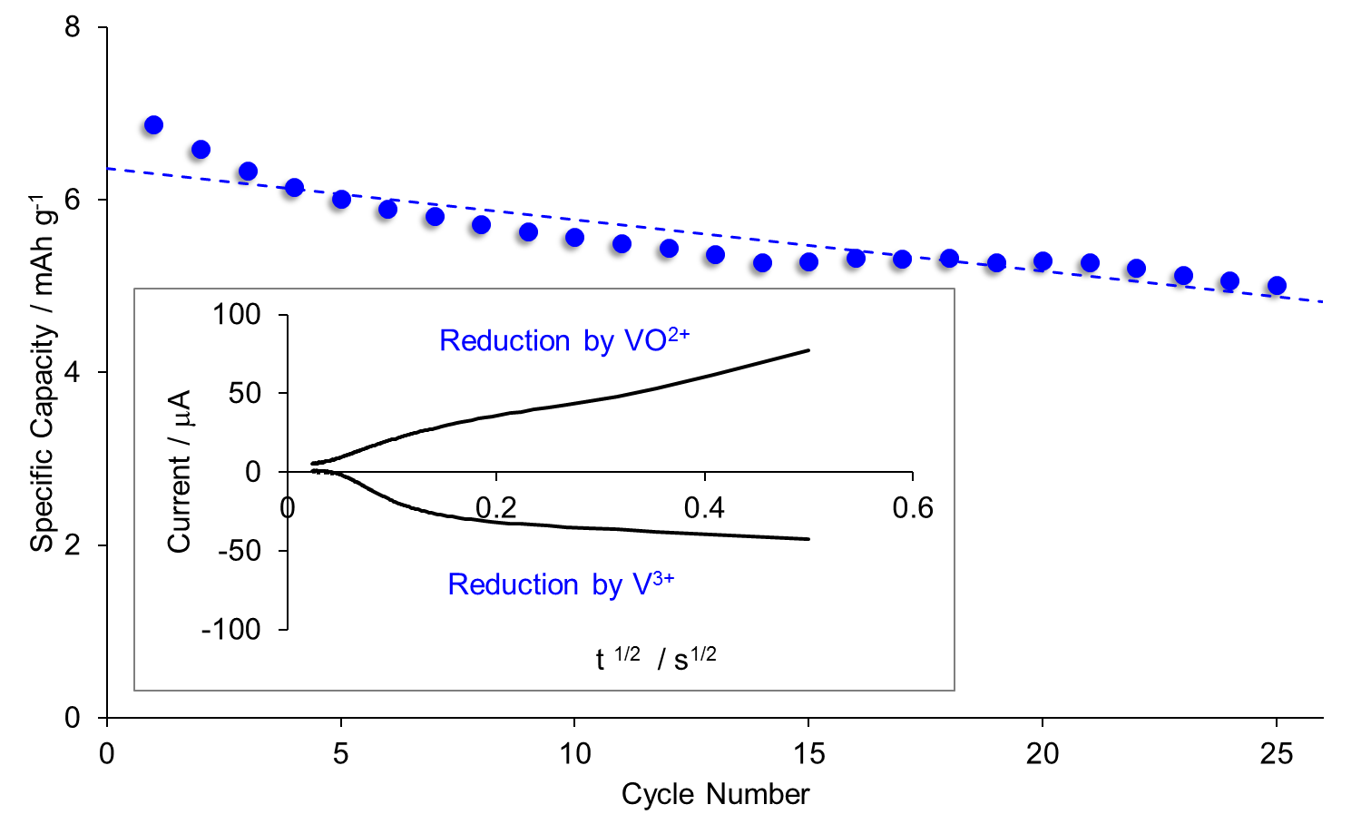
Figure S 3. Specific capacity and coulombic efficiency for 25 cycles. The inset depicts a Cottrell plot for a typical cycle.
The relatively low specific capacity is attributed to the relatively poor kinetics of the V(IV/III) couple. Several attempts were made to mitigate the effect of kinetics by increasing the surface area at the counter electrode. The data shown are the highest values, which were obtained using an 8 cm² carbon felt counter electrode.

Flow cell test – negative V(IV/III) electrode
During cycling, the potential of the negative electrode was also measured. The results are shown in Figure S 2 below.
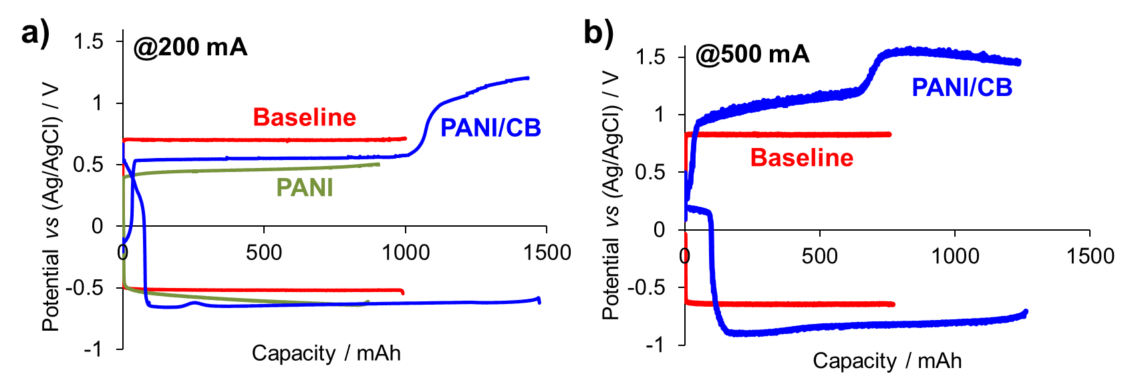
Figure S 4. Potential of the negative (V(IV/III) electrode of a redox flow battery cycling at a) 200 mA and b) 500 mA with PANI and PANI/CB added to the electrolyte tanks. The ‘baseline’ corresponds to cycling of only the electrolyte. Note: the battery containing PANI was not cycled at 500 mA, due to it’s poor performance at 200 mA.
The kinetic limitations of the V(IV/III) couple are evident from the large overpotentials present, even in the baseline data. Adding PANI/CB to the electrolyte tanks appears to provide some ‘buffering’ effect during oxidation (discharging). Nonetheless, the overpotentials observed are much too large for this redox mediator to be used in a practical battery.

Cost estimation for PANI/CB
A simplified cost estimate was performed for PANI/CB. The prices for the reagents were obtained from advertisements on Alibaba.com (accessed 21 December, 2016), assuming all reagents will be purchased in multi-ton quantities. The prices used are as follows: Aniline – 1.08 USD/kg; Carbon black – 2 USD/kg; Ammonium Persulfate – 1 USD/kg. Based on these prices, the material cost to synthesize 1 kg of PANI/CB 3.23 USD/kg. From our experimental work, we measured a specific capacity of 48.6 Ah/kg for PANI/CB, yielding a price of 0.066 USD/Ah. If we assume that the final flow battery has a nominal cell voltage of 1V, then the ‘capacity cost’ for the positive active material would be 66 USD/kWh. Note that this simplified cost estimate represents only the material cost for PANI/CB, and excludes costs for: manufacturing electrolyte, cell stacks, tanks, ancillary equipment, etc.

