

***Figure S1 – Summary of the UV-C photolysis experiments for the two different energy output systems. Absorbance spectra changes during the UV exposure.***





***Figure S2 – UV/H2O2 Advanced Oxidation of Venlafaxine: global analyses. a) COD removal, TOC reduction (red traces and axis) and H2O2 consumption (blue trace and axis) with addition of 50 mg/L H2O2. b) Absorbance changes during UV/H2O2 treatment (50 mg/L H2O2).***

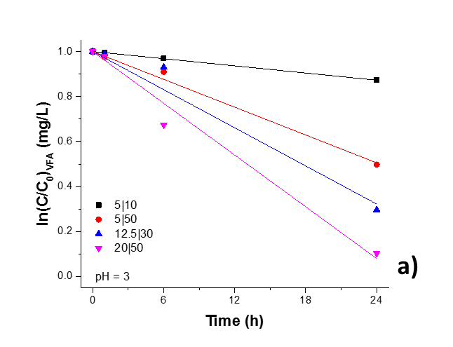

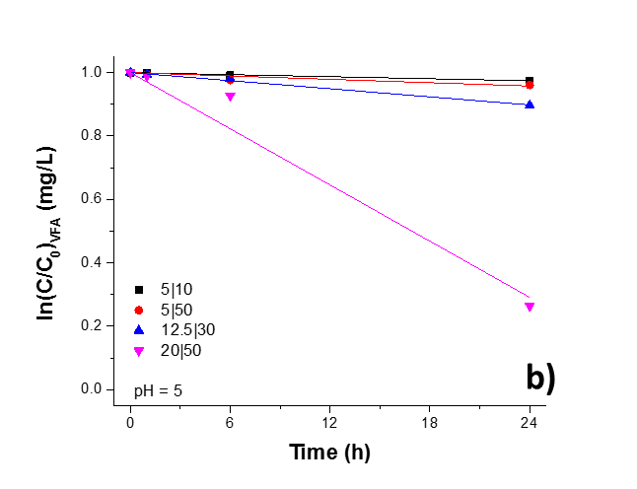

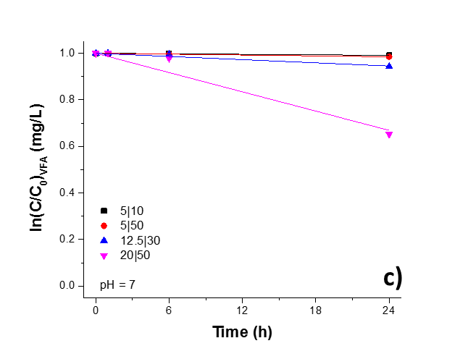

***Figure S3 – Treatment of Venlafaxine by the Fenton process in the dark. a) VFA degradation at pH=3 and varied Fe|H2O2 ratio. b) VFA degradation at pH=5 and varied Fe|H2O2 ratio. c) VFA degradation at pH=7 and varied Fe|H2O2 ratio***

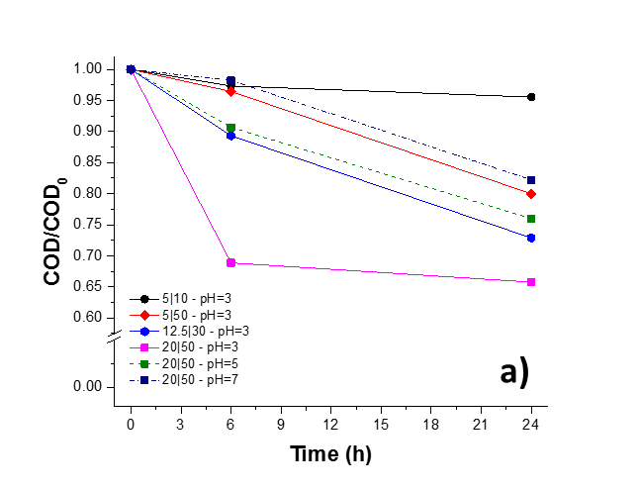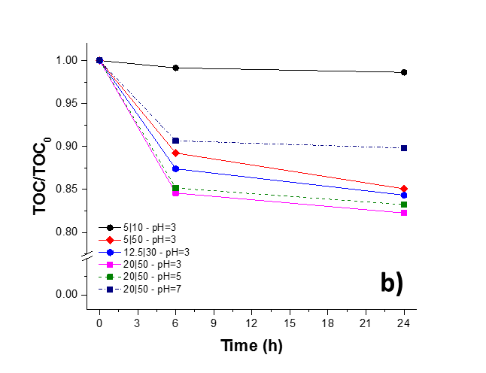

***Figure S4 – Treatment of Venlafaxine by the Fenton process in the dark. a) COD reduction by the Fenton process in by the various Fe|H2O2 ratios at pH=3 and increasing pH for 20|50 ratio. b) TOC removal by the Fenton process in by the various Fe|H2O2 ratios at pH=3 and increasing pH for 20|50 ratio.***

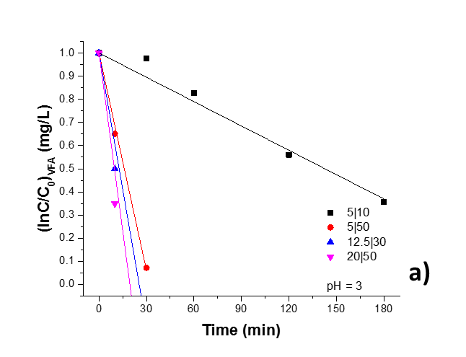

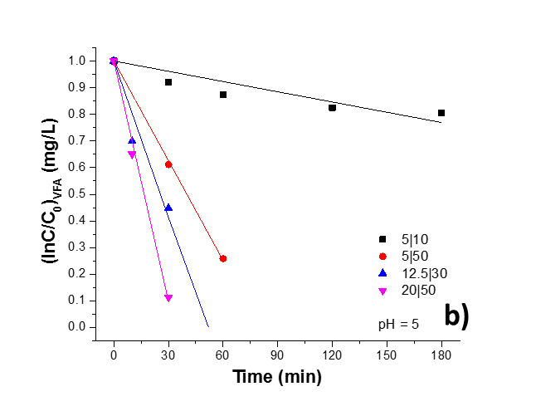

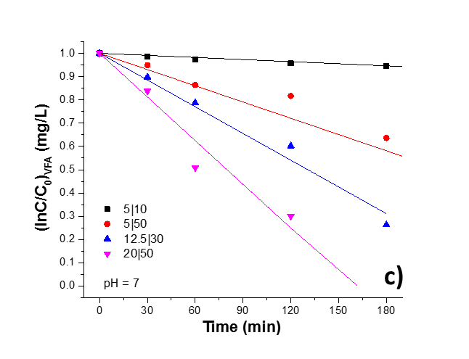

***Figure S5 - Treatment of Venlafaxine by the photo-Fenton process (irradiance: 900 W/m2). a) VFA degradation at pH=3 and varied Fe|H2O2 ratio. b) VFA degradation at pH=5 and varied Fe|H2O2 ratio. c) VFA degradation at pH=7 and varied Fe|H2O2 ratio.***

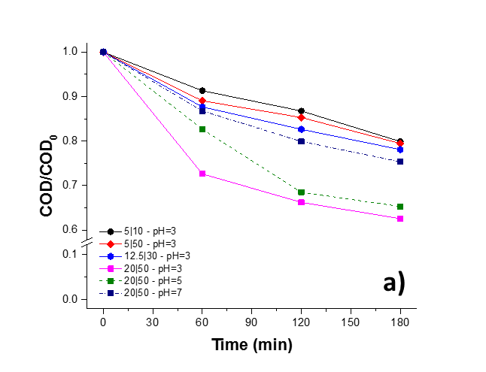

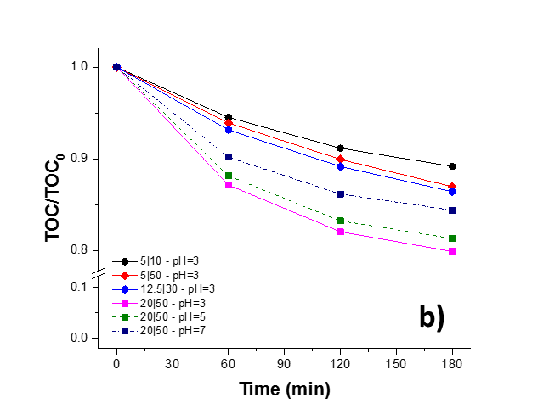

***Figure S6 - Treatment of Venlafaxine by the photo-Fenton process (irradiance: 900 W/m2). a) COD reduction by the photo-Fenton process by the various Fe|H2O2 ratios at pH=3 and increasing pH for 20|50 ratio. b) TOC removal by the photo-Fenton process by the various Fe|H2O2 ratios at pH=3 and increasing pH for 20|50 ratio.***

***Supplementary Tables***

***Table S1 – H2O2 evolution during the Fenton and photo-Fenton experiments in MQ water***

|  |  |  |  |  |  |
| --- | --- | --- | --- | --- | --- |
| **Fenton** | | | **photo-Fenton** | | |
| *pH= 3* |  |  | *pH= 3* |  |  |
| **Sample ID** | **initial [H2O2]** | **H2O2 consumption in 24 hours [ppm]** | **Sample ID** | **initial [H2O2]** | **H2O2 consumption during the experiment [ppm]** |
| 5|10 | 10 | 4.83 | 5|10 | 10 | 5.32 |
| 5|50 | 50 | 40.74 | 5|50 | 50 | 48.15 |
| 20|50 | 50 | 28.34 | 20|50 | 50 | 37.27 |
| 12.5|58.3 | 58.3 | 48.3 | 12.5|58.3 | 58.3 | 54.13 |
| 12.5|30 | 30 | 23.62 | 12.5|30 | 30 | 23.24 |
|  |  |  |  |  |  |
| *pH= 5* |  |  | *pH= 5* |  |  |
| **Sample ID** | **[H2O2]** | **H2O2 consumption in 24 hours [ppm]** | **Sample ID** | **[H2O2]** | **H2O2 consumption during the experiment [ppm]** |
| 5|10 | 10 | 1.28 | 5|10 | 10 | 6.5 |
| 5|50 | 50 | 15.11 | 5|50 | 50 | 45.25 |
| 20|50 | 50 | 21.27 | 20|50 | 50 | 39.97 |
| 12.5|58.3 | 58.3 | 26.24 | 12.5|58.3 | 58.3 | 49.26 |
| 12.5|30 | 30 | 6.44 | 12.5|30 | 30 | 20.79 |
|  |  |  |  |  |  |
| *pH= 7* |  |  | *pH= 7* |  |  |
| **Sample ID** | **[H2O2]** | **H2O2 consumption in 24 hours [ppm]** | **Sample ID** | **[H2O2]** | **H2O2 consumption during the experiment [ppm]** |
| 5|10 | 10 | 0.39408867 | 5|10 | 10 | 6.3 |
| 5|50 | 50 | 11.5 | 5|50 | 50 | 33.9 |
| 20|50 | 50 | 14.02 | 20|50 | 50 | 26.3 |
| 12.5|58.3 | 58.3 | 17.94 | 12.5|58.3 | 58.3 | 35.55 |
| 12.5|30 | 30 | 4.14 | 12.5|30 | 30 | 20.9 |

***Table S2 – Basic physicochemical characteristics of the used effluents in the study.***

|  |  |  |  |  |
| --- | --- | --- | --- | --- |
| Parameter | Unit | Wastewater previously treated with | | |
|  |  | *Activated* | *Moving Bed* | *Coagulation* |
|  |  | *Sludge* | *Bioreactor* | *Flocculation* |
| pH | *-* | 7.3-7.8 | 6.6-7.4 | 7.3-7.9 |
| TOC | *mg/L* | 28.08±12.62 | 14.615±7.9 | 68.47±15.94 |
| COD | *mg/L* | 51±10 | 20±11 | 85±5 |
| Alkalinity | *mg CaCO3/L* | 230±35 | 95±10 | 240±10 |
| TSS | *mg/L* | 12.1±2.8 | 14.2±1.4 | 28.5±5.7 |
| Total iron | *mg Fe/L* | 0.95±0.05 | 1.75±0.15 | 5.5±1 |

***Table S3 – Basic average physicochemical characteristics of the used urine in the study.***

|  |  |  |
| --- | --- | --- |
| ***Parameter*** | ***Value*** | ***unit*** |
| ***TDS*** | ***60*** | ***g/L*** |
| ***pH*** | ***6.5*** |  |
| ***COD*** | ***8.3*** | ***g/L*** |
| ***TOC*** | ***5*** | ***g/L*** |

***Table S4 - Mass spectrum characteristics of Venlafaxine's products identified in degradation studies***

|  |  |  |  |  |  |  |  |
| --- | --- | --- | --- | --- | --- | --- | --- |
| **No** | **Product** | **Treatment** | **Formula** | **m/z experimental** | **m/z theoretical** | **ppma** | **DBEb** |
| 1 | P6 | *Solar* | C17H25NO | 260.2016 | 260.2009 | 2.69 | 5.5 |
|  |  |  |  |  |  |  |  |
| 1 | P3 | *UV* | C11H15NO2 | 194.1179 | 194.1175 | 2.06 | 4.5 |
| 2 | P5 | *UV* | C12H20O4 | 229.1429 | 229.1434 | 2.18 | 2.5 |
| 3 | P6 | *UV* | C17H25NO | 260.2012 | 260.2009 | 1.15 | 5.5 |
| 4 | P8 | *UV* | C17H27NO3 | 294.2057 | 294.2064 | 2.38 | 4.5 |
| 5 | P9 | *UV* | C17H27NO4 | 310.2021 | 310.2013 | 2.58 | 4.5 |
| 6 | P10 | *UV* | C17H27NO5 | 326.1956 | 326.1962 | 1.84 | 4.5 |
|  |  |  |  |  |  |  |  |
| 1 | P1 | *UV/H2O2* | C8H8O | 121.0652 | 121.0648 | 3.30 | 4.5 |
| 2 | P4 | *UV/H2O2* | C15H18O | 215.1431 | 215.1430 | 0.46 | 6.5 |
| 3 | P6 | *UV/H2O2* | C17H25NO | 260.2017 | 260.2009 | 3.07 | 5.5 |
| 4 | P8 | *UV/H2O2* | C17H27NO3 | 294.2072 | 294.2064 | 2.72 | 4.5 |
| 5 | P9 | *UV/H2O2* | C17H27NO4 | 310.202 | 310.2013 | 2.26 | 4.5 |
|  |  |  |  |  |  |  |  |
| 1 | P1 | *Fenton* | C8H8O | 121.0653 | 121.0648 | 4.13 | 4.5 |
| 2 | P2 | *Fenton* | C11H15NO | 178.1231 | 178.1226 | 2.81 | 4.5 |
| 3 | P3 | *Fenton* | C11H15NO2 | 194.1181 | 194.1175 | 3.09 | 4.5 |
| 4 | P4 | *Fenton* | C15H18O | 215.1433 | 215.1430 | 1.39 | 6.5 |
| 5 | P6 | *Fenton* | C17H25NO | 260.2017 | 260.2009 | 3.07 | 5.5 |
| 6 | P7 | *Fenton* | C17H25NO3 | 292.1914 | 292.1907 | 2.40 | 5.5 |
| 7 | P8 | *Fenton* | C17H27NO3 | 294.2070 | 294.2064 | 2.04 | 4.5 |
|  |  |  |  |  |  |  |  |
| 1 | P1 | *Photo-Fenton* | C8H8O | 121.0654 | 121.0648 | 4.96 | 4.5 |
| 2 | P2 | *Photo-Fenton* | C11H15NO | 178.1231 | 178.1226 | 2.81 | 4.5 |
| 3 | P3 | *Photo-Fenton* | C11H15NO2 | 194.1182 | 194.1175 | 3.61 | 4.5 |
| 4 | P4 | *Photo-Fenton* | C15H18O | 215.1434 | 215.1430 | 1.86 | 6.5 |
| 5 | P6 | *Photo-Fenton* | C17H25NO | 260.2018 | 260.2009 | 3.46 | 5.5 |
| 6 | P8 | *Photo-Fenton* | C17H27NO3 | 294.2071 | 294.2064 | 2.38 | 4.5 |
| 7 | P9 | *Photo-Fenton* | C17H27NO4 | 310.2017 | 310.2013 | 1.29 | 4.5 |
|  |  |  |  |  |  |  |  |
| **appm - mass accuracy in ppm** | | |  |  |  |  |  |
|  |  |  |  |  |  |  |  |
| **bDBE - Double Bond Equivalent** | | |  |  |  |  |  |