Proceeding Paper

The influence of weld geometry on plastic strain history in cyclic loading – a parametric study

Albano de Castro e Sousa*, Alain Nussbaumer

^{1), 2)} Steel Structures Laboratory (ICOM), École Polytechnique Fédérale de Lausanne (EPFL), 1015 Lausanne, Switzerland
¹⁾albano.sousa@epfl.ch

ABSTRACT

The loss of material ductility in the presence of very high amplitude cyclic straining is an observed phenomenon in many extreme conditions like earthquake loadings. This phenomenon is called ultra-low cycle fatigue (ULCF) and failure is often achieved in a few number of cycles – around 5 to 10. Design to ULCF often involves the use of finite element (FE) models to assess the plastic strain history at critical points in a component. In the case of a welded joint, a number of factors contribute to its ultimate cyclic fracture strain, such as the weld and heat affected zone’s (HAZ) material characteristics, and the weld geometry, which cause a local rise in plastic strains at the weld toe.
The purpose of the paper is to study the influence of the weld geometry on the plastic strain history of material points near the weld toe, through an FE parametric analysis with nonlinear kinematic hardening. The motivation behind this study stems from a set of experiments conducted on high-strength S770QL steel, whose material properties will be used in this paper. The joint that will be analyzed consists of a welded tube to plate connection. Here 3 geometric parameters will be studied: throat thickness (a – 4, 6, 8 and 10mm, on a 8 mm thick tube wall), weld angle (Θ – 30°, 45° and 60°), and weld toe radius (R – 0, 1 and 2 mm). In addition to these factors, the impact of the type of loading (L – bending, pure torsion and combined proportional bending and torsion during 5 high amplitude cycles) and mesh size (M – 1.0 and 0.5 mm) will also be addressed. As a simplification, the weld material and heat affected zone have the same mechanical properties as the base material.
Stress state variables important in ULCF analyses, such as the stress triaxiality and the Lode parameter, are analyzed in addition to the plastic strain history.

- INTRODUCTION

Research into ultra-low cycle fatigue (ULCF) is currently a subject of increasing study in the academic community. The fundamental interest in this field is to develop tools for more accurate predictions of failure in structural components subjected to high cyclic strains in such loadings cases as earthquakes, exceptional wind gusts or tides.
Micromechanical models are often employed in ULCF for the reason that they offer a physical understanding to the damage process involved in ductile fracture initiation by modelling void growth to coalescence. The works of (Gurson 1975; Hancock and Mackenzie 1976; McClintock 1968; Rice and Tracey 1969) have strongly influenced the field and show that one of the fundamental variables governing the growth of voids is the stress state to which they are subjected to - namely the stress triaxiality. The stress triaxiality is defined as the ratio between the hydrostatic and the von Mises stress, which can be seen as a measure of the ratio between the hydrostatic and deviatoric components of the stress tensor – Eq.(1).

$T={σ_{h}}/{σ_{vm}}$ (1)

The models that are most used in UCLF stem from the work of Rice and Tracey, in which the growth rate of spherical void with radius R in an elastic perfectly plastic medium is expressed in terms of the stress triaxiality and an increment in equivalent plastic strain – ${dε}_{eq}^{p}$ cf. Eq.(3).
$\frac{dR}{R}=0.283\exp\left(1.5T\right){dε}_{eq}^{p}$ (2)

${dε}_{eq}^{p}=\sqrt{\frac{2}{3}{dε}_{ij}^{p}{dε}_{ij}^{p}}$ (3)

Integrating Eq.(2) up to the point where monotonic fracture occurs yields the so-called void growth model (VGM) given in terms of the monotonic fracture void growth index (VGI) $η_{mon}^{f}$ by Eq.(4).

$η_{mon}^{f}=\int_{0}^{ε_{eq}^{p,f}}{\exp\left(1.5T\right){dε}_{eq}^{p}}$ (4)

For cyclic loading in the ULCF domain, (Kanvinde and Deierlein 2004) have proposed to reduce the resistance of the monotonic fracture VGI as a function of a damage variable D.

$η_{cyclic}^{f}=f\left(D\right)η_{mon}^{f} ; f\left(D\right)=exp⁡(-λD)$ (5)

Several measures of damage of been proposed (Kanvinde et al. 2007; Myers, Deierlein, and Kanvinde 2009) but all depend chiefly on the total equivalent plastic strain.
On the demand side the VGI is defined as,

$η_{cyclic}^{}=\sum_{T>0}{\int_{ε_{eq}^{p,initial}}^{ε_{eq}^{p,final}}{\exp\left|1.5T\right|{dε}_{eq}^{p}}}-\sum_{T<0}{\int_{ε_{eq}^{p,initial}}^{ε_{eq}^{p,final}}{\exp\left|1.5T\right|{dε}_{eq}^{p}}}$ (6)

Eq.(6) coupled with Eq.(5) constitute the cyclic void growth model (CVGM). Failure is said to occur when $η_{cyclic}^{}≤η_{cyclic}^{f}$ over a characteristic length designated l*. For structural steel l* assumes values between 0.05-0.5mm (Kanvinde et al. 2007)
There is a known limitation in the application of the VGM in general stress states, i.e. for cases involving low triaxialities and non-axisymmetric conditions simply because the mechanisms involved in the coalescence of voids are different for stress state conditions. Here another measure of the stress state is often used to have it fully characterized (Nahshon and Hutchinson 2008; Tekoğlu, Hutchinson, and Pardoen 2015) like the Lode parameter – Eq. (7).

$L=\frac{2σ_{2}-σ_{1}-σ_{3}}{σ_{1}-σ_{3}}$ (7)

where $σ_{1},σ_{2}$ and $σ_{3}$ are respectively the maximum, middle and minimum principal stresses.
There have been recent attempts to address the deficiencies in the applicability of the CVGM with the Stress-Weighted Damage Model (SWDM) - (Smith, Deierlein, and Kanvinde 2014) which make use of the Lode parameter.
Applying such models to welded structural components presents itself with two distinct challenges: 1 -inhomogeneity of the material, due to microstructural differences in the weld, heat affected zone and base materials; 2 - weld toe geometry, which can vary significantly depending on the type of specified detail, welding process/ electrode type, welding position (flat, vertical overhead, etc.) and even among different welders. This paper aims to evaluate the sensitivity of these types of models to different weld geometries in a particular tube-to-plate connection.
To achieve this goal, a finite element (FE) parametric study will be presented in which the main variables after the same cyclic loading are compared to different weld geometries of a welded tube to plate connection. The choice of this type of connection stems from an experimental test program being conducted with it and from observations that the geometry might indeed have an influence in the ULCF life of the specimens. This test program was designed to evaluate ULCF in multiaxial stress states, by applying bending and torsion to the circular tube.

- FINITE ELEMENT PARAMETRIC STUDY

As was mentioned in the introduction, this parametric study is inspired on a set of tests being conducted on welded tube to plate specimens. The fundamental dimensions and material characteristics are, therefore, the same as the ones used in the experiments. The circular tube has an outer nominal diameter of 101.6mm and a thickness of 10mm. The base material consists of high strength S770QL steel. Since the purpose of this study is only to analyze the impact of weld geometry, the material in the weld is assumed to have the same properties as the base material. A full penetration weld, as fabricated, is considered.
Finite element simulations were conducted using the software Abaqus 6.11 (Systèmes 2011) with 3D 8-noded reduced integration brick elements. All values were taken at nodal points. A nonlinear kinematic hardening Chaboche model with multiple backstresses was used. Backstress coefficients were determined from half cycle tensile tests on the base material. The material behavior was approximated by a power law after yielding – Eq.(8). The coefficients that were determined from the tensile tests were: $σ_{y0}=700MPa$, $K=615MPa$ and $n=0.245$.

$σ_{y}=σ_{y0}+K{\left(ε_{eq}^{p}\right)}^{n}$ (8)

Figure 1 presents a view of the FE model.
- b)
Fig. 1 – a) FE model; b) Cut view of FE model
The variables involved this parametric study are the loading L_{i}, throat thickness a, weld angle with respect to tube Θ, the radius making the fillet between the weld and the tube face R, and the mesh size M - see Figure 2-b). A minimum of 4 elements along the radius was used. In order to have strains concentrated near the weld, the tube thickness is reduced in this region from 10mm to 8mm (t) - Figure 2-a). This transition starts at a fixed value of 20mm from the edge of the base plate. The reason for this fixed value is that in the experimental program the tubes were all fabricated in this way and its influence is felt more as the weld throat thickness increases, i.e. as the weld toe approaches the transition. Since it is a full penetration weld, throat thickness was specified to be the minimum required a_{min}=4.0mm. With this value the distance from the transition is sufficiently spaced so as to not influence the measurements at the weld toe. As the thickness increases its influence becomes more prominent. As an indication at a=10.0mm, with an angle of 30° the weld toe is at 20mm, right at the start of the transition.
Loading is applied in the model by means of an imposed deformation (u₁) for bending and an imposed rotation (ur₂). u₁ is applied at the tip of the tube at 500mm from the base plate and ur₂ is applied at 200mm. The reason for this difference is because in the experiments the bending actuator is at 500mm and the inclinometer measuring the rotation is at 200m due to geometric constraints of the test. Three types of loadings were considered: L₁ – [$±$ 20mm,0°] – bending; L₂ – [0mm,$±$3°] – torsion; L₃ – [$±$ 20mm,$±3$°] – proportional. Models were subjected to 5 cycles of loading.
- b)
Fig. 2 – a) Cut Schematic; b) Detail Schematic
Next are the geometric variables:
- $a ϵ \left\{4.0, 6.0, 8.0, 10.0\right\} mm$ or $a ϵ \left\{0.5, 0.75, 1.0, 1.2\right\} t$;
- $θ ϵ \left\{30.0, 45.0, 60.0\right\} °$
- $R ϵ \left\{0, 1.0, 2.0\right\} mm$
Two different mesh sizes (M) were used 1.0mm and 0.5mm. Due to the computational time required to calculate the models of 0.5mm, only a few were actually performed. For the 1.0mm mesh, all 108 models were calculated.
Smaller mesh sizes were not considered due to computational limitations, even though 10 to 15 elements across l* is suggested by (Kanvinde and Deierlein 2004). In (Myers et al. 2009) 0.25mm was used to evaluate the CVGM in a moment resisting column connection, using sub-modelling and sharp transitions. For the analysis in this paper, considering 1.0mm and 0.5mm was deemed sufficient to catch the most important trends between these variables.
The next section will present and discuss the results obtained in this analysis.

- RESULTS AND DISCUSSION

This section is divided into three subsections, each pertaining to the main variables governing ULCF behavior, the equivalent plastic strain (Eq.(3)), the stress triaxiality (Eq.(1)) and the Lode parameter (Eq.(7)), as explained in the introduction. The results are presented in graphical form with the main variable in the Y axis and the distance from the weld toe on the X axis. The weld toe is defined as the point in the surface of the tube where the radius starts – see Fig.2-b).
Due to the amount of information that could be represented, only a few cases that were deemed the most relevant are presented.

  - Equivalent plastic strain - $ε_{eq}^{p}$

Figure 3-a) shows the $ε_{eq}^{p}$ for different throat thicknesses in the presence of a shallow weld angle (30°), for bending (L₁ and standard mesh size 1.0mm – M). Here it can be seen that it has close to a 60% difference at the weld toe. This influence in the thickness, however, can be explained by the proximity of the transition in Figure 2 that increases with increasing thickness and with decreasing angles. As such, naturally one would expect $ε_{eq}^{p}$ to be lower in regions closer to a thicker section. For steeper angles, however there inverse is observed – see Figure 3-b). Even in Figure 3-a) this can be observed in the a=4mm to a=6mm where the distance to the transition does not have too much of an influence, and only then does the plastic strain begin to decrease.
Also, an important takeaway in Figure 3-b) is the fact that near the weld toe the gradient of $ε_{eq}^{p}$ drops, which suggests a numerical problem in calculating plastic strains at these points. This is due very steep gradients brought about by having a sharp edge between the weld and the tube (R=0mm). By inserting a radius a smoother transition between the weld and the tube is possible - see Figure 4 –b).

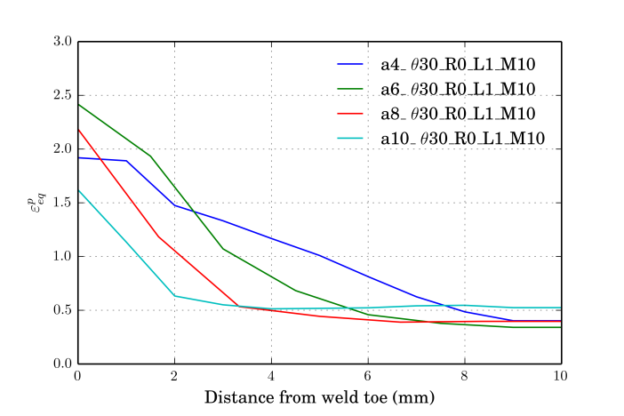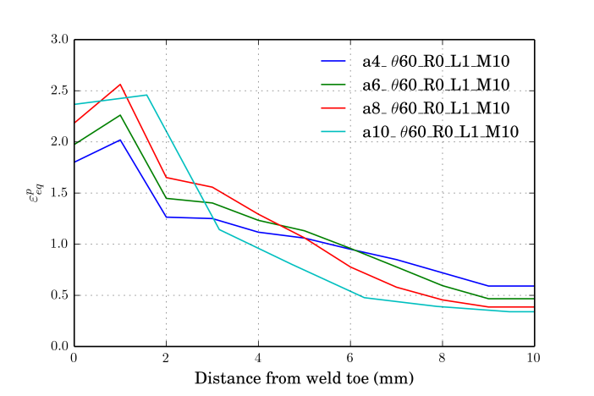
- b)
Fig. 3 – Equivalent plastic strain: a) thicknesses, Θ=30°, R=0mm, L₁ & M=1.0mm;
b) thicknesses, Θ=60, R=0mm, L₁ & M=1.0mm
In Figure 4-a), for a small throat thickness of 4mm the influence of different angles and radii is practically negligible.
To illustrate the impact of these variables on different loadings, Fig. 5 and Fig.6 are presented. For pure torsion (L₂) for regions sufficiently away from the transition of thicknesses (a=4mm) the only variable that has a sizeable impact on $ε_{eq}^{p}$ is the radius – Figure 5-a). For thicker throats, differences of around 30% are still visible between different radii – Figure 5-b). Again the proximity of the tube thickness transition is clearly visible in Figure 5-b). The same conclusions can be made for proportional bending + torsion loading (L₃) – Figure 6.
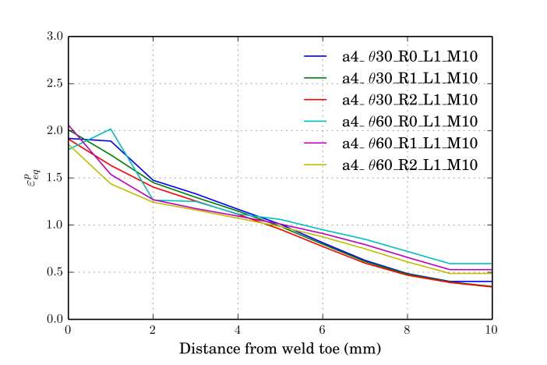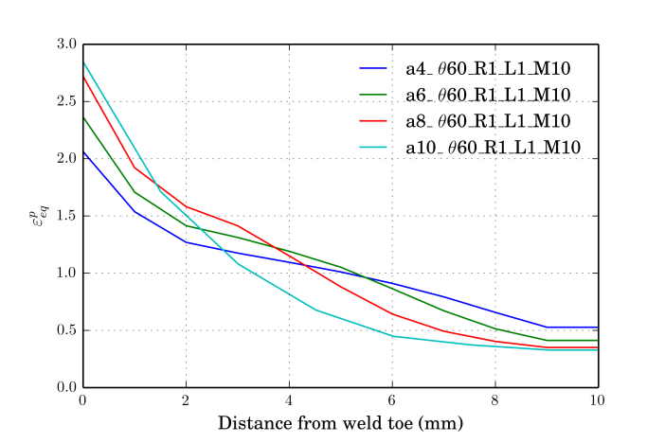
a) b)
Fig. 4 – Equivalent plastic strain: a) a=4mm, Θ=30°, 60°, radii, L₁ & M=1.0mm;
b) thickness, Θ=60°, R=1.0mm, L₁ & M=1.0mm
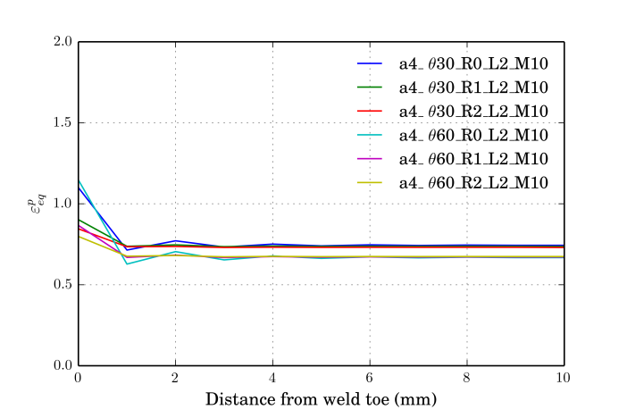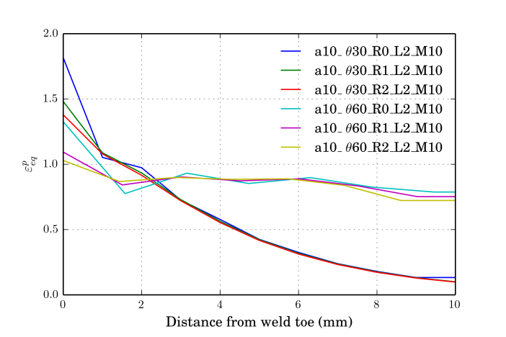
- b)
Fig. 5 – Equivalent plastic strain: a) a=4mm, Θ=30°,60°, radii, L₂ & M=1.0mm;
b) a=10mm, Θ=30°,60°, radii, L₂ & M=1.0mm
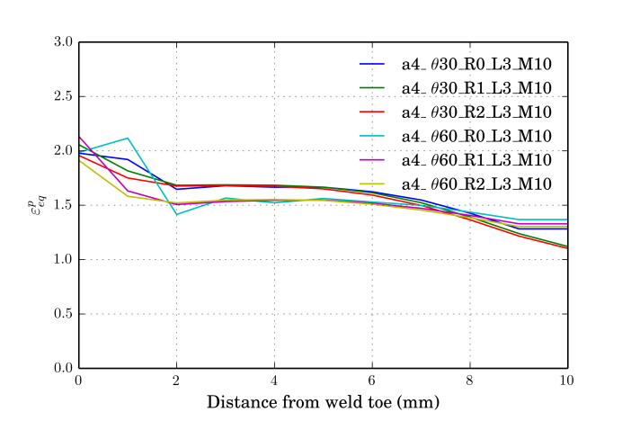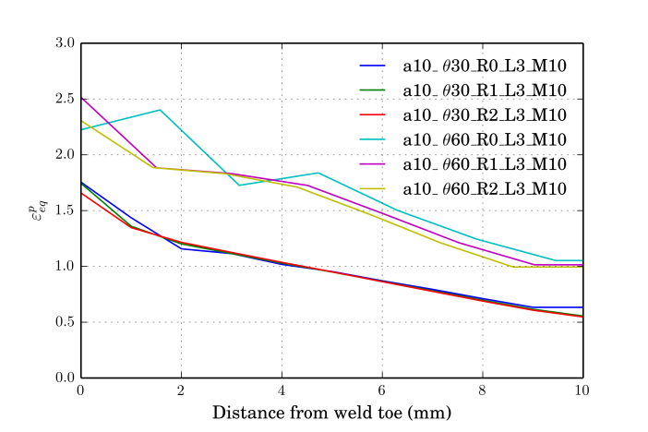
- b)
Fig. 6 – Equivalent plastic strain: a) a=4mm, Θ=30°,60°, radii, L₃ & M=1.0mm;
b) a=10mm, Θ=30°,60°, radii, L₃ & M=1.0mm
In Figure 7, mesh sensitivity is briefly addressed. Here it is clear that even at this level of fine mesh and considering a smooth rounding of R=1.0mm, a difference of around 25% in equivalent plastic strain can be observed in the weld toe, irrespective of the angle - shallow or steep.
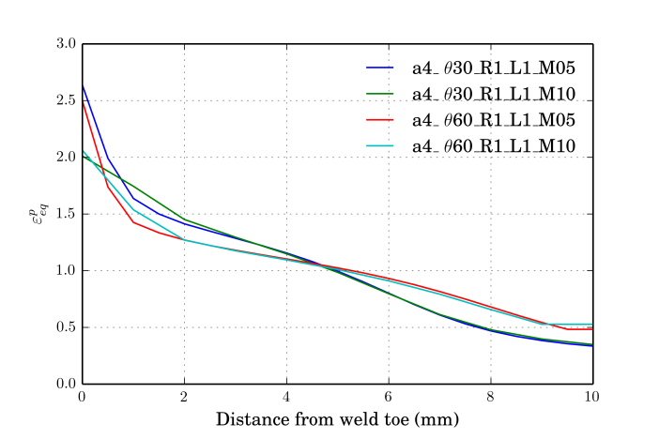
Fig. 7 – Equivalent plastic strain: a=4mm, Θ=30°, 60°, R=1.0mm, L₁ & M=0.5,1.0mm

  - Triaxiality

Stress triaxiality is an important variable in assessing ULCF. To have an idea of the impact of this variable, for sufficiently high and constant triaxialities and axisymmetric stress states, initiation life in a specimen can be seen as directly proportional to the ratio exp(-1.5T₁)/exp(-1.5T₂) – see Eq. (4) and (6).
From Figure 8, for 1mm radius, it can be seen that triaxiality is relatively insensitive at the weld toe to changes in weld throat thickness and angle.

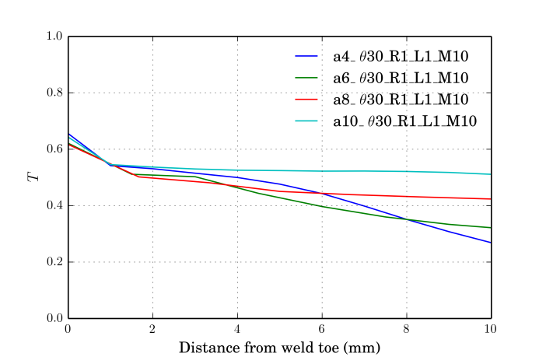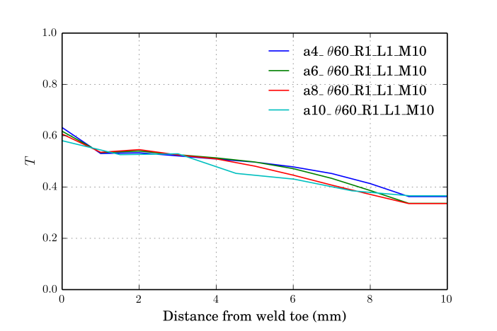
- b)
Fig. 8 – Triaxiality: a) thicknesses, Θ=30°,R=1.0mm, L₁ & M=1.0mm;
b) thicknesses, Θ=60, R=1.0mm, L₁ & M=1.0mm
The case of different radii, however, is not the same. Figure 9 shows the triaxiality for different radii and L₁ and L₃. For pure torsion (L₂) it is a constant value of zero at all points and, therefore, not plotted. Differences around 15% can be observed.
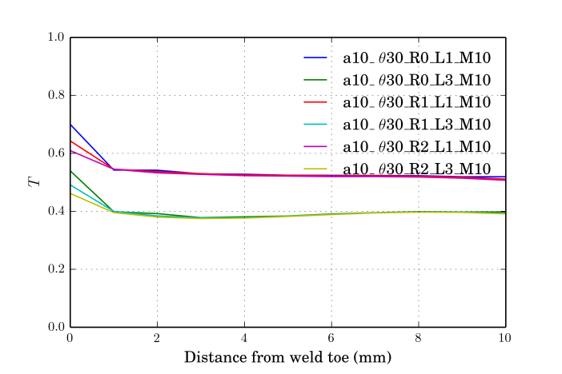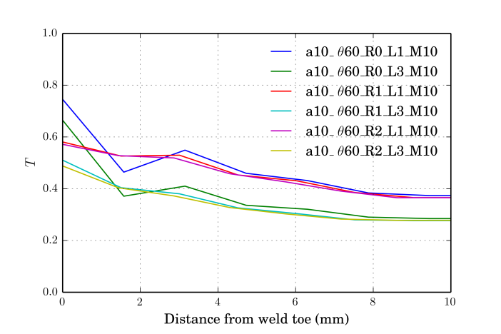
- b)
Fig. 9 – Triaxiality: a) a=10mm, Θ=30°, radii, L₁, L₃ & M=1.0mm;
b) a=10mm, Θ=30°, radii, L₁,L₃ & M=1.0mm
Triaxiality does not seem to be that sensitive to the mesh size – Figure 10.

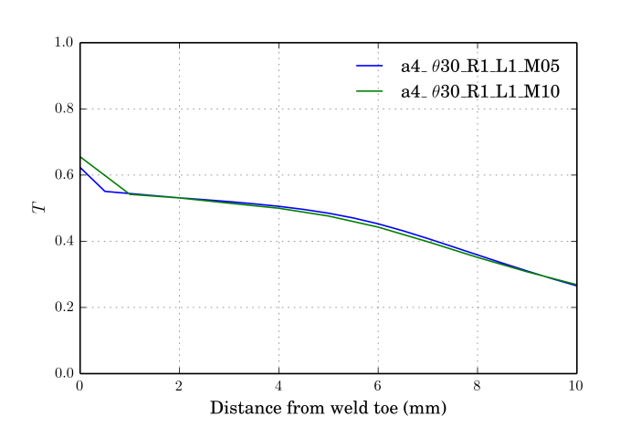
Fig. 10 – Triaxiality: a=4mm, Θ=30°, radii, L₁ & M=0.5,1.0mm

  - Lode parameter

The Lode parameter is generally observed to be insensitive to different weld throat thicknesses and angles at the weld toe – Figure 11. Differences occur only along the surface where the transition between tube thicknesses play a role. This effect is less pronounced for steeper angles precisely because of the bigger distance to the transition.
The effect of varying radii and also different load cases can be seen in Figure 12. The impact of different radii is quite small whereas, naturally, different Lode parameters are observed for different load cases.
Figure 13 shows that L, as was the case for the triaxiality, is quite insensitive to the mesh size.

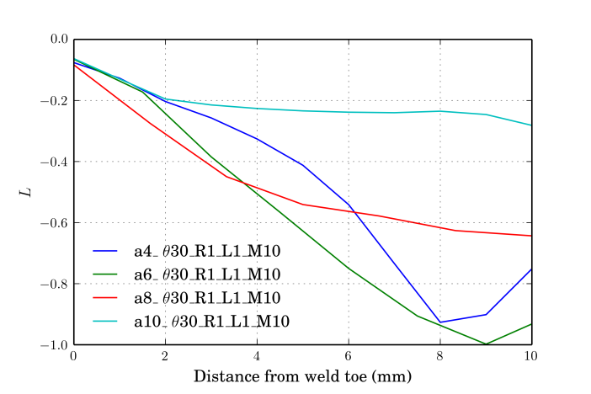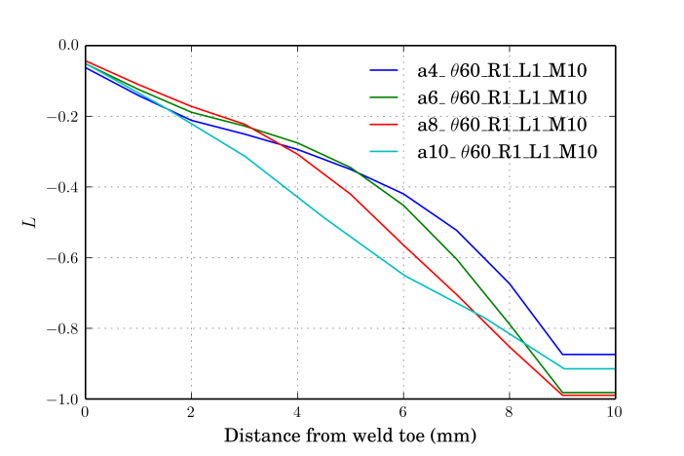
- b)
Fig. 11 – Lode parameter: a) thicknesses, Θ=30°,R=1.0mm, L₁ & M=1.0mm;
b) thicknesses, Θ=60, R=1.0mm, L₁ & M=1.0mm
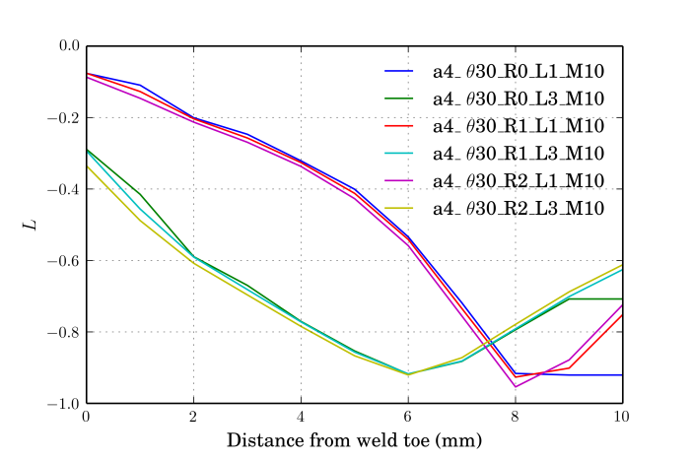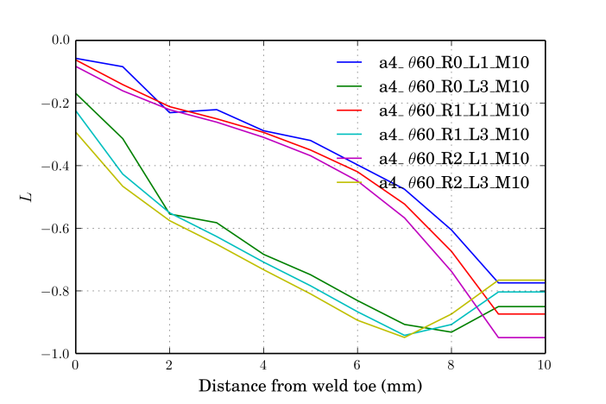
- b)
Fig. 12 – Lode parameter: a) a=4mm, Θ=30°, radii, L₁, L₃ & M=1.0mm;
b) a=4mm, Θ=60, radii, L₁, L₃ & M=1.0mm
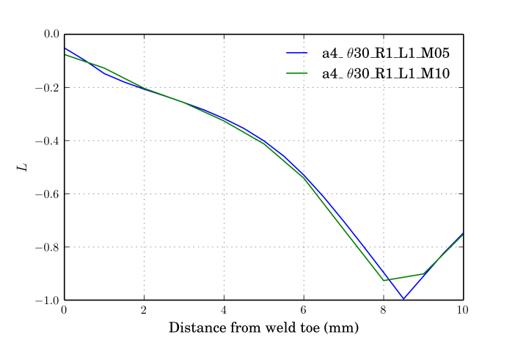
Fig. 13 – Lode parameter: a=4mm, Θ=30°, R=1.0mm, L₁ & M=0.5, 1.0mm;

- CONCLUSIONS

This paper presents a parametric study of the influence of weld geometry on the plastic strain history of a structural component. The interest in such type of an analysis comes from its consequences in evaluating fatigue life in ULCF conditions.
The main conclusions are as follows.
- Equivalent plastic strain
  - Increasing weld throat thickness leads increased plastic strains;
  - Steep weld angle accompanied by no transition radius leads to an incorrect assessment of plastic strains;
  - Mesh size was observed to increase plastic strains on the order of 25% for a decrease of mesh size of 1.0mm to 0.5mm, even when a transition radius of 1.0mm is used;
- Triaxiality
  - Insensitive to weld throat thickness, angle and mesh size;
  - Somewhat sensitive to radii – around 15%;
- Lode parameter
  - Insensitive to weld throat thickness, angle, radius and mesh size;
The consideration of a transition radius is a factor that normally isn’t taken into account in ULCF verifications. From the parametric study that was presented, however, the parameters that vary with varying radius suggest that it has an impact on ULCF life that has hitherto been overlooked. The justification for its consideration is the poor estimation of plastic strains in the weld toe with a sharp transition.

REFERENCES

Gurson, AL. 1975. “Continuum Theory of Ductile Rupture by Void Nucleation and Growth. Part I. Yield Criteria and Flow Rules for Porous Ductile Media.” Journal of Engineering Materials and Tecnology 99:2–15.
Hancock, J. W. and A. C. Mackenzie. 1976. “On the Mechanisms of Ductile Failure in High Strength Steels Subjected to Multi-Axial Stress-States.” Journal of Mechanics and Physics of Solids 24:147–69.
Kanvinde, A. M., A. M. Asce, G. G. Deierlein, and F. Asce. 2007. “Cyclic Void Growth Model to Assess Ductile Fracture Initiation in Structural Steels due to Ultra Low Cycle Fatigue.” 133(6):701–12.
Kanvinde, Amit M. and Gregory G. Deierlein. 2004. Micromechanical Simulation of Earthquake Induced Fracture in Steel Structures. Stanford, Ca.: Blume Center, Stanford University.
McClintock, Frank A. 1968. “A Criterion for Ductile Fracture by the Growth of Holes.” Journal of Applied Mechanics 35(2):363–71.
Myers, A. T., Gregory G. Deierlein, and Amit M. Kanvinde. 2009. Testing and Probabilistic Simulation of Ductile Fracture Initiation in Structural Steel Components and Weldments.
Nahshon, Ken and J. W. Hutchinson. 2008. “Modification of the Gurson Model for Shear Failure.” European Journal of Mechanics and Solids 27(1):1–17.
Rice, JR and DM Tracey. 1969. “On the Ductile Enlargement of Voids in Triaxial Stress Fields.” Journal of the Mechanics and Physics of Solids 17:201–17.
Smith, Christopher M., Gregory G. Deierlein, and Amit M. Kanvinde. 2014. A Stress-Weighted Damage Model for Ductile Fracture Initiation in Structural Steel under Cyclic Loading and Generalized Stress States. Stanford, Ca.: Blume Center, Stanford University.
Systèmes, Dassault. 2011. “Abaqus Documentation.”
Tekoğlu, C., J. W. Hutchinson, and T. Pardoen. 2015. “On Localization and Void Coalescence as a Precursor to Ductile Fracture.” Philosophical Transactions of the Royal Society A 373.

– Ph.D. Candidate
– Prof.

