Large scale inkjet-printing of carbon nanotubes electrodes for antioxidant assays in blood bags

* Electronic supporting information -

Andreas Lesch,a Fernando Cortés-Salazar,a Michel Prudent,b Julien Delobel,b Shokoufeh Rastgar,c Niels Lion,b Jean-Daniel Tissot,b Philippe Tacchinid andHubert H. Giraulta,*

a Ecole Polytechnique Fédérale de Lausanne, Laboratoire d’Electrochimie Physique et Analytique, Station 6, CH-1015 Lausanne, Switzerland

b Service Régional Vaudois de Transfusion Sanguine, Unité de Recherche et Développement, CH-1066 Epalinges, Switzerland

cDepartment of Chemistry, Sharif University of Technology, Tehran 11155-9516, Iran.

d Edel for Life, PSE-B/EPFL, CH-1015 Lausanne, Switzerland

* CORRESPONDING AUTHOR FOOTNOTE

EMAIL: hubert.girault@epfl.ch

Telephone number: +41 (0)21 693 31 51

Fax number: +41 (0)21 693 36 67

**SI-1 Laser scanning microscopy and scanning electron microscopy of the inkjet-printed carbon nanotubes electrodes**

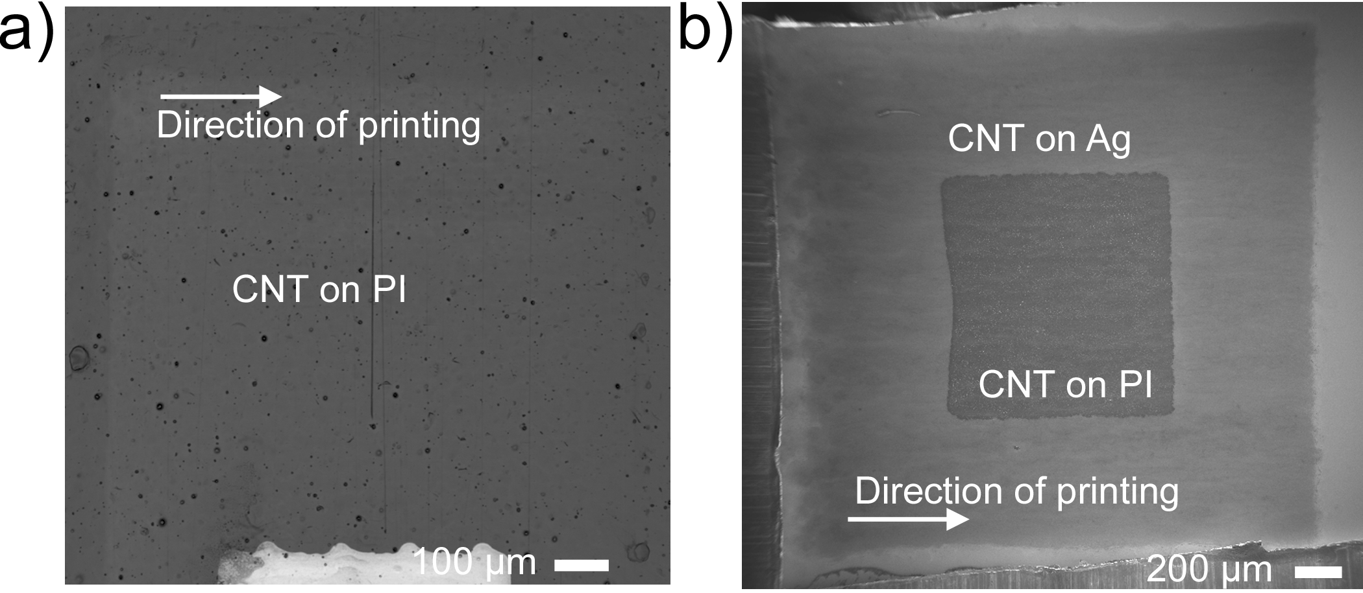

**Figure SI-1.** a) Laser scanning micrograph of a 4-IJPL CNT pattern on polyimide (PI). b) Scanning electron micrograph of a 4-IJPL CNT pattern on Ag and PI substrate.

**SI-2 Cyclic voltammetry of the inkjet-printed carbon nanotubes electrodes**

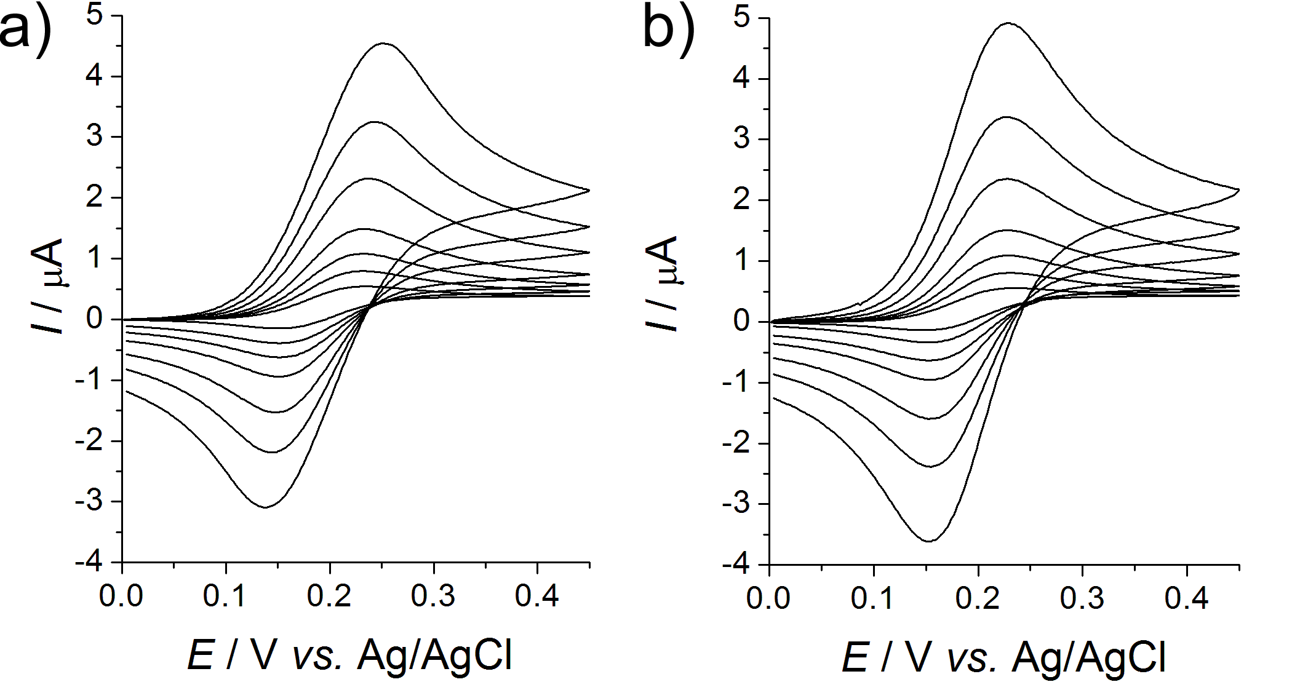

**Figure SI-2****.**Cyclic voltammetries (CVs, first cycle) in 2 mM FcMeOH using one 1-IJPL CNT sensor (a) and one 4-IJPL CNT sensor (b). Various scan rates *ν* in mV·s-1: 10, 25, 50, 100, 250, 500, 1000.

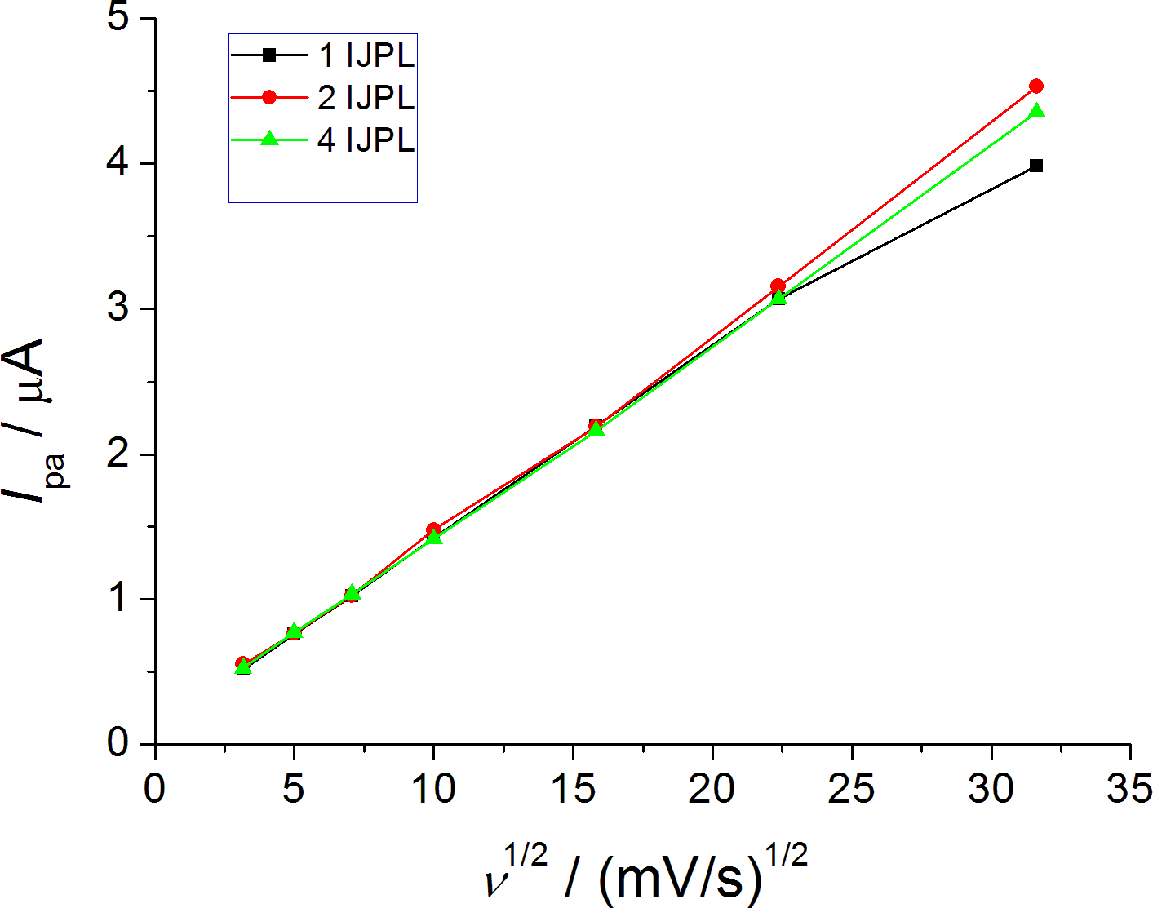

**Figure SI-3.**Baseline-corrected anodic peak current *I*pa *vs.* the square root of the scan rate (*ν*1/2) for 1-IJPL, 2-IJPL and 4-IJPL CNT sensors. Electrolyte solution: 2 mM FcMeOH in 0.1 M KCl.

**SI-3 Randles-Sevcik equation**

The Randles-Sevcik equation is as follows,



The Randles-Sevcik equation at room temperature can be written as:



*A*m – microscopic electrode area (cm2)

*i*pa – anodic peak current in (A)

*n* – number of transferred electrons

*D* – diffusion coefficient of the redox mediator (cm2·s-1)

*ν* – scan rate (V·s-1)

*c*\* – concentration of the redox mediator in bulk solution (mol·cm-3)

**SI-4 Variation of *λ* and *E*threshold in the pseudo-titration voltammetry**

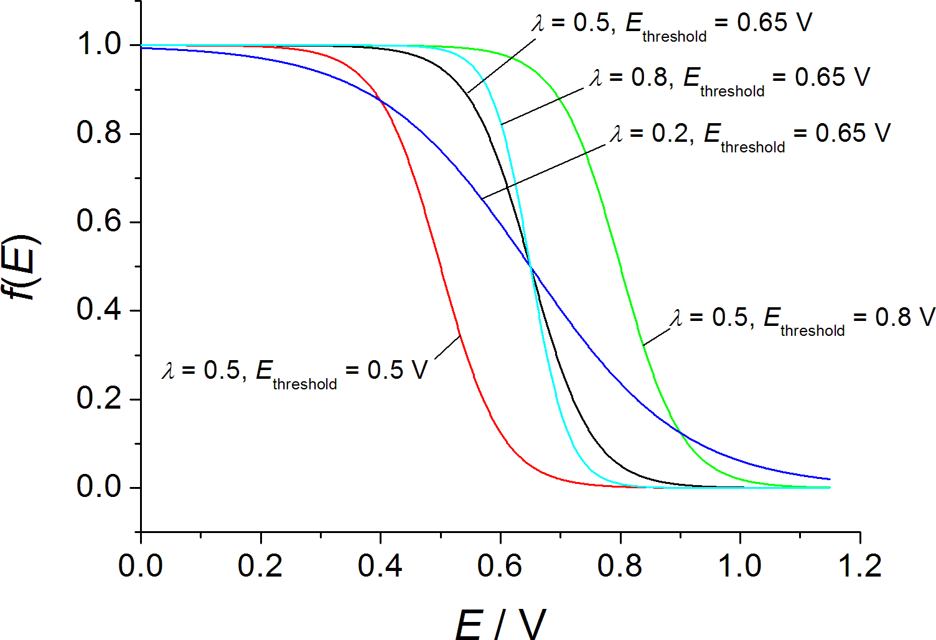

**Figure SI-4.**Effect of adjusting *λ* and *E*threshold in the pseudo-titration process.