Electrostatic Spray Ionization Mass Spectrometry Sniffing for perfume fingerprinting

Supporting Information

Elena Tobolkinaª, Liang Qiaoª, Guobin Xu^{b} and Hubert H. Girault^{a*}

a) Laboratoire d’Electrochimie Physique et Analytique, Ecole Polytechnique Fédérale de Lausanne (EPFL), Station 6, CH-1015 Lausanne, Switzerland

b) Department of Chemistry and Institute of Biomedical Sciences, Fudan University, Shanghai, 200433, P.R. China

SI-1: The structure and molecular weights of the compounds used in preparation of “model perfume” sample.
Constituents | Structure | Mol. Weight
AMBROX | 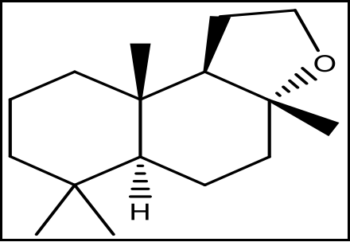 | 236.34
CITRONELLYL  NITRILE | 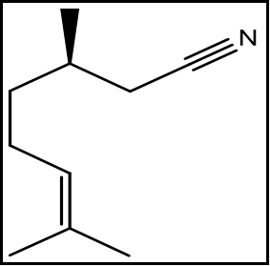 | 151.25
CYCLOGALBANATE | 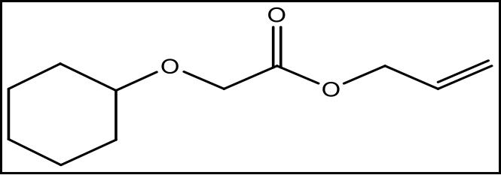 | 198.26
DAMASCENONE | 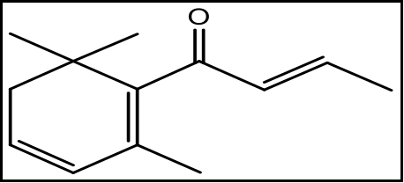 | 190.28
DIPHENYL ETHER | 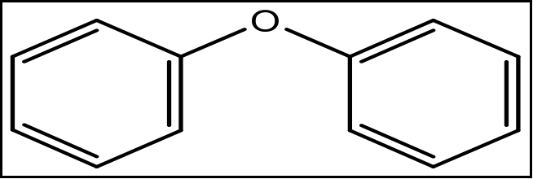 | 170
HEDIONE | 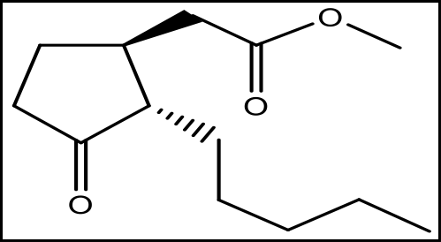 | 226.32
NEOBUTENONE ALPHA | 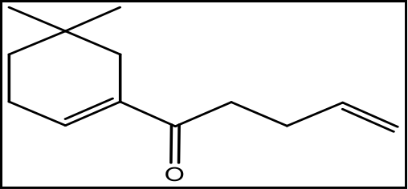 | 192.2
ISO E SUPER | 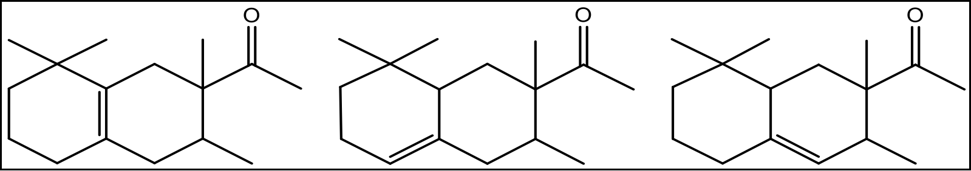 | 234.38
SCLAREOLATE | 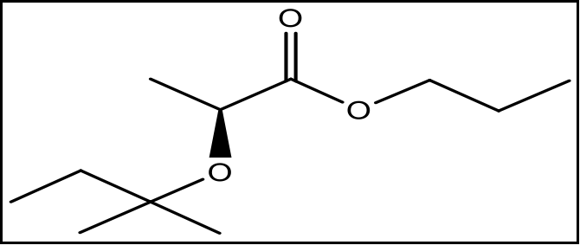 | 202.15
TONALIDE PF | 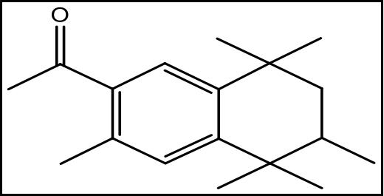 | 258.29

