In vivo imaging of pancreatic endocrine islets

Martin Villiger*ª, Joan Goulley^{b}, Christophe Pacheª, Michael Friedrichª, Anne Grapin-Botton^{b}, Paolo Meda^{c}, Rainer Leitgeb^{d}, Theo Lasserª
ªLaboratoire d’Optique Biomédicale, Ecole Poytechnique Fédérale de Lausanne, Switzerland;
^{b}Swiss Institute for Experimental Cancer Research, Ecole Polytechnique Fédérale de Lausanne, Switzerland;
^{c}Department of Cell Physiology and Metabolism, Centre Médicale Universitaire, Geneva, Switzerland;
^{d}Center of Biomedical Engineering and Physics, Medical University of Vienna, Austria

Abstract
Extended focus optical coherence microscope (xfOCM) circumvents the compromise between lateral resolution and depth of field by us of a Bessel-like illumination beam. The high sensitivity and parallel depth profiling of Fourier domain optical coherence tomography are preserved, and combined with high isotropic resolution of 1.5 - 2 μm. To comply with the requirements for in vivo measurements, beam scanning had to be implemented. We then performed measurements, first of excised pancreas, validated by standard immunohistochemistry, to investigate the structures that can be observed. For a quantitative analysis, a semi-automatic islet detection algorithm evaluated the islet size, position, contrast and homogeneity. The influence of streptozotocin on the signature of the islets was investigated in a next step. Finally, xfOCM was applied to make measurements of the murine pancreas in situ and in vivo, visualizing pancreatic lobules, ducts, blood vessels and individual islets of Langerhans.

Keywords: Optical Coherence Tomography, Optical Coherence Microscopy, extend depth of field, islet, pancreas, in vivo imaging

INTRODUCTION
It is essential to be able to measure the structure and function of individual islets of Langerhans [1]. These endocrine islets are assemblies of insulin secreting beta cells contained within the exocrine tissue of the pancreas. To further the understanding of diabetes’ mechanisms and to evaluate treatments of the disease, monitoring of functional islet parameters is mandatory. Most applicable to a clinical setting are positron emission tomography (PET) and magnetic resonance imaging (MRI) [2, 3, 4]. Their medical potential is undoubted, but to date, only optical methods have provided the necessary spatial resolution to resolve individual islets [5]. Although most optical methods are likely to have little impact in the clinical practice and human in vivo imaging, they are indispensable and complementary tools to provide insight into the cellular and molecular mechanisms of this disease.
Fourier Domain Optical Coherence Tomography (FDOCT) is an ideally suited for in vivo applications, especially because of the absence of any labelling [6, 7, 8]. Its high sensitivity [9] and capacity to extract the sample depth profile in parallel allows rapid acquisition of volumetric data. This is a mandatory prerequisite for small animal in vivo imaging.
Classical optical coherence microscopy (OCM) [10, 11] would provide the high spatial resolution necessary to visualize individual islets and gain biologically relevant insights. However, it uses standard focusing optics to obtain high lateral resolution and the resulting short depth of field hampers Fourier domain OCT’s parallel depth extraction. Time-consuming scanning in all three dimensions is thus necessary which makes in vivo measurements difficult. We introduced extended focus OCM (xfOCM) which circumvents the compromise between lateral resolution and depth of field [12] by engineering and axially extended focal volume. To achieve fast imaging times, needed for in vivo imaging, a system that scans the beams rapidly and correctly in the lateral directions was designed.
Here we report on three dimensional in vivo imaging of the murine pancreas macro- and microstructure with xfOCM. The islets are studied in their natural environment with their native innervation and vascularisation [13].

Endocrine islets
The pancreas is a gland organ, attached to the duodenum, in the digestive and endocrine system. On one hand it is an exocrine gland, secreting pancreatic juice, containing digestive enzymes that are guided through a network of ducts to the small intestine. On the other hand, the pancreas contains small assemblies of endocrine cells, called islets of Langerhans, containing the insulin secreting beta-cells. These endocrine islets contain to a smaller amount also glucagon and somatostatin secreting cells. The insulin is secreted in response to the blood glucose level, and regulates the uptake of blood glucose in cells in the liver, muscle and fat tissue. To sense the blood glucose level and secrete the insulin, the pancreas provides a dense blood vessel network.
Patients with diabetes type I, or juvenile diabetes, experienced a T-cell mediated autoimmune attack of their beta cells which destroyed the islets of Langerhans. They depend on external insulin. In diabetes type II, the islets lack to produce the required amount of insulin because the body has developed insensitivity to insulin. Either case of diabetes can lead to severe complications. According to the World Health Organization (WHO) the current rates of diabetes are at epidemic levels. By 2030, the WHO estimates that 366 million people will be affected by diabetes, which is more than twice the amount of diabetics in 2000 (170 millions) [1].
This increasing incidence of diabetes requires a better understanding of the pathogenesis of the clinical disease. Significant efforts are made to develop biomedical imaging modalities that enable estimation of the mass of insulin producing beta cells in a noninvasive manner and clinical setting. A great impact on the diagnosis and treatment of this burdensome disease is expected. PET and MRI are two very promising techniques. Although they might provide a signal indicating the total beta cell mass, these techniques lack the spatial resolution to resolve individual islets. To understand the detailed mechanism of this disease on a microscopic level, the high resolution of optical methods is indispensable.
The preparation of sections with immunocytochemical labelling is the standard method to visualise sub-cellular structures and to discriminate between the various islet cell types. This method is time consuming and only gives a two dimensional view of the tissue slices. Optical projection tomography (OPT) [14] has been used to image the adult mouse pancreas and to retrieve the three dimensional and undistorted structure of the tissue, which may be quantified. However, such approaches require sample fixation and immunolabelling, and hence, cannot be applied in vivo [15].
Likewise, functional studies are performed in vitro on isolated islets [16] and often after fluorochrome labelling, which is prone to bleaching and phototoxicity. Two-photon microscopy reduces these effects [17]. Even so, the islets are deprived of their natural tissue environment which limits the physiological relevance of such studies.
In recent work [18] islets have been transplanted into the mouse eye. Engrafted on the iris they could be repeatedly imaged using the eye as a natural body window. This minimally invasive approach allows longitudinal monitoring of individual islets, visualisation of islet vascularisation, beta cell function and death, by using two-photon fluorescence microscopy in combination with appropriate fluorochromes and transgenic mouse models expressing green fluorescent protein.

extended focus optical coherence microscopy
The idea of xfOCM is to physically engineer an extended depth of field. The laws of diffraction set a lower bound on the spot size an optical wave can be focused to, and also guarantee that the wave diffracts behind the focus, the more rapid the smaller the spot size. The strategy to nevertheless obtain a focus, with a very narrow lateral definition, but extending over a long axial range, consists in creating a field with a central spot that however does not concentrate most of the field’s energy in its centre. A significant amount of energy is left in the side lobes of the field. Upon propagation the energy from the central lobe diffracts into the outer lobes, and in turn the side lobes aliment the central lobe. One class of beams following this strategy is the class of Bessel-like beams. A true Bessel beam of order zero can be best pictured as a multitude of plane waves, with its wave vectors k=2π/λ lying on a cone with tip angle 2α. The superposition of all these waves creates an interference pattern with a strong central lobe and infinitely many side lobes. Each of these side lobes carries the same amount of energy as the central lobe, but since their surface increases with the radius ρ their amplitude decreases for higher radii. Thus, a true Bessel beam, like a plane wave, carries an infinite amount of energy. In practice, Bessel-like beams with a radial apodization and thus finite energy content can be obtained.
Fig. 1. Principle layout of the xfOCM setup. The incoming broadband light is collimated (L_{S}) and split by beamsplitter BS₁ into sample and reference beam. The illumination in the sample arm passes through the axicon, is relayed by lense L_{R} into the scanning system. The light is reflected onto the rotation axis of the slow scanner (scanner 2) and then reflected twice, by mirrors fixed on the slow scanner, to the fast scanner (scanner 1). The scan lens L_{S} finishes the relay, and the following tube lens L_{T} focuses the illumination into a thin annulus in the objective’s back aperture. In the sample region, interference produces a light-needle which extends over a long axial range, scanning the sample in the lateral directions. The backscattered light is recombined with the light from the reference arm at beamsplitter BS₂ and coupled into the detection fibre trough the lenses L_{T} and L_{D}.

A simple way to produce such a light pattern is the use of a conical lens termed axicon [19]. As displayed in fig. 1 each radial component of the collimated Gaussian beam incident on the axicon is refracted towards the optical axis to an angle α, and produces according to [20] a Bessel-like interference pattern of the form U(ρ, z) = env(k,z) * exp(ikcos α) * Jo(kρsin α). An axicon with tip angle π - 2β and refractive index n_{ax} results in α = arcsin(n_{ax}sinβ) – β. The width ω_{ill} of the incident beam produces an axial envelope env(k,z) defining a geometric depth of field T proportional to ωill /sinφ.
The layout of the setup is displayed in fig. 1. The light source is a Ti:Sapphire low coherence laser with a spectral bandwidth of 135nm at a central wavelength of 800nm, resulting in ultrahigh resolution of 2-3 μm in tissue. The collimated input beam is split into sample and reference path before passing the axicon. The pattern behind the axicon is relayed through the scanning system (L_{R}, L_{Scan}) to an intermediate image plane (iip). The tube lens L_{T} projects the illumination beam into a thin annulus in the back aperture of the sample objective (L_{obj}). It has long been known that using annular masks in the back aperture of an objective lens results in a needle like illumination pattern [21]. The axicon presents a more energy efficient way to obtain such an annular pattern. The microscope objective then creates a downscaled image of the Bessel-like beam behind the axicon in the sample space, resulting in a light needle extending over 400 μm with a lateral definition of 1.3 μm. The light scattered back from the sample is de-scanned and relayed (L_{T}, L_{D}) to the detection fiber. The detection path is decoupled from the illumination path by means of beamsplitter BS₂. The reference is combined with the sample signal at the same beam splitter. This decoupling of the detection path is crucial for the imaging performance of the setup. Detection through the axicon would result in an amplification of the side lobes. Scanning a reflecting knife edge in such an axicon double pass configuration would increase the detected signal by an equal amount for each additional side lobes falling on the knife edge, blurring the edge completely. The approximately Gaussian mode with 1/e² radius of 2.6 μm of the detection fiber is imaged onto the central part of the illumination needle. The Gaussian envelope attenuates the side lobes of the illumination needle. This attenuation is more efficient within the Rayleigh range of the detection mode and the side lobes become more apparent at distances further away from the focal plane. The detection efficiency is optimal in the focal plane, and then decreases due to the axial envelope of the Gaussian mode along the optical axis. Nevertheless this combination of Gaussian detection volume and Bessel-like illumination pattern compromises signal detection efficiency, lateral resolution and depth of field, providing a near constant lateral resolution of 1.3 μm along an extended depth of field of about 300 μm.
Looking at the detection mode profile in the sample objective back aperture, it is apparent that the waist radius of this approximately Gaussian detection mode is significantly smaller than the illumination annulus diameter. Light reflected from a flat surface at the sample location travels through the same annular aperture, and its overlap with the detection mode is very weak. Light from specular reflection is suppressed, which produces a dark field effect.
The resulting interference signal in the detection fiber is injected in the spectrometer consisting of a transmission grating (1200 lines/mm), a camera objective (f=135mm) and a line detector (Atmel Aviiva) with 2048 pixels set to an integration time of 40µs, operating at a line rate of 20 kHz. The spectrometer resolution is Δλ = 0.08nm allowing for a maximal instrument depth range of 2.23mm in air. The power measured on the sample was 3 mW.
The scanning system consists of two galvo scanners (Cambridge Technology). The surface of the fast axis scanner (blue) is conjugated to the back aperture of the sample objective by the telescope consisting of the scanning and tube lens (LScan, LT). This configuration ensures that the annular pattern in the back aperture experiences a correct tilt, without lateral shift, resulting in a needle of light that is correctly scanned in the lateral direction. To obtain a correct shift in the second scanning direction, the pivot point of the second scanning should likewise lie in a conjugate plane of the back aperture. Instead of using additional relay optics, the slow galvo (green) scans an assembly of two mirrors. Its rotation axis passes through the pivot point of the fast galvo scanner. The incident beam is aligned onto this rotation axis by means of a deflection mirror. The mirrors of the rotating assembly reflect the beam onto the fast galvo scanner and create a virtual pivot point in the second scanning direction. When correctly aligned, both pivot points are coincident and scan the beam correctly in both lateral directions.
Together with the 20 kHz line rate of the camera, acquisition times for a volume of 256 x 256 lateral points of a little more than four seconds were achieved.

Ex vivo imaging of endocrine islets

Ex vivo imaging of pancreas
The whole pancreas of adult wild type mice were excised, fixed, and placed on microscope slides. The optical setup was mounted on a table in the horizontal direction and the sample was accessed from the side, as indicated in figure 2 (A). The pancreas comprises a tail (t) or splenic part attached to the spleen and a head (h) encircled by the duodenum, connected by a thin neck (n). Figure 2 (B) shows the tomogram of a B-scan in the neck of a pancreas. Two islets of Langerhans of different size are clearly visible as spherical structures with high contrast. The exocrine tissue has a more granular structure and scatters less light while the ducts and vascular networks appear as dark regions, with only their epithelial walls scattering incident light. Adjacent lateral scans were assembled to produce en face images (Fig. 2 (C)), and to generate 3D renderings of the whole volume data, giving access to the spatial position and shape of the islets (Fig. 2 (D)).

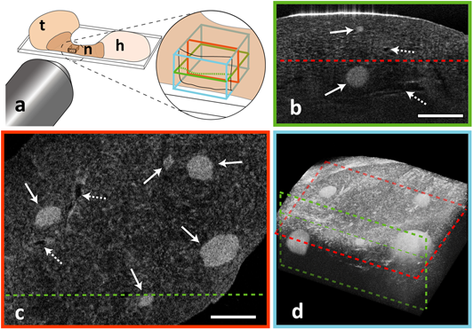
Fig. 2. Scanning principle of xfOCM. (a) Scanning along one lateral direction creates a B-scan tomogram (green rectangle). Acquiring many B-scans by scanning along the second lateral direction provides a 3D volume (blue cube). En face images can be generated by selecting one depth (red rectangle). The pancreas consists of the head (h) and the tail (t), connected by the neck (n). (b) B-scan of a fixed sample, measured in the neck region depicting a 1 mm x 0.65 mm field (Scale bar: 250 μm). Two small islets are present (arrows), along with vessel-structures (dashed arrows). The bright line at the top of the tomogram indicates the sample surface that strongly reflects the incident light. (c) En face image at a depth of 220 μm showing 5 islets (arrows) and vessels (dashed arrows) (Scale bar: 250μm). (d) The volume data can be represented with a 3D rendering, giving a three dimensionsonal impression (1.5 x 1 x 0.65 mm).

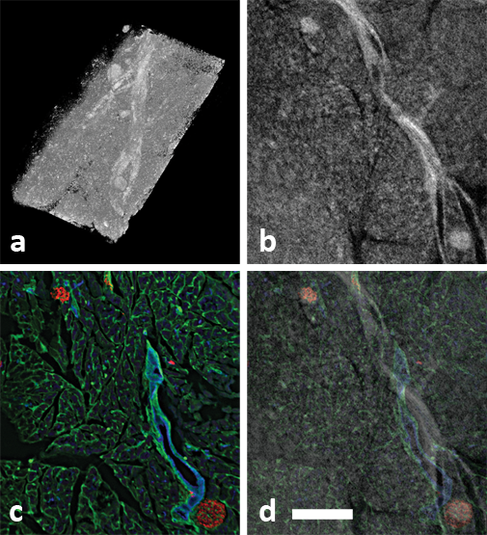
Fig. 3. (a) 3D-rendered volume (0.86 x 1.7 x 0.78 mm) of the pancreas head. (b) Virtual section of the tomographic data. (c) Cryosection of the same area, immunohistochemically labelled for insulin (red), PECAM (green) and DBA lectin (blue). (d) Overlay of cryosection with xfOCM data identifying the islets and vessel structures (Scale bar 250 μm in b,c and d).

Validation with immunohistochemistry
To ascertain that the spherical structures were indeed islets, we sectioned a subset of the samples. Figure 3 shows alignments between immunostained sections and virtual sections through an xfOCM stack. Cryosections were immunolabeled to identify β cells (anti insulin antibody), ducts (anti DBA lectin antibody) and blood vessels (anti PECAM antibody). Overlays showed a good correspondence between the cryosections and the virtual sections from the xfOCM data (Fig. 3). The few differences in the matching result from the distortions that tissues undergo during fixation and cryo-sectioning, and were compensated by a slight scaling of the xfOCM data. This demonstrates the advantage of accessing the tissue structure in fresh, unfixed tissue, where the native tissue morphology is retrieved.

quantitative analysis of detected Islets
In order to analyse the measured pancreas and identify and quantify the comprised islets, we developed a semi-automatic detection algorithm. Visually it is easy to identify an islet in the surrounding exocrine tissue. But the tomogram signal covers an important dynamic range, and the signal decreases significantly at bigger depths and away from the focus along the depth axis. Defining an absolute threshold to distinguish between the islet and the background is impossible. Also, the granular appearance of the tomograms requires smoothing of the data, all while maintaining the edges between the islet background boundary.
Determination of the islet volume and position was achieved by manually defining a region of interest and automatic extraction of the precise islet shape by filtering and thresholding. The obtained volumetric islet mask was used to estimate the mean of the islet signal. Likewise, the mean of the exocrine tissue surrounding the islet was extracted. The difference of these two values gives a measure of the contrast of an islet. In a further step, the signal variation within the islet core was analysed to evaluate homogeneity, expressed as the lateral gradient of the mean signal in function of depth within the islet, going from the outer surface to its inner core.
The steps of the semi automatic detection and processing algorithm are listed below:
- Intensity correction of the signal in depth by reconstructing the tomograms from their raw data and applying a moving dynamic range with approximately -7dB/mm in the axial direction to avoid clipping of the tomogram data.
- User selects a region of interest (ROI) around the centre of the islet in the en face view. This initial ROI defines the kernel size of the consequent volumetric median filtering, varying between 5 by 5 (laterally) by 5 (depth) pixels for small regions, and 15 by 15 by 5 for bigger regions.
- Volumetric median filtering of the central volume indicated by the ROI in the lateral directions, and 10 pixels along the depth axis.
- Computation of the histogram of the filtered volume and estimation of the two signal distribution means of the islet and the background signal, to define the threshold.
- Thresholding of the data and detection of the biggest connected area to eliminate small islands of thresholded pixels. The remaining area is taken as islet mask (Sup. fig. 1).
- Iteration of steps 3 to 6 for an axially displaced ROI, until an end cap of the islet mask is met. The ROI is shifted by 5 pixels at a time, first toward positive z, and ones the islet cap was found, towards smaller z to find the upper cap of the islet.
- Postprocessing of the islets slices, combining the detected islet masks into a single islet volume. From this volume, the mean of the intensity signal of the islet is estimated (Sup. fig. 2 (c)). To estimate the mean of the background signal, the islet is projected into the z-direction. This shadow is dilated by 9 pixels, and then an annulus of width 21 is used as region of interest for the background signal (Sup. fig. 2 (a, c)). The difference between the mean of the islet and the background expresses the contrast of the islet.
Further, the islet is separated into a layered structure in a central region of height 10 around the centre of mass of the islet (Sup. fig. 2 (b)). From each shell the mean of the islet signal is estimated, and the variation of this mean in function of islet layer serves as a measure of the islet homogeneity.
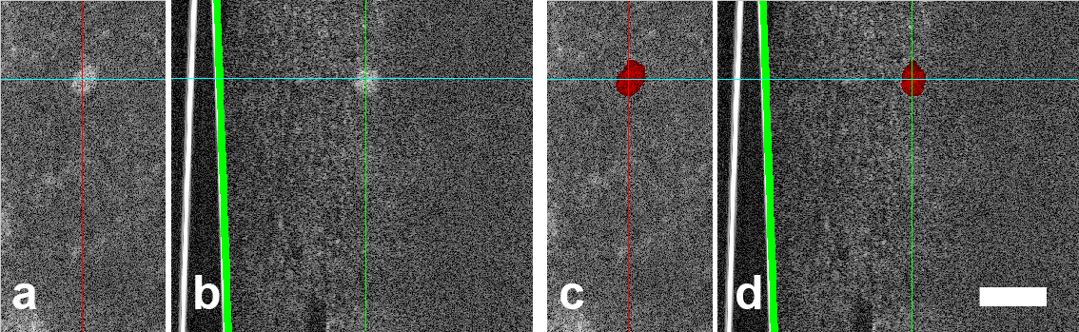
Fig. 5. En face and side view of an islet, without (a, b) and with (c, d) the islet mask. The scale bar measures 200 μm.
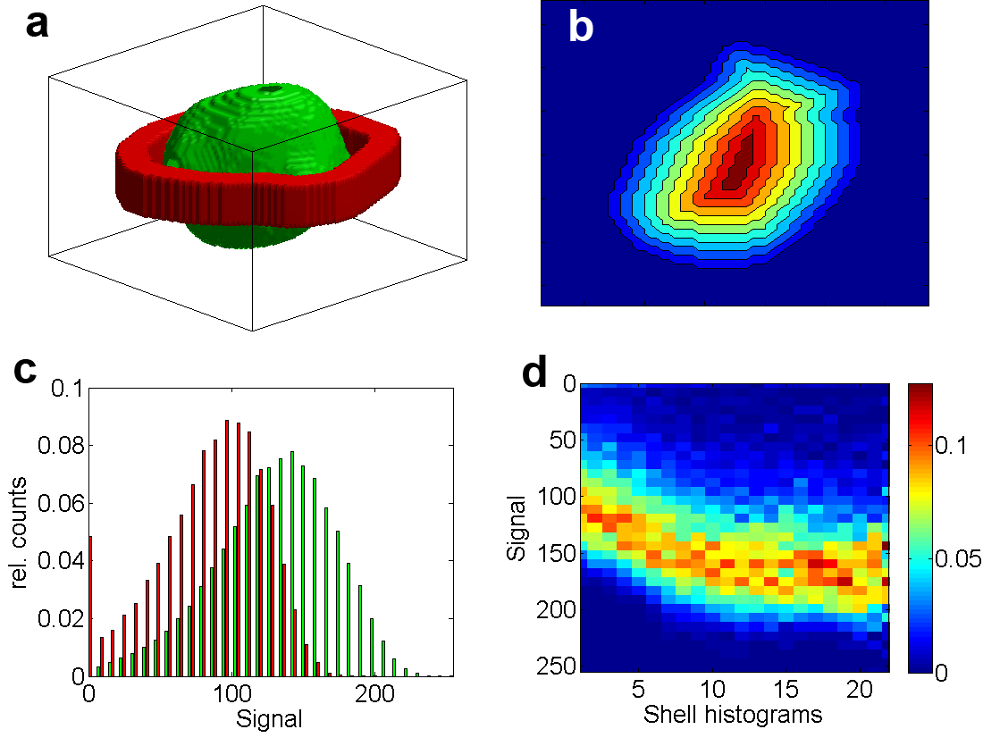
Fig. 6. (a) Islet mask (green) and the annulus (green) defining the region of interest for the evaluation of the background mean value. (c) Histograms of the islet and the background region of interest. (b) Separation of the islet into shell layers. From each of these layers, the histogram is plotted in (d) along the columns, with color expressing relative counts. The variation of the mean of each histogram for increasing layer depth expresses the islet homogeneity.

With the semi-automatic islet detection algorithm at hand the measured tissue sections were screened and the data on the individual islets could be gathered. Figure 6 (a) depicts the total of 146 islets found in four tissue regions, of 1.5x1 mm each, binned into different depth categories. Despite the scattering of the pancreatic tissue, which disturbs the propagation of the incident beam to deeper lying structures and ultimately limits the imaging depth, we could image islets up to more than 500 μm. The histogram of linearly increasing size categories (fig. 6 (b)) shows that many small islets were found, but only few of bigger size. The same data, but in a logarithmic scale is displayed in figure 6 (c). Islets down to a size of only about 15 μm in diameter (~2000 μm³), corresponding to an aggregate of only a few cells, are reliably detected.
Figure 6 (d) presents an assembly of tomograms from islets of different sizes and depths, illustrating the resolving power of xfOCM.

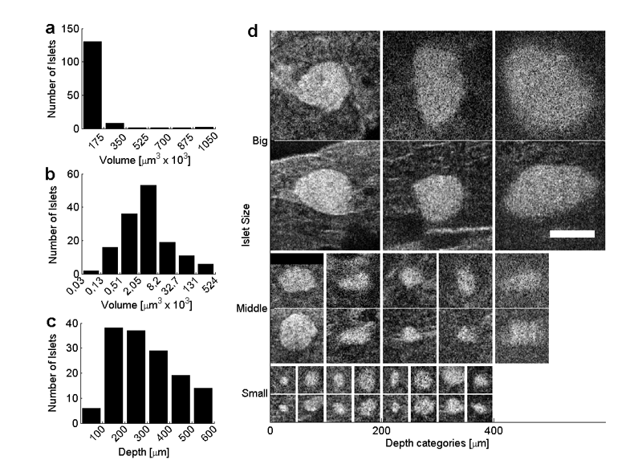
Fig. 6. (a) Size distribution of the islets in linear scale. (b) The same data as in (a), but organised in logarithmic scale. (c) Depth distribution of the detected islets. Close to the surface, the pancreas has fewer islets than in the deeper lying tissue. The reduced number of islets for bigger depths points out the detection limits of the method. (d) Islets of different sizes and at different sample depths. Each islet is shown with an en face view (top) and a B-scan (bottom). Scale bar: 100 μm.
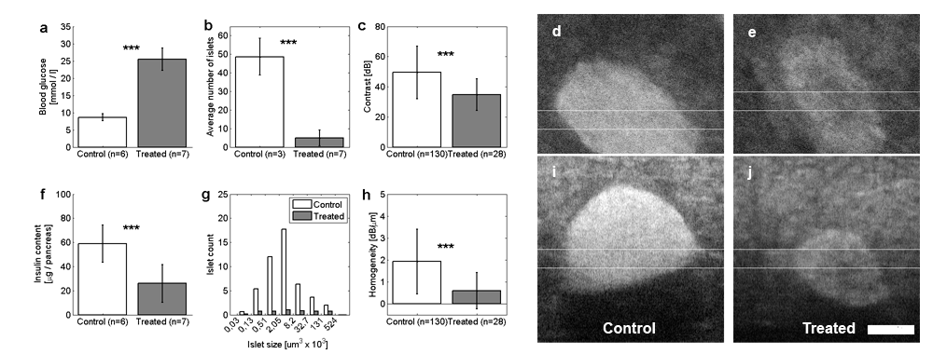
Fig. 7. Exposure of C57B6 mice to streptozotocin (solid bars) resulted in a marked increase in blood glucose levels (a) and in a parallel decrease in the insulin content of the pancreas (f) compared to the control group (white bars). The effect of the drug also decreased the number of islets found in the analysed regions (b). g The logarithmic distribution of the islet size exhibits a characteristic pattern for the control islets that is lost in the case of the remaining islets of treated animals. The few remaining islets (only islets >1000 μm3 taken into account) likewise show a reduced contrast (c) and homogeneity (h). (a,b,c,f and h show means ± SE,***p<0.001). An islet surviving in a diabetic mouse (e, j) shows a significant reduction in contrast, compared to a control islet (d, i). The columns show en-face (d, e) and B-scan (i, j) views, averaged over the 20 slides indicated by the white lines. The B-scans are adjusted in their axial position to show identical sample depths. The scale bar measures 100 μm and applies to all tomograms.

Imaging of samples from streptozotocin injected mice
To investigate on the nature of the contrast observed for the endocrine islets, and to determine whether xfOCM could detect changes in beta cell mass, we injected a group of mice (n=7) with streptozotocin, a drug which selectively kills insulin-producing cells [22]. A control group (n=6) was injected with the citrate buffer that served as the vehicle for the drug. Four to seven days after injection all control mice showed normal levels of blood glucose (8.6 ± 1 mmol/l, n=6) and total insulin content (58.8 ± 15.4 μg per pancreas, n=6) (Fig. 7 (a, f)). In contrast, the mice that had received streptozotocin showed markedly increased (p<0.002) blood glucose levels (25.47 ±3.27 mg/dl, n=7) and a significantly lower (p<0.001) total insulin content (25.9 ± 15.6 μg per pancreas, n=7) (Fig. 7 (a, f)).
The xfOCM analysis of the samples, carried out under double blind conditions, showed that some of the pancreata contained numerous islets whereas others contained significantly (p<0.001) fewer islets (Fig. 7(b). Opening of the codes revealed that all of the pancreata of the former type were from control mice with normal glucose homeostasis, whereas all the samples of the latter type suffered from hyperglyceamia due to streptozotocin-injection.
The few islets remaining after streptozotocin treatment were of various sizes without privileged volume category. (Fig. 7 (g)). The contrast as well as the islet homogeneity exhibit a significant difference in their means (p<0.001) with respect to the control islets (Fig. 7 (c, h)), taking only into account islets bigger than 1000 μm3. Figure 7 (d, e, i, j) shows two selected islets of approximately same size and depth in the tissue, evidencing the difference in homogeneity of control and treated islets. These experiments demonstrate that xfOCM can detect beta cell loss and alterations in streptozotocin-treated animals.

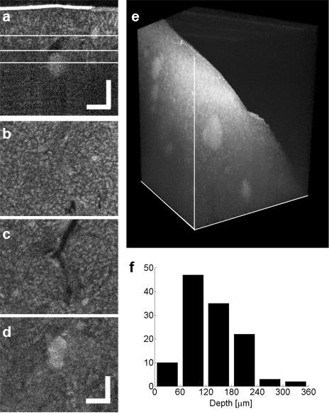
Fig. 8. In vivo imaging of islets. (a) Side view and (b,c,d) corresponding en-face views (indicated by the white lines in the side view, median value over 5 slices) at different depths, showing islets and a duct- or vessel-like structure. The scale bars measure 100 μm and apply to all views. (e) 3D rendering of a similar in vivo tomogram showing several islets at various depths, contained in a lobe of a pancreas. The volume measures 1mm x 1mm in the lateral directions and 500 μm in the vertical axis. (f) displays the depth distribution of the islets detected in vivo (6 animals, 123 islets).

In vivo imaging of endocrine islets
To access the pancreas in the anesthetised animal, an incision of 0.5-1 cm was made through the abdominal muscles to gently pull out the duodenum encircling the head of the pancreas. The duodenum was stabilized around a pillar during the scanning procedure. The mouse was exposed to a heating lamp and both pancreas and intestine sprayed with 0.9% NaCl during the modus operandi. To increase the scanning speed, small regions of 256x256 pixels were scanned with low sampling in less than five seconds. The few remaining movement artefacts were corrected with an image registration algorithm [23]. After imaging, within 30 minutes from the beginning of the operation, the incision was sutured allowing the mouse to recover.
An overview of samples measured in vivo is shown in figure 8. The semi-automatically detected islets were analysed and revealed a stronger absorption of tissue in the living organism, limiting the imaging depth to about 300 μm, as indicated in figure 8 (f). The excised tissue was kept in sucrose, which clears the samples optically and thus increases the penetration depth of the probing beam.

Conclusion
The high sensitivity and parallel depth probing of FDOCT make it a confirmed tool for in vivo imaging. xfOCM combines these advantages with high, isotropic resolution, without compromising on the parallel depth detection and thus maintaining a high acquisition speed for three dimensional tissue volumes. With the fast scanning of the xfOCM the acquisition is currently limited by the camera speed, which can be increased with the newest generation of line cameras.
In this study, we first characterized the imaging capacity of xfOCM by measuring fixed and excised pancreatic tissue. Comparison with histology confirmed that xfOCM can detect islets of all sizes and their association with ducts and blood vessels. Next, we found that xfOCM can discriminate between the islets of animals that had normal insulin content from the mice suffering from hyperglycaemia and decreased insulin content as a result of the beta cell death induced by streptozotocin. The data show that xfOCM can detect changes in the number of islets and in the contrast and homogeneity of the few residual islets that survive the cytotoxic effect of the drug. The following measurements on living mice showed that xfOCM can visualise pancreatic lobules, ducts, blood vessel networks, and islets of Langerhans in vivo.
The exact nature of the strong scattering of the islets remains yet unclear. Whether it is the whole structure of the beta cell that strongly scatters the light, as pointed out by the streptozotocin experiments, or only the insulin containing vesicles within the beta cells has to be shown by further experiments.
The possibility to monitor islets in the living animal in real time unlocks a new field of investigation that will complete the understanding of the islet biology. Repeated measurements should be feasible, given the same area of the pancreas can be identified consecutively. For such longitudinal studies, the access to the pancreas could be simplified by employing an endoscope or a glass window in the abdominal wall, making our method minimally invasive.
Furthermore, the quantitative analysis estimated the imaging depth, which was more limited in living than in fixed samples. The achieved depths are comparable to those reported for two photon microscopy. A trade-off between a light source in a longer wavelength region and the resulting reduced axial resolution could further optimize imaging performance. Even then, it is unlikely that xfOCM could measure the whole volume of the pancreas. Still, the surface volume of the pancreas is screened with unprecedented accuracy, offering new insight into this organ. Essentially, with xfOCM the islets are studied in their natural environment, and disease evolution and islet destiny can be evaluated.
OCT’s capacity to perform Doppler flow measurements [24, 25, 26] could reveal the pancreatic blood flow and provide additional functional parameters. Spectral contrast [27] could likewise contribute to more functional imaging. xfOCM’s sensitivity should prove useful to monitor changes in beta cell number – for instance during islet regeneration or upon islet transplantation to visualise the islets and their vascularisation in the recipient environment. Eventually, xfOCM could help design new PET and MRI probes, that selectively label the pancreatic beta cells and that are most needed for the forthcoming clinical imaging of pancreatic islets by these techniques. Adding a contrast agent for xfOCM to prospective probes would enable the monitoring of their dynamics and specificity on a microscopic scale.

ACKNOWLEDGEMENTS
This research was funded by the Swiss National Fonds and an EU grant (SNF grant 205321-10974, EU FP7-222980). J.G. is funded by the Beta Cell Biology Consortium (Grant NIDDK U19 DK072495-02). P.M. is further supported by grants from the SNF (310000-122430) and the JDRF (1-2207-158). R.A.L is also funded by an EU grant (FP7-201880).

References
- Souza, F., M. Freeby, et al., "Current progress in non-invasive imaging of beta cell mass of the endocrine pancreas,” Current Medicinal Chemistry 13(23), 2761-2773 (2006).
- Evgenov, N. V., Z. Medarova, et al., "In vivo imaging of islet transplantation,” Nature Medicine 12(1), 144-148 (2006).
- Tai, J. H., P. Foster, et al., "Imaging islets labeled with magnetic nanoparticles at 1.5 Tesla,” Diabetes 55(11), 2931-2938 (2006).
- Kim, S. J., D. J. Doudet, et al., "Quantitative micro positron emission tomography (PET) imaging for the in vivo determination of pancreatic islet graft survival,” Nature Medicine 12(12), 1423-1428 (2006).
- Holmberg, D. and U. Ahlgren, "Imaging the pancreas: from ex vivo to non-invasive technology,” Diabetologia 51(12), 2148-2154 (2008).
- Hitzenberger, C. K., "Optical Measurement of the Axial Eye Length by Laser Doppler Interferometry,” Investigative Ophthalmology & Visual Science 32(3), 616-624 (1991).
- Huang, D., E. A. Swanson, et al., "Optical Coherence Tomography,” Science 254(5035), 1178-1181.
- Fercher, A. F., C. K. Hitzenberger, et al., "Measurement of Intraocular Distances by Backscattering Spectral Interferometry,” Optics Communications 117(1-2), 43-48 (1995).
- Leitgeb, R., C. K. Hitzenberger, et al., "Performance of fourier domain vs. time domain optical coherence tomography,” Optics Express 11(8), 889-894 (2003).
- Izatt, J. A., M. R. Hee, et al., "Optical Coherence Microscopy in Scattering Media,” Optics Letters 19(8), 590-592 (1994).
- Huang, S. W., A. D. Aguirre, et al., "Swept source optical coherence microscopy using a Fourier domain mode-locked laser,” Optics Express 15(10), 6210-6217 (2007).
- Leitgeb, R. A., M. Villiger, et al., "Extended focus depth for Fourier domain optical coherence microscopy,” Optics Letters 31(16), 2450-2452 (2006).
- Villiger, M., Goulley, J., et al., "In vivo imaging of murine endocrine islets of Langerhans with extended-focus optical coherence microscopy”, DOI 10.1007/s00125-009-1383-y.
- Sharpe, J., U. Ahlgren, et al., "Optical projection tomography as a tool for 3D microscopy and gene expression studies,” Science 296(5567), 541-545 (2002).
- Alanentalo, T., A. Asayesh, et al., "Tomographic molecular imaging and 3D quantification within adult mouse organs,” Nature Methods 4(1), 31-33 (2007).
- Hermann, M., D. Pirkebner, et al., "Real-time assessment of human islet preparations with confocal live cell imaging,” Transplantation Proceedings 37(8), 3409-3411 (2005).
- Takahashi, N., T. Nemoto, et al., "Two-photon excitation imaging of pancreatic islets with various fluorescent probes,” Diabetes 51: S25-S28, (2002).
- Speier, S., D. Nyqvist, et al., "Noninvasive in vivo imaging of pancreatic islet cell biology,” Nature Medicine 14(5), 574-578 (2008).
- McLeod, J. H., "The Axicon - a New Type of Optical Element,” Journal of the Optical Society of America 44(8), 592-597 (1954).
- Herman, R. M. and T. A. Wiggins, "Production and Uses of Diffractionless Beams,” Journal of the Optical Society of America a-Optics Image Science and Vision 8(6), 932-942 (1991).
- Sheppard, C. J. R. and T. Wilson, "Imaging Properties of Annular Lenses,” Applied Optics 18(22), 3764-3769 (1979).
- Lenzen, S., "The mechanisms of alloxan- and streptozotocin-induced diabetes,” Diabetologia 51: 216-226 (2008).
- Thevenaz, P., U. E. Ruttimann, et al., "A pyramid approach to subpixel registration based on intensity,” Ieee Transactions on Image Processing 7(1), 27-41 (1998).
- Leitgeb, R. A., L. Schmetterer, et al., "Real-time measurement of in vitro flow by Fourier-domain color Doppler optical coherence tomography,” Optics Letters 29(2), 171-173 (2004).
- Leitgeb, R. A., L. Schmetterer, et al., "Real-time assessment of retinal blood flow with ultrafast acquisition by color Doppler Fourier domain optical coherence tomography,” Optics Express 11(23), 3116-3121 (2003).
- Bachmann, A. H., M. L. Villiger, et al., "Resonant Doppler flow imaging and optical vivisection of retinal blood vessels,” Optics Express 15(2), 408-422 (2007).
- Leitgeb, R., M. Wojtkowski, et al., "Spectral measurement of absorption by spectroscopic frequency-domain optical coherence tomography,” Optics Letters 25(11), 820-822 (2000).

