Supplementary Information
Closed-loop haptic feedback control using a self-sensing soft pneumatic actuator skin

Harshal A. Sonar, Aaron P. Gerratt, Stéphanie P. Lacour, Jamie K. Paik*

- Supplementary figures
- Supplementary movies

- List of supplementary figures:
Supplementary Figure S1: Stretchable strain sensor characterization and sample sensor, actuator designs.
Supplementary Figure S2: Experimental validation of the analytical model.
Supplementary Figure S3: Closed loop controller performance evaluation and testbed design.

- List of supplementary movies:
Supplementary Movie 1: SPA-skin operation at low frequency (5 Hz) and high frequency (50 Hz).

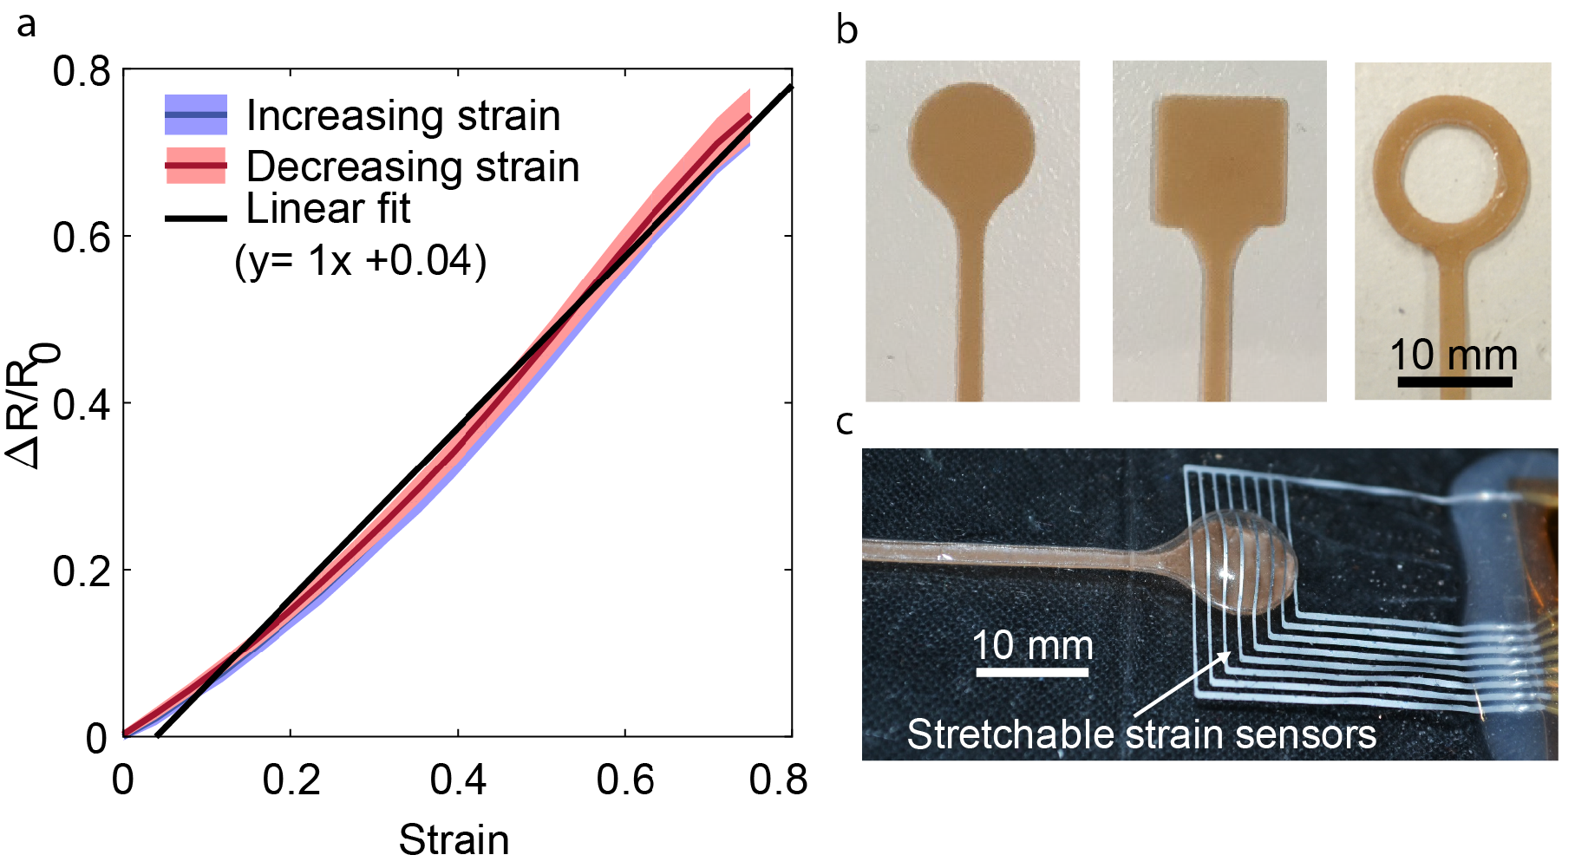
Supplementary Figure S1: Stretchable strain sensor characterization and sample sensor, actuator designs.
(a) Average nominal sensor resistance change with standard deviation for strain rates: 0.018 mm/s, 0.18 mm/s and 1.8mm/s, in increasing and decreasing directions of the applied uniaxial strain. The linear fit for the average resistance change gives gauge factor (GF) of ‘1’. (b) Three sample designs of SPA, demonstrating the configurability and distributability of the SPA skin design. The brown colored mask determines the inflation region for SPA. (c) An SPA skin prototype design flexibility of the sensor-actuator system, with eight independent sensors 100 μm apart placed on a 10 mm diameter actuator.

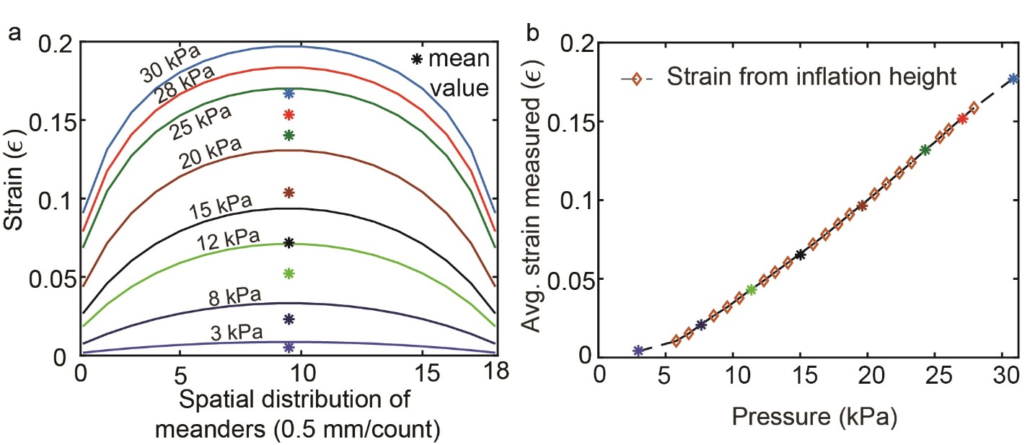
Supplementary Figure S2: Experimental validation of the analytical model.
(a) The analytical model predicting uniaxial strain over each sensor meander using the measured inflation height. The mean value of the sensor strain determines the measured change in the resistance of the sensor. (b) The measured average strain from the analytical model is plotted with respect to the actuator input pressure. Each colored (*) marker maps to the corresponding mean value of the strain in Figure S2c and is then used to validate the strain model with measurements from sensor resistance (Figure 3c).

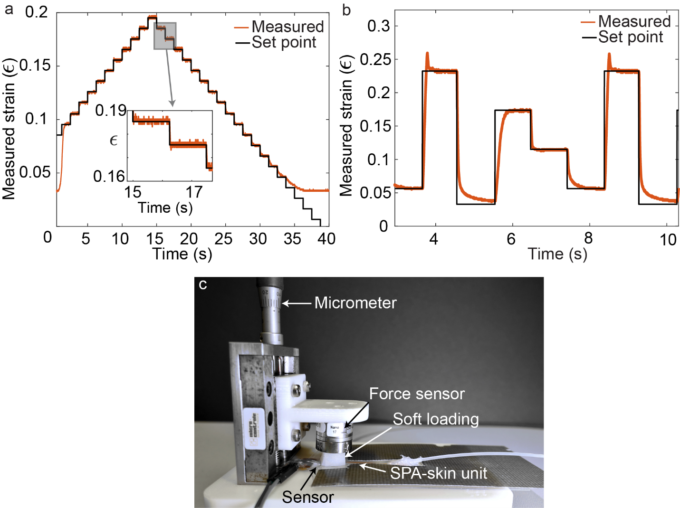
Supplementary Figure S3: Closed loop controller evaluation and testbed design. (a) A staircase set point tracking using integrated stretchable strain sensor and external pressure regulation shows high precision performance of the controller to control the SPA-skin system. The controller cannot track the actuator state below 3% strain set point, as the SPA cannot be deflated further without an external preloading. (b) In the second test case, an arbitrary set point tracking test shows the stability of PID-controller over the full range of safe actuation (0-25% strain at 35kPa) for the SPA-skin unit. (c) The physical testbed used to validate the SPA-skin system model and test the active closed loop controller performance. This testbed consists of a precision micrometer to control the preload, a force sensor, a soft silicone preload to simulate the human skin, a pressure regulator, a microcontroller and a sensor readout electronics.

