Progress in the design and manufacturing of the EDIPO 2 cryostat

Roberto Guarino*, Evgeny Solodko, Xabier Sarasola, Pierluigi Bruzzone, Kamil Sedlak
École Polytechnique Fédérale de Lausanne (EPFL), Swiss Plasma Center (SPC), CH-5232
Villigen PSI, Switzerland
* Corresponding author (roberto.guarino@epfl.ch)

Abstract
A major upgrade of the European DIPOle (EDIPO) test facility, which will allow the testing of superconducting samples both for fusion and for high-energy physics applications, is taking place at the Swiss Plasma Center. With a target background field of 15 T, the new magnet design requires a large engineering current density and thus an accelerator-like magnet cooled by a saturated helium bath is foreseen. Therefore, a helium vessel has been designed and procured.
In this work, we present recent design and manufacturing activities of the EDIPO 2 cryostat. First, we provide an analytical estimation of the thermal budget at the temperature levels of interest. Then, we describe the design and manufacturing of the helium vessel, according to relevant norms. Finite-element numerical simulations are employed both to refine the design and to provide a comparison with the experimental pressure tests.

Keywords
Test facilities; superconducting magnets; helium vessel; assembly; finite-element simulations.

1. Introduction
The European DIPOle (EDIPO) test facility, owned and operated by the Swiss Plasma Center at the premises of the Paul Scherrer Institut (Villigen, Switzerland), is used for high magnetic field testing of superconducting cables for fusion and accelerator magnets [1]. EDIPO 2 is a major upgrade of the facility, currently under design and manufacturing, with a target magnetic field of 15 T at the centre of the magnet aperture and a uniform field length of 1000 mm (with a 1% drop in the field along the axis of the aperture) [2,3]. A 144x144 mm² square aperture will allow the testing of cables and insert coils of various sizes and shapes [4].
The ongoing magnet design studies are based on high current density (about 3000 A mm⁻² at 4.2 K and 12 T) Nb₃Sn strands, arranged in flat Rutherford-like cables. The corresponding engineering current density of the superconducting magnet will be in the order of 200 A mm⁻², if a 6-coil layout is implemented [4]. This range of engineering current density calls for a compact magnet design, which cannot rely on forced-flow conductors such as in the old EDIPO facility [1]. The use of forced-flow conductors, in fact, would require an unreasonably large amount of superconductor to reach the target magnetic field.
Therefore, a cooling configuration based on a saturated helium bath kept at about 4.2 K has been selected. This allows an accelerator magnet-like design, thus increasing the maximum field and the uniform field length mentioned above. For this purpose, a stainless steel helium vessel has been conceived, designed and manufactured, and has been delivered in December 2021. A preliminary design of its pressure relief system has also been carried out [5].
In this paper, we present recent updates on the design and manufacturing of the EDIPO 2 cryostat, with a particular focus on the helium vessel. First of all, we provide an overall estimation of the thermal budget of the cryostat, i.e., the heat loads to the two temperature levels of interest. Starting from geometric and assembly constraints, we describe the main requirements of the helium vessel, as well as its integration into the existing infrastructure. Numerical simulations by means of the finite-element method are then used to verify the proposed structural design. Finally, we show the manufactured helium vessel and the results of experimental pressure tests, as well as their comparison with the numerical results.

2. Cryostat design
2.1 Geometry and assembly
The EDIPO 2 cryostat is composed of an existing thermal shield and vacuum vessel, and a newly designed helium vessel, which is conceived for the new accelerator-like magnet design. One of the main requirements of the EDIPO 2 helium vessel is the perfect match with the existing facility, i.e., it must not interfere with the thermal shield and vacuum vessel. Figure 1 shows the integration of the new helium vessel into the magnet assembly. The same Figure 1 displays the three main components of which the EDIPO 2 helium vessel is composed: (1) a top lid with a dished shape; (2) a cylindrical central body; and (3) a flat bottom base. All the components are made of AISI 304L stainless steel (EN 1.4307). The choice of a flat bottom base, instead of a more standard dished end, has been driven by an easier integration into the existing vacuum vessel and an easier assembly of the magnet.
The whole assembly is supported by four feet protruding from the bottom base, which exactly match the existing facility. The magnet weight of about 23 t will rest on four circular supports at the inner side of the bottom base, once inserted into the vessel. The flat bottom base further includes a protruding square envelop with size 144x144 mm², needed for accommodating the extremity of the test sample. Since the feedthroughs of the top lip (required for the current leads, the helium outlet line, the instrumentation cables, the insertion of the test sample, etc.) are not fully defined yet, the top lid is manufactured without the openings in order to have the possibility of testing the vessel after manufacturing. The vessel is demountable at both extremities: accessibility from the top extremity is required in order to insert the magnet, and accessibility from the bottom is convenient for alignment and fixation purposes. The three main components are assembled by bolted joints (each made of 52xM16 bolts). The helium leak tightness is ensured by semi-permanent welded rings, according to the norm DIN 2695 [6]. These welded rings can be cut and re-welded several times, in the case it is needed to disassemble and re-assemble the vessel (e.g., after the pressure tests).
Table 1 summarises the main parameters driving the design of the EDIPO 2 helium vessel.

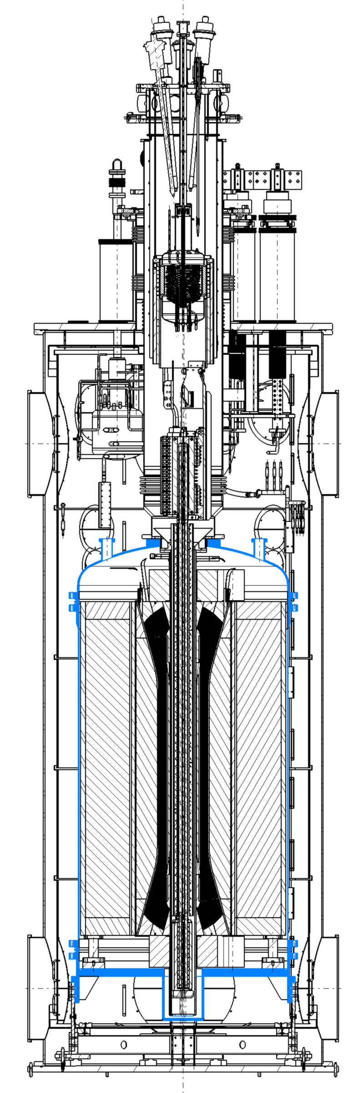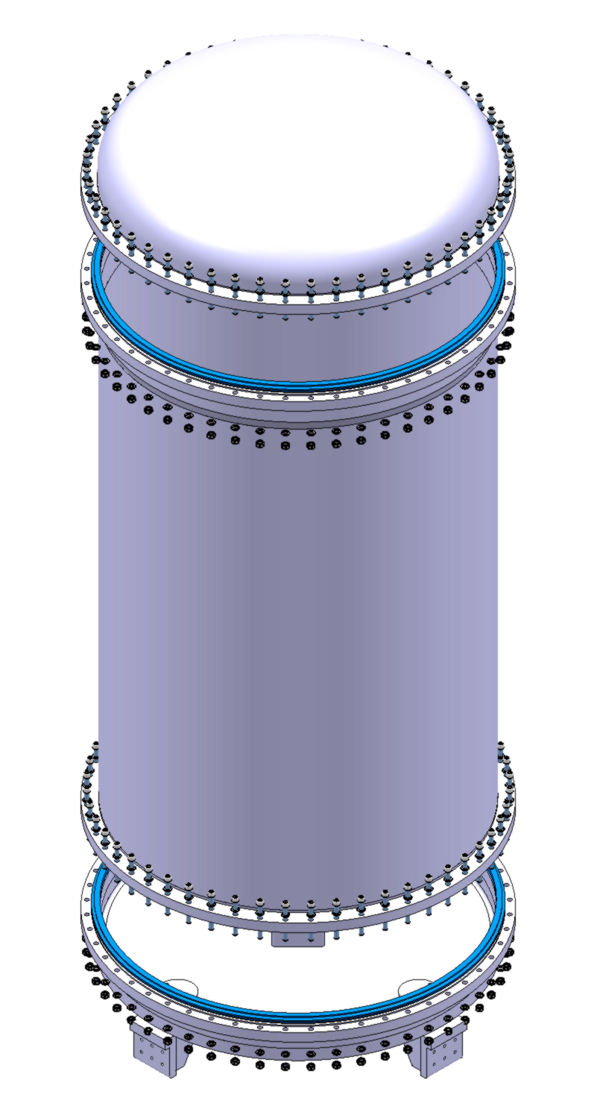
Figure 1 Geometry of the EDIPO 2 cryostat: integration into the proposed magnet assembly and existing vacuum vessel and thermal shield (left), and three-dimensional view of the main components of the helium vessel (right).

Table 1 Main design parameters of the EDIPO 2 helium vessel.
Quantity | Value
content | He (liquid/gas)
operating pressure (inside) | 1.0 bar
operating pressure (outside) | 10⁻⁸ bar
accidental pressure (inside, maximum allowable working pressure) | 3.0 bar
accidental pressure (outside) | 10⁻⁸ bar
operating temperature | from 4 to 293 K
fluid leak rate | < 10⁻¹¹ bar l s⁻¹
material | AISI 304L (EN 1.4307)

2.2 Thermal budget
The estimation of the thermal budget of the EDIPO cryostat, i.e., the overall heat load to the relevant temperature levels, is important for quantifying the performance of the insulating structures and for the cryogenic operation of the helium vessel. Here we consider the following heat load contributions [7]:
- residual gas conduction;
- radiation (from the vacuum vessel to the thermal shield and from the thermal shield to the helium vessel);
- solid conduction through supports, feedthroughs, etc.
The residual gas conduction can play a role in the case of low vacuum conditions (or, e.g., of partial loss of vacuum) and is given by the Kennard’s law, valid in the so-called molecular regime [8]:
$$Q_{g}=A_{2}α\frac{γ+1}{γ-1}\sqrt{\frac{R}{8πMT_{avg}}}p\left(T_{3}-T_{2}\right)$$ | (1a)
$$Q_{g}=A_{1}α\frac{γ+1}{γ-1}\sqrt{\frac{R}{8πMT_{avg}}}p\left(T_{2}-T_{1}\right)$$ | (1b)
where A₁ ≈ 13.94 m² is the surface of the helium vessel, A₂ ≈ 26.47 m² the surface of the thermal shield, α an accommodation coefficient (here assumed ≈ 0.9), γ ≈ 1.4 the heat capacity ratio of air, R the universal gas constant, M the molecular weight of the gas, T_{avg} its average temperature, p the operating pressure outside the helium vessel, and T₁, T₂ and T₃ the temperatures of the helium vessel, thermal shield and vacuum vessel, i.e., 4.2, 80 and 293 K, respectively. By using the pressure value reported in Table 1 (i.e., p = 10⁻⁸ bar), we get Q_{g} ≈ 7.53 W at 80 K and Q_{g} ≈ 2.97 W at 4 K.
The radiative heat load from the vacuum vessel to the thermal shield, and from the thermal shield to the helium vessel, can be computed, respectively, according to [7]:
$$Q_{r}=\frac{σA_{2}\left(T_{3}^{4}-T_{2}^{4}\right)F_{23}}{\frac{1}{ε_{2}}+\frac{A_{2}}{A_{3}}\left(\frac{1}{ε_{3}}-1\right)}$$ | (2a)
$$Q_{r}=\frac{σA_{1}\left(T_{2}^{4}-T_{1}^{4}\right)F_{12}}{\frac{1}{ε_{1}}+\frac{A_{1}}{A_{2}}\left(\frac{1}{ε_{2}}-1\right)}$$ | (2b)
where σ is the Stefan-Boltzmann’s constant, A₃ ≈ 31.44 m² the surface of the thermal shield F₁₂ and F₂₃ geometrical view factors, ε₁ ≈ 0.20 the stainless steel emissivity (i.e., the material of the helium vessel) at 4 K, ε₂ ≈ 0.06 the copper emissivity (i.e., the material of the thermal shield) at 80 K, and ε₃ ≈ 0.20 the stainless steel emissivity (i.e., the material of the vacuum vessel) at 293 K. For convenience, in Equation (2) we approximate the helium vessel and the thermal shield as two concentric cylinders, and thus we assume F₁₂ = F₂₃ ≈ 1.0. Finally, we get Q_{r} ≈ 549.05 W at 80 K and Q_{r} ≈ 2.44 W at 4 K.
The conductive heat load through every component i that connects the thermal shield or the helium vessel to higher temperature levels is given, respectively, by [7,8]:
$$Q_{c,i}=\frac{S_{i}}{L_{i}}\int_{T_{2}}^{T_{i}}{k_{i}\left(T\right)\text{d}T}$$ | (3a)
$$Q_{c,i}=\frac{S_{i}}{L_{i}}\int_{T_{1}}^{T_{i}}{k_{i}\left(T\right)\text{d}T}$$ | (3b)
where S_{i} is the cross section, L_{i} the conduction length, T_{i} the maximum temperature “seen” by the considered component, and k_{i}(T) the temperature-dependent thermal conductivity. The main components contributing to the conductive heat load to the helium vessel are: four gravity supports, two stainless steel pipes (for the helium outlet and the instrumentation), the pipes connecting the two current leads to the helium vessel, and the test well. They are displayed in Figure 2 and the detailed calculation of the heat loads according to Equation (3) is reported in Table 2.

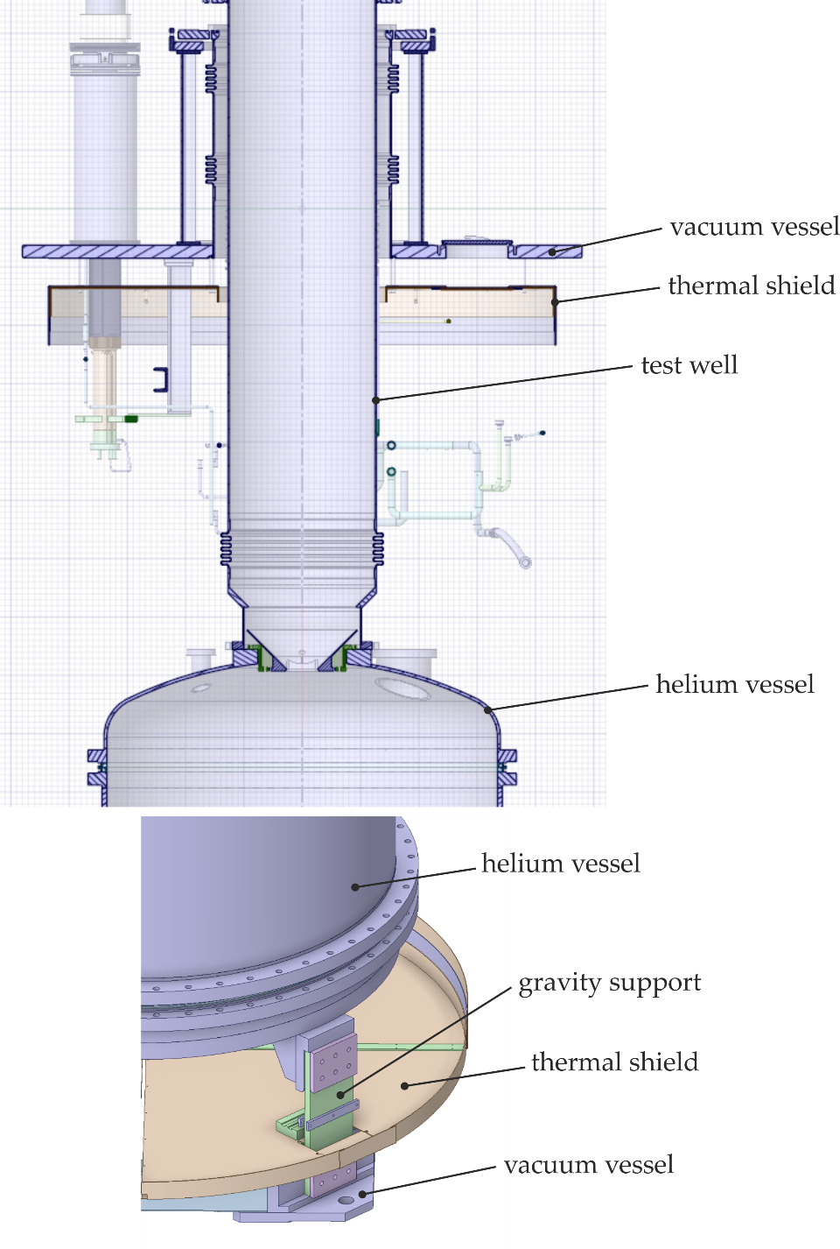
Figure 2 Geometrical details of the test well (top) and of the support (bottom) considered for the estimation of the conductive heat loads onto the EDIPO 2 helium vessel.

Table 2 Overview of the main conductive heat loads onto the EDIPO cryostat, divided by temperature level.
Component | S_{i} | L_{i} | T_{i} | Q_{c,i}
80 K temperature level
1 – support | 3200.0 mm² | 100.0 mm | 293 K | 3.61 W
2 – stainless steel pipe | 469.7 mm² | 160.0 mm | 293 K | 7.70 W
3 – current lead pipe | 59.7 mm² | 100.0 mm | 293 K | 1.57 W
4 – stainless steel test well | 6333.5 mm² | 700.0 mm | 80 K | 23.73 W
4 K temperature level
1 – support | 3200.0 mm² | 100.0 mm | 80 K | 0.56 W
2 – stainless steel pipe | 469.7 mm² | 1385.0 mm | 293 K | 1.01 W
3 – current lead pipe | 59.7 mm² | 1112.0 mm | 293 K | 0.16 W
4 – stainless steel test well | 6333.5 mm² | 1300.0 mm | 80 K | 1.69 W

Finally, the overall conductive heat load to the 80 and to the 4 K temperature levels is given, respectively, by:
$$Q_{c}=4Q_{c,1}+{2Q}_{c,2}+2Q_{c,3}$$ | (4a)
$$Q_{c}=4Q_{c,1}+{2Q}_{c,2}+2Q_{c,3}+Q_{c,4}+{2Q}_{cl}$$ | (4b)
Note that at the 80 K temperature level we do not include the stainless steel test well (see Table 2) because the corresponding heat load is not applied onto the thermal shield, i.e., it has no thermal intercept, but it is cooled by a separate cooling circuit. In Equation (4b), Q_{cl} is the conductive heat lead to the low-temperature level due to the current leads. It has been estimated to be Q_{cl} ≈ 5.1 W per current lead in the old EDIPO design [9]. Therefore, we obtain Q_{c} ≈ 32.98 W at 80 K and Q_{c} ≈ 16.47 W at 4 K. Here we neglect the resistive heat load due to the contact resistance of the current leads, because it has a small value (i.e., in the order of 3 nΩ at the cold contact [9]) and is present only when the current leads are operated at the maximum current.
The total heat load to the 4 K level, considering the contributions of residual gas conduction, radiation and solid conduction described above, is thus:
$$Q_{tot}=Q_{g}+Q_{r}+Q_{c}$$ | (5)
i.e., around 590 W at 80 K and 22 W at 4 K.
The overall heat load to the 4 K temperature level produces a constant vaporisation of the helium bath, whose mass flow rate can be estimated from:
$${\dot{m}}_{vap}=\frac{Q_{tot}}{C_{Lvap}}$$ | (6)
By using C_{Lvap} ≈ 2.09·10⁴ J kg⁻¹ as latent heat of vaporisation [10], we get a helium mass flow rate of about 1.1 g s⁻¹.

2.3 Structural design
A preliminary structural design of the EDIPO 2 helium vessel is performed analytically, and then it is verified by means of finite-element numerical simulations. The design is performed according to EN 13445-3 [11] and the main objective is to find the minimum shell thicknesses of the vessel component (see Appendix A for the detailed procedure). In our case, we get a minimum thickness of about 1.74 mm and 5.18 mm for the cylindrical part and the dished end, respectively.

2.4 Finite-element structural verification
In addition to the main structural design performed according to the relevant norms, as outlined above, a detailed finite-element structural verification has also been carried out. This need derives from the observation that the norms deal with “ideal” unfired pressure vessels, which in some components may differ from the proposed EDIPO 2 helium vessel. A first important difference is that the helium vessel will host a magnet with an approximate mass of 23 t, which can significantly affect the mechanical behaviour of the bottom base. Another point concerns the bottom base itself: a flat geometry is not covered by the analytical method provided by the norms, thus a precise calculation must be performed. Finally, a numerical study allows to take into account also the influence of the dismountable joints and of the several apertures foreseen on the top lid.
We perform finite-element numerical simulations in ANSYS® Mechanical® [12]. The geometry has been discretised with solid elements (SOLID186 and SOLID187) and, for symmetry reasons, only a 90-degree sector has been simulated in order to minimise the computational cost. The vessel has been constrained by applying a 0.0 mm vertical and a 2.0 mm lateral displacement on the gravity supports, in order to have a zero lateral strain after cool down (i.e., this takes into account the thermal contraction of the vessel). In addition, vertical loads (directed towards the outside of the vessel) are applied on the flanges of the top lid in order to simulate the effect of the covers that are placed during the pressure tests. A bolt pretension of 10.0 kN has been applied to both flanges. Finally, a constant pressure P = 4.72 bar has been assigned to the internal surfaces of the helium vessel. This value differs from that provided by Equation (A4) (see Appendix A) because the pressure tests are performed under external atmospheric pressure (i.e., about 1 bar), while the simulations are performed in vacuum.
Two scenarios are simulated, namely:
- the normal operation, with a maximum internal pressure of 2.0 bar;
- the accidental/test scenario, which reproduces the pressure tests needed as final acceptance tests.
The stresses in the helium vessel have been linearised along several “stress classification lines” (see Annex C of EN 13445-3 [11]), and then the maximum membrane and membrane + bending values are compared to the allowable limits. Table 3 lists the maximum stresses and the corresponding allowable limits computed at the operating temperature (see Appendix A), for each of the three main components of the helium vessel.

Table 3 Value of the maximum stress components along the worst-case “stress classification lines” of the EDIPO 2 helium vessel, for the two simulated scenarios, and corresponding allowable limits according to EN 13445-3 [11].
Stress component | Scenario | Value | Allowable limit
top lid
membrane stress | normal | 30 MPa | 173 MPa
membrane + bending stress | normal | 49 MPa | 520 MPa
membrane stress | test | 71 MPa | 260 MPa
membrane + bending stress | test | 116 MPa | 780 MPa
cylindrical body
membrane stress | normal | 25 MPa | 173 MPa
membrane + bending stress | normal | 26 MPa | 260 MPa
membrane stress | test | 57 MPa | 260 MPa
membrane + bending stress | test | 57 MPa | 390 MPa
bottom base
membrane stress | normal | 62 MPa | 173 MPa
membrane + bending stress | normal | 113 MPa | 520 MPa
membrane stress | test | 137 MPa | 260 MPa
membrane + bending stress | test | 240 MPa | 780 MPa

Starting from the analytical results reported above, initial thicknesses of 5.0 and 6.0 mm have been chosen for the cylindrical and the dished end parts, respectively, due to manufacturability requirements. An initial thickness of 50.0 mm, instead, has been chosen for the flat base. After an iterative study, the thickness of the top lid has been increased up to 10.0 mm, in order to get rid of local stress concentrations and to guarantee a conservative design in the case of additional apertures. This increased thickness has been deemed necessary also for avoiding a too large opening of the top flange, especially in the accidental/test scenario. The final geometry is displayed in Figure 3; whereas Figure 4 shows the stress distribution on the top lid in normal operation.

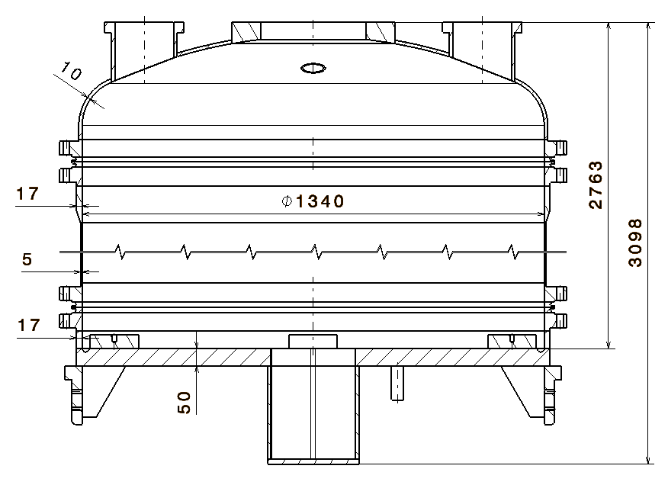
Figure 3 Final geometry and main dimensions of the EDIPO 2 helium vessel.

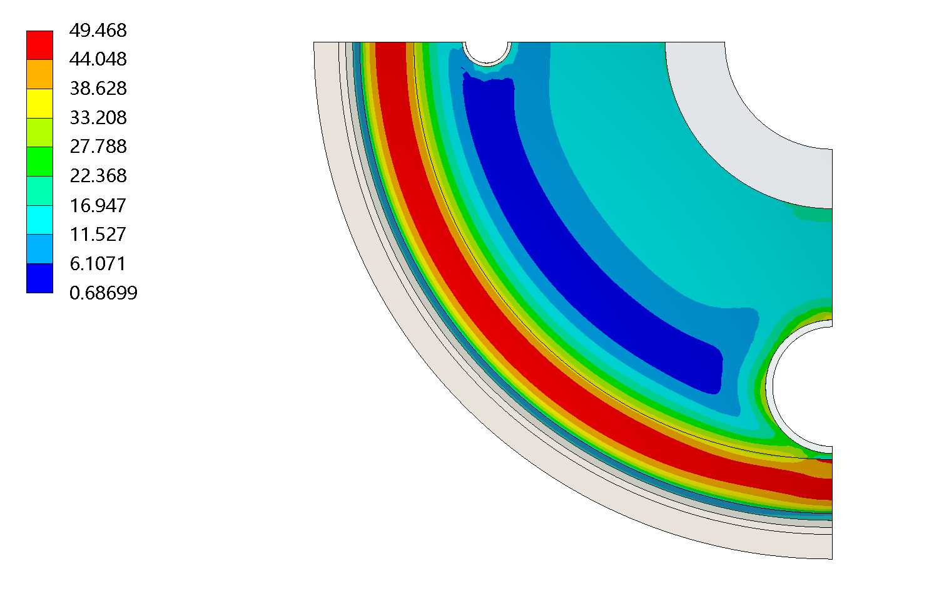
Figure 4 Von Mises stress distribution on the top lid in normal operation (values in MPa), seen from the inside of the helium vessel. Only a quarter of the geometry is displayed, for symmetry reasons.

3. Manufacturing and testing
3.1 Manufacturing details
The cylindrical shell and the torispherical lid have been cold-folded into the final shape and then welded to the flanges. Specifically, the cylindrical shell has been cold-rolled and longitudinally joined by Tungsten Inert Gas (TIG) welding. The flanges have been machined separately and then welded to the cylindrical shell and the top lid. Particular precautions were taken to ensure the required tolerances. The bottom base has been machined from a thick round plate and the four feet were welded at the end; whereas the protruding square pipe has been formed separately and welded to the base. The top lid and the bottom base are joined to the cylindrical body through weld ring gaskets, including a graphite layer about 0.5 mm thick, supplied by Klinger Kempchen GmbH (Oberhausen, Germany) [13].
The EDIPO 2 helium vessel has been manufactured by KASAG Swiss AG (Langnau i.E., Switzerland) [14] and delivered at the premises of the Swiss Plasma Center in December 2021. Figure 5 displays the assembled vessel with temporary welding of the top lid and the bottom base.

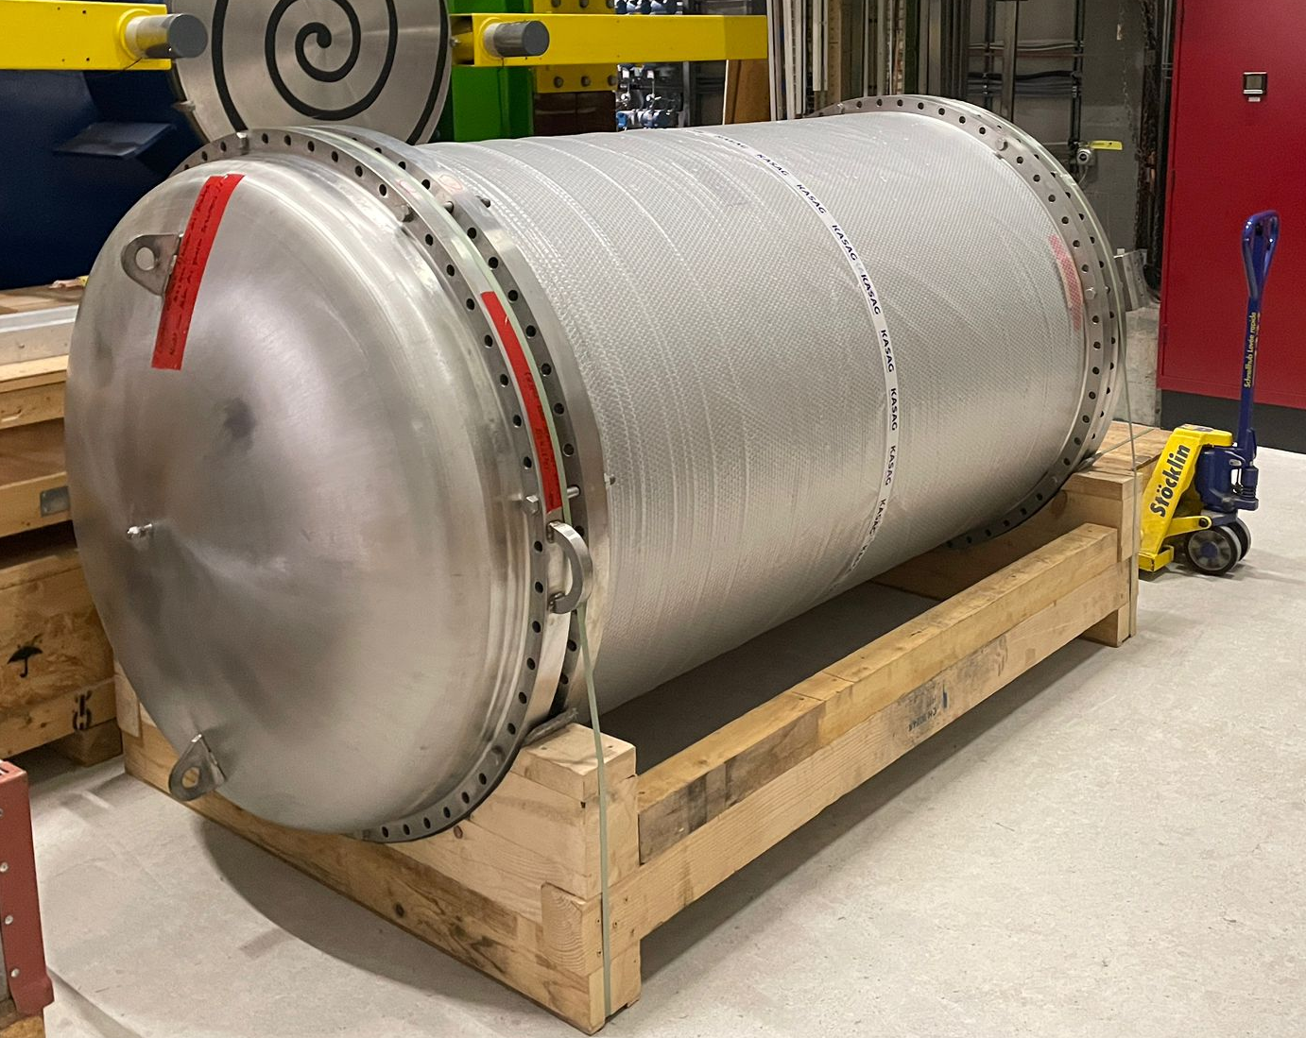
Figure 5 Assembled EDIPO 2 helium vessel delivered at the premises of the Swiss Plasma Center at the Paul Scherrer Institut (Villigen, Switzerland). The lugs welded on the top lid are temporary, and used only for transportation and handling purposes.

3.2 Pressure tests
The pressure tests, as part of the final acceptance test procedure, have been performed by filling the helium vessel with water and controlling the pressure up to the value of the accidental/test scenario provided by Equation (A4) (see Appendix A). Eight uniaxial strain gauges have been applied onto the external surface of the helium vessel to monitor the strain over time, at the locations displayed in Figure 6.

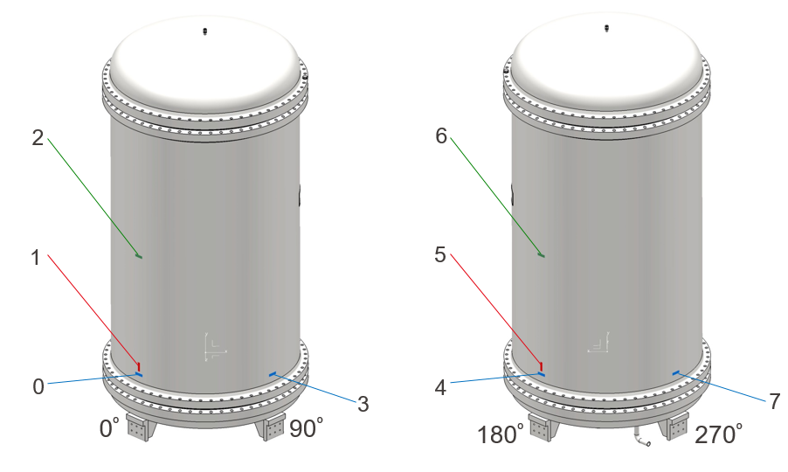
Figure 6 Schematic view of the location and the orientation of the uniaxial strain gauges during the pressure tests of the EDIPO 2 helium vessel, with respect to the angular orientation of the vessel.

Specifically, three types of strain gauges have been installed, namely to measure (i) the hoop strain and (ii) the vertical strain at the lower part of the cylinder, and (iii) the hoop strain at the middle of the cylindrical body. The experimental results are compared with the finite-element numerical simulations described above, as displayed in Figure 7. For each strain gauge, the average value and the standard deviation are reported. Whereas the finite-element results are shown in a range corresponding to a thickness range of the cylindrical body of the vessel, i.e., a minimum value of 5.2 mm and a maximum value of 6.0 mm. We observe that the numerical results are in very good agreement with the experimental ones, except only for the measurement of the vertical strain, which is slightly underestimated by the numerical simulations. This discrepancy can be due to the fact that the vertical strain components change significantly (in contrast to the hoop strain) when moving away from the welding seam of the bottom base. In the actual vessel, the bottom welding seam is quite thick and thus it is closer to the location of the strain gauge. This effect cannot be well captured by the finite-element model. Note also that the resolution of the manometer used in the pressure tests was 0.1 bar, thus the expected effect on the strain values is maximum 5% at 2.0 bar.

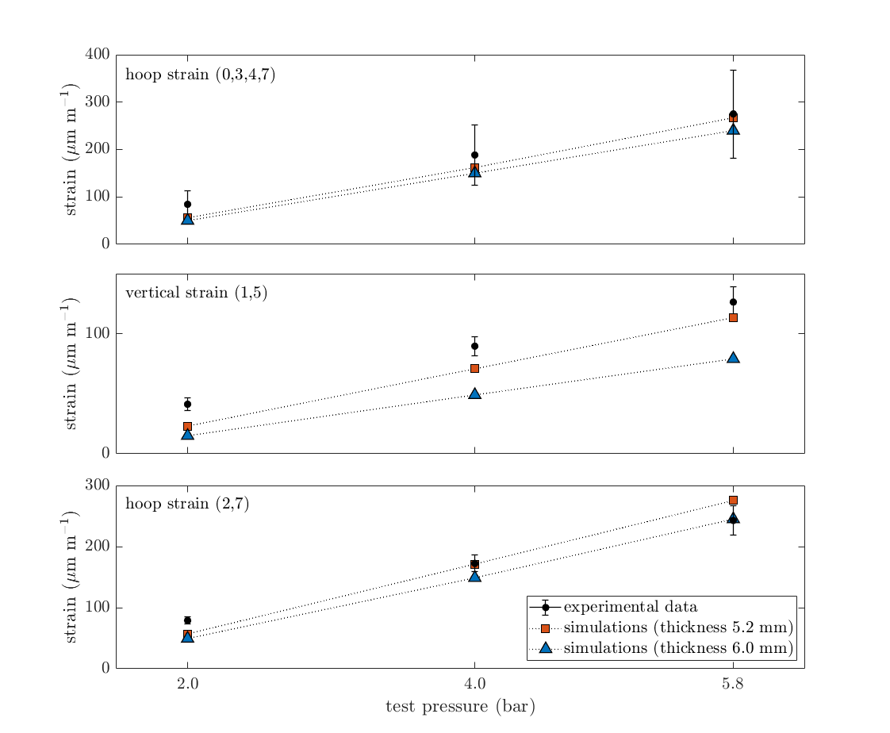
Figure 7 Measured and simulated strain components at different locations of the EDIPO 2 helium vessel. The numbers refer to the location of the strain gauges as shown in Figure 5.

4. Conclusions
We have presented relevant updates related to the ongoing design of the EDIPO 2 cryostat at the Swiss Plasma Center. The helium vessel, which has been conceived to host a new 15 T magnet to be integrated into the existing infrastructure, has been designed and manufactured.
The determination of the thermal budget of the helium vessel, which is relevant for the cryogenic operation of the facility, has shown that the main heat loads to the lowest temperature level (i.e., 4.2 K approximatively) are due to conduction through the supports, the test well and other pipes. Radiation, instead, is the predominant source of heat load at the 80 K temperature level. The structural design of the vessel has been carried out according to EN 13445-3, and finite-element structural simulations have been employed to validate the design, as well as provide a good agreement with experimental pressure tests.

Acknowledgements
The authors acknowledge KASAG Swiss AG for fruitful discussions, and the technical support of the Paul Scherrer Institut (PSI). The authors also acknowledge Dr. Rainer Wesche for providing the data on the EDIPO current leads.
This work has been carried out within the framework of the EUROfusion Consortium, funded by the European Union via the Euratom Research and Training Programme (Grant Agreement No 101052200 – EUROfusion). Views and opinions expressed are however those of the authors only and do not necessarily reflect those of the European Union or the European Commission. Neither the European Union nor the European Commission can be held responsible for them.

References
[1] P. Bruzzone, B. Stepanov, D. Uglietti, R. Wesche, K. Sedlak, EDIPO: The test facility for high-current high-field HTS superconductors, IEEE Transactions on Applied Superconductivity 26 (2016) 35-40.
[2] P. Bruzzone, L. Bottura, F. Cau, G. de Rijk, P. Ferracin, J. Minervini, A. Portone, S. Prestemon, E. Rochepault, E. Ravaioli, G. Sabbi, P. Testoni, Conceptual design of a large aperture dipole for testing of cables and insert coils at high field, IEEE Transactions on Applied Superconductivity 28 (2018) 4005505.
[3] D.M. Araujo, A. Ballarino, B. Bordini, L. Bottura, S.C. Hopkins, J.C. Perez, E. Ravaioli, G. de Rijk, P. Bruzzone, X. Sarasola, K. Sedlak, E. Solodko, F. Cau, A. Portone, L. Reccia, P. Testoni, D. Arbelaez, P. Ferracin, I. Pong, S. Prestemon, G. Sabbi, G. Vallone, Progress on the upgrade of EDIPO, a 15 T large aperture dipole, IEEE Transactions on Applied Superconductivity 31 (2021) 9500205.
[4] X. Sarasola, P. Bruzzone, R. Guarino, K. Sedlak, E. Solodko, Progress on the design of the 15 T magnet of the EDIPO test facility, IEEE Transactions on Applied Superconductivity 32 (2022) 9500505.
[5] R. Guarino, X. Sarasola, E. Solodko, P. Bruzzone, K. Sedlak, Preliminary design of the pressure relief system of the EDIPO 2 helium vessel, Cryogenics 124 (2022) 103470.
[6] DIN 2695:2021, Diaphragm-weld packings and weld ring seals for flange connections, https://dx.doi.org/10.31030/3249555.
[7] V. Parma, Cryostat design, Proceedings of the CAS-CERN Accelerator School: Superconductivity for Accelerators, Ed: R. Bailey, Erice, Italy, 24 April - 4 May 2013, http://dx.doi.org/10.5170/CERN-2014-005.353.
[8] B. Baudouy, Heat transfer and cooling techniques at low temperatures, Proceedings of the CAS-CERN Accelerator School: Superconductivity for Accelerators, Ed: R. Bailey, Erice, Italy, 24 April - 4 May 2013, http://dx.doi.org/10.5170/CERN-2014-005.329.
[9] R. Wesche, M. Bagnasco, P. Bruzzone, R. Felder, M. Guetg, M. Holenstein, M. Jenni, S. March, F. Roth, M. Vogel, Test results of the 18 kA EDIPO HTS current leads, Fusion Engineering and Design 86 (2011) 1414-1417.
[10] M.N. Wilson, Superconducting Magnets, Oxford University Press, Oxford, United Kingdom, 1983.
[11] EN 13445:2014, Unfired pressure vessels – Part 3: Design.
[12] ANSYS® Mechanical®, Release 2021R1, Ansys Inc., https://www.ansys.com.
[13] Klinger Kempchen GmbH, https://www.klinger-kempchen.de.
[14] KASAG Swiss AG, https://www.kasag.com.
[15] ISO 21009:2008, Cryogenic vessels – Static vacuum-insulated vessels – Part 1: Design, fabrication, inspection and test.

Appendix A – Preliminary sizing according to EN 13445-3
The maximum allowed value of the nominal design stress for pressure vessels made of austenitic steel with an elongation at fracture larger than 35%, is defined as [11]:
$$f_{d}=\text{max}\left\{\left(\frac{R_{p1.0/T}}{1.5}\right);\text{min}\left(\frac{R_{p1.0/T}}{1.2};\frac{R_{m/T}}{3.0}\right)\right\}$$ | (A1)
where R_{p0.1/T} and R_{m/T} refer to the calculation temperature T, and f_{d} refers to normal operating load cases.
The maximum allowed value of the testing stress and in the case of exceptional load cases, instead, is given by [11]:
$$f_{test}=\text{max}\left\{\left(\frac{R_{p1.0/T_{test}}}{1.05}\right);\left(\frac{R_{m/T_{test}}}{2.0}\right)\right\}$$ | (A2)
where all the quantities refer to the test (or exceptional load case) temperature T_{test}.
By considering the material properties reported in Table 3, for the EDIPO 2 helium vessel we get f_{d} ≈ 173 MPa and f_{test} = 260 MPa. Taking the worst-case value (i.e., f_{test}), the minimum wall thickness of the vessel can be computed. Specifically, for cylindrical shells, it is given by:
$$e=\frac{PD_{i}}{2f_{test}z-P}$$ | (A3)
where D_{i} is the inner diameter, z a coefficient related to the joint welding and P the minimum test pressure computed according to the norm ISO 21009-1 [15] as (in bar units):
$$P=1.43\left(p_{s}+1\right)$$ | (A4)
where p_{s} is the maximum allowable pressure reported in Table 1. In our case, considering an inner diameter of 1340 mm and choosing a welding coefficient equal to 0.85 [11], we get a minimum thickness e ≈ 1.74 mm.

Table 3 AISI 304L stainless steel (EN 1.4307) properties.
Quantity | Value
0.2% offset yield strength (R_{p0.2}) | 220 MPa
1.0% offset yield strength (Rp_{1.0}) | 240 MPa
tensile strength (R_{m}) | 520 MPa
Young’s modulus | 200 GPa
Poisson’s ratio | 0.28
density | 7900 kg m⁻³

Regarding the dished end (i.e., the top lid in the proposed design), the required minimum shell thickness e shall be the greatest among e_{s}, e_{y} and e_{b}, defined, respectively, by [11]:
$$e_{s}=\frac{PR}{2f_{test}z-0.5P}$$ | (A5a)
$$e_{y}=\frac{βP(0.75R+0.2D_{i})}{f_{test}}$$ | (A5b)
$$e_{b}=\left(0.75R+0.2D_{i}\right){\left[\frac{P}{111f_{b}}{\left(\frac{D_{i}}{r}\right)}^{0.825}\right]}^{\left(\frac{1}{1.5}\right)}$$ | (A5c)
where β ≈ 0.83 is a dimensionless coefficient extracted from tables [11], $f_{b}={R_{p0.2/T}}/{1.5}$ and R is the main radius of curvature of the dished end, with r = 0.1R. Finally, in our case we get e = e_{b} ≈ 5.18 mm.

