Discussion of “Diagnostic Curve for Confined Aquifer Parameters from Early Drawdowns” by Sushil K. Singh
July/August 2008, Vol. 134, No. 4, pp. 515–520.
DOI: 10.1061/(ASCE)0733-9437(2008)134:4(515)
D. A. Barry¹; L. Wissmeier², J.-Y. Parlange³; and L. Li⁴
¹Professor, Ecole polytechnique fédérale de Lausanne, Faculté de l’environnement naturel, architectural et construit, Institut des sciences et technologies de l’environnement, Laboratoire de technologie écologique, Station no. 2, CH-1015 Lausanne, Switzerland. Ph. +41 (21) 693-5576; Fax. +41 (21) 693-5670; Email: andrew.barry@epfl.ch.
²Doctorant, Ecole polytechnique fédérale de Lausanne, Faculté de l’environnement naturel, architectural et construit, Institut des sciences et technologies de l’environnement, Laboratoire de technologie écologique, Station no. 2, CH-1015 Lausanne, Switzerland. Ph. +41 (21) 693-5727; Fax. +41 (21) 693-5670; Email: laurin.wissmeier@epfl.ch.
³Professor, Department of Biological and Environmental Engineering, Cornell University, Ithaca, New York 14853-5701 USA. Ph. +1 (607) 255-2476; Fax. +1 (607) 255-4080; Email: jp58@cornell.edu.
⁴Professor, School of Engineering, The University of Queensland, St. Lucia, Queensland 4067 Australia. Ph. +61 (7) 3365-3911; Fax. +61 (7) 3365-4599; Email: l.li@uq.edu.au.
The determination of aquifer parameters is fundamental to groundwater resources assessment. This important topic has received much attention in the literature over many years. The author presents a method for determination of parameters for an ideal confined aquifer, based on early drawdown data. The Theis well function (Theis, 1935), the topic of interest here, arises as a core part of the analysis. It is, of course, essential that approximations to the Theis well function be robust and accurate so that reliable estimates of aquifer parameters are obtained.
Two approximations for the Theis well function are presented by Singh (2008). The purposes of this Discussion are (i) to examine these two approximations, in particular their relative error as reported by the author, and (ii) to alert readers to an existing, easy-to-calculate approximation to the Theis well function.
Note that the Theis well function is identical to the exponential integral, $E_{1}\left(u\right)$, defined by (e.g., Roscoe Moss Company, 1990):
$$E_{1}\left(u\right)=\int_{u}^{∞}{\frac{exp\left(-\overline{u}\right)}{\overline{u}}}d\overline{u}.$$
In groundwater applications $u≥0$. Below the Theis well function will be referred to as $E_{1}\left(u\right)$.
In the following, equations from Singh (2008) are identified using an “S” before the identifying number.
The author’s analysis makes use of a scaled well function, $w$, which is related to the Theis well function by Eq. (S11):
$$w\left(η_{α}\right)=\frac{exp\left(\frac{10}{23}\right)}{η_{α}}E_{1}\left(\frac{10}{23η_{α}}\right).$$
The author gives two approximations for $w\left(η_{α}\right)$ – Eqs. (S20) and (S21), and Eqs. (S22) and (S23). From Eq. (S11),
$$u=\frac{10}{23η_{α}},$$
thus the author’s approximations for $E_{1}\left(u\right)$ can be readily determined. Substituting $η_{α}$ by $u$ in Eq. (2) using Eq. (3) gives:
$$E_{1}\left(u\right)=\frac{10}{23u}exp\left(-\frac{10}{23}\right)w\left(\frac{10}{23u}\right).$$
In other words the author’s approximations for $w\left(η_{α}\right)$ give directly approximations for $E_{1}\left(u\right)$. In addition, it is apparent from Eq. (4) that the relative error of approximations to $w$, here those reported in Singh (2008), will have the same relative error if considered as approximations for $E_{1}$.
The author’s first approximation for $E_{1}\left(u\right)$, denoted here as $E_{1,S1}\left(u\right)$, is given by Eqs. (4), (S20) and (S21) as:
$$E_{1,S1}\left(u\right)=\left\{\begin{matrix}exp\left(-\frac{10}{23}\right)ln\left(\frac{170\sqrt{2π}}{759u}\right), & u<\frac{2}{69}, \\ \frac{90exp\left(\frac{20}{23}-u\right)}{23u\left[9+7\sqrt{π}{\left(\frac{10}{23u}\right)}^{\frac{3}{4}}\right]}, & u≥\frac{2}{69}.\end{matrix}\right.$$
Observe that $E_{1,S1}\left(u\right)$ does not reduce to the analytical limits for $E_{1}\left(u\right)$ for $u→0$ or $u→∞$. For $u→0$ the limit is (e.g., Abramowitz and Stegun, 1964):
$${}_{u→0}^{lim}{E_{1}}=ln\left[\frac{exp\left(-γ\right)}{u}\right],$$
where $γ$ (= 0.5772…) is the Euler constant. It is evident that $\frac{170\sqrt{2π}}{759}$ in Eq. (5) is an approximation to $exp\left(-γ\right)$. We suggest that it is more appropriate to use $exp\left(-γ\right)$ directly in Eq. (5) rather than this approximation. Also, the small-$u$ approximation in Eq. (5) contains the leading factor $exp\left(-\frac{10}{23}\right)$, which appears to be due to a misprint and should be ignored.
Figure 1 shows the relative error of Eq. (5) near $u=\frac{2}{69}$, which is the point at which the two expressions in Eq. (5) switch from one to the other. Overall, the approximation is discontinuous, having also discontinuous slopes. These discontinuities could lead to numerical difficulties in this region if, for example, aquifer parameters were being estimated. A continuous function would better serve such tasks. The figure shows that the maximum relative error of the first expression in Eq. (5), without the factor $exp\left(-\frac{10}{23}\right)$, is about 0.96% as $u→\frac{2}{69}$, which agrees with the better-than-1% error stated by the author.
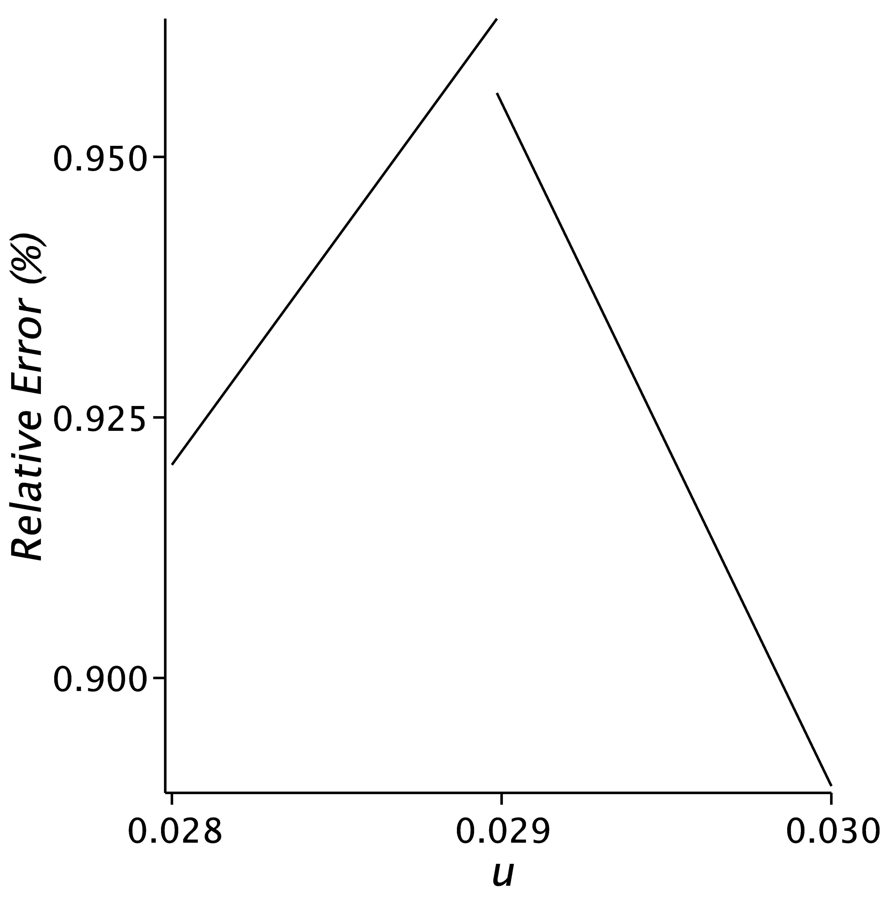
Fig. 1. Relative error in the vicinity of $u=\frac{2}{69}$ The relative error (%) is defined by 100$\left|1-\frac{approximation}{E_{1}\left(u\right)}\right|$, where the approximation is given by Eq. (5), except that the factor $exp\left(-\frac{10}{23}\right)$ has been removed for $u<\frac{2}{69}$. The relative error in this region increases substantially if this factor is retained.

Next, the relative error of the author’s approximation for the range $u≥\frac{2}{69}$ was calculated. In the large $u$ limit, the well function expansion gives (e.g., Abramowitz and Stegun, 1964):
$${}_{u→∞}^{lim}{E_{1}\left(u\right)}=\frac{exp\left(-u\right)}{u}.$$
On the other hand, the large $u$ expansion of Eq. (5) gives:
$${}_{u→∞}^{lim}{E_{1,S1}\left(u\right)}=\frac{10exp\left(\frac{20}{23}-u\right)}{23u}≈1.037\frac{exp\left(-u\right)}{u}.$$
Equation (8) shows that the relative error of Eq. (5) reaches 3.7% for $u≥\frac{2}{69}$, which is also the maximum relative error over its range of applicability. Singh (2008) reported that Eqs. (S20) and (S21) give a maximum error of less than 1%, suggesting a possible misprint.
Singh (2008) provides a second approximation that is continuous over the range of applications envisaged by the author. As noted above, a continuous approximation is preferable so as to avoid possible numerical problems in parameter estimation. Denote the author’s second approximation to the well function, given by Eqs. (S22) and (S23), as $E_{1,S2}\left(u\right)$:
$$E_{1,S2}\left(u\right)=\frac{10}{23u}exp\left[\sqrt{2}\left(1-\frac{115u}{162}\right)-\frac{10}{23}\right]{\left[1+ln\left(3\right){\left(\frac{10}{23u}\right)}^{\frac{π}{4}}\right]}^{-1-\frac{π}{5}-\frac{π^{2}}{61}{\left[ln\left(1+\frac{10}{23u}\right)\right]}^{-\frac{31π}{90}}}.$$
This approximation is valid in the range $\frac{5}{100}≤η_{α}≤{10}^{14}$, i.e., $\frac{{10}^{-13}}{23}≤u≤\frac{200}{23}$ (Singh, 2008). The minimum relative error of this approximation for the range given in Singh (2008) is about 23.8%, rather than the better-than-0.9% error reported by Singh (2008). This suggests that Eqs. (S22) and (S23) contain a transcription error.
Theis Well Function Approximation of Barry et al. (2000)
It seems that Singh (2008) was not aware of the approximation of Barry et al. (2000) for the Theis well function. This approximation reproduces the two leading terms of the small-$u$ and large-$u$ expansions of $E_{1}\left(u\right)$, and as well provides an optimized interpolation between those limits. The maximum relative error is less than 0.07%, meaning that the approximation provides at least three significant digits of precision. Their formula, denoted $E_{1,B}$, is:
$$E_{1,B}\left(u\right)=\frac{exp\left(-u\right)ln\left[1+\frac{exp\left(-γ\right)}{u}-\frac{1-exp\left(-γ\right)}{{\left(h+bu\right)}^{2}}\right]}{exp\left(-γ\right)+\left[1-exp\left(-γ\right)\right]exp\left[\frac{-u}{1-exp\left(-γ\right)}\right]}, u≥0,$$
where
$$h={\left(1+u\sqrt{u}\right)}^{-1}+{b\left\{1+\frac{exp\left(-2γ\right)}{6\left[2-exp\left(-γ\right)\right]}\right\}\left(1+\frac{47}{20}u^{-\sqrt{\frac{31}{26}}}\right)}^{-1}, and$$
$$b^{2}=\frac{2\left[1-exp\left(-γ\right)\right]}{exp\left(-γ\right)\left[2-exp\left(-γ\right)\right]}.$$
$E_{1,B}$ was constructed for the purpose of easily and quickly calculating $E_{1}$ using a programmable calculator or spreadsheet program.
Conclusions
Neither of the two approximations to the Theis well function of Singh (2008) has a relative error of less than 1%, presumably due to typographical errors. On the other hand, the existing approximation of Barry et al. (2000), given here as Eqs. (10) – (12), is straightforward and rapid to compute and has a maximum relative error of 0.07%, making it suitable for use in applications such as predicting drawdowns or estimating aquifer parameters from data.
References
Abramowitz, M., and Stegun, I. A. (1964). “Handbook of Mathematical Functions, with Formulas, Graphs and Mathematical Tables.” US National Bureau of Standards, Applied Mathematics Series 55, Washington DC, USA.
Barry, D. A., Parlange, J.-Y., and Li, L. (2000). “Approximation for the exponential integral (Theis well function).” J. Hydrol., 227(1-4), 287-291.
Roscoe Moss Company (1990). “Handbook of Ground Water Development”, Wiley, New York, USA.
Singh, S. K. (2008). “Diagnostic curve for confined aquifer parameters from early drawdowns.” ASCE J. Irrig. Drain. Eng., 134(4), 515-520.
Theis, C. V. (1935). The relation between the lowering of the piezometric surface and the rate and duration of discharge of a well using groundwater storage. Trans. Amer. Geophys. Union, 16(2), 519-524.

