Supporting Information
Swelling-Induced Chain Stretching Enhances Hydrolytic Degrafting of Hydrophobic Polymer Brushes in Organic Media
Jian Wang and Harm-Anton Klok*
Institut des Matériaux and Institut des Sciences et Ingénierie Chimiques, Laboratoire des Polymères, École Polytechnique Fédérale de Lausanne (EPFL), Bâtiment MXD, Station 12, CH-1015 Lausanne, Switzerland
jian.wang@epfl.ch, harm-anton.klok@epfl.ch

CORRESPONDING AUTHOR: Email: harm-anton.klok@epfl.ch; Tel: + 41 21 693 4866

EXPERIMENTAL SECTION
MATERIALS. All chemicals were used as received unless described otherwise. Copper(I)bromide (99.995+%), copper(II)bromide (99.999 %), 2-bromo-2-methylpropionyl bromide, allylamine (98%), trimethylacetyl chloride (99%), ethanol (99.8%) and aluminum oxide were purchased from Sigma-Aldrich. Anisole (99%) and chlorodimethylsilane (98%) were purchased from ABCR. Pt/C (10% Pt) was purchased from Alfa-Aesar. Tert-butyl methacrylate (98%) was purchased from Sigma-Aldrich. Prior to polymerization, the monomer was passed over a basic aluminum oxide column to remove the inhibitor. Sulfuric acid, acetone (99.5%), hydrofluoric acid (38%-40%) and triethylamine (distilled over KOH before use) were purchased from Merck. Dichloromethane, acetone (HPLC grade) and acetone (extra dry) were purchased from Fisher chemicals. The water content in the dry acetone was determined to 4500 ppm, or 0.45 vol%. 4,4'-Dinonyl-2,2'-bipyridyl (dnbpy) and 1,4,8,11-tetramethyl-1,4,8,11-tetraazacyclotetradecane (Me₄cyclam) were purchased from TCI. Tetrahydrofuran (THF), dimethylformamide (DMF) and toluene were purified and dried by a solvent-purification system (PureSolv). The water content in the dried DMF was determined to 65 ppm. Toluene with 330 ppm water was prepared by mixing water and toluene (volume ratio 1/50) and shaking overnight at room temperature. Then, the toluene part was used for the degrafting experiments. Deionized water was obtained from a Millipore Direct-Q 5 ultrapure water system. Degrafting experiments were performed on polymer brushes that were grown from 0.8 cm × 1 cm sized rectangular silicon wafers. To determine the molecular weight of the surface grafted polymer before and after degrafting, polymer brushes grown from 2.5 cm × 7 cm sized rectangular silicon wafers were used. All the silicon wafers used in this study are covered by a ~ 2 nm silicon oxide layer.
METHODS. X-ray photoelectron spectroscopy (XPS) was carried out using an Axis Ultra instrument from Kratos Analytical equipped with a conventional hemispheric analyzer. The X-ray source employed was a monochromatic Al Kα (1486.6 eV) source operated at 100 W and 10⁻⁹ mbar. Static water contact angles (WCA) were determined using a DataPhysics OCA 35 contact angle measurement instrument at ambient conditions. Surfaces were cleaned with a Femto O₂ Plasma system (200 W, Diener Electronic). The water content in organic solvents was measured with a Karl Fischer coulometric titrator (Mettler ToleDo DL 32). ¹H NMR spectra were recorded on a Bruker AVANCE-400 Ultra Shield spectrometer.
Ellipsometry (Figure 1A-1C, S3). A Sopra GES 5E spectroscopic ellipsometer (Sopra SA, France) was used to determine dry film thicknesses. Measurements were recorded at 15 nm intervals from 305 nm to 800 nm at an angle of incidence of 70° under ambient conditions. The ellipsometry data were analyzed using the WINELLI_II Software (Sopra SA, France) and the calculation method was based on a four-layer silicon/silicon oxide/polymer brush/air model, assuming the polymer brush to be isotropic and homogeneous. The refractive index (n) of the PtBMA layer is described by the Cauchy approximation (n = A_{n} + B_{n}/λ²), where A_{n} = 1.463, B_{n} = -4.3681×10⁻⁵ μm² and λ is the wavelength of the incident light. Measurements were conducted at three different points on each substrate. All reported dry film thicknesses represent the average ± standard deviation (SD) of five substrates.
Ellipsometry. The thicknesses of swollen brushes were determined using a SemiLAB (SE2000) ellipsometer with a liquid cell. The swelling ratio of polymer brushes on silicon substrates was determined by calculating the ratio of the swollen film thickness to the dry film thickness in air. Samples were placed on the sample stage and the reflected laser was properly aligned to the detector through the microspot placed on the detection arm. Dry film thicknesses were calculated based on a four-layer silicon/silicon oxide/polymer brush/air model, assuming the polymer brush to be isotropic and homogeneous. To determine the swollen film thicknesses, a gradient model was set up assuming that the polymer brush consists of four layers with different brush-solvent volume ratio.
AFM (Figure S5). Atomic force microscopy (AFM) was performed on a Veeco CP-II instrument (Digital Instruments, Santa Barbara, CA) controller in contact mode using an MPP-11123-10 (Veeco) cantilever to measure swollen brush thicknesses.
Gel permeation chromatography (GPC). GPC analysis was performed using an Agilent 1260 infinity system equipped with a Varian 390-LC refractive index detector, two PLgel 5 μm Mixed C (Agilent) columns and a PLgel guard column. The mobile phase was THF (HPLC grade) at a flow of 1.0 mL/min at 40 ºC. Samples were filtered prior to analysis and results were calibrated with linear PMMA standards (2200-201000 g/mol, Polymer Standard Service Mainz).

PROCEDURES.
Synthesis of the ATRP initiator and functionalization of silicon oxide substrates with the ATRP initiator. The preparation of the ATRP initiator, 2-bromo-2-methyl-N-{3-[chloro(dimethyl)silyl]-propyl}propanamide and the functionalization of silicon oxide surfaces with this initiator were performed following a published protocol.^{[1]} The ATRP inactive, dummy initiator, N-(3-(chlorodimethylsilyl)propyl)pivalamide was synthesized via the same method using trimethylacetyl chloride instead of α-bromoisobutyryl bromide. Silicon surfaces with different grafting densities were prepared by placing the substrates in anhydrous toluene solutions with 10 mM of the chlorosilanes that contained 20, 50 or 100 mol% of the ATRP active compound. ¹H-NMR spectra of the ATRP initiator and dummy chlorosilane are shown in Figure S9 and Figure S10. Figure S11 and Figure S12 present the results of the water contact angle analysis and XPS characterization of the ATRP initiator modified substrates.
Surface-initiated polymerization of tBMA. PtBMA brushes were prepared according to a previously published protocol. Instead of tert-butyl acrylate at a concentration of [M] = 3.5 M, tert-butyl methacrylate ([M] = 3.1 M) was used.^{[2]}
Patterned Polymer Brushes. Patterned polymer brushes were prepared via surface-initiated polymerization from micropatterned substrates, which were obtained by UV irradiation of initiator-modiﬁed silicon wafers using a TEM grid as a photomask.^{[3]} A Hamamatsu (Lightningcure L8858, 200 W, wavelength = 360 nm) UV lamp was used as the light source and substrates were irradiated for 8 min. at a distance of 6 cm from the lamp.
Degrafting experiments. Degrafting experiments were performed at room temperature by incubating polymer brush coated substrates in the appropriate medium. The following media have been investigated: toluene, THF + 11 ppm water, toluene + 330 ppm water, THF + 5 vol% water, THF + 20 vol% water, DMF, acetone, DMF + 5 vol% water, acetone + 5 vol% water and pure water. At deﬁned times, the substrates were removed from the medium, washed extensively with ethanol and dried under a ﬂow of N₂. The degrafting of the polymer brushes was assessed by monitoring the dry film thickness as a function of incubation time.
Cleaving PtBMA brushes from silicon oxide substrates: 3 pieces of PtBMA brush grafted silicon oxide substrates (2.5 × 7 cm) were incubated in a Teflon beaker containing THF (28.5 mL) and 40% hydrofluoric acid (1.5 mL). The mixture was vigorously stirred at 240 rpm for 2 h. After removing the silicon oxide substrates, the content of the Teflon beaker was allowed to evaporate to dryness overnight under ambient conditions in the fume hood. The residual polymer in the beaker was then redissolved in 300 uL THF and subjected to GPC analysis. To determine the molecular weight of the remaining surface-tethered polymer after exposure to THF + 5 vol% water for 4 h, cleavage was performed via the same method using 4 pieces of PtBMA brush grafted silicon oxide substrates (2.5 × 7 cm) instead of 3. (Figure S3).

Figure S1. Ellipsometric dry thickness of PtBMA brushes as a function of incubation time upon exposure to: dry DMF (65 ppm water) (■), dry acetone (0.45 vol% water) (▼).

Figure S2. Comparison of the dry film thickness of a PtBMA brush sample with an initial dry film thickness of 174 nm (red) after incubation in THF + 5 vol% water for 4 hours without further washing (1) as well as after application of several washing steps (2-5).

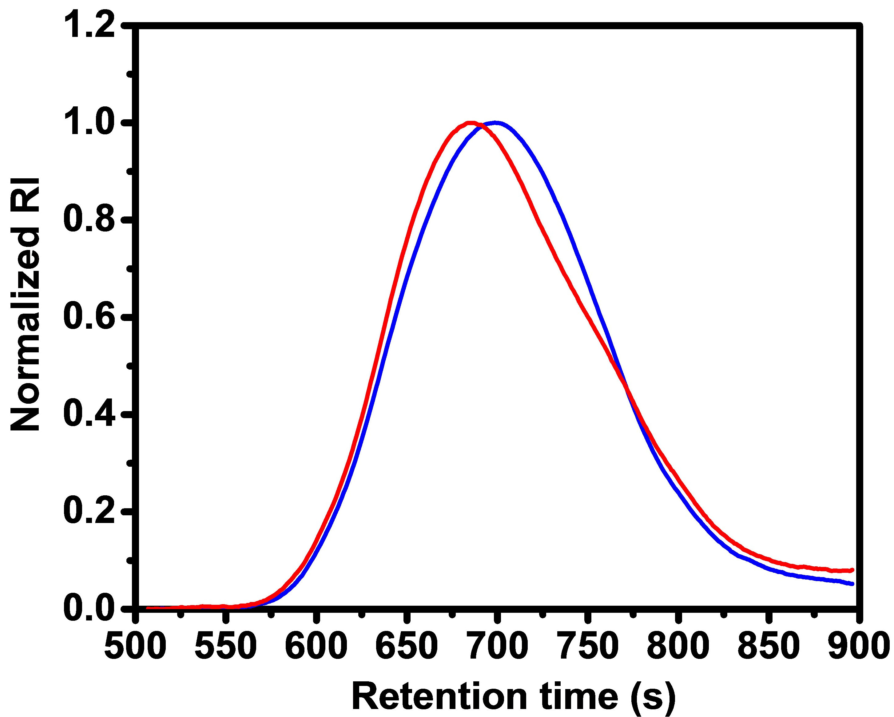
Figure S3. Normalized GPC traces of PtBMA cleaved from brush coated silicon oxide substrates. Original PtBMA brush (red) (initial dry film thickness = 165 nm), M_{n}＝248 kDa, M_{w}＝422 kDa and PtBMA brush after 4 h degrafting in THF + 5 vol% water (blue), M_{n}＝231 kDa, M_{w}＝397 kDa.

Figure S4. Evolution of the dry film thicknesses of PtBMA brushes with initial dry film thicknesses of 160 nm (▲), 80 nm (●) and 50 nm (■) upon incubation in THF + 5 vol% water for 7 days.

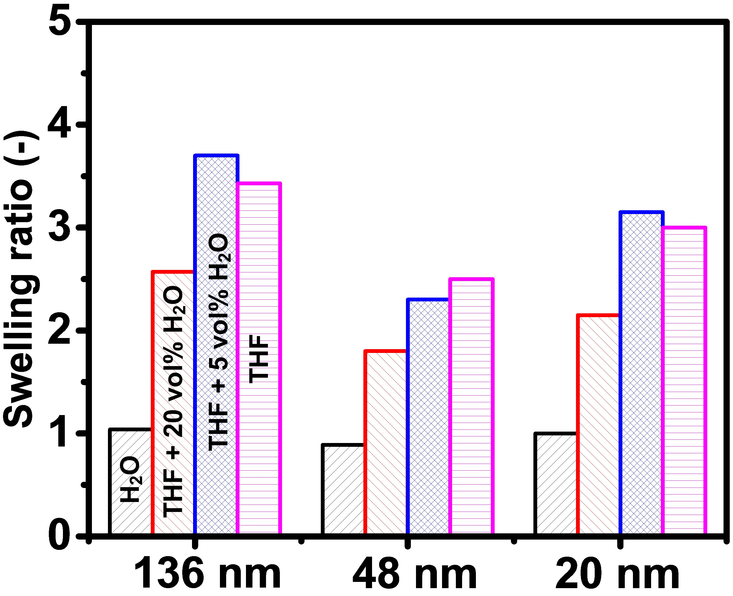
Figure S5. Swelling ratios of PtBMA brushes with initial dry film thicknesses of 20, 48 and 136 nm in water (black), THF + 20 vol% water (red), THF + 5 vol% water (blue) and THF (pink) as measured by AFM.

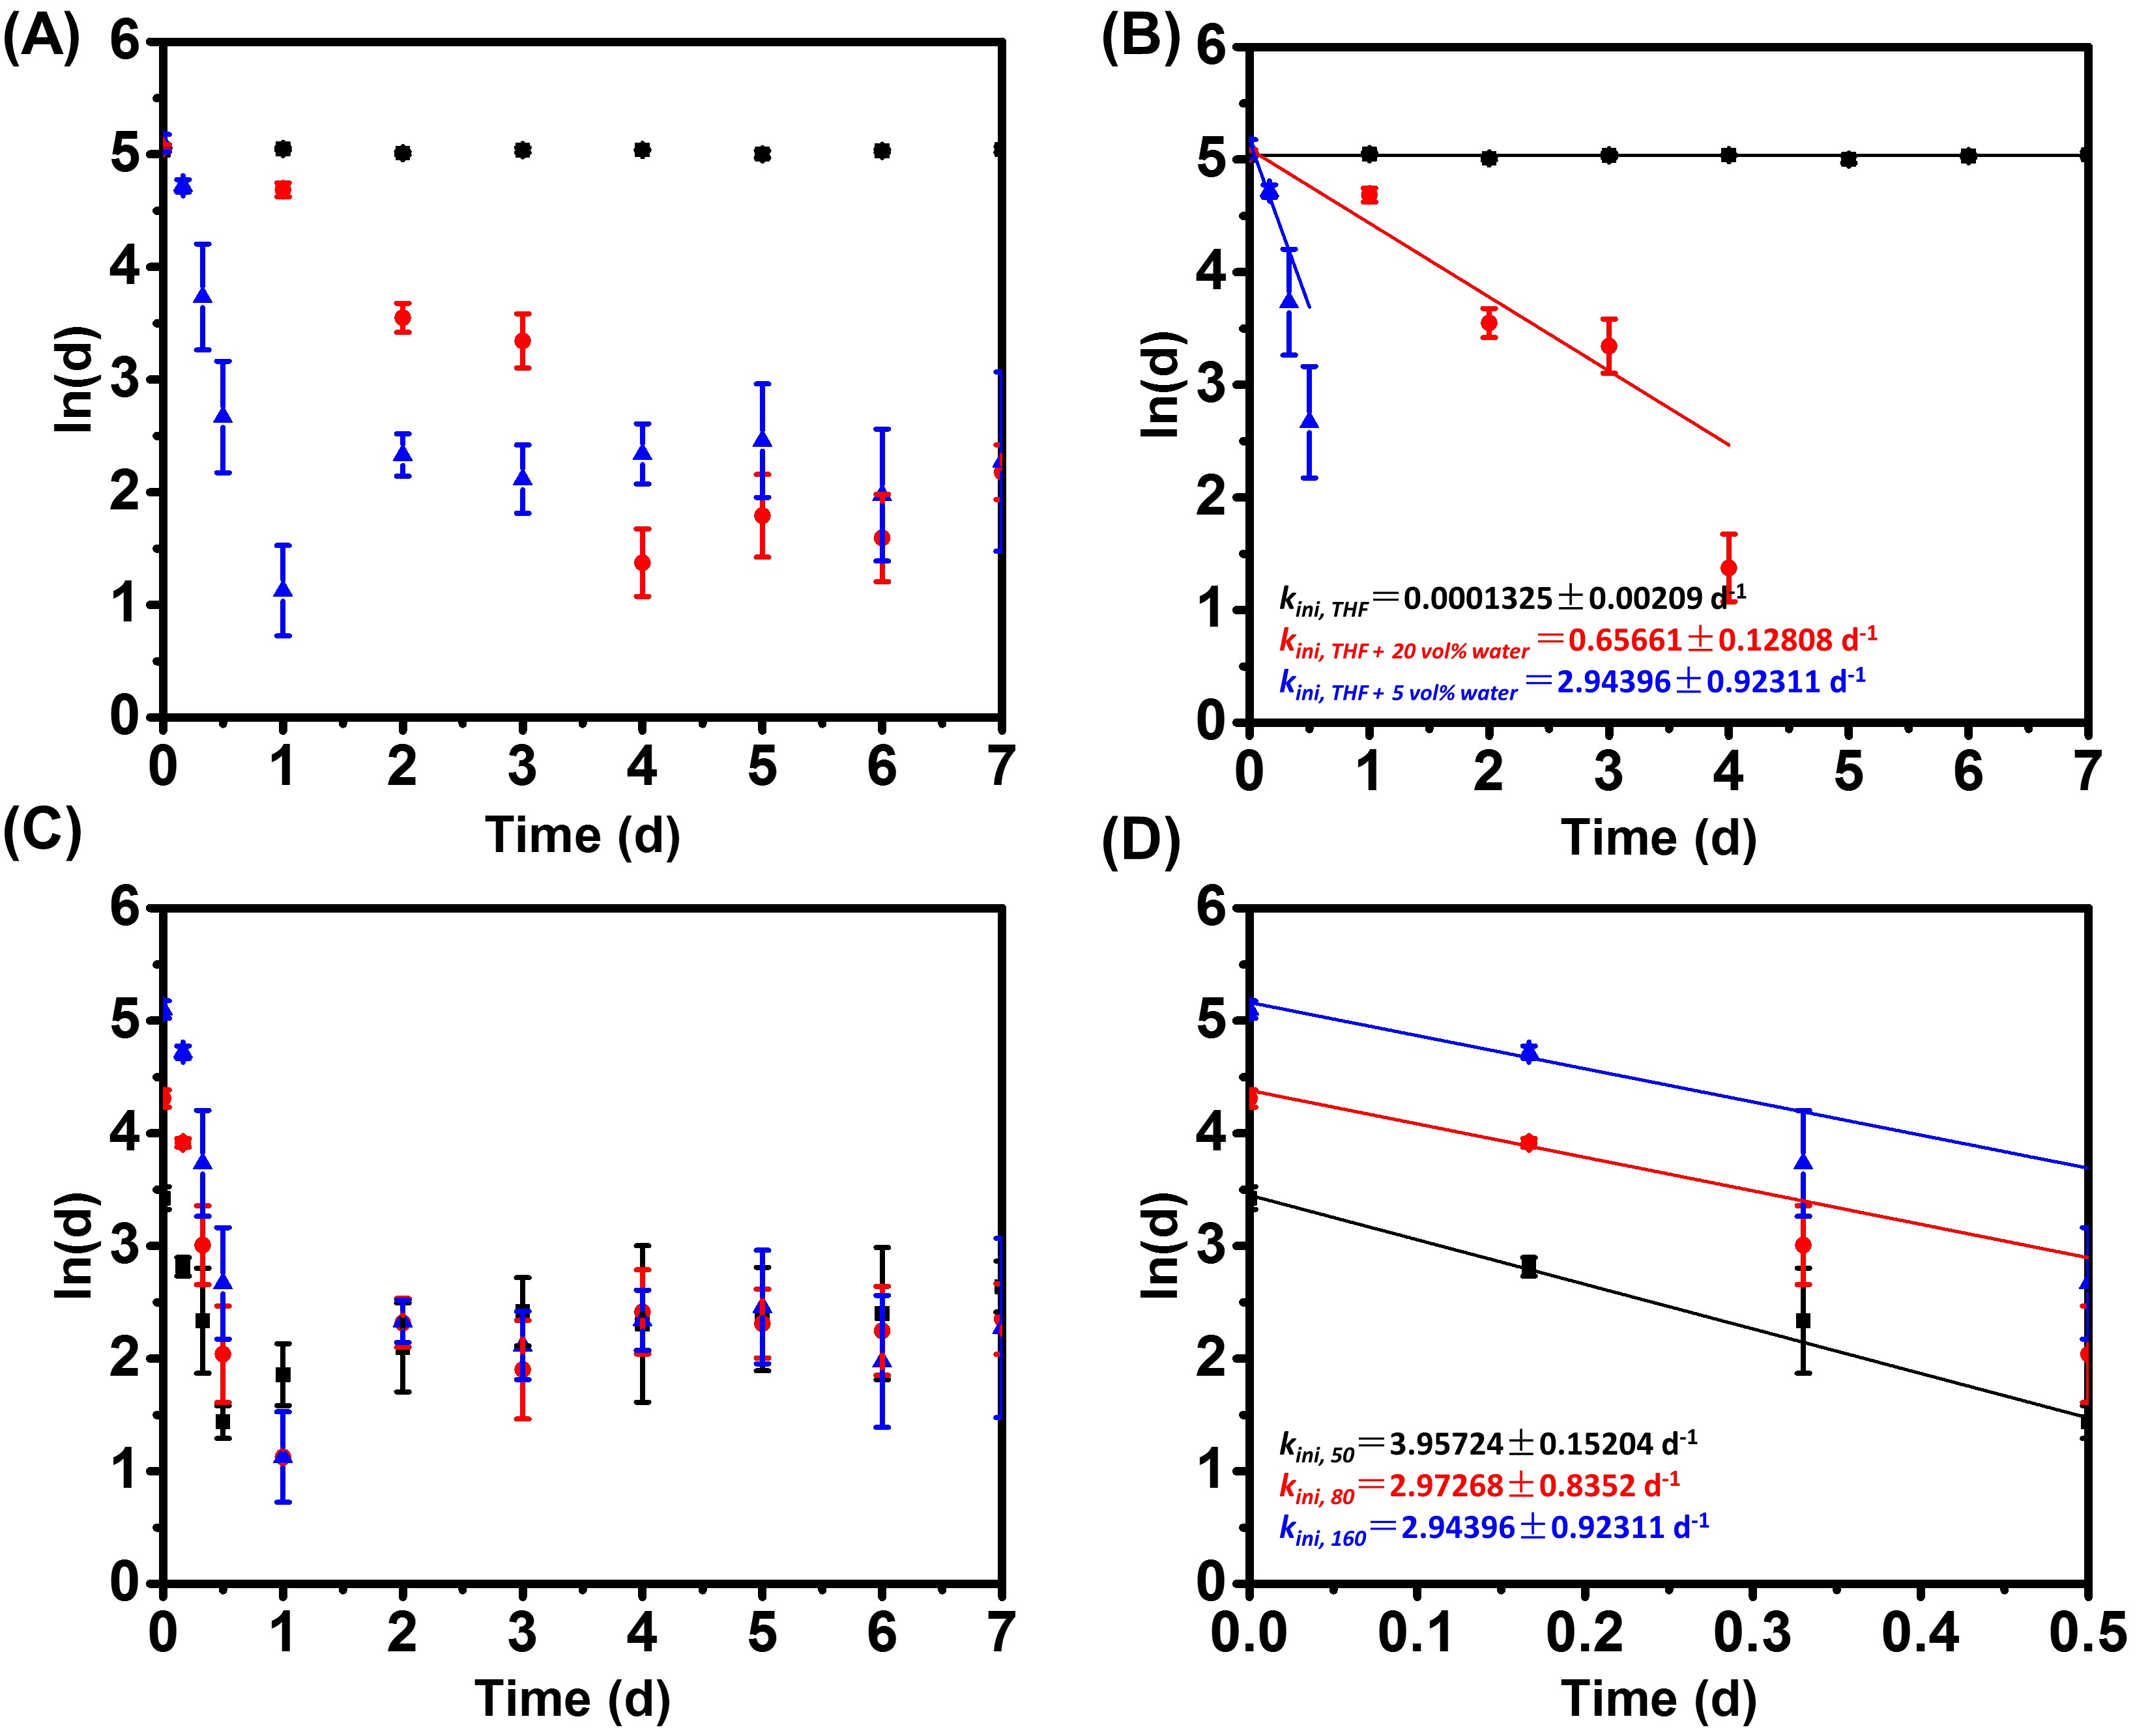
Figure S6. (A) ln (d) (d = dry film thickness) as a function of time for PtBMA brushes with an initial dry film thickness of 160 nm upon incubation in THF + 11 ppm water (■), THF + 5 vol% water (▲) and THF + 20 vol% water (●); (B) Determination of the initial rate constant of degrafting for PtBMA brushes with an initial dry film thickness of 160 nm upon incubation in THF + 11 ppm water (■), THF + 5 vol% water (▲) and THF + 20 vol% water (●); (C) ln (d) (d = dry film thickness) as a function of time for PtBMA brushes with initial dry film thicknesses of 50 (■), 80 (●) and 160 nm (▲) upon incubation in THF + 5 vol% water; (D) Determination of the initial rate constant of degrafting for PtBMA brushes with initial dry film thicknesses of 50 (■), 80 (●) and 160 nm (▲) upon exposure to THF + 5 vol% water.

Figure S7. (A) ln (d) (d = dry film thickness) as a function of time for PtBMA brushes with an initial dry film thickness of 160 nm upon incubation in DMF + 5 vol% water (■), acetone + 5 vol% water (●) and THF + 5 vol% water (▲); (B) Determination of the initial rate constant of degrafting for PtBMA brushes with an initial dry film thickness of 160 nm upon incubation in DMF + 5 vol% water (■), acetone + 5 vol% water (●) and THF + 5 vol% water (▲).

Figure S8. (A) Ellipsometric dry thicknesses of PtBMA brushes with an initial grafting density of 20% as a function of incubation time upon exposure to in DMF + 5 vol% water (▲), acetone + 5 vol% water (●) and THF + 5 vol% water (■); (B) ln (d) (d = dry film thickness) as a function of time for PtBMA brushes with an initial grafting density 20% upon incubation in DMF + 5 vol% water (▲), acetone + 5 vol% water (●) and THF + 5 vol% water (■); (C) Determination of the initial rate constant of degrafting for PtBMA brushes with an initial grafting density of 20% upon incubation in DMF + 5 vol% water (▲), acetone + 5 vol% water (●) and THF + 5 vol% water (■); (D) Ellipsometric dry thicknesses of PtBMA brushes with an initial grafting density of 50% as a function of incubation time upon exposure to DMF + 5 vol% water (▲), acetone + 5 vol% water (●) and THF + 5 vol% water (■); (E) ln (d) (d = dry film thickness) as a function of time for PtBMA brushes with an initial grafting density 50% upon incubation in DMF + 5 vol% water (▲), acetone + 5 vol% water (●) and THF + 5 vol% water (■); (F) Determination of the initial rate constant of degrafting for PtBMA brushes with an initial grafting density of 50% upon incubation in DMF + 5 vol% water (▲), acetone + 5 vol% water (●) and THF + 5 vol% water (■).

Figure S9. ¹H-NMR spectrum of 2-bromo-2-methyl-N-{3-[chloro(dimethyl)silyl]-propyl}propanamide recorded in chloroform-d₁.

Figure S10. ¹H-NMR spectrum of N-(3-(chlorodimethylsilyl)propyl)pivalamide recorded in chloroform-d₁.

Figure S11. Water contact angle analysis of (A) an unmodified plasma cleaned silicon oxide surface (46.9º) and (B) a silicon oxide surface modified with 2-bromo-2-methyl-N-{3-[chloro(dimethyl)silyl]-propyl}propanamide (69.2º).

Figure S12. (A) XPS survey scan; B) C_{1s} high resolution spectrum; C) O_{1s} high resolution spectrum and D) N_{1s} high resolution spectrum of a 2-bromo-2-methyl-N-{3-[chloro(dimethyl)silyl]-propyl}propanamide modified silicon surface.

REFERENCES
[1] N. C. Ataman, H.-A. Klok, Macromolecules 2016, 49, 9035.
[2] Z. Bao, M. L. Bruening, G. L. Baker, J. Am. Chem. Soc. 2006, 128, 9056.
[3] S. Tugulu, M. Harms, M. Fricke, D. Volkmer, H.-A. Klok, Angew. Chem. Int. Ed. 2006, 45, 7458; Angew. Chem. 2006, 118, 7619.

