First B-dot measurements in the RAID device, an alternative negative ion source for DEMO neutral beams
Rémy Jacquierª, Riccardo Agnelloª, Basile Pouradier Duteilª, Philippe Guittienne^{b}, Alan Howlingª, Gennady Plyushchevª, Claudio Mariniª, Alain Simonin^{c}, Iaroslav Morgal^{c}, Stephane Bechu^{d}, Ivo Furnoª

ªEcole Polytechnique Fédérale de Lausanne (EPFL), Swiss Plasma Center (SPC), Lausanne, Switzerland
^{b}Helyssen, Belmont-sur-Lausanne, Switzerland
^{c}IRFM, CEA, Saint-Paul-lez-Durance, France
^{d}LSPC, CNRS/IN2P3, Grenoble, France

As a new concept of Neutral Beam Injectors (NBI) for DEMO-like reactors, SIPHORE (IRFM, CEA, in France) expects to extract negative deuterium ions and photo-neutralize the accelerated D-. The Swiss Plasma Center (SPC) of EPFL is involved in this project by developing an innovative helicon source, which could provide the adequate D₂ negative ion blade-shaped plasma, in terms of density and homogeneity along the axial direction. In the Resonant Antenna Ion Device (RAID), the test bed, a helicon wave is sustained by a resonant antenna plasma source at 13.56 MHz (input power ≤ 10 kW), connected to a cylindrical vacuum chamber (1.5 m long, 0.4 m diameter) and is surrounded by 6 Helmholtz coils, providing a DC magnetic field up to 800 G on axis. To characterize the helicon wave propagation, RAID has been recently equipped with a three-axis magnetic probe (B-dot). The paper describes the RAID experiment and its helicon source, including a 3D characterization of density and temperature, together with the B-dot design and calibration. It presents measurements of helicon wave propagation; in typical H₂ plasmas (0.3 Pa), preliminary results show a helicon wave right-handed polarized with a wavelength of approximately 240 mm.

Keywords: plasma, source, resonant antenna, helicon, magnetic probe, wave.

1. Introduction
Neutral Beam Injectors (NBI) for DEMO-like reactors will need D₂ neutrals at a high energy (>0.8 MeV) and a fair injector overall efficiency (>50 %) for plasma heating and current drive [1-3]. The neutralization efficiency of positive ions drops for energies higher than 100 keV/nucleon and thus NBIs based on negative ions are required [4]. A conceptual design of injectors (SIPHORE at IRFM, CEA, in France) expects to extract negative D₂ ions from a plasma 3 m long and 15 cm wide, and to photo-neutralize the accelerated D⁻ [2,3]. The Swiss Plasma Center (SPC) of EPFL has developed a helicon device (RAID: Resonant Antenna Ion Device) as a test bench of plasma sources for this new concept of NBI injectors [5]. On RAID, a birdcage resonant antenna is used to generate and sustain the plasma [6]. The electromagnetic configuration created by the resonant source and the axial DC magnetic field enables the propagation of a bounded type of whistler wave, called a helicon wave [7]. There are several reasons to use a helicon source instead of conventional inductive coils. Firstly, for the same power, helicon mode provides an electron density one order of magnitude higher than inductive mode (typically 10¹⁸ m⁻³ in H₂ and D₂ discharges [8,9]) although why this occurs is not fully understood yet. Secondly, the plasma can be maintained even at low pressure (<0.3 Pa), resulting in less wave damping and a quasi-homogeneous electron density along the plasma column. Moreover, in H₂ and D₂ plasmas, a high degree of dissociation and a high volume production of negative ions was demonstrated [8]. These results are very promising for negative ion beam application for fusion. Here, we present first helicon wave measurements on RAID in H₂ plasmas. The deposition of wave energy into the plasma is still an open issue. Advancing its basic understanding requires detailed measurements of wave properties. This stresses the importance of magnetic field measurements with B-dot probes, which measures the three components of the RF magnetic field of the helicon wave. The main challenge is achieving a high signal-to-noise ratio, with the smallest perturbation by the use of a miniaturized probe head. An accurate measurement of the induced current is performed by using a hybrid transformer, which reduces capacitive parasitic pickup.
The following chapters expand on the RAID device and its diagnostics, the design and calibration of the B-dot probe and, finally, preliminary results are given for our standard plasma parameters to demonstrate how a helicon wave is efficiently created in RAID.
2. The RAID experiment and its source
2.1 Design and configuration
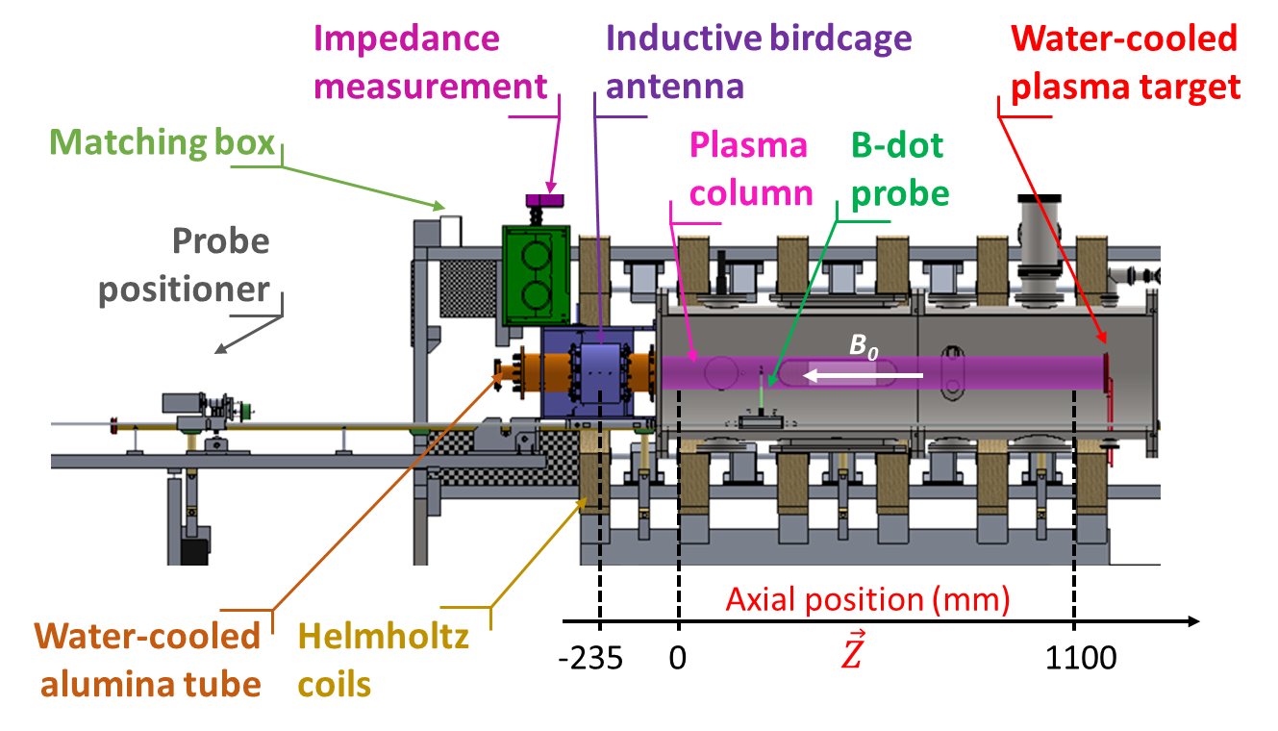
Fig. 1. The RAID experiment with the main elements.
RAID, shown in Figure 1, is a linear device composed of a cylindrical vacuum chamber (1.5 m long and 0.4 m in diameter). It is pumped by a turbo-molecular and a backing pump below 10⁻⁶ mbar with a constant pumping speed of 170 l /s. Different gases (H₂, D₂, Ar and He) can be injected and, commonly, the pressure during experiments is maintained at 0.3 Pa (the pressure usually required for NBI reactors [2,3]) using a mass flow meter.
The resonant source, a birdcage antenna located on the left side of the vacuum vessel, creates a plasma inside an alumina tube (40 cm long and 9.5 cm in diameter). An automatic T-matching circuit adapts the antenna impedance to the 50 ohm output impedance of the 13.56 MHz generator (15 kW maximum power). The chamber is surrounded by five magnetic Helmholtz coils providing a DC magnetic field up to 800 G on axis. A sixth coil, around the antenna, produces a reversed field to generate a magnetic field gradient, which helps plasma stabilization. When the helicon mode reaches 500 W, a plasma column is generated and sustained between the antenna and a copper target (see Figure 1), which absorbs most of the plasma energy. The vacuum vessel, the antenna, the matching box, the ceramic tube and the copper target are water-cooled.
2.2 The birdcage source
Birdcage antennas have been extensively studied for nuclear magnetic resonance [10]. The use of birdcage antennas as inductive plasmas source was first proposed by Ph. Guittienne [6] and first prototypes were developed in collaboration with the SPC [11]. It is a network of capacitors and copper tubes acting as RLC parallel resonant circuits (see Figure 2). The antenna resonates at 13.56 MHz, generating a sinusoidal distribution of high current in the legs. This results in a uniform transverse RF magnetic field in the antenna interior, which efficiently excites helicon wave, a category of bounded whistler waves propagating in magnetized plasmas in the presence of an external axial DC magnetic field.
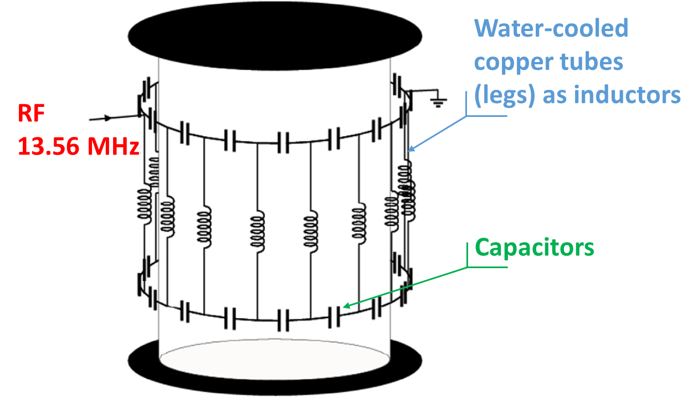
Fig. 2. Equivalent Radio Frequency (RF) circuit of the RAID antenna.
In pure inductive plasma mode, this system has been widely studied for industrial and research applications [11-14]. The high, purely-real input impedance around 140 ohm in vacuum drops with the plasma ignition to around 20 ohm and a small shift of the resonance frequency causes an imaginary component. This is due to the coupling of the network with the current induced in the plasma. The real input impedance facilitates the matching with the generator 50 Ohm output impedance with respect to a purely reactive load by diminishing the current in the transmission line and thus decreasing the heating of the coaxial cable internal conductor. Moreover, it is scalable and the geometry of the network can be either cylindrical or planar [14].
2.3 Characterization of plasma profiles
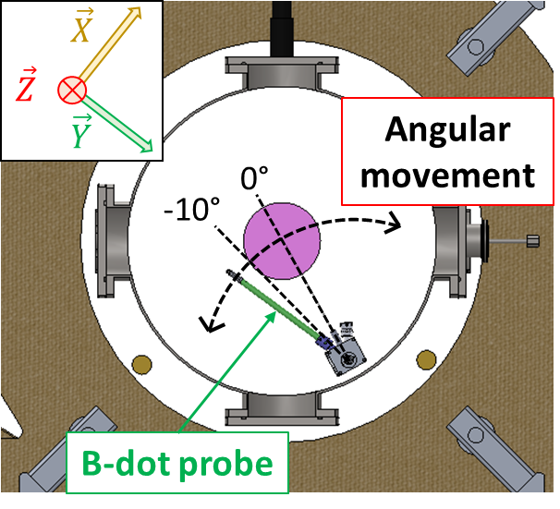
In RAID, a number of diagnostics have been installed and successfully tested, such as: Optical Emission Spectroscopy (OES) [8], cavity ring down spectroscopy [9], Langmuir probe assisted laser photo-detachment, laser induced fluorescence [15], interferometry, Langmuir and magnetic probes. A probe positioner can move Langmuir or magnetic probes in axial and angular direction to obtain a three-dimensional (3D) full coverage of RAID plasmas (see Figures 1 and 3).
Fig. 3. Angular movement of the B-dot probe.
Langmuir probe profiles of electron temperature and density are shown in Figure 4 in a H₂ plasma, at 3 kW power and a DC magnetic field of 200 G. Both profiles are quite homogeneous in the axial direction. The electron density on axis, which has also been measured absolutely by interferometry, is of the order of 10¹⁸ m⁻³.
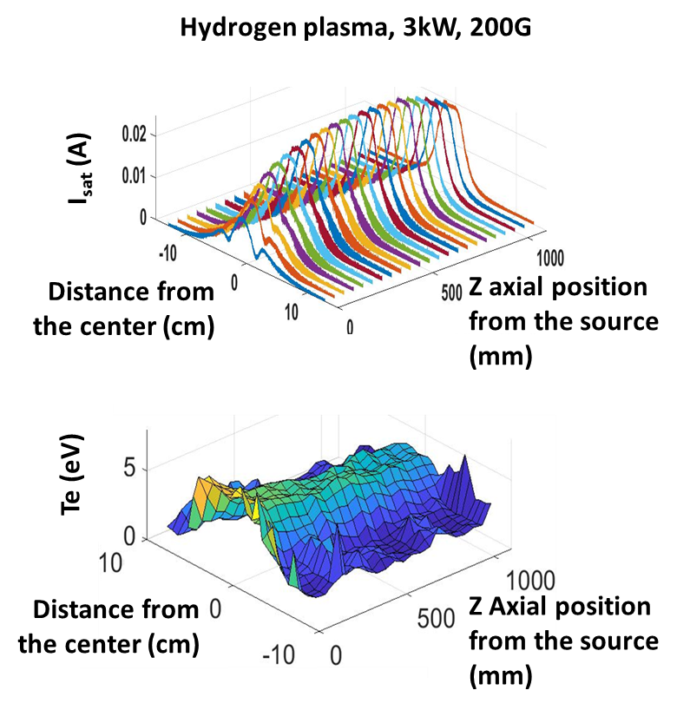
Fig. 4. 3D ion saturation current and temperature profiles in RAID. The antenna is located at the axial position z = -185 mm in Figure 1.
In the future SIPHORE experiment, this shape would be favorable for the extraction of a negative beam showing a sheet shape (3 m high, 1 cm wide) well adapted to the photo-neutralization concept [2,3]. Furthermore, the electron temperature in the center is high enough to excite rovibrational states of H₂ molecules. These molecules diffuse towards the chamber wall in the lower temperature region, where dissociative attachment produces negative atomic ions. Thus, in H₂ plasmas, pressure 0.3 Pa and 3.5 kW RF power, an integrated negative ion density of ̴ 2 x 10¹⁶ m⁻³ and ̴ 3 x 10¹⁶ m⁻³ have been respectively measured by OES [8] and cavity ring down spectroscopy [9]. Today, it is not known how the extraction of negative ions from helicon device will react, but studies are ongoing in the IRFM at Cadarache.
3. A magnetic probe for 3D measurements
3.1 Design of the B-dot
The B-dot is a magnetic probe dedicated to the measurement of the 3 components of the RF magnetic field in the plasma. It consists of 3 inductive pick-up coils, wrapped around a cubic probe head (5 x 5 x 5 mm³), made of ceramic. The Z-coil measures the varying magnetic field in the axial direction of the RAID reactor while X-coil and Y-coil measure the fields in the cross section (see in Figure 1 and 3). The interpretation of the measurements is made by using Faraday’s law. Since the coil’s cross-section is small enough and considering a harmonic time varying field B(t)=$\tilde{\left|B\right|}$e^{iωt}, the amplitude of the probe voltage is:
$V=-nωA\tilde{\left|B\right|}$, (1)
where n is the number of turns and B is the component of the magnetic field perpendicular to the area A and $ω$ is the angular frequency at 13.56 MHz. At this specific frequency, nA is the calibration factor described in the next section [16]. The B-dot probe should be as small as possible to minimize the plasma perturbations and it should provide a reasonable signal-to-noise ratio with low parasitic signals. Probe coils, made of 3 turns, have a square section of 6 x 6 mm². A twisted wire pair, an efficient method to cancel the parasitic inductive pick up in the line, connects each coil to a differential hybrid combiner (Figure 5). To reduce the capacitive coupling of the wires to the plasma, a Faraday shield in non-magnetic stainless steel screens the wires. The whole assembly is protected from plasma heating by an alumina cover.
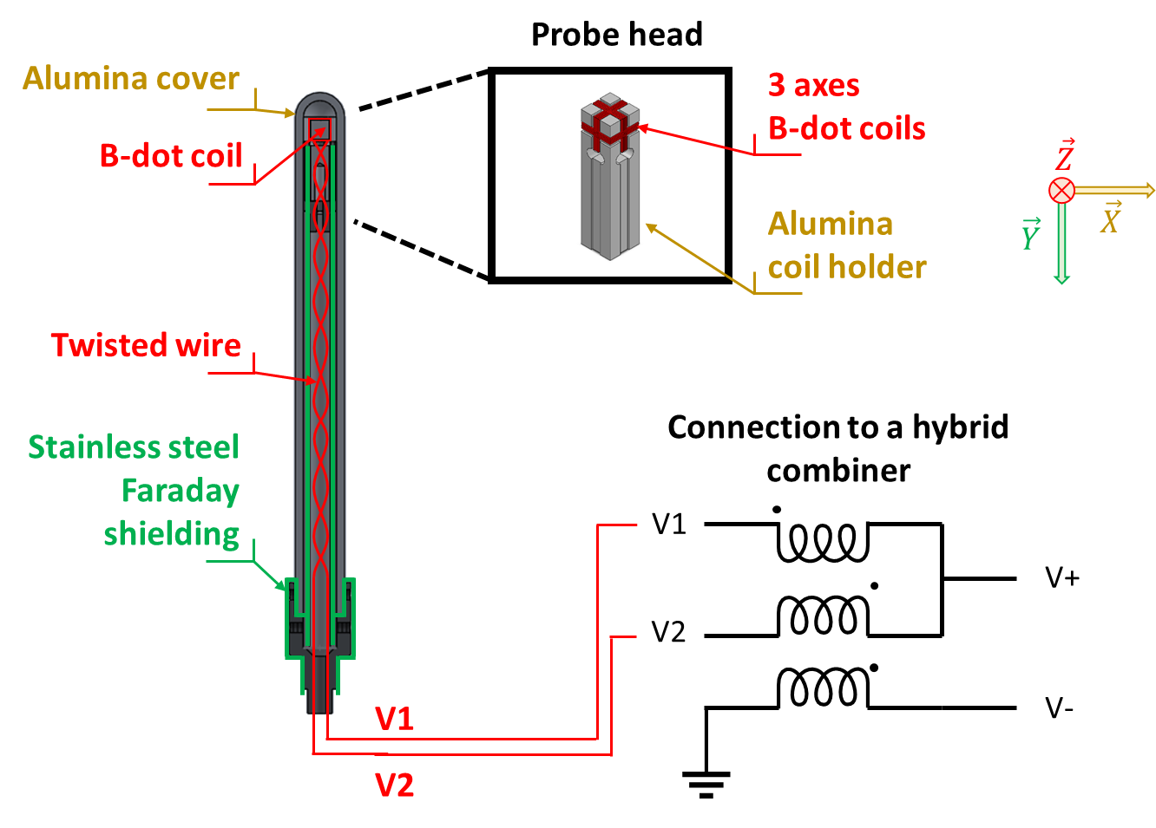
Fig. 5. B-dot connected to a hybrid combiner
The coil voltage signals also have common mode capacitive pick up, V_{cap}, due to a difference of potential between the plasma and the coil. Therefore, the measurement of the coil voltage is V= V_{ind} + V_{cap}, with V_{ind}, the magnetically induced voltage. To reduce the capacitive signal, a hybrid combiner is used [17]. V₁ and V₂, voltages coming from both ends of one pick-up twisted pair, are inputs of the hybrid combiner made with trifilar windings on a toroidal ferrite core. One can verify that V₁ – V = V₊ and V₂ + V = V₊. As V₋ = V:
$V_{-}=\frac{V_{1}-V_{2}}{2}=V_{ind}$ , (2)
$V_{+}=\frac{V_{1}+V_{2}}{2}=V_{cap}$ . (3)
3.2 Calibration on a test bench
To reduce the uncertainty of the absolute value of the magnetic field and to compensate for small relative differences in geometry of the 3-axis pick up coils, it is necessary to calibrate the B-dot probe with a known magnetic field.
Calibration of the B-dot probe is performed using a birdcage antenna (Figure 6), which generates an oscillating magnetic field homogeneous in the cross section [10]. Figure 6 shows the calculated amplitude of this magnetic field at one instant using a central cross section of the calibration birdcage.
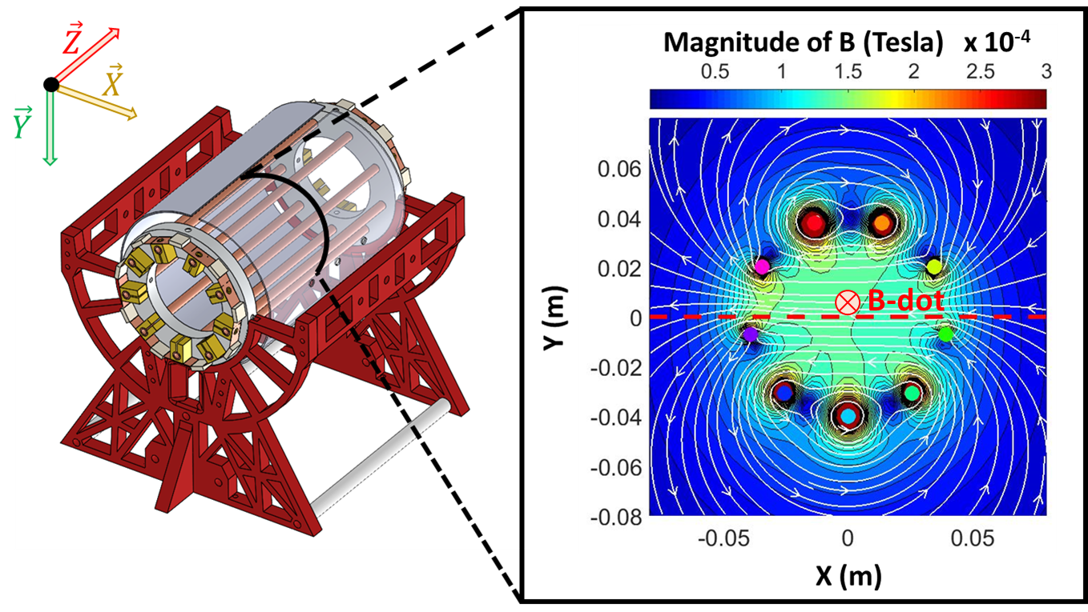
Fig. 6. Calibration antenna on the left and a model of the magnetic field magnitude in the central cross section on the right.
To compute the magnetic field lines with Faraday’s law, the current distribution in the legs (copper tubes) is needed. For this, the voltages at both ends of the legs are measured and the impedances of the legs are calculated taking into account the mutual inductances with the neighbours and of the cylindrical screens. The B-dot probe head is precisely located at X = 0 m Y = 0.006 m and each of the three B-dot coils is oriented in turn along the z axis, i.e. the axis of the antenna. The B-dot voltages V₋ are measured for different RF power injected into the calibration device to change the magnetic field intensity. Figure 7 is the resulting linear calibration of the B-dot with the calibration factors nA described in equation (1).
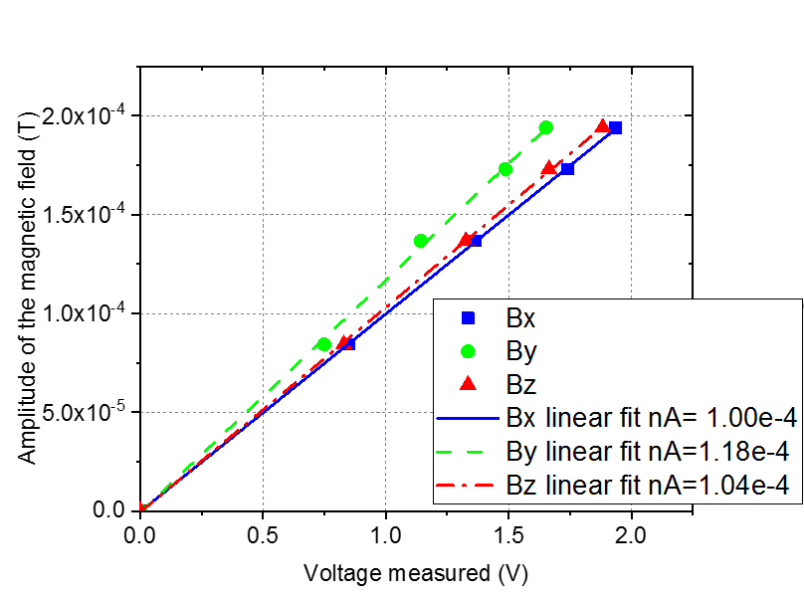
Fig. 7. Calibration curve of the B-dot probe.
Taking as a reference the magnetic field measured with a large single turn pick up with a known area and in series with 50 ohm to minimize the transmission line effect, we estimate an error on the absolute value of the B-field around ± 30%. However, because the field is quite homogeneous close to the center of the antenna and the error on the X and Y axes is < 1 mm, the relative error between the coil calibration factors is < 0.2 %. For this study, where a measurement of the wavelength has been performed, as well as a 3D characterization of the wave field, the relative accuracy between the coils is the most important and this calibration method is very appropriate for this.
4. Preliminary measurements in RAID
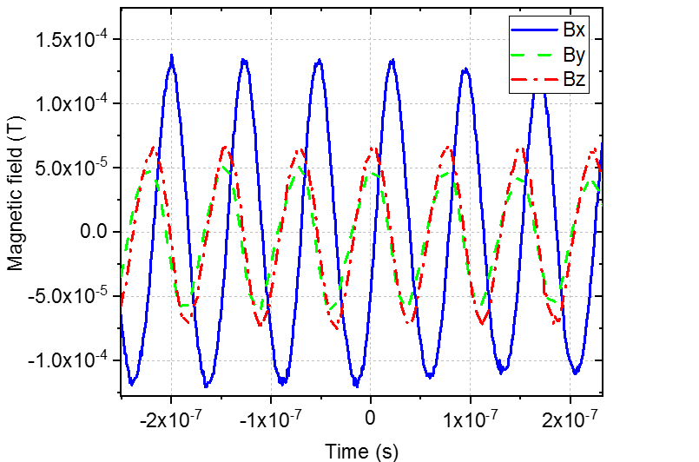
Fig. 8. Example of a time varying magnetic field.
Preliminary results obtained with the B-dot probe in RAID are discussed in this section. Figure 8 shows the time-varying magnetic field at a fixed position (10 cm from the source axially in figure 1 and -10° from the centre of the plasma column in Figures 1 and 3). This position corresponds to the edge of the plasma column. There are no measurements in the centre of the column because the wire used does not survive excessive temperatures (700°C). Plasma parameters are: H₂ plasma, 0.3 Pa, DC magnetic field 200 G and RF power 3 kW. As shown in the figure below, By leads Bx in phase.
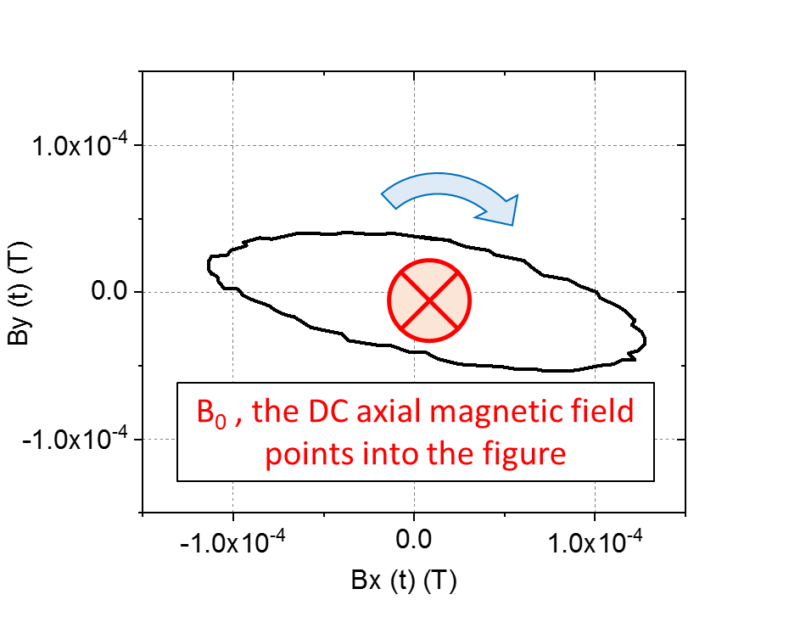
Thus, taking the direction of the DC magnetic field $\vec{B_{0}}$ as the reference, the temporal polarisation of the wave is right-handed (see Figure 9). This is in agreement with the standard measurements of helicon wave [7]. The last experiment done with the B-dot was an axial scan at a fixed RF phase at a fixed angular position (-10° from the centre) and the same plasma conditions as Figure 8. For this case, Figure 10 shows the amplitude of the magnetic field and highlights the wavelength of the wave, which can be measured at ̴ 240 mm.
Fig. 9. Temporal polarization of the helicon wave
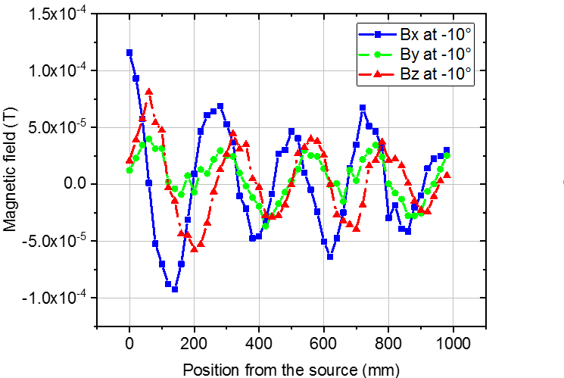
Fig. 10. Axial scan of the magnetic field.
5. Conclusion
This paper presented RAID, the principle of the helicon source and the first measurements with the new B-dot probe. Preliminary results demonstrate the potential of the B-dot probe for analysing the magnetic configuration of the helicon wave. After a calibration of the 3 axes, we measured a right handed polarized wave with a wavelength of ̴ 240 mm. With this diagnostic, we expect a better comprehension of the power deposition mechanism of the helicon wave into the plasma and, hopefully, to link it to the electron temperature and density profiles. It is very important for the SIPHORE concept of NBI because the production of negative ions is directly linked to the gradient of electron temperature between the centre and the edges of the plasma column (5 eV to 2 eV). In the near future, we will also test other geometries of resonant antennas in order to choose the best source to match the requirements for NBI injector sources. A full set of B-dot measurements as well as numerical modelling will follow.
Acknowledgments
This work has been carried out within the framework of the EUROfusion Consortium and has received funding from the Euratom research and training programme 2014-2018 under grant agreement number 633053. The views and opinions expressed herein do not necessarily reflect those of the European Commission.
References
[1] P. Sonato et al., New J. Phys. 18 (2016) 125002.
[2] A. Simonin et al., New J. Phys. 18 (2016) 125005.
[3] A. Simonin et al., Nucl. Fusion 55 (2015) 123020.
[4] T. Inoue et al., Nucl. Fusion 46 (2006) 369.
[5] I. Furno et al., Helicon wave-generated plasmas for negative ion beams for fusion, EPJ Web of Conferences 157 (2017) 03014.
[6] Ph. Guittienne et al., J. Appl. Phys. 98 (2005) 083304.
[7] R.W. Boswell, Plasma Phys. Control. Fusion 26 (1984) 1147.
[8] C. Marini et al., Nuc Fusion 57 (2017) 036024.
[9] R. Agnello et al., Rev. Sci. Instrum. 89, (2018) 103504
[10] J. Jin, Electromagnetic analysis and designs in magnetic resonant imaging, (Boca, Raton, FL: CRC Press), 1988.
[11] Ch. Hollenstein et al., Plasma Source Sci. Technol. 22 (2013) 055021.
[12] P. Demolon et al., Vacuum 147 (2018) 58.
[13] A. A. Howling et al., Plasma Sources Sci. Technol. 24 (2015) 065014.
[14] Ph. Guittienne et al., Plasma Sources Sci. Technol. 24 (2015) 065015.
[15] D. Thompson et al., Phys. Plasmas 24 (2017) 063517.
[16] M.P. Reilly et al., Rev. Sci. Instrum. 80 (2009) 053508.
[17] G.G. Borg, Rev. Sci. Instrum. 65 (1994) 449.

