Cell-Mediated Delivery of
Synthetic Nano- and Microparticles

Maxime Ayer, Harm-Anton Klok*
École Polytechnique Fédérale de Lausanne (EPFL), Institut des Matériaux and Institut des Sciences et Ingénierie Chimiques, Laboratoire des Polymères, Bâtiment MXD, Station 12, CH-1015 Lausanne, Switzerland
AUTHOR EMAIL ADDRESS maxime.ayer@epfl.ch, harm-anton.klok@epfl.ch
CORRESPONDING AUTHOR FOOTNOTE harm-anton.klok@epfl.ch, Fax: +41 21 693 5650; Tel: +41 21 693 4866

ABSTRACT
Cell mediated delivery of synthetic nano- and microparticle based drug carriers is a very promising strategy to enhance control over the distribution of drugs and improve targeting. This article will present an overview of work, which has been done to explore cell surface modification strategies for the cellular hitchhiking of synthetic nano- and microparticles. The first part of this article will present and discuss the different types of cells that have been explored for cell mediated drug delivery. The second part of this review will discuss the various chemical strategies that have been elaborated for the conjugation or immobilization of nano- and microparticles on the surface of these cells.

GRAPHICAL ABSTRACT

KEYWORDS Nano- and microparticles, cellular backpacks, cell surface-conjugation, cellular hitchhiking, cell-mediated drug delivery

INTRODUCTION
Small molecule drugs are lacking tissue and organ specificity, suffer from rapid body clearance and are often associated with numerous side effects, especially chemotherapeutic agents, which are usually highly toxic [1]. The use of polymer conjugates or lipid or polymer nanoparticles to encapsulate, transport and release the active substance has allowed to enhance tissue and organ specificity, either in a passive fashion taking advantage of the so-called enhanced permeation and retention (EPR) effect or by exploring active targeting strategies by incorporating ligands that target receptors that are overexpressed at the cancer cell-surface [1-3] While the EPR effect and active targeting strategies allow to modulate the biodistribution to some extent, still only a fraction of all nanocarriers reaches the tumor whilst the vast majority of drug loaded nanocarriers are cleared by the reticuloendothelial system (RES). Additionally, the clinical translation of the EPR effect from animal models to humans has proven to be challenging [4]. Moreover, whereas the EPR effect may be relatively efficient in some cancer models due to the leaky nature of blood vessels in angiogenic tumors, there is a range of indications to which it does not apply. In several instances, for example, the active substances need to be transported across tight endothelial cell barriers. Finally, targeting circulating or disseminated tumor cells after primary tumor resection is extremely challenging and is unmet with current nanocarrier approaches.
A strategy that potentially allows to overcome many of the challenges listed above and to control biodistribution in a highly specific manner involves the use of cells to mediate the transport of drug loaded nanocarriers [5-7]. Cells have unique properties e.g. to circulate in the blood stream for extended period of time, to target (cancer) cells or to pass challenging biological barriers. Attaching polymer-drug conjugates or drug-loaded nanocarriers to the cell surface or incorporating them in the cell could provide unique possibilities to enhance the cell or tissue specificity or circulation time of those nanomedicines. While this article will focus exclusively on the decoration of cell surfaces with synthetic nano- and microparticles, cells are also explored as Trojan horses [5]. There are a number of limitations associated with the internalization of drug-loaded particles and polymer conjugates in cell carriers. A first one is the risk of premature degradation of the nanoparticle and its payload inside the cell carrier. A second is the need for the cell carrier to release its cargo at the target site, which adds an additional step to the whole process. Finally, internalization of a cargo is essentially limited to cells with an efficient phagocytic system such as monocytes or macrophages whereas surface functionalization is in principle possible with the entire repertoire of circulating cells, opening doors to long circulating delivery approaches based on red blood cell functionalization or highly specific targeting strategies based on modification of cells from the adaptive immune system such as B and T lymphocytes [8, 9] or based on the pathotropism of stem cells [10].
The aim of this article is to provide an overview of the state-of-the art in the use of surface-modified cells to mediate the delivery of synthetic nano- and microparticles. The first part of this article will present and discuss the different types of cells that have been explored for cell mediated drug delivery. The second part of this review will discuss the various chemical strategies that have been elaborated for the conjugation or immobilization of nano- and microparticles on the surface of these cells.

CELLS USED FOR CELL-MEDIATED DRUG DELIVERY
This section will give an overview the different types of cells that have been used as vehicles for the cell surface attachment and transport of synthetic nano- and microparticles.

Red blood cells
Red blood cells (RBCs) are biconcave disc-shaped cells lacking organelles and a nucleus, measuring approx. 7 μm in diameter. They constitute > 99% of the blood and are long-circulating, up to approx. 120 days in humans [11]. They are specialized in oxygen transport, which is mediated by hemoglobin, encapsulated in large amount inside RBCs. RBCs are highly deformable and flexible to allow them to reach capillary venules. RBCs do not normally extravasate from the circulation into tissues except within the spleen and liver where senescent RBCs are removed from the circulation by the phagocytic system [11]. The plasma membrane of a RBC is slightly negatively charged and comprised of > 300 different membrane proteins [12], which offer many opportunities for cell surface modification. RBCs intrinsically play an important role in altering the biodistribution and pharmacokinetics of many drugs, increasing their circulation times [11]. The ability to prolong the circulation time of drugs, together with a high biocompatibility, especially in the case of autologous transfer, are very attractive features in the context of drug delivery. RBCs have been intensively investigated as carriers for the vascular delivery of a variety of surface bound molecules and more recently for the transport of nanoparticulate carriers as will be discussed in the next section [11, 13].

Leukocytes
Leukocytes form the innate and adaptive immune system and respond, for example, against infection, inflammation and tumor growth [14]. Both the innate and adaptive immune system play a crucial role in detecting and killing cancer cells. The unique features of leukocytes, such as their ability to travel to a specific site of disease as well as to transmigrate across endothelial barriers [15] and penetrate into hypoxic tumor regions [16] provide unique opportunities for delivery to areas that are otherwise difficult or impossible to reach by traditional drug delivery approaches. Particularly interesting cells for cell-mediated delivery are monocytes, which are long lived white blood cells deriving from the bone marrow and which can differentiate into tissue-resident macrophages or dendritic cells (DC) [17], as well as B cells, T cells, especially of the CD4⁺ (helper) and CD8⁺ (cytotoxic) subtypes and natural killer (NK) cells. The T lymphocytes used in adoptive cell therapy could potentially concomitantly serve as drug carrier. The decorated adoptively transferred lymphocytes are then not only a carrier but also directly exert a therapeutic activity.
The primary mission of monocytes is to replenish the pool of tissue-resident immune cells [18]. Furthermore, they are also involved in the innate immune response against bacterial, fungal, parasitic and viral infection [19]. In humans, 3 classes of monocytes coexist in the peripheral blood circulation, which are characterized by their relative expression of CD14 and CD16 surface markers. The largest subpopulation, consisting of approx. 80 to 90% off all monocytes, is the CD14⁺CD16⁻ subset, which shows the highest phagocytic activity and also produces IL-10. In contrast, the others subpopulations are expressing CD16 and express CD14 at high or low level. These are divided in two classes (i) the CD14⁺CD16⁺ subset, which is entirely responsible for the production of TNF-α and IL-1 and which also has a phagocytic activity and (ii) the CD14^{dim}CD16⁺ subset, whose actual function is not well understood. Monocytes of this last subset express low level of the CD14 markers. They are poorly phagocytic and do not express cytokines such as TNF-α and IL-1 [20].
Tissue differentiated macrophages are present in a broad spectrum of pathological conditions including cancers and several inflammatory diseases [18]. Monocytes and macrophages along with DCs, neutrophils and mast cells are ‘professional’ phagocytic cells, which express specialized membrane receptors and are able to detect apoptotic/necrotic cells, opsonized pathogens or cell debris [18]. The phagocytic competence of macrophages and monocytes represents a major challenge in attaching and immobilizing a cargo on their surface for delivery purposes [21]. The few successful examples of stable and long-lasting surface functionalization required the use of very large synthetic particles, which have a disk-like shape, thus avoiding internalization (see Doshi et al. [22]). These examples will be discussed in more detail in the following section.
B and T lymphocytes are part of the adaptive immune system and immunological memory. B lymphocytes originate from the bone marrow and are the central player of the humoral immunity [23]. Upon antigen exposure, mature naïve B cells, which trafficked to secondary lymphoid organs, differentiate via series of fast evolutionary selection steps to antibody-secreting B cells also called plasma cells [24]. These plasma cells can subsequently reenter the blood circulation via the lymphatic system to reach distant sites of infection/inflammation. T lymphocytes derive from the thymus and are classified in two important subsets, which mediate the adaptive cellular response through (i) activation of other immune cells (CD4⁺ Helper T cells) or (ii) via killing target/infected cells (CD8⁺ Cytotoxic T cells) [25]. Lymphocyte trafficking depends on their activation status. Whilst blood-borne naïve T cells, similarly to naïve B cells, possess surface markers that enable them to home to secondary lymphoid organs, antigen-experienced lymphocytes migrate towards sites of inflammation [26]. This duality in homing properties, i.e. secondary lymphoid organs vs inflamed tissues is very attractive for cell-mediated drug delivery, especially in the context of cancer therapy, in which these distinct trafficking patterns allow targeting either the primary tumor or disseminated tumor cells in the lymph nodes. T lymphocytes are activated by DCs in the lymph nodes via interaction with the MHC class II complexes. The migration and accumulation of lymphocytes into diseased tissues is general to all subsets of circulating leukocytes [27]. It is triggered by an adhesion cascade, consisting of a series of interactions between endothelial recruiting molecules called selectins and activation of lymphocyte chemoattractant receptors. This activation induces the expression of integrins on the lymphocytes, which mediate firm binding to intercellular and vascular endothelial adhesion molecules. Finally, lymphocytes diapedese through the endothelial barrier to reach their target area [25].
CD8⁺ T cells elicit their cytotoxic effect essentially by secreting perforin together with a variety of granzymes or via activation of the tumor-necrosis factor receptor FAS of target cells and to a lesser extent via production of cytokines such as TNF and IFN-γ that have cytotoxic action when secreted nearby target cells [28]. CD4⁺ T cells mediate the immune response via the release of cytokines of two different classes, Th1 and Th2, which activate different cells of the innate and adaptive immune system [29].
Natural killer (NK) cells represent about 10-20% of all peripheral blood mononuclear cells [30]. Human NK cells are subdivided into 5 categories depending on the relative expression of the surface markers CD56 (an adhesion molecule) and CD16 (a low affinity Fc receptor) [31]. NK cells are not only localized in peripheral blood but are also present in lymph nodes, spleen and bone marrow where they exert different functions based on their phenotype [30]. NK cells are mainly involved in innate immunity [32] but also influence and shape adaptive immune responses [31]. Their role in immunoregulation is also important and predominantly mediated through secretion of cytokines of the T helper type 1 (Th1) [32]. NK cells are activated by a variety of stimuli, in particular by contact with DCs, MHC-I-negative cells, IgG of the immune complexes or via direct activation by tumor-associated markers present on tumor cells or pathogen-derived products as well as a myriad of interleukins and type I interferons [30]. NK cells represent the first line of defense against tumor and infected cells, recognizing stressed cells with low MHC class I expression and elicit a cytotoxic and necrotic effect via liberation of perforin and granzymes [30]. Additionally, NK cells are eliciting an apoptotic effect on targeted cells, induced by exposition of surface ligand of the TNF family such as of the Fas Ligand, TNF-α and TRAIL, the latter having gained some clinical interest as a drug and whose effective delivery will be discussed in greater detail later on in this review.

Stem cells
Stem cells, in particular adult stem cells such as hematopoietic stem cells and mesenchymal stem cells, which can be directly obtained from patients, cultured and expanded in vitro and used in subsequent autologous transplant, have attracted considerable interest in recent years [33]. Adult stem cells, as opposed to embryonic stem cells, which originate from the inner cell mass of a blastocyst, are tissue specific cells, which can in principle only differentiate to a limited set of specialized cells [34]. Although not as pluripotent and as self-renewing as embryonic stem cells, adult stem cells have the important advantage that they are much less likely to give rise to tumors after transplantation [33]. Moreover, many accounts also suggest that most adult stem cells from a tissue specific lineage are able to be converted to tissues types of another lineage through mechanism such as transdifferentiation or dedifferentiation [35, 36].
While the main focus in stem cell therapy has been on cell replacement or tissue regeneration, the pathotropic nature of stem cells, and more specifically their ability to migrate towards tumor tissues, also makes them ideal delivery vectors in cancer therapy [33]. Stem cells are used as carriers to efficiently deliver genetically encoded apoptotic proteins [37], immunomodulators [38], oncolytic viruses [39] or nanoparticle encapsulated chemotherapeutic agents (as will be discussed in detail below) [40], with high precision and enhanced tracking of tumor metastases.
Principally, two different stem cell lineages have been utilized for their tumor-tropic properties, mesenchymal stem cells (MSCs), which are primarily derived from bone marrow and neural stem cells (NSCs) deriving from specific neurogenic regions of the brain. MSCs can spread into many tissues after being systemically injected and, similar to immune cells, can extravasate from the blood vessels due to the expression of adhesion molecules on their surface [41]. MSCs have been used as a delivery vector in various types of cancers, such as melanoma [42] but have also been shown to be effective in targeting glioma [43] or disseminated metastases [44]. Although MSCs are readily isolated clinically and as such represent an important source of adult stem cells, they have also been associated with promoting primary and metastatic tumor growth and development via an immunosuppressive mechanism, which may restrict their use in specific clinical settings [45-47]. NSCs are well-characterized non-tumorigenic and minimally immunogenic adult stem cells, showing extensive tropism to a multitude of tumors types. NSCs have been used as delivery vectors in particular for gene therapy [48]. One major drawback linked to clinical harnessing of NSCs lies in the accessibility of its source for autologous transfer, which is the brain, and the complications associated with an invasive procedure to withdraw these cells. However, some reports have shown that autologous neural stem-like cells could potentially be accessible from bone marrow, which represents a very attractive opportunity for future clinical uses [49, 50].
The use of stem cells is, of course, not limited to tumor targeting. Stem cells show tropism to a variety of other lesions as well as to neurodegenerative areas and as such represent a unique delivery vector with a very broad scope for therapy [10, 48].

CHEMICAL MODIFICATION OF CELL SURFACES

This section will provide an overview of the various strategies that have been used to decorate cell surfaces with synthetic nano- and microparticles and discuss the properties and uses of the resulting surface modified cells. Table 1 provides an overview of the different cell surface modification strategies that have been used so far. Cell surface modification strategies can be subdivided in two main classes, viz. non-covalent and covalent. The remainder of this section will first discuss non-covalent cell surface modification approaches and the properties of the resulting cells and then present covalent cell surface modification strategies. Whereas covalent approaches are usually considered as more stable, their principal disadvantage lies in the fact that the site of modification is not controlled. Non-covalent approaches that use ligand-receptor interactions can be highly specific, yet pose the risk of triggering undesired cellular responses. These two examples already illustrate that selecting the appropriate cell surface modification strategy is a challenging task that depends on many factors including but not restricted to the cell type, cell surface biochemistry, the need for a robust particle conjugation or for release strategies, to name a few. In either way, a common feature of any cell surface modification strategy is that it does not affect the viability and function of the cell.

Table 1. Overview of different strategies that have been used for the conjugation or immobilization of synthetic nano- or microparticles to cell surfaces.
Method | Mechanism | Cell type | Type of cargo (payload) | Application | Ref.
Non-Covalent | Nonspecific adsorption  (Van der Waals, electrostatic, hydrogen bonds, hydrophobic interactions) | Murine and human red blood cells (RBCs) | Polystyrene based nano- and microparticles (range between ~ 100nm – 1000 nm) | Long circulating delivery vehicles | [51-53]
Non-Covalent | Nonspecific adsorption | Mouse red blood cells (RBCs) | (Anti-ICAM-1 coated) polystyrene based nanoparticles and nanorods | Nanoparticle delivery to the lungs | [54, 55]
Non-Covalent | Cell adhesive polyelectrolyte | Human chronic myeloid leukemia derived K562 cell, mouse embryonic stem cells (mESCs) and human mesenchymal stem cells (hMSCs) | Disc-shaped microdevices | Drug delivery | [56-59]
Non-Covalent | Hyaluronic acid mediated adhesion | Human T lymphocytes and mouse B lymphocytes | Superparamagnetic nanoparticles loaded polyelectrolyte multilayer (PEM) patches | Spatial migration of cells towards a magnetic field | [60]
Non-Covalent | Chitosan / hyaluronic acid mediated adhesion | Mouse B lymphocytes | PEM patches / polymeric backpacks | Cell aggregation induced by freely suspended backpacks | [61]
Non-Covalent | Chitosan / hyaluronic acid mediated adhesion | Mouse B lymphocytes | PEM patches / polymeric backpacks | Mechanistic studies of B cell immobilization by PEM patches | [64]
Non-Covalent | Chitosan / hyaluronic acid mediated adhesion | Mouse macrophages | PEM patches / polymeric backpacks | Cell-based drug delivery | [22]
Non-Covalent | Chitosan / hyaluronic acid mediated adhesion | Mouse B lymphocytes | Polymeric microtubes | Selective orientation of microtubes on cell surface | [65]
Non-Covalent | Antibody targeted  (normal mouse IgG) | Mouse monocytes | PEM patches / polymeric backpacks  (DOX loaded liposomes) | Targeted drug delivery | [62, 63]
Non-Covalent | Antibody targeted  (mouse IgG) | Mouse monocytes | Polymeric backpacks | In vivo targeted delivery | [67]
Non-Covalent | Antibody targeted  (anti CD73, CD90) | Human mesenchymal stem cells (hMSCs) | Silica nanorattles  (Dox loaded) | Tumor-targeted drug delivery | [68]
Non-Covalent | Biotin-avidin | Human embryonic kidney (HEK293) and murine T lymphoma EL4 cells | PLA-PEG⁽¹⁾ microparticles (average diameter of 1.4 μm) |  | [74]
Non-Covalent | Biotin-Neutravidin | Human neural stem cells (NSCs) | PEG-PDPAEMA⁽²⁾ nanoparticles | Brain tumor targeting | [40, 75]
Non-Covalent | Biotin-Neutravidin | Human mesenchymal stem cells (hMSCs) | 40 nm diameter polystyrene based nanoparticles | Tumor-tropic delivery | [73]
Non-Covalent | E-selectin - mediated, anti-CD57 antibody and  anti-NK1.1 antibody - mediated | Human leukocytes, murine natural killer cells | Liposomes | Circulating tumor cells tracking and killing | [76-79]
Non-Covalent | Biomimetic polymer or dendrimer – agglutinin or lectin | Chinese hamster ovary (CHO), Jurkat T cells | Carbon nanotubes (CNTs) | Model system for non-toxic CNTs binding | [80, 81]
Non-Covalent | Biomimetic dendrimer - agglutinin | Chinese hamster ovary | Boron nitride nanotubes (BNNTs) | Biosensing and bioimaging | [82]
Covalent | Coupling to amine groups (via NHS ester, isocyanate or cyanuric chloride end-functionalized polymers) | Langerhans Islets and red blood cells | Synthetic branched or linear polymers | Graft and cytoprotection | [86-89]
Covalent | Maleimide - thiol | Mouse CD8⁺ T lymphocyte and  hematopoietic stem cells (HSCs) | Lipid nanoparticles  (imunomodulator) | Adoptive cell therapy | [92, 93]
Covalent | Maleimide - thiol | Mouse CD4⁺ and CD8⁺ T cells | Lipid nanoparticles  (Chemotherapeutic agent SN-38) | Disseminated tumor targeted chemotherapy | [94]
Covalent | Disulfide | Mouse CD8⁺ T cells | Lipid based nanoparticles | Reversible attachment of nanoparticles | [96]
Covalent | Schiff base | Mouse macrophages | Quantum dots and stealth dendrimer nanoparticles | Hypoxia-targeted drug delivery | [97]
Covalent | SPAAC | Mouse macrophages | PAMAM dendrimers |  | [98]

(1) Poly(lactic acid)-poly(ethylene glycol) (2) poly(ethylene glycol)-poly((diisopropyl amino) ethyl methacrylate)

Non-covalent cell surface modification
Non-covalent attachment of synthetic polymer nano- or microparticles to cell surfaces can be achieved using both non-specific (e.g. hydrophobic, electrostatic) interactions as well as specific ligand-receptor interactions. The remainder of this section will present several examples that highlight the use of these different approaches.

Non-specific interactions. Mitragotri and coworkers, in a series of studies, have extensively explored adsorption of model polystyrene nanoparticles onto RBCs as a means to avoid clearance by the reticuloendothelial system (RES). It was found that circulation times can be dramatically altered, by several orders of magnitude, if the nanoparticles are adsorbed onto RBCs. The adsorption of the polystyrene nanoparticles was proposed to involve a combination of van der Waals, electrostatic, hydrogen bonding and hydrophobic forces [51]. This hypothesis was supported by the observation that nanoparticle adsorption was inhibited in the presence of serum or albumin [52]. When nanoparticles and RBCs were mixed at a ratio of 100 : 1, approximately 25 nanoparticles were adsorbed to each cell. This was found to be the maximum loading capacity, since higher nanoparticles loadings tend to cause cell aggregation. The RBC morphology and integrity is not adversely affected by the nanoparticle adhesion also under osmotic, mechanical, oxidative or complement stress that are typically encountered in the systemic circulation [53]. The conjugation is stable in vitro for many hours [51] and circulation times of RBC-bound nanoparticles are increased approximately 100-fold in vivo as compared to free NPs [52]. Circulation times are maximal for nanoparticles in the middle-size range (200-500 nm) and are dependent of nanoparticle surface chemistry [52]. The prolonged circulation times are due to a decrease in uptake and clearance by the spleen and liver. Interestingly, this lowered clearance was accompanied by accumulation in the lung. This effect was even more pronounced when (i) surface bound nanoparticles were coated with anti-ICAM-antibody and (ii) when nanorods were used instead of spherical NPs (Figure 1) [54]. The combination of both i.e. adsorption of nanorods onto RBCs with subsequent anti-ICAM coating of the exposed surface of nanorods, led to the best performance in terms of immune system avoidance and lung targeting for a RBC-hitchhiked nanomaterial [54, 55]. Nanoparticles are eventually detached from RBCs surface over time, essentially due to shear stress, cell-cell and cell-vessel wall interactions that become increasingly challenging in capillaries [52].

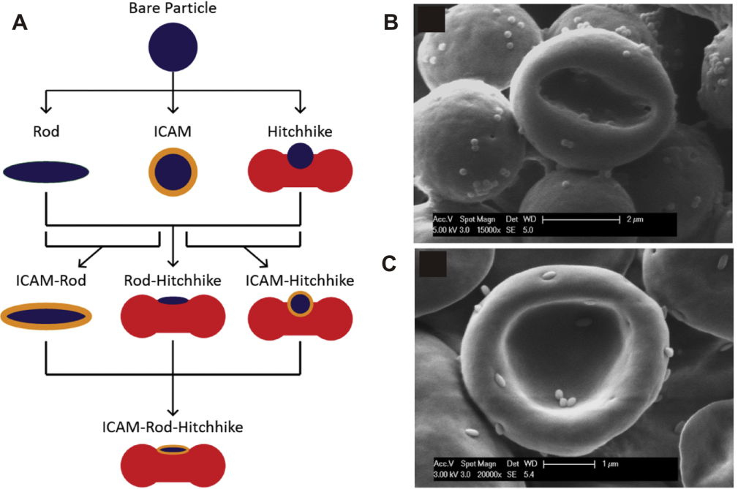
Figure 1. (A) Schematic overview of the preparation of spherical or rod-shaped nanoparticle decorated RBCs. Scanning electron micrographs of nanoparticle formulations: (B) 200 nm spheres attached to red blood cells and (C) rods stretched from 200 nm spheres attached to red blood cells. Reprinted from Biomaterials, 68, A.C. Anselmo, S. Kumar, V. Gupta, A.M. Pearce, A. Ragusa, V. Muzykantov, S. Mitragotri, Exploiting shape, cellular-hitchhiking and antibodies to target nanoparticles to lung endothelium: Synergy between physical, chemical and biological approaches, 1-8, Copyright (2015), with permission from Elsevier. [54]

A second example of the application of non-specific, non-covalent interactions to modify cell surfaces with synthetic nano- and microparticles involves the use of cell adherent polyelectrolytes. This approach has been explored by Guan et al. to decorate a variety of cells, including human leukemic cells, mouse embryonic stem cells and human mesenchymal stem cells, with a range of microcontact-printed biomaterials [56, 57]. Figure 2 schematically outlines the process developed by the Guan lab to prepare cell adhesive microparticles. Microcontact printed particles are disclike multilayered particles ranging in the size of several micrometers (7 μm particles are typically used for cell surface modification), which can be prepared from a large variety of cationic and anionic polymers such as poly(allylamine hydrochloride) (PAH), poly(diallyl dimethyl ammonium chloride) (PDAC), poly(ethylene imine) (PEI), poly(L-Lysine) (PLL), chitosan, poly(acrylic acid) (PAA), poly(sodium 4-styrene sulfonate) (PSS) as well as biodegradable and biocompatible polymers such as PLGA or poly(lactic acid) (PLA) and poly(ε-caprolactone) (PCL), which are particularly interesting for drug delivery purposes. The microparticles are fabricated by soaking a polydimethyl siloxane (PDMS) stamp with a micropillar surface structure into a polymer solution. Additional layers are subsequently adsorbed on the stamp via a layer-by-layer (LbL) assembly process. Finally, the multilayer film on the stamp is transferred via microcontact printing onto a substrate coated with a polymer sacrificial layer which will be subsequently used to release of the microparticles [56]. The sacrificial layer, which is composed of poly(vinyl alcohol) (PVA) or poly(N-isopropylacrylamide) (PNIPAM) is deposited onto the glass substrate via spin-coating. The PVA sacrificial layers are primarily used for the preparation of a suspension of the microdevices. In this case, the release of the microdevices is simply triggered by dissolution of the PVA film in an aqueous medium. PNIPAM is used as a thermoresponsive sacrificial layer when cells are first bound to the printed materials directly on the array and subsequently the cell-microdevice complexes are released from the substrate upon decreasing the temperature below the lower critical solution temperature (LCST) of PNIPAM as illustrated in Figure 2 [57]. This second approach yields well-defined cell-microdevices complexes in which each cell is bearing a single microdisk. Cell binding is mediated through electrostatic interactions with a cell-adhesive polyelectrolyte such as PAH, PLL or PEI. This fabrication process can in principle also be used for the preparation of ligand functionalized microdevices for receptor-mediated cell-attachment [58]. Interestingly, asymmetric PLGA/(3-aminopropyl)triethoxysilane)/glutaraldehyde/PAH microdevices, with covalent bonding between the (3-aminopropyl)triethoxysilane)-coated PLGA region and PAH systems, prepared via LbL assembly and microcontact printing showed no cell aggregation upon functionalization of cells with a microdevices suspension [58]. Single cell bearing multiple microdevices were also detected, especially at high microdevice-to-cell ratio. No evidence of internalization of the microdevices was observed. Viability and proliferation of these cells were not affected over a period of seven days [58]. This technique was also used to modify cells with 2-naphtalenethiol coated gold nanoparticles packed microdisks. These microdisks could be used as non-invasive in vivo tracking system for therapeutic cells [59].

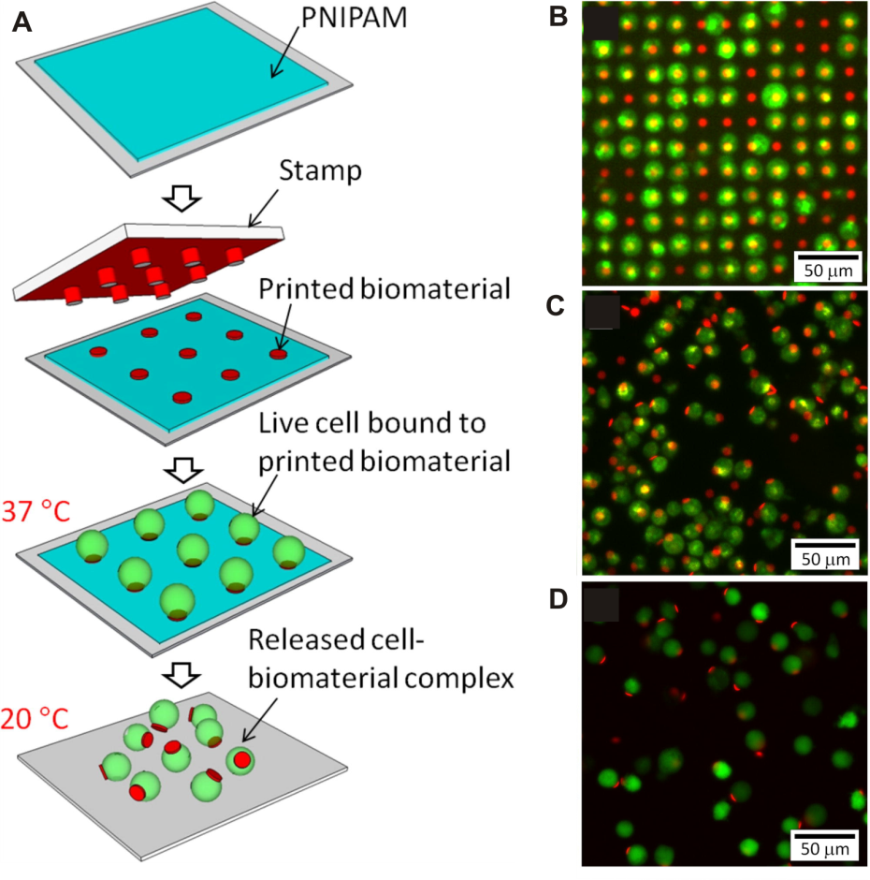
Figure 2. (A) Functionalization of live cells with microcontact printed biomaterials using spin-coated PNIPAM as the sacrificial layer. (B) Fluorescence micrograph of K562 cells (green) immobilized on an array of circular microparticles of polyelectrolyte multilayer (red) before being released, (C) immediately after being released and (D) cell-microparticle complexes after being cultured for 24 h. Reprinted from Acta Biomater., 11, Z. Wang, J. Xia, Y. Yan, A.-C. Tsai, Y. Li, T. Ma, J. Guan, Facile functionalization and assembly of live cells with microcontact-printed polymeric biomaterials, 80-87, Copyright (2015), with permission from Elsevier. [57]

Ligand–receptor mediated cell surface conjugation. As an alternative to the non-specific interactions discussed above, another approach that has been successfully and extensively explored to non-covalently conjugate synthetic nano- and microparticles to cell surfaces involves the use of specific ligand-receptor interactions. This approach has been pioneered by Rubner and coworkers who have used CD44-hyaluronic acid and Fc receptor-Fc interactions to conjugate polyelectrolyte multilayer (PEM) patches to cells [60]. Cell surface conjugation of PEM patches is a three step process in which first a patterned array of cell-adhesive functionalized heterostructured patches is prepared via a photolithographic lift-off process combined with a multilayer assembly of ultrathin polymer films (LbL assembly). Cells are then sedimented onto the patterned array and binding is promoted by incubation at 37° C. Finally, the cell-patch complexes are released from the substrate by a pH and/or temperature or an enzyme-mediated triggering mechanism (Figure 3). This approach ensures the production of well-defined cell-patch complexes bearing a single patch per cell whereas the use of freely suspended backpacks prepared by this method tends to lead to cell aggregation during cell functionalization [61]. Using pre-released backpacks, however, is attractive from a clinical perspective as they could be used to modify cells ex vivo before reinjection or as a direct injectable formulation. Cell-patch complexes could nevertheless be prepared in suspension if the ratio of cells-to-backpacks as well as the size of the backpacks are carefully adjusted. Large aggregates could partially be avoided by moderate agitation[61] and/or are removed using a cell strainer [62].
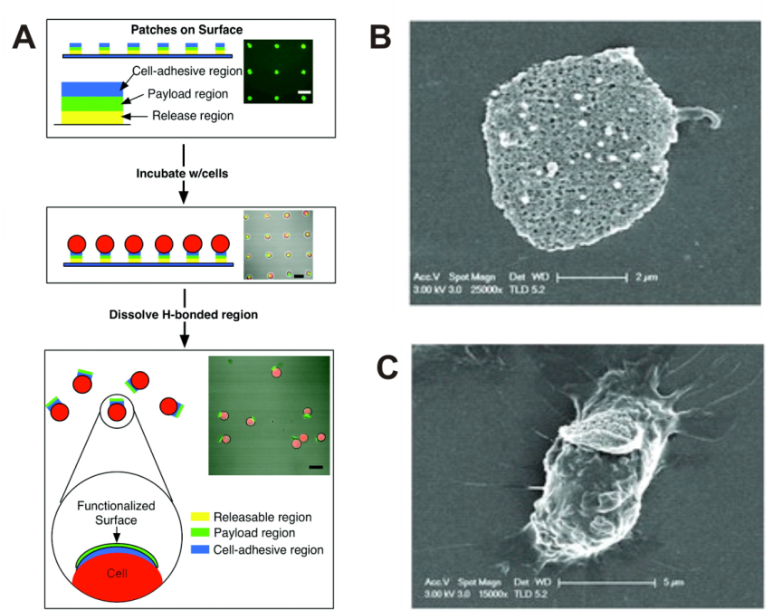
Figure 3. (A) Schematic overview of the fabrication and cell surface attachment of polymer patches. Scanning electron micrograph of (B) PEM backpack and (C) a macrophage modified with a HA/CHI coated backpack. Adapted with permission from Nano Lett., 8, A.J. Swiston, C. Cheng, S.H. Um, D.J. Irvine, R.E. Cohen, M.F. Rubner, Surface Functionalization of Living Cells with Multilayer Patches, 4446-4453, Copyright (2008) American Chemical Society. [60] Adapted with permission from Adv. Mater., 23, N. Doshi, A.J. Swiston, J.B. Gilbert, M.L. Alcaraz, R.E. Cohen, M.F. Rubner, S. Mitragotri, Cell-Based Drug Delivery Devices Using Phagocytosis-Resistant Backpacks, H105-H109, Copyright (2011) John Wiley and Sons [22].

As illustrated in Figure 3, cellular backpacks are 3-layer heterostructured assemblies that are composed of (i) a releasable region that deconstructs and releases the patches from the substrates (in microcontact printed patches, the release region is replaced by a spin-coated sacrificial layer) (ii) a payload region that encapsulates a cargo and (iii) a cell-adhesive region to anchor the patch to the cell membrane (Figure 3). The release region of the patch is designed to dissolve upon exposure to a stimulus such as pH, temperature, enzymatic or a combination of those. The stimulus needs to be noncytotoxic if the attachment of cells is performed prior to the release of cell-patch complexes. One example of a release region that has been used are hydrogen-bonded, poly(methacrylic acid)-poly(N-isopropylacrylamide) (PMAA-PNIPAM) multilayer, which are both pH and thermally responsive. The release only occurs at a pH higher than approx. 6.2 and below the critical solution temperature (LCST) of PNIPAAm (approx. 32° C). Sacrificial thin film systems based on bovine submaxillary mucin (BSM) and the lectin jacalin (JAC) were also used for post-cell attachment release. These films are stable over a wide range of pH (pH 3-9) and ionic strengths, allowing LbL assembly of additional films in a variety of conditions. The (BSM/JAC) film disintegrates at physiological pH in presence of melibiose [63] and a mucinase enzyme [62]. When patches are first to be released and used as a suspension to modify cells, the release region is designed as simple pH responsive region and is made of a poly(methacrylic acid) (PMAA) and poly(vinylpyrolidone) (PVPON) hydrogen-bonded multilayer system, which dissolves at a pH value of approx. 6.4. The second region of the heterostructured patch is the payload region, which can encapsulate drugs, proteins, nanoparticles or even liposomes. This region is usually composed of structural multilayers and a cargo containing region. The structural rigidity is required to withstand sonication during patch fabrication. For example, anionic superparamagnetic nanoparticles can be alternately deposited with a poly(allylamine hydrochloride) (PAH) to create magnetically responsive patches conferring magnetic properties to the patched cells [60]. The advantage of this ‘magnetic region’ is two-fold, as it facilitates purification of the complexes and adds additional structural rigidity. Proteins, such as bovine serum albumin (BSA) can be entrapped in the payload region with poly(lactic-co-glycolic acid) (PLGA) using an airbrush spraying method to form a biodegradable film, which is usually deposited in between rigid PEM films such as the one above or alternatively poly(diallyl dimethyl ammonium chloride) (PDAC) and poly(styrene sulfonate) (PSS) or (PAH/PSS) based films [22]. Direct loading of small molecules such as Doxorubicin (DOX) into PEM films can be challenging as they may rapidly elute from the polymer films. This can be overcome by loading DOX into liposomes, which are then subsequently incorporated in the payload region. Maintaining liposomal integrity is not trivial during adsorption at a solid-fluid interface and may result in vesicle disruption or fusion into a lipid bilayer. It was possible to incorporate intact DOX loaded liposomes in a sandwich-like structure with (PDAC/PSS). These constructs showed up to a nine-fold increase in DOX loading within the payload region as compared to the free DOX [62]. The third region of the patch is the cell-adhesive region and is composed of a biocompatible and biodegradable hyaluronic acid/chitosan multilayer (HA/CHI). The binding affinity of the HA/CHI layer can be tuned by and depends on the deposition conditions as well as on the nature of the last deposited layer (HA or CHI) [64]. HA binds specifically to CD44 cell-surface receptors and the positively charged CHI chains contribute to the overall binding through electrostatic interactions with the negatively charged cell membrane [64]. By controlling the presentation of the cell adhesive HA/CHI domains, polymer microtubes could be attached to B-cells either in an end-on or side-on fashion [65]. In addition to the HA-CD44 binding motif, Rubner et al. have also used mouse IgG antibodies to bind to the Fc receptors of immune cells to decorate cell surfaces with backpacks. The antibodies are introduced onto a final PEM film through biotinylation [62]. Patch attachment is normally non-toxic and does not impair key cellular functions. Proliferation inhibition was, however, observed when monocytes were functionalized with patches containing DOX loaded liposomes, likely due to the close proximity of DOX release from the carrying cells [62]. Remarkably, functionalized T cells retain their ability to migrate on intercellular adhesion molecule-1 (ICAM-1), a common inflammatory marker, coated substrates. The patch only blocked a fraction of all CD44 receptors and was found at the trailing end of the polarized lymphocytes during migration when CD44 are clustering at the uropod [66]. Micron-scale patches are also particularly suitable for delivery with monocytes and macrophages. Most approaches for monocyte/macrophage-mediated drug delivery use ex vivo nanoparticle internalization followed by re-injection to the systemic circulation or target site [5]. This approach is potentially deleterious for the payload, which can be degraded along the endosomal pathway before its release. Disk-like PEM patches efficiently avoid phagocytic internalization whilst remaining on the monocyte or macrophage surface. Backpack attachment does not adversely alter normal phagocytosis, nor reduces the mobility of these patched cells, making them particularly suitable for cell-mediated drug delivery [22]. Monocytes modified with backpacks that were attached via mouse IgG-Fc interaction also retained key cellular functions [67]. Differentiation of backpack modified monocytes to macrophages was unaltered. Patched monocytes were also able to transmigrate through a confluent HUVEC monolayer and approx. 60% of monocyte-hitchhiked backpacks were transported through the endothelial monolayer after 48 hours whereas their free counterparts were not transported at all. In vivo, monocyte-hitchhiked backpacks showed a 9-fold higher accumulation in a skin inflammation model and a 2-fold higher accumulation in a lung inflammation model as compared to the free backpacks in those two models. This selective accumulation of monocytes into inflamed tissues is mediated by ICAM and VCAM which are overexpressed on inflamed endothelial barriers [67].
In addition to CD44-hyaluronic acid and Fc receptor-Fc interaction, a third example of a specific non-covalent interaction that has been used for cell surface modification with synthetic nano- and microparticles is that between the CD73 and CD90 membrane proteins of mesenchymal stem cells (MSCs) and the respective monoclonal antibodies. Using this strategy, Li et al. conjugated anti-CD73/CD90 monoclonal antibody coated silica nanorattles to mesenchymal stem cells for tumor-tropic delivery of doxorubicin (DOX) (Figure 4) [68]. Silica nanorattles are biocompatible, mesoporous and hollow structures with very high drug loading capacity and sustained drug release properties. Exposing MSCs to antibody coated silica nanorattles was found to lead both to cell surface conjugation as well as internalization of the nanoparticles. DOX loaded silica nanorattles had negligible adverse effects on MSC viability. Modified cells showed slightly decreased migratory capacities in chemotaxis assay as compared to unmodified cells. In mice, MSC mediated delivery of DOX loaded silica nanorattles was found to result in increased accumulation and broader distribution in tumor tissues and consequently resulted in enhanced tumor cell apoptosis compare to free DOX or silica nanorattles encapsulated DOX.
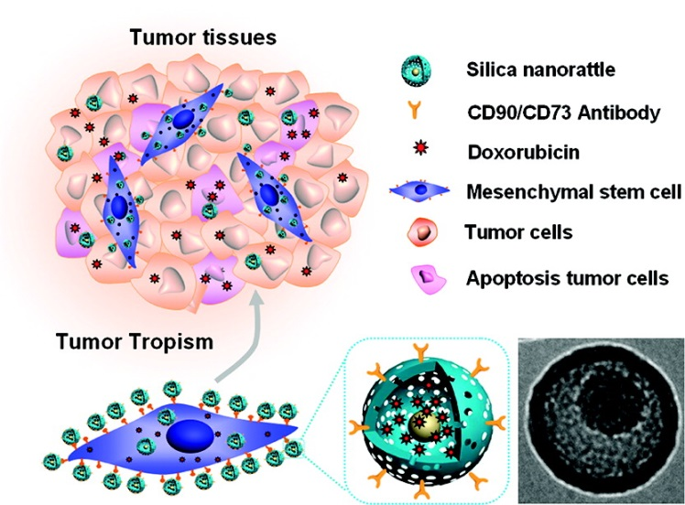
Figure 4. MSC mediated tumor tropic delivery of cell-surface anchored Doxorubicin-loaded silica nanorattles. Reprinted with permission from Acs Nano, 5, L. Li, Y. Guan, H. Liu, N. Hao, T. Liu, X. Meng, C. Fu, Y. Li, Q. Qu, Y. Zhang, S. Ji, L. Chen, D. Chen, F. Tang, Silica Nanorattle-Doxorubicin-Anchored Mesenchymal Stem Cells for Tumor-Tropic Therapy, 7462-7470. Copyright (2011) American Chemical Society [68].

Another example of specific, non-covalent interactions that has been extensively used for cell surface conjugation is that between biotin and (strept)avidin. The biotin-(strept)avidin interaction is among the strongest interactions known [69, 70] and biotinylation has been widely used in biotechnology for decades e.g. in immunological assays and as an affinity system for biomolecule purification [71]. While concerns about the potential immunogenicity of the biotin-(strept)avidin link have been cited [72], which may require the use of alternative cell-surface conjugation approaches in further translational work, this interaction has been successfully used in several reports [40]. Attachment of synthetic materials to cell surfaces via biotin-avidin mediated conjugation requires pre-treating the cells to introduce a biotin group on their surface. This can be performed for instance by covalent attachment of a biotin moiety through amide bond formation with lysine residues of membrane proteins [73] or via prior modification of cell surface monosaccharides such as sialic acid with a mild oxidizing agent to generate aldehyde groups followed by functionalization with a hydrazide-biotin crosslinker [74]. The biotinylated cells can then be directly treated with avidin, streptavidin or NeutrAvidin-modified particles [73, 75] or further functionalized with free avidin and subsequently with biotin-modified particles [40].
Cheng et al. conjugated NeutrAvidin coated nanoparticles to human mesenchymal stem cells (hMSCs) that presented biotin moieties on the plasma membrane [73]. The cells were first reacted with sulfosuccinimidyl-6-(biotinamido)hexanoate and then 40 nm diameter NeutrAvidin-modified polystyrene nanoparticles were anchored to the cell membrane. Although some nanoparticles were internalized, a substantial amount remained on the outer membrane and existed as large clusters, sitting on the main body of hMSCs. The clustering of nanoparticles was attributed (at least in part) to membrane reorganization and it was further hypothesized that the formation of clusters reduced nanoparticle internalization. These modified stem cells are ideal candidates for tumor-tropic cell-mediated delivery of nanoparticles. Nanoparticles decorated hMSCs were tested for their ability to sense and respond to tumor spheroid growth in vitro, which remained unaltered by the surface conjugation of nanoparticles. A similar strategy was used by Mooney et al. who decorated biotinylated NSCs with ~ 800 nm diameter polystyrene nanoparticles [75]. The aim of this study was to investigate whether tumor-tropic neural stem cells could help to improve the distribution and retention of nanoparticles in a brain tumor model. The modification had a negligible effect on the viability and tropism in vitro and the nanoparticles remained on the surface of the cells for at least 1 hour after coupling, a time frame sufficient for NSCs to reach tumor foci in vivo after injection. The nanoparticle conjugated NSCs were injected adjacent to the intracerebral glioma, into the contralateral hemisphere or intravenously and in all cases showed improved intracranial nanoparticle targeting and retention as compared to their free counterparts. Surface conjugation to NSCs dramatically reduced nanoparticle clearance over a period of 4 days and anchored nanoparticles are retained at day 1 level, whereas 93% of free nanoparticles were cleared over the same period. The intravenous administration is of great clinical interest as it represents a much less invasive procedure for the patient than intratumoral injection, and this example represents the first successful example of >200 nm particles penetrating the blood-tumor barrier after systemic administration.
Nanoparticle decorated neural stem cells have also been explored to improve the efficacy of docetaxel loaded nanoparticles in a triple negative breast cancer mouse model (Figure 5) [40]. In this study, biotin moieties were introduced on the cell surface via hydrazone formation after oxidation of cell surface sialic acid residues and biotinylated poly(ethylene glycol)-b-poly((diisopropyl amino) ethyl methacrylate) (PEG-b-PDPAEMA) based nanoparticles were then conjugated to the NSCs using an avidin linker. This sophisticated delivery system exerts a dual pH responsive behavior. Upon reaching the mildly acidic tumor environment, docetaxel is either directly released from the particles by disassembly of the PDPAEMA nanoparticle core or alternatively the entire particle is cleaved off from the NSC surface via hydrolysis of the pH labile hydrazone linkage. The polymer particles could then be taken up by tumor cells where the drug is released intracellularly with the decrease in pH along the endosomal pathway. Docetaxel loaded nanoparticles did not adversely affect NSC viability over 12 hours and under physiological pH conditions, during which only a small fraction of the drug is released. Tumor tropism, however, was slightly affected because of the potent microtubule stabilizing effect of docetaxel, which is directly related to cell mobility. The efficacy of NSC coupled docetaxel loaded nanoparticles administered via intratumoral injection was eventually evaluated by monitoring tumor microvasculature, tumor cells proliferation and apoptosis over a period of 7 days. The conjugation of nanoparticles to NSCs decreased tumor vessel density and altered cell proliferation whereas freely administered nanoparticles were ineffective at this low drug dosage.

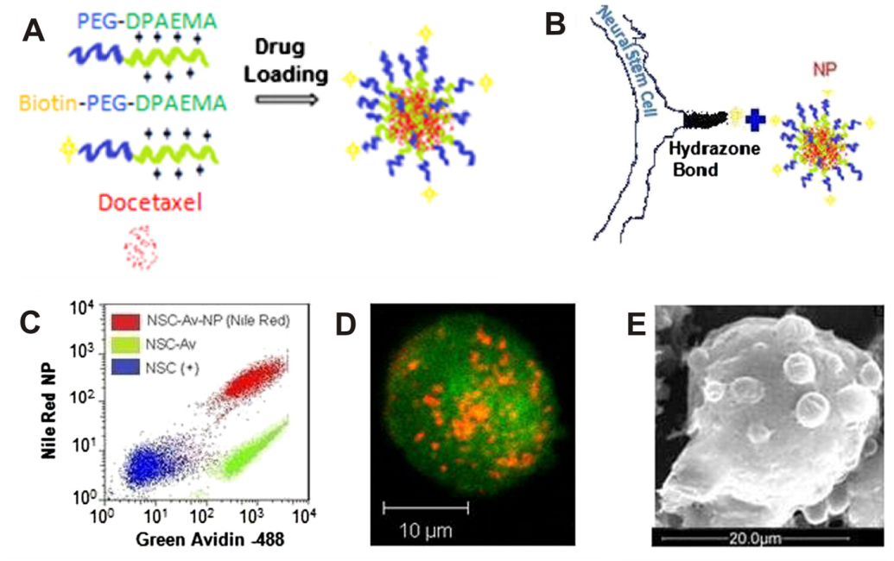
Figure 5. (A) Preparation of pH responsive, biotin functionalized and Docetaxel loaded poly(ethylene glycol)-b-poly((diisopropyl amino) ethyl methacrylate) block copolymer nanoparticles. (B) Schematic illustration of the conjugation of biotinylated nanoparticles onto a NSC surface, which presents hydrazone linked biotin moieties, via an avidin linker (C) Flow cytometric analysis of control NSCs (blue) and biotinylated NSCs after incubation with both fluorescein-conjugated avidin (green) and nile-red, biotinylated, pH responsive nanoparticles (red). (D) Confocal z-stack micrograph of a NSC-nanoparticle conjugate (NSC are shown in green and nanoparticles in red). (E) Scanning Electron microscopy micrograph of a nanoparticle modified NSC. Reprinted from J. Controlled Release, 191, R. Mooney, Y.M. Weng, E. Garcia, S. Bhojane, L. Smith-Powell, S.U. Kim, A.J. Annala, K.S. Aboody, J.M. Berlin, Conjugation of pH-responsive nanoparticles to neural stem cells improves intratumoral therapy, 82-89, Copyright (2014), with permission from Elsevier [40].

Carbohydrate ligands that are present on the cell surface also provide opportunities for the selective non-covalent conjugation of synthetic nano- and microparticles. King and coworkers have taken advantage of the ability of E-selectin to bind to these cell surface ligands to decorate leukocytes with tumor necrosis factor-related apoptosis-inducing ligand (TRAIL) functionalized liposomes [76]. E-selectin coated liposomes bearing TRAIL attach to leukocyte surfaces under shear by interacting with sialylated carbohydrates present on the cell membrane. This approach is highly effective in killing circulating tumors cells in vitro in human blood samples under flow conditions as well as in vivo in the peripheral circulation of mice by simple injection of a E-selectin/TRAIL-coated liposome solution in the circulation. This approach was also evaluated in a more advanced orthotopic xenograft animal model for prostate cancer and sustained delivery of E-selectin/TRAIL-coated liposomes efficiently eliminated circulating tumor cells and prevented the formation of metastasis in distant organs [77]. The same laboratory has also decorated NK cells with TRAIL-coated liposomes [78, 79]. In this case cell surface conjugation was achieved by presentation of anti-CD57 or anti-NK1.1 antibodies on the liposome surface, which bind to the CD57 or to the NK1.1 cell surface proteins, respectively (Figure 6). These enhanced NK cells, also named super NK cells by the authors, were able to induce apoptosis to several metastatic cancer cell lines (of three different cancer types i.e. prostate, colorectal and breast cancer) co-cultered in vitro in a lymph node mimetic system and were significantly more efficient than when co-cultured with unmodified NK cells or with TRAIL-functionalized liposomes only [78]. In vivo, this strategy also proved effective in preventing lymph node metastasis in mice bearing a subcutaneous human xenograft tumor model [79]. Super NK cells were formed within the tumor draining inguinal lymph node after subcutaneous injection of anti-NK1.1/TRAIL-functionalized liposomes. Tumor burden in the tumor draining inguinal lymph node dramatically decreased after treatment with anti-NK1.1/TRAIL liposomes whereas administration of soluble TRAIL by itself or TRAIL-functionalized liposomes did not hinder metastasis growth.

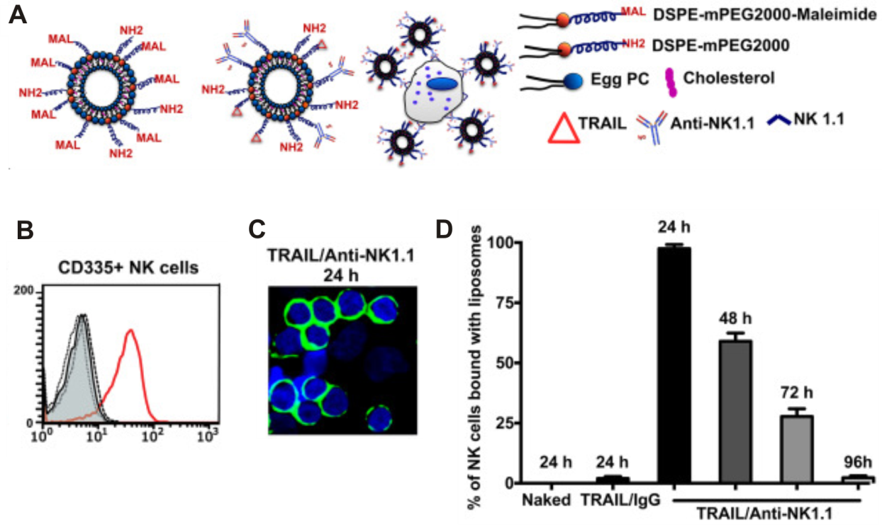
Figure 6. (A) Formulation and immobilization of TRAIL and anti-NK1.1 functionalized liposomes on NK cells. (B) Flow cytometry analysis: histograms from liposome fluorescence (FITC conjugated anti-human TRAIL) from CD335⁺ NK cells from the inguinal lymph nodes of mice injected with buffer (filled), naked liposomes (---------), TRAIL/IgG liposomes (▪▪▪▪▪▪▪▪▪▪▪▪▪▪▪▪) or TRAIL/Anti-NK1.1 liposomes (red) 24 h post-injection. (C) Fluorescent confocal micrograph of NK cells isolated from the inguinal lymph nodes of mice subcutaneously injected with TRAIL/Anti-NK1.1 liposomes (at t=24 h). (D) Numerical quantification of the percentage of NK cells bound with liposomes with different functionalizations. Bars represent the mean and standard deviation from 10 different confocal images for each time point. Reprinted from Biomaterials, 77, S. Chandrasekaran, M.F. Chan, J. Li, M.R. King, Super natural killer cells that target metastases in the tumor draining lymph nodes, 66-76, Copyright (2016), with permission from Elsevier [79].

In a series of reports, Bertozzi and coworkers have explored the highly selective binding properties of lectins to decorate living cells with carbon and boron nitride nanotubes. In a first report, carbon nanotubes were coated with a biomimetic glycopolymer, prepared by post-polymerization modification of a C₁₈ lipid tail functionalized poly(methyl vinyl ketone) with α-N-acetylgalactosamine residues. The lipid tail was used to anchor the synthetic polymer to the surface of the carbon nanotube via hydrophobic interactions and at the same time to reduce the cytotoxicity of the carbon nanotubes. The polymer coated carbon nanotubes were then modified by addition of Helix pomatia agglutinin (HPA) (a hexavalent lectin) and then added to the cell suspension (CHO cells or Jurkat cells) or alternatively the cells were treated with HPA prior to addition of the coated nanotubes. HPA specifically recognizes α-N-acetylgalactosamine residues and is used to mediate crosslinking between cell-surface glycoproteins and the glycopolymer coated carbon nanotubes [80]. The use of the poly(methyl vinyl ketone) based glycopolymers to modify the carbon nanotubes, however, resulted in irregular surface coatings of non-uniform thickness. To overcome these problems, the Bertozzi laboratory prepared bifunctional glycodendrimers composed of a pyrene tail that can bind to the carbon nanotube surface via π-π interactions as well as a number of peripheral carbohydrate units that can be used to mediate cell surface immobilization. In this way, G2-mannose modified glycodendrimers were used to selectively bind carbon nanotubes to the surface of CHO cells in the presence of the lectin Canavalia ensiformis agglutinin (Con A) [81]. Boron nitride nanotubes, isosteres of carbon nanotubes, are more chemically inert and structurally stable than their carbon counterpart. They have similar mechanical and thermal properties. However, their most attractive feature is that they are inherently noncytotoxic. Boron nitride nanotubes were successfully assembled on the surface of CHO cells using the same glycodendrimers, which were discussed above for the cell surface immobilization of carbon nanotubes [82]. These nanotubes offer then an interesting alternative to carbon nanotubes in living systems and have the potential to be useful in therapy or diagnosis.

Covalent cell surface modification
Synthetic nano- and microparticles can be covalently attached to cell surfaces either via the native functional groups that are present on the cell surface such as amine or thiol groups or by using non-natural functional groups, which can be in introduced onto the cell surface e.g. using metabolic strategies [83] or by chemically generating reactive groups such as aldehydes on the cell surface. Even though there is a vast range of chemoselective and bioorthogonal reactions that have been successfully used to modify peptides, proteins and polysaccharides [84], not all of these are suitable for the surface modification of living cells as the reaction conditions may impair the viability of the cells. The remainder of this section will highlight several covalent cell surface conjugation strategies that have been reported for the modification of specific natural and non-natural functional groups present on the cell surface.

Modification of cell surface amine groups. The concentration of amino groups on the cell surface is high and lysine residues on membrane surface proteins are usually readily accessible [85]. However, while they have been frequently used as anchors to introduce biotin moieties (which are then subsequently used to facilitate (strept)avidin mediated non-covalent cell surface conjugation), amine groups have been scarcely used for the direct covalent attachment of synthetic nano- or microparticles. There are, however, a few reports that describe the direct covalent conjugation of synthetic polymers to amine groups on the cell surface. For instance, poly(ethylene glycol) (PEG) was grafted on the surface of Langerhans islets using either isocyanate or N-hydroxysuccinimide end-functionalized PEGs [86, 87]. Another example are red blood cells, which have been modified with cyanuric chloride end-functionalized PEGs [88], succinimidyl functionalized hyperbranched polyglycerols [89] as well as with ATRP synthesized polymers [90].

Maleimide-thiol coupling. Cysteine thiol groups are attractive anchors for covalent cell surface modification as they are relatively abundant [91] and can undergo various chemoselective reactions. Covalently anchoring nanoparticles via Micheal type addition to cell surface cysteine residues was first proposed by Irvine and coworkers [92]. Maleimide functionalized liposomes, multilamellar liposomes and lipid coated PLGA nanoparticles in the range of 100-300 nm were efficiently conjugated to the surface of CD8⁺ T lymphocytes and hematopoietic stem cells (HSCs) commonly used in cell therapy (Figure 7). Coupling of up to 100-120 nanoparticles on the surface of lymphocytes did not activate them and particles were retained on the surface of the cells for several days. Proliferation profiles were not affected after lymphocyte activation by DC and transendothelial migration efficiencies were similar to those of unmodified cells, with the exception of the more rigid lipid-coated PLGA nanoparticles, which showed a tendency to inhibit T cell migration and were not retained as well as liposomes after migration. Adoptively transferred T cells with surface conjugated 300 nm multilamellar liposomes kept tumor-homing properties in a subcutaneous EL4 tumor model and transported their nanoparticulate cargo with a 176-fold increased accumulation into the tumor tissue as compared to their freely administered counterparts. One of the limitations of adoptive cell therapy lies in the rapid decline of cell viability and function after transplantation. Co-administration of adjuvants such as cytokines during cell therapy is usually necessary and the high systemic levels required induce dose-limiting toxicities. A mixture of interleukins loaded into surface-tethered multilamellar liposomes significantly improved the therapeutic efficacy of the transplanted cells by continuously delivering the cytokines in the direct surroundings of the particle-carrying cells at doses that are typically inefficient if they were administered systemically [92]. This approach markedly amplified T cell expansion and function during adoptive transfer in mice melanoma lung and bone marrow tumors models and efficiently prevented tumor growth after a 30 days T cell treatment. Further investigation of T cells decorated with nanoparticles using thiol-maleimide coupling chemistry revealed that the nanoparticles compartmentalizes at the uropod of polarized T cells after seeding them onto a confluent endothelial cell monolayer (Figure 7) [93]. Interestingly, nanoparticle compartmentalization was reversed when a T cell forms an immunological synapse with an antigen presenting cell. Surface-bound particles were repolarized to the contact zone with the antigen presenting cell after T cell receptor activation (Figure 7). Nanoparticle-binding proteins were identified by mass spectrometry and predominantly consisted of the leukocyte common antigen CD45 as well as an additional small set of other surface proteins such as LFA-1, CD2 or CD97, which are all recruited to the immunological synapse during antigen recognition. This could be exploited to alleviate the effect of suppressive ligand upregulation by tumor cells occurring in the immunological synapse, which effectively prevents tumor cells recognition by the immune system. Inhibiting this tumor-induced suppression effect, locally, directly in the contact zone between the tumor cells and T cells was achieved by loading potent immunomodulators into the surface-bound nanoparticles that are translocated in the immunological synapse during plasma membrane proteins reorganization. Local and accurate delivery could avoid the severe adverse side effects and autoimmune risks associated with the systemic administration of these drugs.

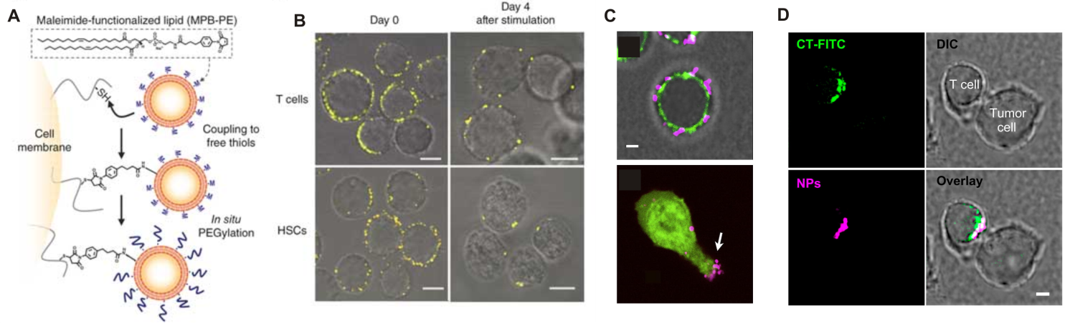
Figure 7. (A) Maleimide-thiol cell surface conjugation of lipid nanoparticles. MPB-PE: 1,2-dioleoyl-sn-glycero-3-phosphoethanolamine-N-[4-(p-maleimidophenyl)butyramide]. (B) Confocal microscopy images of CD8+ effector T cells and hematopoietic stem cells (HSCs) immediately after conjugation with fluorescent 1,1-dioctadecyl-3,3,3,3-tetramethylindodicarbocyanine (DiD)-labeled multilamellar lipid nanoparticles (left) and after 4-d in vitro expansion (right). Scale bars, 2 μm. (C) Confocal micrographs of lipid nanoparticle-conjugated CD8+ effector T cells. Top: T cells surface stained with FITC-cholera toxin (green) immediately after surface-conjugation of fluorescent nanoparticles (magenta) or Bottom CFSE-labeled T-cells (green) conjugated with particles (magenta) migrating on an endothelial cell monolayer toward a chemoattractant. Scale bar 2 μm. (D) CD8+ effector T-cells conjugated with multilayer vesicles were incubated with tumor cells for 20 min, then fixed and stained with FITC-cholera toxin to mark lipid rafts known to accumulate at the immunological synapse. Shown are confocal images of a T-cell forming a synaptic contact with a tumor cell. Nanoparticles were fluorescently labelled with rhodamine-conjugated lipid (magenta).Scale bar: 2 μm. Reprinted by permission from Macmillan Publishers Ltd: Nature Medicine, [92] copyright (2010). Reprinted from Biomaterials, 33, M.T. Stephan, S.B. Stephan, P. Bak, J.Z. Chen, D.J. Irvine, Synapse-directed delivery of immunomodulators using T-cell-conjugated nanoparticles, Biomaterials, 5776-5787, Copyright (2012), with permission from Elsevier [93].

In another example, the Irvine lab used thiol-maleimide coupling chemistry to modify T cells with liposomes coated with the chemotherapeutic agent SN-38 to actively target disseminated tumors [94]. SN-38 is a potent chemotherapeutic agent, which has limited in vivo efficacy due to its poor pharmacokinetics and high toxicity but could potentially be very effective if it were delivered with high precision. Tumor dissemination in multiple organs is characteristic of lymphomas for instance and represents a real challenge for therapy because of the restricted access to tumors in lymph nodes, which can serve as niche for tumor cells survival during chemotherapy. Tumor-bearing lymph nodes were not sensitive to chemotherapy using free SN-38 or a liposome formulation of this drug, presumably because of the lack of a leaky vasculature around the tumor that does not allow passive accumulation of the drug in tumor tissues by the enhanced permeation and retention (EPR) effect. Since targeting lymph nodes was primarily sought, polyclonal T cells, which intrinsically express lymph node homing receptors and migrate throughout lymphoid organs as part of their normal function, were proposed as delivery vectors for SN-38 loaded nanocarriers rather than tumor specific T cells. SN-38 loaded nanocarrier-T cells accumulated in tumor-bearing lymph nodes 20 hours after transfer and SN-38 concentration in lymph nodes was 63-fold higher than that achieved with free nanocarriers, resulting in a significant beneficial therapeutic effect, extending survival of mice up to 12 days at relatively low therapeutic doses (7 mg/kg) (Figure 8). Since many receptors required for T cell trafficking to a variety of organs, such as lungs, skin, gut and brain as well as that the stimuli required to induce expression of these markers are known [95], the authors proposed that T cells as chaperones potentially offer a means of selective delivery to virtually any of these organs without resorting to antigen specific T cells. Moreover, in the case in which tumor-specific T cells could be readily obtained, the concomitant chemotherapeutic agent delivery could in principle be combined with tumor-antigen specific T cells [94].

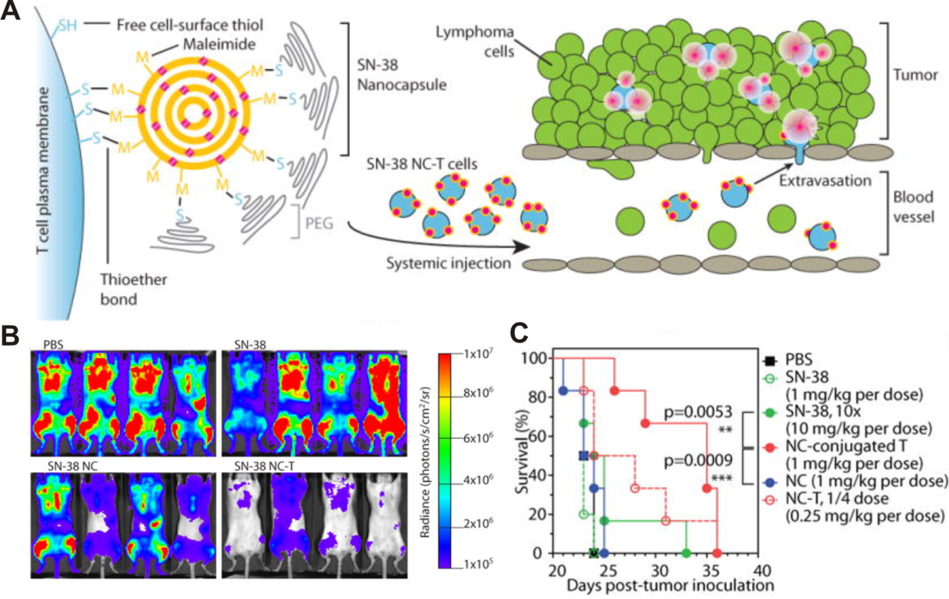
Figure 8. (A) T cell functionalization and cell-mediated delivery of SN-38 nanocapsules (NCs) into tumors. (B) Bioluminescence images of tumor burden on day 16 for mice treated with PBS, SN-38, SN-38 nanocapsules and SN-38 nanocapsules tethered to a T cell carrier (NC-T). (C) Overall survival. ***P < 0.001 by log-rank test. From [94]. Reprinted with permission from AAAS.

Conjugation through disulfide bond formation. In addition to allow covalent attachment of maleimide functionalized liposomes or polymer nanoparticles, cell surface thiol groups also provide the possibility to anchor nano- or microsized carriers via disulfide bonds. Wayteck et al. e.g. used this strategy to attach pyridyldithiopropionate functionalized liposomes to the surface of CD8⁺ T cells [96]. These surface-engineered T cells were proposed to serve two purposes: (i) to allow direct killing of tumor cells and (ii) to enhance the delivery of drug loaded liposomes to the tumor tissue and kill T cell refractory tumor cells. The reversible nature of the disulfide linkage is envisioned as a tumor-specific trigger for liposome detachment in the tumor microenvironment where higher extracellular concentration of glutathione arises from dead cells and where several thiolytic proteins, such as thioredoxin are overexpressed. Liposome conjugation to T lymphocytes did not interfere with cell proliferative capacity after T cell activation, nor affected their cytotoxic function. In vitro liposome detachment was effective at glutathione concentrations of 2 mg/mL and accounted for the release of approx. 50% of all surface bound nanocarriers.

Conjugation through Schiff base formation. Yang and coworkers coupled quantum dots and PAMAM dendrimers which were modified with amine derivatized PEG to the surface of RAW 264.7 macrophages via Schiff base formation [97]. To this end, first the RAW 264.7 macrophages were pretreated with sodium periodate to generate aldehyde groups on the cell surface. Then, the cells were treated with amine functionalized dendrimers or quantum dots. If desired, the imine bond could subsequently be reduced with sodium cyanoborohydride to form a stable secondary amine linkage. The distribution of nanoparticles was assessed by confocal microscopy. Although partly internalized, the fate of these nanoparticles (typically in the range of 10 nm or smaller) depends on the nature of the covalent linkage and showed a bias for cell wall immobilization that was more pronounced when nanoparticles were linked to the cell surface via reductive amination.

Coupling through strain-promoted azide-alkyne cycloaddition (SPAAC). The Yang laboratory also reported the surface modification of RAW 264.7 macrophages with PAMAM dendrimers using a metal free, bioorthogonal click reaction [98]. In this example, first azide moieties were metabolically incorporated into the cell surface. The cell surface azide groups were subsequently reacted with cyclooctyne functionalized PAMAM dendrimers in a strain-promoted azide-alkyne cycloaddition reaction. Dendrimers are interesting in this context as they can transport a high payload of anticancer drugs. Cell surface attachment predominantly yielded membrane bound dendrimers and significantly reduced their uptake as compared to unfunctionalized dendrimers which were mostly internalized. The hybridization process using this bioorthogonal ligation has a negligible effect on macrophage viability and their motility also remained unaffected after functionalization.

CONCLUSIONS AND OUTLOOK
The aim of this article has been to provide an overview on the use of surface-engineered cells to mediate the delivery of synthetic nano- and microparticles. This is a very exciting and rapidly evolving area of research with great clinical potential. The variety of cell types that has been explored as well as the diversity of cell surface conjugation chemistries that are available provide a wide range of opportunities to generate nano- or microparticle decorated cells that are tailored towards a specific indication. Important challenges related to cell surface modification with synthetic nano- and microparticles are (i) whether cellular function remains intact after modification and (ii) whether the nano- or microcarrier remains attached to the cell surface in the systemic circulation upon exposure to shear forces, cell-cell and cell-wall interactions or during endothelial diapedesis. The development of novel, refined cell surface conjugation approaches could help to address these challenges. Genetic engineering [99] or evolutionary methods such as cell-SELEX and phage display could provide interesting solutions to selectively attach a synthetic material to the cell surface with high avidity and without compromising cellular functions. Ideally, cell-mediated drug delivery should enhance targeting of the drug loaded synthetic nano- or microcarrier and reduce off-target delivery. Although surface modified cells have been successfully used to facilitate delivery of nano- and microparticle-based carriers to the target site, a challenge that has received only comparably little attention is the release of the drug and/or drug loaded carrier from the cell surface upon arrival at the target site. This release and the mechanism that triggers it depends on the microenvironment where the drug is to be delivered and then on the nature of the pathological condition. The targeted release of nanoparticles at the tissue-level in the context of cell-mediated delivery is closely related to the field of stimuli-responsive nanomedicines and the same mechanisms can be applied here for delivery to tumor microenvironment, sites of inflammation or infection for instance [100, 101]. There are in principle three main endogenous stimuli that can be used to trigger the liberation of nano- or microparticles from a cell surface: a lowered interstitial pH, a difference in redox status or an increased level of extracellular enzymes such as protease, phospholipase or glycosidases. For example, using a pH sensitive linkage or a pH sensitive polymer or biodegradable nano- or microparticles may promote the release of the drug-loaded carriers or of the encapsulated drug in a slightly acidic environment typically encountered in tumor tissues. Furthermore, and in particular in case drugs are used that act on intracellular targets, the nano- or microcarrier needs to be designed such as to e.g. enhance cellular internalization as well as trafficking and delivery of the active compound to the appropriate organelle, taking advantage of the different intracellular pH, redox status and enzyme concentration. Ultimately, combining cell-mediated delivery with precision polymer nanocarriers could allow (i) an initial delivery mediated by a cellular vehicle to the site of disease and in a second step (ii) liberation of an effective nanomedicine that will precisely release its drug component directly at its site of action. An interesting first proof of principle study that demonstrates the feasibility of this approach was reported by Mooney et al. who decorated neural stem cells with Docetaxel loaded pH responsive particles via a pH cleavable linker [40]. The concept of cell mediated delivery can be taken one step further if cells are not only used to mediate transport of nano- or microparticle based carriers, but also play an active therapeutic role. A nice example of this approach is the work by Wayteck et al. [96], which synergistically combines the direct tumor cell killing properties of cytotoxic T-cells with their ability to enhance delivery of drug-loaded nanoparticles to tumor tissue. The nanoparticles are liberated from their cellular carriers via a redox-sensitive linkage. This last example represents the state-of-the art technology in term of combination of cell therapy and cell-mediated drug delivery.

ACKNOWLEDGEMENTS
The authors gratefully acknowledge financial support from the Swiss National Science Foundation (SNSF)

REFERENCES
[1]. R. Duncan, Polymer conjugates as anticancer nanomedicines, Nature Reviews Cancer, 6 (2006) 688-701.
[2] R. Duncan, The dawning era of polymer therapeutics, Nature Reviews Drug Discovery, 2 (2003) 347-360
[3] T.M. Allen, Ligand-targeted therapeutics in anticancer therapy, Nature Reviews Cancer, 2 (2002) 750-763.
[4] F. Danhier, To exploit the tumor microenvironment: Since the EPR effect fails in the clinic, what is the future of nanomedicine?, J. Controlled Release, 244 (2016) 108-121.
[5] E.V. Batrakova, H.E. Gendelman, A.V. Kabanov, Cell-mediated drug delivery, Expert Opin. Drug Deliv., 8 (2011) 415-433.
[6] A.C. Anselmo, S. Mitragotri, Cell-mediated delivery of nanoparticles: Taking advantage of circulatory cells to target nanoparticles, J. Controlled Release, 190 (2014) 531-541.
[7] Y. Su, Z. Xie, G.B. Kim, C. Dong, J. Yang, Design Strategies and Applications of Circulating Cell-Mediated Drug Delivery Systems, ACS Biomaterials Science & Engineering, 1 (2015) 201-217.
[8] C. Eyileten, K. Majchrzak, Z. Pilch, K. Tonecka, J. Mucha, B. Taciak, K. Ulewicz, K. Witt, A. Boffi, M. Krol, T.P. Rygiel, Immune Cells in Cancer Therapy and Drug Delivery, Mediators Inflamm., (2016).
[9] M.T. Stephan, D.J. Irvine, Enhancing cell therapies from the outside in: Cell surface engineering using synthetic nanomaterials, Nano Today, 6 (2011) 309-325.
[10] C.D. Porada, G. Almeida-Porada, Mesenchymal stem cells as therapeutics and vehicles for gene and drug delivery, Adv. Drug Del. Rev., 62 (2010) 1156-1166.
[11] V.R. Muzykantov, Drug delivery by red blood cells: vascular carriers designed by mother nature, Expert Opin. Drug Deliv., 7 (2010) 403-427.
[12] E.M. Pasini, M. Kirkegaard, P. Mortensen, H.U. Lutz, A.W. Thomas, M. Mann, In-depth analysis of the membrane and cytosolic proteome of red blood cells, Blood, 108 (2006) 791-801.
[13] F. Pierige, S. Serafini, L. Rossi, A. Magnani, Cell-based drug delivery, Adv. Drug Del. Rev., 60 (2008) 286-295.
[14] T.F. Gajewski, H. Schreiber, Y.-X. Fu, Innate and adaptive immune cells in the tumor microenvironment, Nat. Immunol., 14 (2013) 1014-1022.
[15] W.A. Muller, Leukocyte-endothelial-cell interactions in leukocyte transmigration and the inflammatory response, Trends Immunol., 24 (2003) 327-334.
[16] L. Griffiths, K. Binley, S. Iqball, O. Kan, P. Maxwell, P. Ratcliffe, C. Lewis, A. Harris, S. Kingsman, S. Naylor, The macrophage - a novel system to deliver gene therapy to pathological hypoxia, Gene Ther., 7 (2000) 255-262.
[17] C. Shi, E.G. Pamer, Monocyte recruitment during infection and inflammation, Nature Reviews Immunology, 11 (2011) 762-774.
[18] P.J. Murray, T.A. Wynn, Protective and pathogenic functions of macrophage subsets, Nature Reviews Immunology, 11 (2011) 723-737.
[19] J. Cros, N. Cagnard, K. Woollard, N. Patey, S.Y. Zhang, B. Senechal, A. Puel, S.K. Biswas, D. Moshous, C. Picard, J.P. Jais, D. D'Cruz, J.L. Casanova, C. Trouillet, F. Geissmann, Human CD14(dim) Monocytes Patrol and Sense Nucleic Acids and Viruses via TLR7 and TLR8 Receptors, Immunity, 33 (2010) 375-386.
[20] C. Auffray, M.H. Sieweke, F. Geissmann, Blood monocytes: development, heterogeneity, and relationship with dendritic cells, Annu. Rev. Immunol., 27 (2009) 669-692.
[21] N. Doshi, S. Mitragotri, Macrophages Recognize Size and Shape of Their Targets, PLoS One, 5 (2010).
[22] N. Doshi, A.J. Swiston, J.B. Gilbert, M.L. Alcaraz, R.E. Cohen, M.F. Rubner, S. Mitragotri, Cell-Based Drug Delivery Devices Using Phagocytosis-Resistant Backpacks, Adv. Mater., 23 (2011) H105-H109.
[23] T.W. LeBien, T.F. Tedder, B lymphocytes: how they develop and function, Blood, 112 (2008) 1570-1580.
[24] M.I. Yuseff, P. Pierobon, A. Reversat, A.M. Lennon-Dumenil, How B cells capture, process and present antigens: a crucial role for cell polarity, Nature Reviews Immunology, 13 (2013) 475-486.
[25] U.H. von Andrian, C.R. Mackay, Advances in immunology: T-cell function and migration - Two sides of the same coin, New Engl. J. Med., 343 (2000) 1020-1033.
[26] A.D. Luster, R. Alon, U.H. von Andrian, Immune cell migration in inflammation: present and future therapeutic targets, Nat. Immunol., 6 (2005) 1182-1190.
[27] E.J. Kunkel, E.C. Butcher, Plasma-cell homing, Nature Reviews Immunology, 3 (2003) 822-829.
[28] M. Barry, R.C. Bleackley, Cytotoxic T lymphocytes: All roads lead to death, Nature Reviews Immunology, 2 (2002) 401-409.
[29] M. DuPage, J.A. Bluestone, Harnessing the plasticity of CD4(+) T cells to treat immune-mediated disease, Nature Reviews Immunology, 16 (2016) 149-163.
[30] L. Zamai, C. Ponti, P. Mirandola, G. Gobbi, S. Papa, L. Galeotti, L. Cocco, M. Vitale, NK Cells and Cancer, The Journal of Immunology, 178 (2007) 4011-4016.
[31] A. Poli, T. Michel, M. Thérésine, E. Andrès, F. Hentges, J. Zimmer, CD56bright natural killer (NK) cells: an important NK cell subset, Immunology, 126 (2009) 458-465.
[32] K. Cheent, S.I. Khakoo, Natural killer cells: integrating diversity with function, Immunology, 126 (2009) 449-457.
[33] M.F. Corsten, K. Shah, Therapeutic stem-cells for cancer treatment: hopes and hurdles in tactical warfare, Lancet Oncol., 9 (2008) 376-384.
[34] A.J. Wagers, I.L. Weissman, Plasticity of adult stem cells, Cell, 116 (2004) 639-648.
[35] D.J. Anderson, F.H. Gage, I.L. Weissman, Can stem cells cross lineage boundaries?, Nat. Med., 7 (2001) 393-395.
[36] D.L. Clarke, C.B. Johansson, J. Wilbertz, B. Veress, E. Nilsson, H. Karlstrom, U. Lendahl, J. Frisen, Generalized potential of adult neural stem cells, Science, 288 (2000) 1660-1663.
[37] L.S. Sasportas, R. Kasmieh, H. Wakimoto, S. Hingtgen, J.A.J.M. van de Water, G. Mohapatra, J.L. Figueiredo, R.L. Martuza, R. Weissleder, K. Shah, Assessment of therapeutic efficacy and fate of engineered human mesenchymal stem cells for cancer therapy, Proceedings of the National Academy of Sciences, 106 (2009) 4822-4827.
[38] M. Ehtesham, P. Kabos, A. Kabosova, T. Neuman, K.L. Black, J.S. Yu, The use of interleukin 12-secreting neural stem cells for the treatment of intracranial glioma, Cancer Res., 62 (2002) 5657-5663.
[39] A.U. Ahmed, M.A. Tyler, B. Thaci, N.G. Alexiades, Y. Han, I.V. Ulasov, M.S. Lesniak, A Comparative Study of Neural and Mesenchymal Stem Cell-Based Carriers for Oncolytic Adenovirus in a Model of Malignant Glioma, Mol. Pharm., 8 (2011) 1559-1572.
[40] R. Mooney, Y.M. Weng, E. Garcia, S. Bhojane, L. Smith-Powell, S.U. Kim, A.J. Annala, K.S. Aboody, J.M. Berlin, Conjugation of pH-responsive nanoparticles to neural stem cells improves intratumoral therapy, J. Controlled Release, 191 (2014) 82-89.
[41] A. Uccelli, L. Moretta, V. Pistoia, Mesenchymal stem cells in health and disease, Nature Reviews Immunology, 8 (2008) 726-736.
[42] M. Studeny, F.C. Marini, R.E. Champlin, C. Zompetta, I.J. Fidler, M. Andreeff, Bone marrow-derived mesenchymal stem cells as vehicles for interferon-beta delivery into tumors, Cancer Res., 62 (2002) 3603-3608.
[43] K. Nakamura, Y. Ito, Y. Kawano, K. Kurozumi, M. Kobune, H. Tsuda, A. Bizen, O. Honmou, Y. Niitsu, H. Hamada, Antitumor effect of genetically engineered mesenchymal stem cells in a rat glioma model, Gene Ther., 11 (2004) 1155-1164.
[44] K.S. Aboody, J. Najbauer, N.O. Schmidt, W. Yang, J.K. Wu, Y. Zhuge, W. Przylecki, R. Carroll, P.M. Black, G. Perides, Targeting of melanoma brain metastases using engineered neural stem/progenitor cells, Neuro Oncol., 8 (2006) 119-126.
[45] A.E. Karnoub, A.B. Dash, A.P. Vo, A. Sullivan, M.W. Brooks, G.W. Bell, A.L. Richardson, K. Polyak, R. Tubo, R.A. Weinberg, Mesenchymal stem cells within tumour stroma promote breast cancer metastasis, Nature, 449 (2007) 557-U554.
[46] B. Ljujic, M. Milovanovic, V. Volarevic, B. Murray, D. Bugarski, S. Przyborski, N. Arsenijevic, M.L. Lukic, M. Stojkovic, Human mesenchymal stem cells creating an immunosuppressive environment and promote breast cancer in mice, Sci. Rep., 3 (2013).
[47] K.L. Lye, N. Nordin, S. Vidyadaran, K. Thilakavathy, Mesenchymal stem cells: From stem cells to sarcomas, Cell Biol. Int., 40 (2016) 610-618.
[48] F.-J. Muller, E.Y. Snyder, J.F. Loring, Gene therapy: can neural stem cells deliver?, Nat. Rev. Neurosci., 7 (2006) 75-84.
[49] P. Kabos, M. Ehtesham, A. Kabosova, K.L. Black, J.S. Yu, Generation of Neural Progenitor Cells from Whole Adult Bone Marrow, Exp. Neurol., 178 (2002) 288-293.
[50] X.P. Yuan, J.W. Hu, M.L. Belladonna, K.L. Black, J.S. Yu, Interleukin-23-expressing bone marrow-derived neural stem-like cells exhibit antitumor activity against intracranial glioma, Cancer Res., 66 (2006) 2630-2638.
[51] E. Chambers, S. Mitragotri, Prolonged circulation of large polymeric nanoparticles by non-covalent adsorption on erythrocytes, J. Controlled Release, 100 (2004) 111-119.
[52] E. Chambers, S. Mitragotri, Long circulating nanoparticles via adhesion on red blood cells: Mechanism and extended circulation, Exp. Biol. Med., 232 (2007) 958-966.
[53] D. Pan, O. Vargas-Morales, B. Zern, A.C. Anselmo, V. Gupta, M. Zakrewsky, S. Mitragotri, V. Muzykantov, The Effect of Polymeric Nanoparticles on Biocompatibility of Carrier Red Blood Cells, PLoS One, 11 (2016) e0152074-e0152074.
[54] A.C. Anselmo, S. Kumar, V. Gupta, A.M. Pearce, A. Ragusa, V. Muzykantov, S. Mitragotri, Exploiting shape, cellular-hitchhiking and antibodies to target nanoparticles to lung endothelium: Synergy between physical, chemical and biological approaches, Biomaterials, 68 (2015) 1-8.
[55] A.C. Anselmo, V. Gupta, B.J. Zern, D. Pan, M. Zakrewsky, V. Muzykantov, S. Mitragotri, Delivering Nanoparticles to Lungs while Avoiding Liver and Spleen through Adsorption on Red Blood Cells, Acs Nano, 7 (2013) 11129-11137.
[56] P. Zhang, J. Guan, Fabrication of Multilayered Microparticles by Integrating Layer-by-Layer Assembly and MicroContact Printing, Small, 7 (2011) 2998-3004.
[57] Z. Wang, J. Xia, Y. Yan, A.-C. Tsai, Y. Li, T. Ma, J. Guan, Facile functionalization and assembly of live cells with microcontact-printed polymeric biomaterials, Acta Biomater., 11 (2015) 80-87.
[58] J.F. Xia, Z.B. Wang, D.T. Huang, Y.W. Yan, Y. Li, J.J. Guan, Asymmetric Biodegradable Microdevices for Cell-Borne Drug Delivery, Acs Applied Materials & Interfaces, 7 (2015) 6293-6299.
[59] P.P. Zhang, J.F. Xia, Z.B. Wang, J.J. Guan, Gold nanoparticle-packed microdisks for multiplex Raman labelling of cells, Nanoscale, 6 (2014) 8762-8768.
[60] A.J. Swiston, C. Cheng, S.H. Um, D.J. Irvine, R.E. Cohen, M.F. Rubner, Surface Functionalization of Living Cells with Multilayer Patches, Nano Lett., 8 (2008) 4446-4453.
[61] A.J. Swiston, J.B. Gilbert, D.J. Irvine, R.E. Cohen, M.F. Rubner, Freely Suspended Cellular "Backpacks" Lead to Cell Aggregate Self-Assembly, Biomacromolecules, 11 (2010) 1826-1832.
[62] R. Polak, R.M. Lim, M.M. Beppu, R.N.M. Pitombo, R.E. Cohen, M.F. Rubner, Liposome-Loaded Cell Backpacks, Advanced Healthcare Materials, 4 (2015) 2832-2841.
[63] R. Polak, T. Crouzier, R.M. Lim, K. Ribbeck, M.M. Beppu, R.N.M. Pitombo, R.E. Cohen, M.F. Rubner, Sugar-Mediated Disassembly of Mucin/Lectin Multilayers and Their Use as pH-Tolerant, On-Demand Sacrificial Layers, Biomacromolecules, 15 (2014) 3093-3098.
[64] F.C. Vasconcellos, A.J. Swiston, M.M. Beppu, R.E. Cohen, M.F. Rubner, Bioactive Polyelectrolyte Multilayers: Hyaluronic Acid Mediated B Lymphocyte Adhesion, Biomacromolecules, 11 (2010) 2407-2414.
[65] J.B. Gilbert, J.S. O'Brien, H.S. Suresh, R.E. Cohen, M.F. Rubner, Orientation-Specific Attachment of Polymeric Microtubes on Cell Surfaces, Adv. Mater., 25 (2013) 5948-5952.
[66] C. Gómez-Moutón, J.L. Abad, E. Mira, R.A. Lacalle, E. Gallardo, S. Jiménez-Baranda, I. Illa, A. Bernad, S. Mañes, C. Martínez-A., Segregation of leading-edge and uropod components into specific lipid rafts during T cell polarization, Proceedings of the National Academy of Sciences, 98 (2001) 9642-9647.
[67] A.C. Anselmo, J.B. Gilbert, S. Kumar, V. Gupta, R.E. Cohen, M.F. Rubner, S. Mitragotri, Monocyte-mediated delivery of polymeric backpacks to inflamed tissues: a generalized strategy to deliver drugs to treat inflammation, J. Controlled Release, 199 (2015) 29-36.
[68] L. Li, Y. Guan, H. Liu, N. Hao, T. Liu, X. Meng, C. Fu, Y. Li, Q. Qu, Y. Zhang, S. Ji, L. Chen, D. Chen, F. Tang, Silica Nanorattle-Doxorubicin-Anchored Mesenchymal Stem Cells for Tumor-Tropic Therapy, Acs Nano, 5 (2011) 7462-7470.
[69] N.M. Green, Avidin, Adv. Protein Chem., 29 (1975) 85-133.
[70] N.M. Green, AVIDIN AND STREPTAVIDIN, Methods Enzymol., 184 (1990) 51-67.
[71] E.P. Diamandis, T.K. Christopoulos, THE BIOTIN (STREPT)AVIDIN SYSTEM - PRINCIPLES AND APPLICATIONS IN BIOTECHNOLOGY, Clin. Chem., 37 (1991) 625-636.
[72] G. Paganelli, P. Magnani, F. Zito, E. Villa, F. Sudati, C. Rossetti, F. Fazio, Three-Step Monoclonal Antibody Tumor Targeting in Carcinoembryonic Antigenpositive Patients, Cancer Res., 51 (1991) 5960-5966.
[73] H. Cheng, C.J. Kastrup, R. Ramanathan, D.J. Siegwart, M.L. Ma, S.R. Bogatyrev, Q.B. Xu, K.A. Whitehead, R. Langer, D.G. Anderson, Nanoparticulate Cellular Patches for Cell-Mediated Tumoritropic Delivery, Acs Nano, 4 (2010) 625-631.
[74] Y. Krishnamachari, M.E. Pearce, A.K. Salem, Self-assembly of cell-microparticle hybrids, Adv. Mater., 20 (2008) 989-+.
[75] R. Mooney, Y.M. Weng, R. Tirughana-Sambandan, V. Valenzuela, S. Aramburo, E. Garcia, Z.Q. Li, M. Gutova, A.J. Annala, J.M. Berlin, K.S. Aboody, Neural stem cells improve intracranial nanoparticle retention and tumor-selective distribution, Future Oncology, 10 (2014) 401-415.
[76] M.J. Mitchell, E. Wayne, K. Rana, C.B. Schaffer, M.R. King, TRAIL-coated leukocytes that kill cancer cells in the circulation, Proc. Natl. Acad. Sci. U. S. A., 111 (2014) 930-935.
[77] E.C. Wayne, S. Chandrasekaran, M.J. Mitchell, M.F. Chan, R.E. Lee, C.B. Schaffer, M.R. King, TRAIL-coated leukocytes that prevent the bloodborne metastasis of prostate cancer, J. Controlled Release, 223 (2016) 215-223.
[78] S. Chandrasekaran, M.J. McGuire, M.R. King, Sweeping lymph node micrometastases off their feet: an engineered model to evaluate natural killer cell mediated therapeutic intervention of circulating tumor cells that disseminate to the lymph nodes, Lab on a Chip, 14 (2014) 118-127.
[79] S. Chandrasekaran, M.F. Chan, J. Li, M.R. King, Super natural killer cells that target metastases in the tumor draining lymph nodes, Biomaterials, 77 (2016) 66-76.
[80] X. Chen, U.C. Tam, J.L. Czlapinski, G.S. Lee, D. Rabuka, A. Zettl, C.R. Bertozzi, Interfacing carbon nanotubes with living cells, J. Am. Chem. Soc., 128 (2006) 6292-6293.
[81] P. Wu, X. Chen, N. Hu, U.C. Tam, O. Blixt, A. Zettl, C.R. Bertozzi, Biocompatible Carbon Nanotubes Generated by Functionalization with Glycodendrimers, Angew. Chem. Int. Ed., 47 (2008) 5022-5025.
[82] X. Chen, P. Wu, M. Rousseas, D. Okawa, Z. Gartner, A. Zettl, C.R. Bertozzi, Boron Nitride Nanotubes Are Noncytotoxic and Can Be Functionalized for Interaction with Proteins and Cells, J. Am. Chem. Soc., 131 (2009) 890-891.
[83] J.A. Prescher, C.R. Bertozzi, Chemistry in living systems, Nat. Chem. Biol., 1 (2005) 13-21.
[84] M.A. Gauthier, H.-A. Klok, Peptide/protein-polymer conjugates: synthetic strategies and design concepts, Chem. Commun., (2008) 2591-2611.
[85] M.B. Ulmschneider, M.S.P. Sansom, Amino acid distributions in integral membrane protein structures, Biochim. Biophys. Acta, 1512 (2001) 1-14.
[86] J.L. Panza, W. R. Wagner, H.L.R. Rilo, R. Harsha Rao, E.J. Beckman, A.J. Russell, Treatment of rat pancreatic islets with reactive PEG, Biomaterials, 21 (2000) 1155-1164.
[87] D.Y. Lee, K. Yang, S. Lee, S.Y. Chae, K.-W. Kim, M.K. Lee, D.-J. Han, Y. Byun, Optimization of monomethoxy-polyethylene glycol grafting on the pancreatic islet capsules, J. Biomed. Mater. Res., 62 (2002) 372-377.
[88] M.D. Scott, K.L. Murad, F. Koumpouras, M. Talbot, J.W. Eaton, Chemical camouflage of antigenic determinants: Stealth erythrocytes, Proc. Natl. Acad. Sci. U. S. A., 94 (1997) 7566-7571.
[89] N.A.A. Rossi, I. Constantinescu, R.K. Kainthan, D.E. Brooks, M.D. Scott, J.N. Kizhakkedathu, Red blood cell membrane grafting of multi-functional hyperbranched polyglycerols, Biomaterials, 31 (2010) 4167-4178.
[90] W.P. Clafshenkel, H. Murata, J. Andersen, Y. Creeger, R.R. Koepsel, A.J. Russell, The Effect of Covalently-Attached ATRP-Synthesized Polymers on Membrane Stability and Cytoprotection in Human Erythrocytes, PLoS One, 11 (2016).
[91] B. Sahaf, K. Heydari, L.A. Herzenberg, L.A. Herzenberg, Lymphocyte surface thiol levels, Proc. Natl. Acad. Sci. U. S. A., 100 (2003) 4001-4005.
[92] M.T. Stephan, J.J. Moon, S.H. Um, A. Bershteyn, D.J. Irvine, Therapeutic cell engineering with surface-conjugated synthetic nanoparticles, Nat. Med., 16 (2010) 1035-1041.
[93] M.T. Stephan, S.B. Stephan, P. Bak, J.Z. Chen, D.J. Irvine, Synapse-directed delivery of immunomodulators using T-cell-conjugated nanoparticles, Biomaterials, 33 (2012) 5776-5787.
[94] B. Huang, W.D. Abraham, Y. Zheng, S.C. Bustamante Lopez, S.S. Luo, D.J. Irvine, Active targeting of chemotherapy to disseminated tumors using nanoparticle-carrying T cells, Sci. Transl. Med., 7 (2015) 291ra294.
[95] D. Masopust, J.M. Schenkel, The integration of T cell migration, differentiation and function, Nature Reviews Immunology, 13 (2013) 309-320.
[96] L. Wayteck, L. Dewitte, L. De Backer, K. Breckpot, J. Demeester, S.C. De Smedt, K. Raemdonck, Hitchhiking nanoparticles: Reversible coupling of lipid-based nanoparticles to cytotoxic T lymphocytes, Biomaterials, 77 (2016) 243-254.
[97] C.A. Holden, Q. Yuan, W.A. Yeudall, D.A. Lebman, H. Yang, Surface engineering of macrophages with nanoparticles to generate a cell–nanoparticle hybrid vehicle for hypoxia-targeted drug delivery, Int J Nanomed, 5 (2010) 25-36.
[98] L. Xu, O.Y. Zolotarskaya, W.A. Yeudall, H. Yang, Click hybridization of immune cells and polyamidoamine dendrimers, Adv Healthc Mater, 3 (2014) 1430-1438.
[99] X.L. Wang, W.C. Chang, C.W. Wong, D. Colcher, M. Sherman, J.R. Ostberg, S.J. Forman, S.R. Riddell, M.C. Jensen, A transgene-encoded cell surface polypeptide for selection, in vivo tracking, and ablation of engineered cells, Blood, 118 (2011) 1255-1263.
[100] S. Mura, J. Nicolas, P. Couvreur, Stimuli-responsive nanocarriers for drug delivery, Nature Materials, 12 (2013) 991-1003.
[101] S. Ganta, H. Devalapally, A. Shahiwala, M. Amiji, A review of stimuli-responsive nanocarriers for drug and gene delivery, J. Controlled Release, 126 (2008) 187-204

