Supporting Information for:
3D Printed Biodegradable Soft Actuators from Nanocellulose Reinforced Gelatin Composites
Oliver Müller¹, Alexandre Poulin¹, Xavier Aeby¹, Roberto Emma¹, Ryo Kanno^{2,3}, Toshiaki Nagai³, Jun Shintake³*, Gustav Nyström^{1, 4}*
¹EMPA, Swiss Federal Laboratories for Materials Science and Technology, Cellulose & Wood Materials Laboratory, 8600 Dübendorf, Switzerland
²EMPA, Swiss Federal Laboratories for Materials Science and Technology, Sustainability Robotics Laboratory, 8600 Dübendorf, Switzerland
³UEC, University of Electro-Communications, Department of Mechanical and Intelligent Systems Engineering, 182-8585 Tokyo Chofu, Japan
⁴ETH Zurich, Department of Health Sciences and Technology, 8092 Zurich, Switzerland
*shintake@uec.ac.jp
*gustav.nystroem@empa.ch

Figure S1: 3D printed pneumatic gripper design, all measurements in mm.
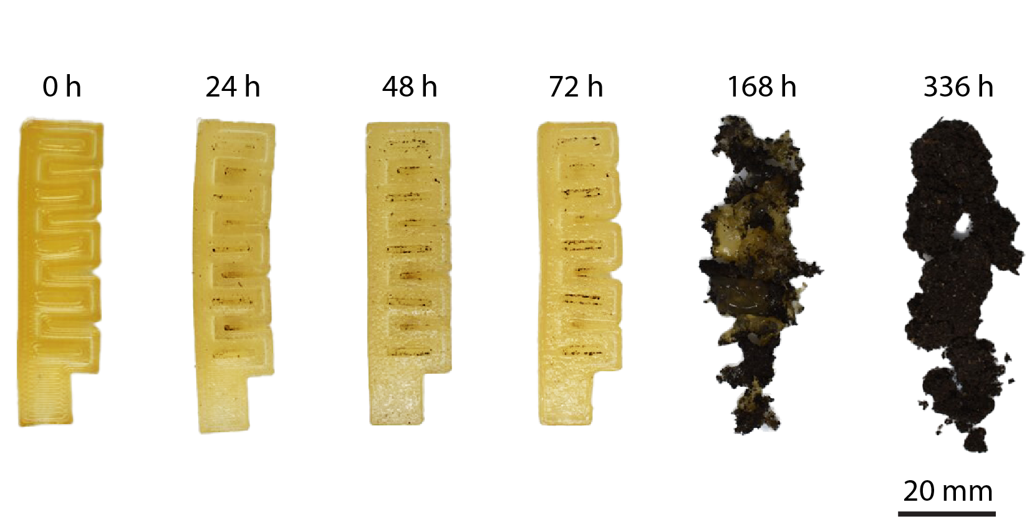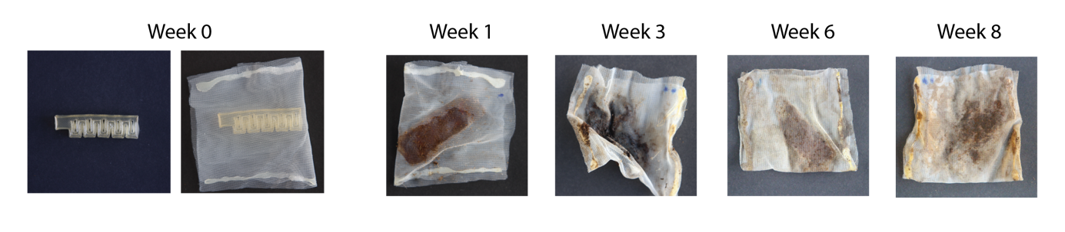
Figure S2: Biodegradation of the soft gripper. The grippers were immersed in artificial simulated soil environment (according to ISO 20200) and stored in an incubator at a constant temperature (58 °C) over a total time period of 8 weeks.

