Buried interface engineering enables efficient and 1,960-hour ISOS-L-2I stable inverted perovskite solar cells
Lin Li¹†, Mingyang Wei²†, Virginia Carnevali³†, Haipeng Zeng¹†, miaomiao Zeng¹, Ranran Liu¹, Nikolaos Lempesis³, Felix Thomas Eickemeyer², Long Luo¹, Lorenzo Agosta³, Mathias Dankl³, Shaik M. Zakeeruddin², Ursula Roethlisberger^{3*}, Michael Grätzel^{2*}, Yaoguang Rong^{4*}, Xiong Li^{1*}

¹Michael Grätzel Center for Mesoscopic Solar Cells, Wuhan National Laboratory for Optoelectronics, Huazhong University of Science and Technology, Wuhan 430074, China.
²Laboratory of Photonics and Interfaces, Institute of Chemical Sciences and Engineering, École Polytechnique Fédérale de Lausanne (EPFL), CH-1015 Lausanne, Switzerland.
³Laboratory of Computational Chemistry and Biochemistry, Institute of Chemical Sciences and Engineering, École Polytechnique Fédérale de Lausanne (EPFL), CH-1015 Lausanne, Switzerland.
⁴School of Chemistry, Chemical Engineering, and Life Sciences, Wuhan University of Technology, Wuhan 430070, China.

†These authors contributed equally to this work.
*Corresponding author. Email: ygrong2022@outlook.com; ursula.roethlisberger@epfl.ch; michael.graetzel@epfl.ch; xiongli@hust.edu.cn.

High-performance perovskite solar cells (PSCs) typically require interfacial passivation, yet this is challenging for the buried interface, owing to the dissolution of passivation agents during the deposition of perovskites. Here, we overcome this limitation with in-situ buried interface passivation – achieved via directly adding a cyanoacrylic acid-based molecular additive, namely BT-T, into the perovskite precursor solution. Classical and ab-initio molecular dynamics simulations reveal that BT-T spontaneously may self-assemble at the buried interface during the formation of the perovskite layer on a nickel oxide hole transporting layer. The preferential buried interface passivation results in facilitated hole transfer and suppressed charge recombination. In addition, residual BT-T molecules in the perovskite layer enhance its stability and homogeneity. We report a power-conversion efficiency (PCE) of 23.48% for 1.0 cm² inverted-structure PSCs. The encapsulated PSC retains 95.4% of its initial PCE following 1,960-hour maximum power point tracking under continuous light illumination at 65 °C (i.e., ISOS-L-2I protocol). Our demonstration of operating-stable PSCs under accelerated ageing conditions represents a step closer to the commercialization of this emerging technology.
- Introduction
Metal halide perovskites have attracted intensive research attention for optoelectronic applications in light of their excellent optoelectronic properties, including tunable bandgaps, strong light absorption, and long carrier diffusion lengths, combined with low-cost solution-processing.^{[1-4]} In just a decade, the power-conversion efficiency (PCE) of perovskite solar cells (PSCs) has reached a certified value of 25.8%,^{[5]} which is competitive with that of crystalline silicon (c-Si) photovoltaics (PV). However, record-efficiency PSCs are lab-made small cells with an active area of merely ~0.1 cm²; scaling up PSCs to large scales devices causes inferior device performance and stability – a challenge that hampers the commercialization of this emerging PV technology.^{[6, 7]}
Efficient and stable PSCs require uniform and defect-less perovskite thin films at large areas, which can improve charge transport, suppress non-radiative energy loss, and minimize device degradation pathways.^{[8-11]} Besides that, improvements in the performance and stability of PSCs also rely on the selection of efficient charge-transport layer (CTL) and passivation of perovskite/ CTL interfaces.^{[12-17]} Compared with efficient but expensive and delicate organic hole transport layers (HTLs), such as 2,2′7,7′-tetrakis-(N, N-di-p-methoxyphenylamine)-9,9′-spirobifluorene (Spiro-MeOTAD) and poly[bis (4-phenyl)(2,4,6-trimethylphenyl)amine] (PTAA),^{[18, 19]} inorganic HTLs of nickel oxide (NiO_{x}) are more favorable for fabricating highly stable PSCs, since they are low cost, stable and readily scalable.^{[20]} In particular, inverted-structure PSCs with NiO_{x} HTLs have delivered some of the best-reported stability results under a variety of stressors, including the 85°C-85% relative humidity damp heat test, temperature cycling from -40°C to 85°C, and operational stability under continuous illumination.^{[21]} Currently, PSCs with NiO_{x} HTLs still demonstrate lower efficiencies than those with organic HTLs.^{[22, 23]} McGehee et. al. found that suppressing the redox reactions at the NiO_{x}-perovskite interface can enhance the open-circuit voltage (V_{OC}) of as-fabricated cells.^{[24]} For the modification of interfaces in PSCs, great efforts have been devoted to the passivation of the top surface of perovskite films, which can be feasibly accomplished by treating them with ammonium halide solutions.^{[25, 26]} Nevertheless, the passivation of the buried interface, i.e., the interface between the perovskite and bottom CTL,^{[27]} remains a challenge: in prior, the buried interface passivation was demonstrated ex-situ in PSCs via the treatment of bottom CTLs before the perovskite deposition.^{[8]} This approach, unfortunately, may cause the dissolution of passivating agents in the perovskite film during its subsequent deposition, eventually reducing the effectiveness of passivation.
We reason that in-situ buried interface passivation – established via directly adding molecular additives into the perovskite precursor inks – could resolve this issue and simplify the cells fabrication.^{[9, 28, 29]} However, typical molecular additives mainly passivate the film surface and grain boundaries of perovskite films. It thereby required the rational design of modifiers for sufficient buried interface passivation: ideally, a molecular additive should exhibit stronger interaction with the bottom CTL than that with perovskites, such that they would self-assemble preferably at the buried interface during perovskite film formation.
Here, we report the use of a cyanoacrylic acid-based molecular additive as an in-situ buried interface modifier for inverted-structure PSCs with NiO_{x} HTLs. Our computational and experimental investigations reveal that this modifier can be anchored spontaneously onto the buried interface during perovskite deposition. This approach suppresses non-radiative charge carrier recombination and facilitates interfacial charge transfer, enabling the demonstration of a PCE of 23.48% for PSC with an active area of 1 cm². The encapsulated cell retained 95.4% of its initial performance after 1,960 h of operation under one-sun equivalent light illumination at 65°C.

- Results and discussion
Organic dye as the in-situ buried interface modifier
We focused on inverted-structure PSCs with solution-processed NiO_{x} as the bottom HTL. We sought herein to endow the NiO_{x} with a molecular surface modifier – during the processing of the perovskite layer – that would passivate the buried interface, thereby improving the device performance and stability of PSCs. Here, we synthesized 2-cyano-3-(4-(7-(4-(diphenylamino)phenyl)benzo[c][1,2,5]thiadiazol-4-yl)phenyl)acrylic acid (BT-T) – a donor-acceptor organic molecule used in dye-sensitized solar cells (DSSCs).^{[30]} BT-T comprises a triphenylamine electron donor and a benzothiadiazole-containing electron acceptor with cyanoacrylic acid as the anchoring group (Fig. 1a). It has been shown that the deprotonated cyanoacrylic acid group binds strongly to Ti ions.^{[31]} Since the electrostatic potential (ESP) calculations indicate a high negative charge density at the cyanoacrylic acid side of the BT-T molecule (Fig. 1b), we reasoned that this molecule might be anchored onto NiO_{x} and perovskites via similar metal ion coordination. Density functional theory (DFT) computations of the highest-occupied-molecular-orbital (HOMO) and lower-unoccupied-molecular-orbital (LUMO) of the deprotonated BT-T molecule (Fig. 1c) further reveal that the carboxyl-group (COO-group) acts as a preferential channel for the hole transport between the HTL and FAPbI₃ surfaces. The HOMO of the deprotonated BT-T molecule is a relevant orbital for the hole transport and the FAPbI₃/BT-T/NiO_{x} band alignment turns out to be favorable (Fig. S1).
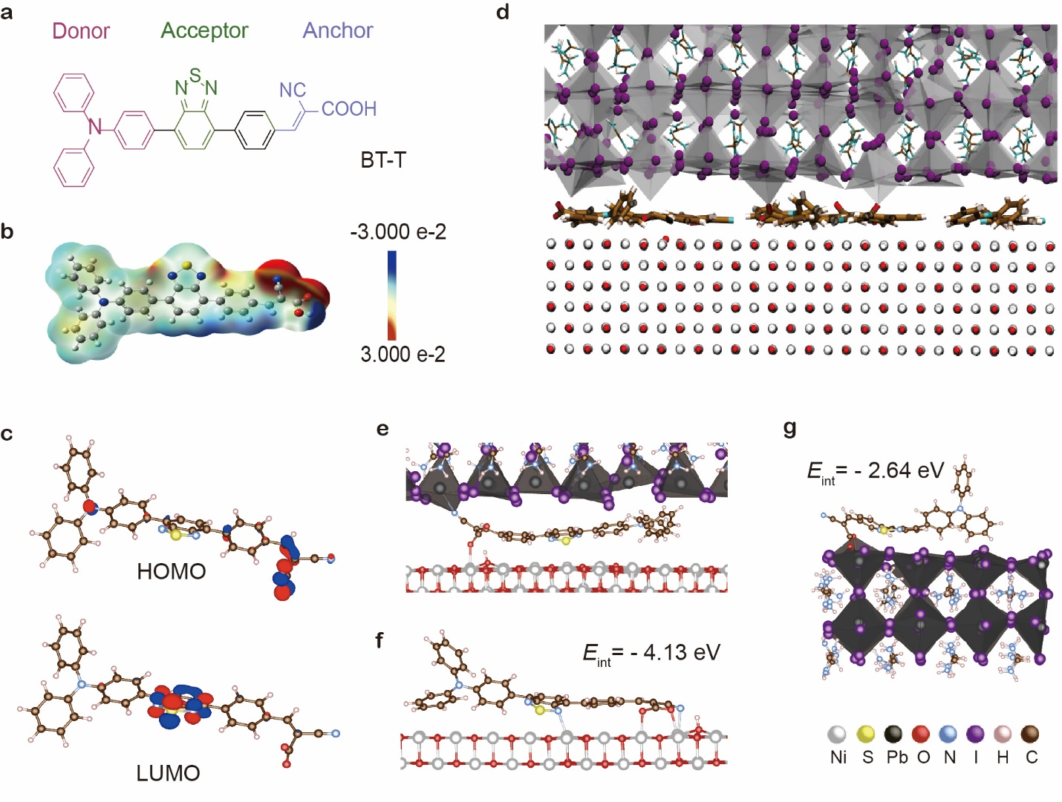
Figure 1 | In-situ buried interface passivation with BT-T (a) Chemical structure and (b) ESP map of BT-T. (c) DFT computations at Γ point of the HOMO and LUMO of the deprotonated BT-T molecule; the blue and red iso surfaces (1.5×10⁻³$\text{|}\text{a.u}\text{.|}$) represent the positive and the negative part of the wave function. (d) Snapshot of an NPT (isothermal-isobaric ensemble) classical molecular dynamics (MD) simulation of the complete FAPbI₃/BT-T/NiO_{x} system. (e) Snapshot of NPT ab-initio MD of the complete FAPbI₃/BT-T/NiO_{x} system; the COO-group of the molecule interacts with the NiO_{x} surface, while the CN-group interacts with the FAPbI₃ surface. (f, g) Stick-and-ball model and DFT adsorption energies (eV) for two representative adsorption configurations of the deprotonated BT-T molecule on NiO_{x} (001) and Pb-terminated perovskite surfaces.
We performed DFT calculations, ab-initio, and classical molecular dynamics (MD) simulations to investigate the interaction between the BT-T molecule and NiO_{x} (BT-T/NiO_{x}), perovskite (BT-T/FAPbI₃), as well as the full system (FAPbI₃/BT-T/NiO_{x}). It should be noted that these calculations do not function as an analytical tool; we conduct computational studies to guide and inform our experimental work. To better explore the space of possible configurations, we used classical MD simulations that showed a preference for the BT-T molecules to lie flat on the surface and form a monolayer at the NiO_{x}-FAPbI₃ interface (Fig. 1d and Movie S1). The planarity of the BT-T molecule concerning the NiO_{x} and FAPbI₃ surfaces was confirmed by ab-initio MD simulations. Details on the implementation and validation of the classical MD simulations can be found in the Computational Methods section of the Supporting Information. At higher BT-T simulated concentrations, upon full coverage of the interfacial area by a monolayer of flat-lying BT-T molecules, some BT-T molecular stacking is noticed. However, this may facilitate the charge transfer between two overlapping BT-T molecules through parallel-displaced 𝜋-stacking Fig. S2 and Movie S2).^{[32, 33]} DFT calculations indicate a strong interaction between deprotonated BT-T and both NiO_{x} and FAPbI₃ surfaces, with a clear preference for the NiO_{x} one (Fig. 1f, g and Table S1).
Considering the full system is crucial to understanding the interaction of BT-T at the buried interface. DFT calculations of the FAPbI₃/BT-T/NiO_{x} interface show a clear tendency of the deprotonated BT-T molecule to bind almost entirely flat on NiO_{x} (Fig. 1f and Supporting information, Fig. 3) as a consequence of the high NiO_{x} surface reactivity due to unsaturated oxygen dangling bonds. Almost perfect planarity of BT-T was retained at finite temperatures, as confirmed by classical MD simulations at ambient conditions (Supporting information, Fig. 4). This preferential binding mode reduces the buried interface volume substantially, promoting optimal contact through BT-T between NiO_{x} and FAPbI₃ (with an average NiO_{x}-FAPbI₃ distance of about 8 Å) (Supporting information, Fig. 4). Both ab-initio and classical MD show that the carboxyl group of the molecule is anchored via one oxygen to the NiO_{x} surface, while the other oxygen stands almost perpendicular concerning the NiO_{x} surface; in addition, ab-initio MD reveals that the CN-group is simultaneously bonded to undercoordinated Pb on the FAPbI₃ surface (Fig. 1e and Supporting information, Fig. 5).
Characterization of the perovskite/NiO_{x} interface
Since DFT calculations indicate the strong binding of BT-T onto the buried interface, we sought to investigate experimentally the buried interface passivation with the BT-T additive. Perovskites with a stoichiometry of Cs_{0.05}(FA_{0.87}MA_{0.13})_{0.95}Pb(I_{0.87}Br_{0.013})₃ were prepared on NiO_{x}-coated ITO substrate. A trace amount of BT-T (0.24 wt%) was directly added to the perovskite precursor to induce molecular passivation. We firstly employed time-of-flight secondary ion mass spectrometry (TOF-SIMS) to reveal the distribution of BT-T molecules throughout the entire thickness of the perovskite layer (Fig. 2a). We used I⁻ and NiO⁻ as the indicators for the perovskite and NiO_{x} layer, respectively; and sulfur as the tracing element for the BT-T molecule. The results indicate that BT-T distributes predominantly at the perovskite/NiO_{x} interface (i.e., buried interface), a condition for preferable buried interface passivation. This inhomogeneous distribution agrees well with the DFT calculations, where BT-T was found to have stronger interactions with NiO_{x} than perovskite surfaces.
To confirm BT-T chemically anchored on the NiO_{x} form a robustness of self-assembly of the monolayer (SAM), we then performed X-ray photoelectron spectroscopy (XPS) measurements. Supporting information, Fig. 6 shows that the ratio of S: Ni and N: Ni increased after increasing the concentration of BT-T in the spin-coating solution. After washing, the ratio of S: Ni and N: Ni in the different concentrations tend to be consistent, confirming that the chemically anchored BT-T monolayer was preserved at the buried interface because it could not be dissolved by the perovskite solution. Furthermore, we used angle-resolved XPS (AR-XPS) to confirm that BT-T is allowed to be located on the NiOx surface and terminated as a single monolayer. In AR-XPS, the maximum probing depth is 3λcosθ, where the θ is take-off angle and λ is the electrons of the material inelastic mean free path.^{[34]} At 0°, all composition information is the same as normal XPS. The sample was titled at 0°, 30°, and 75° take-off angles, respectively. The probing depth is varied from approximately ~8 nm at 0° to only ~2 nm at 75°, which means the compositional information is closer to the NiO_{x} surface at a higher angle. Here we directly performed AR-XPS to characterize the component information of the NiO_{x}/BT-T surface after using a mixed solvent of DMSO and DMF (volume ratio of 4:1) to rinse up BT-T. As Supporting information Fig. 7 shows, from 0° to 75, there is a slightly increased in the ratio of N: Ni and S: Ni, from 0.14 to 0.25 and 0.07 to 0.10, respectively, which indicates that BT-T is likely forming a surface layer of NiO_{x}.
We then probed the interaction between BT-T and NiO_{x} using Fourier-transform infrared spectroscopy (FTIR) and X-ray photoelectron spectroscopy (XPS) measurements. From FTIR, the stretching vibration of C=O (at 1719 cm⁻¹ in pristine BT-T) was shifted to 1710 cm⁻¹ upon interacting with NiO_{x} (Fig. 2b). We ascribed this to a weakened C=O bond by the binding of BT-T with NiO_{x}. We found two characteristic peaks at ca. 1610 and 1382 cm⁻¹ in the FTIR spectra of BT-T molecules on NiO_{x} substrates, corresponding to the asymmetric and symmetric C=O vibrations, respectively.^{[31]} This evidence suggests that the deprotonation of BT-T molecules occurs when they interact with the NiO_{x} surfaces, consistent with the shallow energy barrier of ~0.2 eV for the deprotonation-protonation reaction indicated from DFT calculations (Fig. 2c). From XPS (Supporting information, Fig. 8), the coordination of BT-T with Ni ions was evidenced in the energy shifts of two Ni 2p3/2 core-level peaks for NiO_{x} substrates after the introduction of BT-T atop. The cyano-modified carboxylic acid (−C≡N and −COOH) group present on BT-T have an energy shift in the XPS spectra of C 1s and N 1S in the Supporting information, Fig.9. We rationalize these shifts are due to the bond formation between Ni atoms and the −C=O moieties of BT-T, which supports the FTIR results. Taking these results into consideration, we conclude that BT-T can be anchored on the NiO_{x} surface. Moreover, according to our previous study, when a molecular is applied on top of the NiO_{x} films, it can physically impede the detrimental interfacial reaction, thereby the coverage of BT-T is deemed as a protective measure shielding the NiO_{x} against detrimental interfacial redox reactions.^{[35]}
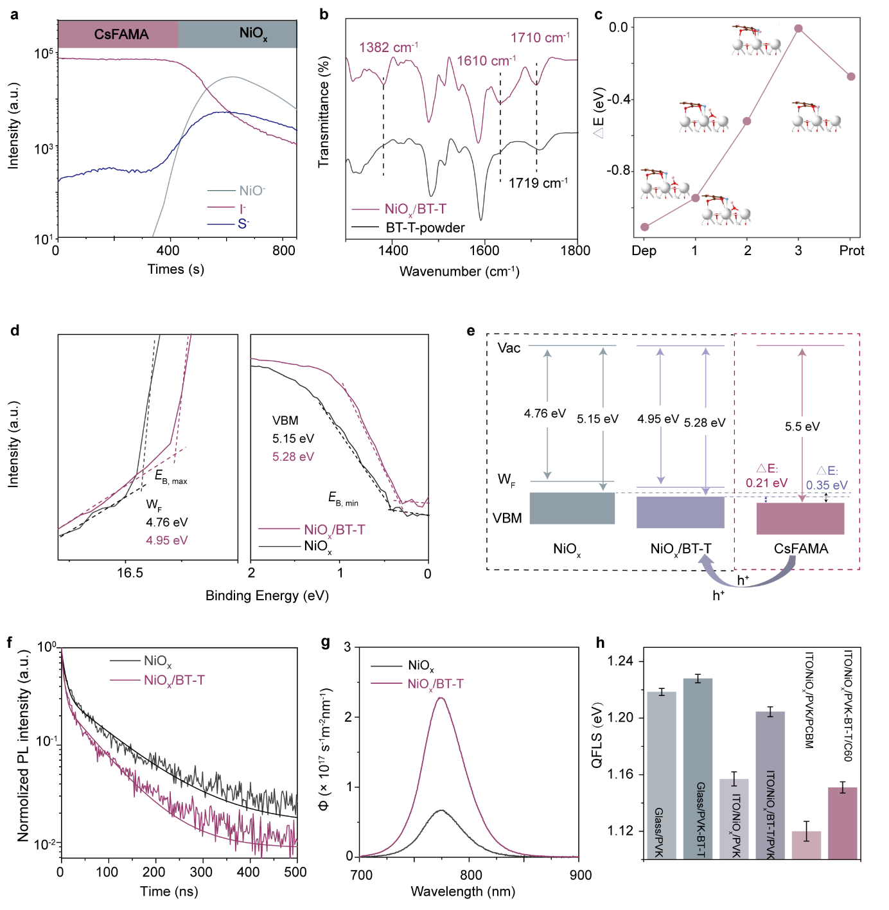
Figure 2 | Characterization of BT-T-passivated buried interface (a) TOF-SIMS profiles of CsFAMA-BT-T perovskites on NiO_{x}/ITO substrates measured in negative polarity. (b) FTIR spectra of BT-T powders and NiO_{x} /BT-T film. (c) DFT calculation of deprotonation-protonation energy barrier for BT-T on NiO_{x}. (d) UPS spectra of pristine NiO_{x} film and NiO_{x}/BT-T film on ITO substrates. (e) Energy-level diagram between pristine NiO_{x} or NiO_{x}/BT-T film and CsFAMA film. (f) Time-resolved photoluminescence curves (each curve represents an average over two measurements) and (g) Absolute intensity photoluminescence measurements for CsFAMA film deposited on pristine ITO/NiO_{x} or ITO/NiO_{x}/BT-T substrates. (h) The bar graph of QFLS of perovskite films deposited on the substrates with or without charge transport. The related PLQY values can be found in Supporting Information Table 3. All the NiO_{x}-BT-T-based samples characterized in Figure 2 used mixed solvents of DMSO and DMF (volume ratio of 4:1) to rinse up the superfluous BT-T, which approaches the real situation of the buried interface as much as possible.

Encouraged by the interactions between BT-T and NiO_{x}, we performed ultraviolet photoelectron spectroscopy (UPS) to evaluate the electronic properties of BT-T-passivated NiO_{x} in relation to the perovskite layer (Fig. 2d). We determined the energy positions of valence band maximum (VBM) and Fermi level (E_{F}) from the UPS data plotted on a logarithmic scale^{[36]} and further obtained the energy position of conduction band minimum (CBM) by adding the bandgap extracted from ultraviolet-visible spectroscopy (UV-Vis) measurements (Supporting information, Fig. 10). The energy level diagram is depicted in Fig. 2e, and the results indicate that the BT-T passivation deepens the E_{f} and VBM positions of NiO_{x}, resulting in a smaller VBM offset between perovskites and NiO_{x}. The reduced interfacial energy barrier for holes may facilitate hole transfer at the buried interface. Furthermore, we used XPS and UPS to directly characterize the buried NiOx surface, which was exposed by washing with solvents to remove the perovskite layer. Supporting information, Fig. 11 shows that there is an obvious S signal present in the XPS spectral. And UPS (Supporting information, Fig.12) shows that the VBM of the buried interface is 5.25 eV, which is similar to the NiOx-BT-T-based sample (5.28 eV).
Time-resolved photoluminescence (TRPL) measurements were carried out to investigate the interfacial carrier dynamics (Fig. 2f and g). We found an initial fast decay emerged in PL transients of perovskites deposited on NiO_{x} substrates that can be mainly attributed to hole injection, followed by a much slower decay for t > 50 ns, which is dominated by non-radiative recombination and hole back-injection.^{[37]} The initial decay time (averaged for two samples) is shorter for the BT-T passivated films (4.1 ns) than that of the control (5.2 ns; Supporting information, Table 2), which points towards a faster hole transfer from the perovskite to the NiO_{x} layer using the BT-T passivation. We further performed steady-state PL measurements and found the average PL quantum yield (PLQY) of perovskites films on NiO_{x} was improved by over four-fold to 0.8% with the addition of BT-T (Fig. 2g). The enhanced PLQY corresponds to an increase in quasi-Fermi level splitting (QFLS) by ca. 40 meV (Fig. 2h and Supporting information, Table 3). By contrast, the improvement in QFLS for perovskites deposited on glass substrates is less than 10 meV with the BT-T passivation.
Structural properties of perovskite films
Next, we investigated how the BT-T additive affects the morphology and crystalline structure of perovskite films. Scanning electron microscopy (SEM) images of the perovskite films with and without BT-T are shown in Fig. 3a and b. Compared to the control film, the film with BT-T exhibited an enlarged average grain domain size (Supporting information, Fig. 13). Cross-sectional SEM (Supporting information, Fig. 14) displays that perovskite films containing BT-T deposited on NiO_{x} substrates exhibited the preferred perpendicular orientation of grains with respect to the substrate. This is accompanied by enlarged grains/domains compared to the pristine ones deposited on NiO_{x} and NiO_{x}-BT-T substrates. The improved film formation is ascribed to the retarded crystallization due to the Lewis acid-base interaction between the carboxylate functional group (C=O) and under-coordinated Pb²⁺, which was probed by FTIR (Supporting information, Fig. 15) and XPS (Fig. 3f). X-ray diffraction (XRD) patterns of the control and BT-T films (Fig. 3c) reveal the inhomogeneity of perovskite films, as evidenced by the coexistence of perovskite and PbI₂ phases. We found that the BT-T addition reduced the formation of PbI₂. This improved phase homogeneity of perovskite films is beneficial for the performance of PSCs.^{[8]}
The film uniformity was further studied using Kelvin probe force microscopy (KPFM) (Supporting information, Fig. 16). The BT-T film displays a reduced variation in the contact potential difference (CPD) among grains, despite having a similar surface roughness to the control. This better film uniformity is explained by more-homogenous crystallization: BT-T was observed from the FTIR spectra (Supporting information, Fig. 17) to form complexes with perovskite precursor constituents (such as PbI₂ and MAI). These interactions induce a delayed and thus uniform crystallization process, driven by the lower volatility of BT-T than that of DMSO.
We then investigated the interaction of BT-T with perovskite thin films. Nanoscale infrared spectroscopy (namely, AFM-IR) was utilized to image the spatial distribution of BT-T on the film surface. Coupled with the AFM topography (Fig. 3d), the AFM-IR imaging of MAPbI₃ perovskites at 1716 cm⁻¹ (corresponding to the C=O stretching vibration) reveals that BT-T molecules were located near the grain boundaries of perovskites (Fig. 3e).^{[38]} It is noted that MA-based perovskites were investigated herein instead of the triple cation formulation since the C=N stretching vibration in FA cations (at 1712 cm⁻¹) cannot be distinguished from the C=O stretching in BT-T (Supporting information, Fig. 18). We further carried out X-ray photoelectron spectroscopy (XPS) to evaluate the passivation capability of BT-T (Fig. 3f). The core-level peaks of Pb 4f were shifted towards lower binding energies with the BT-T additive due to its interaction with under-coordinated Pb²⁺. We found that this interaction can reduce perovskite decomposition, as evidenced by the suppressed metallic Pb⁰ formation compared to the control (Fig. 3f).
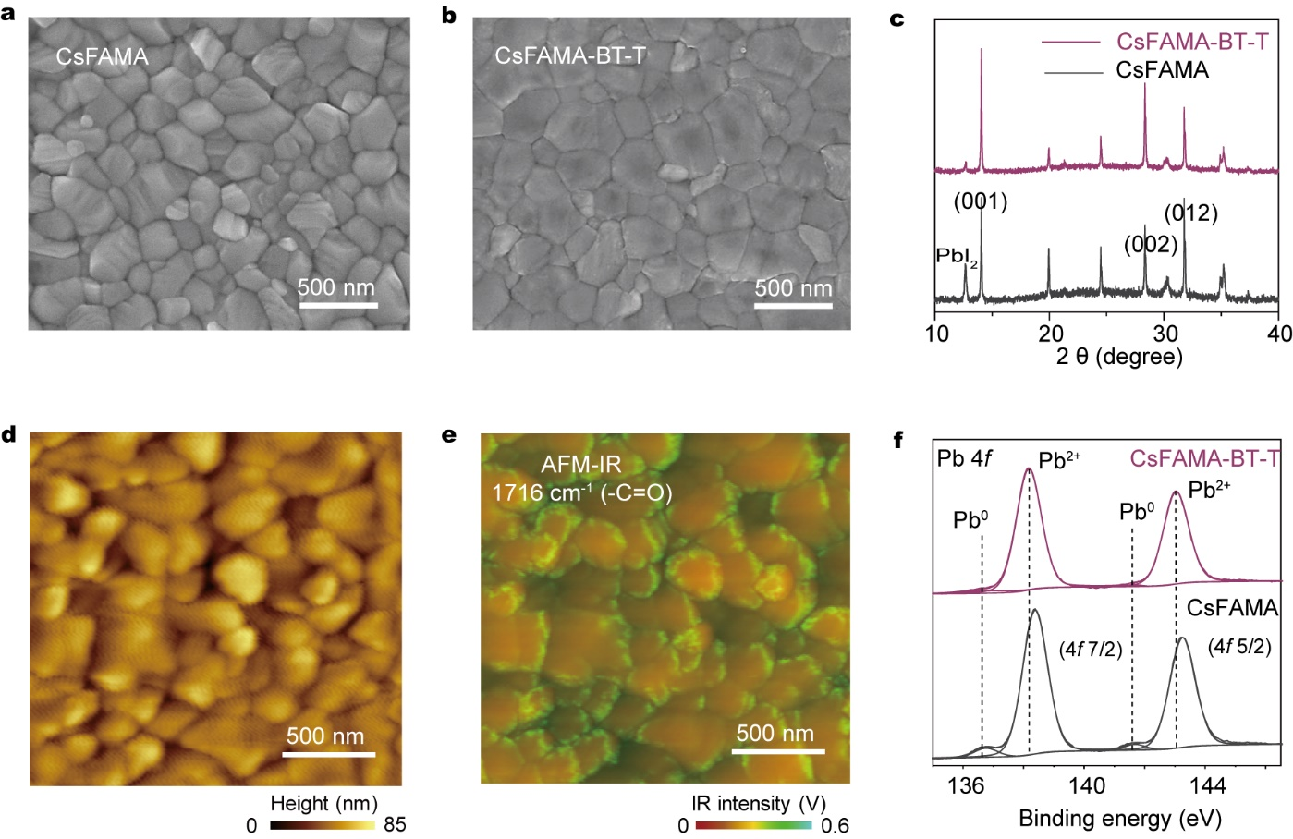
Figure 3 | Characterization of perovskite thin films (a, b) Top-view SEM of perovskite films deposited on ITO/NiO_{x} substrates with or without BT-T passivation. (c) XRD patterns of CsFAMA and CsFAMA-BT-T thin films deposited on ITO substrates. (d, e) AFM height and IR image of the perovskite-BT-T film. The IR signals were collected at a fixed wavenumber that corresponds to the C=O stretching vibration of BT-T in MAPbI₃-BT-T. (f) XPS spectra of Pb 4f core level of CsFAMA and CsFAMA-BT-T perovskite films deposited on the ITO substrates.
The improved material stability was further affirmed in AFM-IR studies. We tracked the nano-scale spatial distribution of MA cations on the perovskite film surface following 100 ℃ thermal annealing in the ambient environment (RH ~20%) for 48 h. The intensity of the MA-related IR signal at 1454 cm⁻¹ (symmetric CH₃ bending) was significantly reduced for the control film after the thermal ageing. By contrast, the BT-T film exhibited stronger IR-signal intensities and a more uniform MA distribution. This indicates that BT-T passivation can reduce the volatilization of MA at high temperatures, which we assign further to the hydrogen bonding between MA and BT-T molecules (Supporting information, Fig. 17). These results suggest that despite predominantly passivating the buried interface, residual BT-T molecules can promote the homogeneity and material stability of the perovskite thin film.
PV performance and stability of PSCs
We fabricated 1 cm²-sized PSCs using NiO_{x} as the HTL, solution-processed PCBM/BCP bilayer as the ETL, and perovskites with a stoichiometry of Cs_{0.05}(FA_{0.98}MA_{0.02})_{0.95}Pb(I_{0.98}Br_{0.02})₃ as the absorbing layer without and with the BT-T additive. The optimal concentration of BT-T in the precursor solution was 0.24 wt%. Compared to the control devices, BT-T-passivated PSCs showed improved PV performances with a higher average PCE of 22.40 % (among 25 devices) than that of the control (20.72%; Supporting information, Table 4, Fig. 19 and 20). Notably, the average V_{OC} was improved from 1.10 V to 1.15 V with the BT-T addition. This we ascribe to the improved band alignment and suppressed non-radiative energy loss, seen in the UPS and PL studies. We achieved a champion PCE of 23.48% for the 1-cm² BT-T-passivated PSC, with a J_{SC} of 24.60 mA cm⁻², an FF of 0.816, and a V_{OC} of 1.170 V. The J-V curves of the champion device are shown in Fig. 4a and Supporting information, Fig. 21 with negligible hysteresis from reverse and forward scans. We measured the external quantum efficiency (EQE) spectra of the devices without and with BT-T (Fig. 4b). The integrated J_{SC} values match well with those from the J-V scans. We further obtained a stabilized PCE of 23.21% from the steady-state power output measurements (Supporting information, Fig. 22), a high value among previously-reported 1 cm²-sized inverted-structure PSCs (Supporting information, Table 5). For the CsFAMA-BT-T devices with a small area of ~0.1 cm², the champion PCE reached 23.48%, with a J_{SC} of 24.83 mA cm⁻², an FF of 0.850, and a V_{OC} of 1.186 V (Supporting information, Fig. 23). Additionally, we successfully fabricated a PSC minimodule with an active area of around 17.11 cm²and tested its J-V characteristics (Supporting information, Fig. 24). The PCE of the minimodule with 6 subcells reached 20.5%, with a J_{SC} of 66.35 mA, an FF of 77.2%., and a V_{OC} of 6.85 V.
We also fabricated devices using different concentrations of BT-T modified NiOx surfaces to further investigate the effects of passivating the buried interface. Supporting information, Table 6 shows that the average V_{OC} was improved from 1.10 V to 1.14 V with the BT-T modification, consistent with the improved band alignment in the UPS study (Fig. 2d) and PLQY results (Fig. 2h)., The obvious increase in the device V_{OC} indicates that using BT-T to modify the NiO_{x} surface is an effective method to reduce the non-radiative recombination. Although the V_{OC} and PCE of devices were improved with the BT-T modified NiO_{x} surface, the PCE of the best-performing device based on NiO_{x}/BT-T still lagged behind the devices that had the BT-T additive directly incorporated into the perovskite precursor solution (Supporting information, Fig. 25). On the one hand, pre-treating the bottom CTLs before perovskite deposition may unfortunately lead to the dissolution of the passivating agents during the subsequent perovskite layer deposition, ultimately reducing the effectiveness of passivation (Supporting information, Fig. 6). On the other hand, the gradient distribution of BT-T in the PSCs, as seen in TOF-SIMS, could have a more extensive impact than when solely concentrated at the buried interface, such as simultaneously passivating defects at the buried interface and bulk perovskite, and controlling of perovskite film growth. To further investigate the effects of BT-T on the charge recombination and transport of the PSC devices, transient photovoltage (TPV) and photocurrent (TPC) decay measurements were performed on the complete devices (Supporting information, Fig. 26). The photovoltage decay time of the CsFAMA-BT-T-based device (154.72 µs) is substantially longer than that of the pristine CsFAMA and NiO_{x}/BT-T-based devices (84.90 and 130.27 µs), which is attributed to the passivation effect of BT-T that leads to suppressed nonradiative recombination. Additionally, the photocurrent decay time of the CsFAMA-BT-T-based device is 2.11 µs, which is shorter than that of the devices based on pristine CsFAMA and NiO_{x}/BT-T (5.92 and 3.21 µs), indicating more efficient extraction of photogenerated charge carriers from the perovskite layer. Finally, we analyzed the V_{OC} -incident light intensity dependence of PSCs and found that the ideality factor n was decreased from 1.70 to 1.38 with the BT-T passivation (Fig. 4c), indicative of reduced trap-assisted recombination due to the buried-interface and bulk passivation.
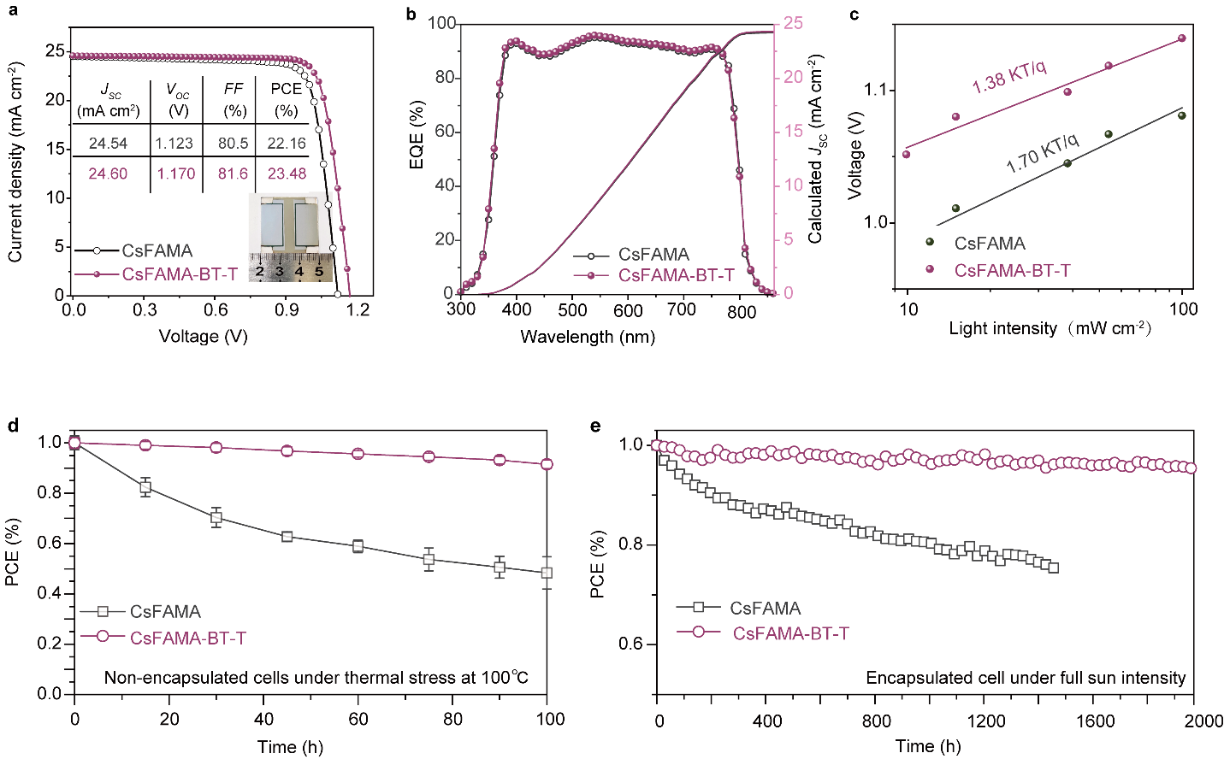
Figure 4 | Device performance and stability of PSCs. (a) J-V curves of the 1-cm²-sized champion cells with and without BT-T measured at reverse scan. (b) The EQE spectra and corresponding integrated J_{SC} of the champion cells with and without BT-T. (c) Dependence of V_{OC} on the light intensity of the cells with and without BT-T. (d) Evolution of PCEs of 1-cm²-sized PSCs with and without BT-T passivation under thermal stress at 100 ℃ in N₂ for 100 h. (e) Evolution of PCEs at MPP tracking of 1-cm²-sized PSCs with and without BT-T modification under light soaking at 65 °C.

To evaluate the stability of PSCs, we first tracked the degradation of their PV performances following annealing at 100 °C in N₂. The control devices were degraded to below 50% of their initial PCE after 100-hour thermal ageing with a T₈₀ (time to 80% of initial PCEs) of 18 hours. BT-T passivation greatly improves the thermal stability of PSCs: the corresponding device retained over 90% of initial performance following 100-hour annealing (Fig. 4d). The damp heat (85 °C and 85% relative humidity) test showed that the device with BT-T retained 95.8% of its maximum PCE after 800 h (Supporting information, Fig. 27). We then assessed the operational stability of encapsulated PSCs under continuous 1-sun-equivalent light illumination in N₂ at 65 °C (corresponding to the ISOS-L-2I level accelerated ageing).^{[39]} The control device showed a rapid initial degradation in the device performance during the MPP-tracking with a T₈₀ of 1,008 hours, while the BT-T-passivated device maintained over 95% of its initial PCE after 1,960 hours of MPP tracking (Fig. 4e).
We performed TOF-SIMS measurements to investigate ion migration for devices that had been aged following 200-hour light-soaking at 85 ℃. For the device without BT-T, iodides diffused into the CTLs and Ag electrode after the accelerated ageing. By contrast, halide diffusion was largely reduced for the BT-T-passivated device, indicative of suppressed ion migration (Supporting information, Fig. 28). 2D TOF-SIMS mapping further confirms that fewer iodide species diffused into the PCBM layer of aged devices with the BT-T passivation (Supporting information, Fig. 28b and d). This suppressed ion migration, combined with reduced MA volatilization, and buried interface passivation, contributes to the improved stability of BT-T-passivated PSCs.
- Conclusion
We have introduced a cyanoacrylic acid-based molecular additive for NiO_{x}-based inverted PSCs using an in-situ buried interface passivation strategy, in which small amounts of molecular additives are into the perovskite precursor solution. The computational and experimental investigations reveal that this modifier can be anchored spontaneously onto the buried interface and grain boundaries of perovskite films during the perovskite deposition. This approach satisfies bottom contact, facilitates interfacial charge transfer, as well as improves the morphology and crystalline structure of perovskite films. As a result, a remarkable PCE of 23.48% for PSCs with an active area of 1 cm² is realized. The encapsulated cell retained 95.4% of its initial performance after 1,960 h of operation under 1-sun equivalent light illumination at 65°C (ISOS-L-2I protocol) and 91.5% of initial performance following 100-hour annealing at 100 ℃. This work proves that the rational design modifier to in-situ passivates buried interface is a facile and effective strategy to boost the performance and stability of inverted-structure PSCs.
- Experimental Section
The experiment details are provided in Supporting Information.
Supporting Information
Supporting Information is available from the Wiley Online Library or the author.
Acknowledgments
This work was financially supported by the National Key Research and Development Program of China (2022YFB4200305), the National Natural Science Foundation of China (21875081, 52172200, and 22279039), the Chinese National 1000-Talent-Plan program; the Frontier Project of the Application Foundation of Wuhan Science and Technology Plan Project (2020010601012202); the Innovation Project of Optics Valley Laboratory (OVL2021BG008); the Foundation of State Key Laboratory of New Textile Materials and Advanced Processing Technologies (Grant No. FZ2021011); the Foundation of State Key Laboratory of Coal Conversion (Grant No. J18-19-913). U.R. acknowledges the Swiss National Science Foundation Grant No. 200020-185092 and the NCCR-MUST for funding as well as computational resources from the Swiss National Computing Centre CSCS. M. W. acknowledges funding from the European Union’s Horizon 2020 Research and Innovation program under the Marie Skłodowska-Curie Grant Agreement No. 101026353. M. G. acknowledges funding from Günes Corporation. We thank the Analytical and Testing Centre from HUST and the Centre for Nanoscale Characterization and Devices (CNCD) from WNLO (HUST) for the facility support of sample measurements. We thank Suzhou Institute of Nano-Tech and Nano-Bionics for performing AFM-IR, TOF-SIMS, and KPFM.
Competing interests
The authors declare that they have no other competing interests.
Author contributions
L.L., M.W., V.C., and H. Z. contributed equally to this work. L.L., M.W., and Y.R. conceived the idea and designed the experiments. X.L., M.G., U.R., and S.M.Z. supervised the study. L.L. fabricated devices and conducted the characterization. H.Z. designed and prepared passivating molecules. F.E. performed the PL and TRPL characterization. R.L. and L.L. conducted the XRD and SEM measurements. V.C., N. L., L.A., and M.D. were responsible for the classical and, ab -initio molecular dynamics simulations and the DFT calculations as well as the related analysis. M.W., L.L., and V.C. co-wrote the manuscript. All authors contributed to data analysis and read and commented on the manuscript.
Data and materials availability: All data are available in the manuscript or the supporting information. Other data that support the findings of this study are available from the corresponding author upon reasonable request.
Keywords
In-situ buried interface passivation, cyanoacrylic acid-based molecular additive, NiO_{x} hole-transporting materials, reduced perovskite decomposition, inverted perovskite solar cells.
References
[1] A. Kojima, K. Teshima, Y. Shirai, T. Miyasaka, Journal of the American Chemical Society 2009, 131, 6050.
[2] D. Shi, V. Adinolfi, R. Comin, M. Yuan, E. Alarousu, A. Buin, Y. Chen, S. Hoogland, A. Rothenberger, K. Katsiev, Y. Losovyj, X. Zhang, P. A. Dowben, O. F. Mohammed, E. H. Sargent, O. M. Bakr, Science 2015, 347, 519.
[3] Q. Dong, Y. Fang, Y. Shao, P. Mulligan, J. Qiu, L. Cao, J. Huang, Science 2015, 347, 967.
[4] Z. Chen, B. Turedi, A. Y. Alsalloum, C. Yang, X. Zheng, I. Gereige, A. AlSaggaf, O. F. Mohammed, O. M. Bakr, ACS Energy Letters 2019, 4, 1258.
[5] National Renewable Energy Laboratory (NREL), Best Research-Cell Efficiency Chart (2021), https://www.nrel.gov/pv/cell-efficiency.html.
[6] Z. Li, T. R. Klein, D. H. Kim, M. Yang, J. J. Berry, M. F. A. M. van Hest, K. Zhu, Nature Reviews Materials 2018, 3, 18017.
[7] N.-G. Park, K. Zhu, Nature Reviews Materials 2020, 5, 333.
[8] Z. Liu, L. Qiu, L. K. Ono, S. He, Z. Hu, M. Jiang, G. Tong, Z. Wu, Y. Jiang, D.-Y. Son, Y. Dang, S. Kazaoui, Y. Qi, Nature Energy 2020, 5, 596.
[9] C. Li, X. Wang, E. Bi, F. Jiang, S. M. Park, Y. Li, L. Chen, Z. Wang, L. Zeng, H. Chen, Y. Liu, C. R. Grice, A. Abudulimu, J. Chung, Y. Xian, T. Zhu, H. Lai, B. Chen, R. J. Ellingson, F. Fu, D. S. Ginger, Z. Song, E. H. Sargent, Y. Yan, Science 2023, 379, 690.
[10] Q. Cao, Y. Li, H. Zhang, J. Yang, J. Han, T. Xu, S. Wang, Z. Wang, B. Gao, J. Zhao, X. Li, X. Ma, S. M. Zakeeruddin, W. E. I. Sha, X. Li, M. Grätzel, Science 2021, 7, eabg0633.
[11] M. Li, H. Li, Q. Zhuang, D. He, B. Liu, C. Chen, B. Zhang, T. Pauporté, Z. Zang, J. Chen, Angewandte Chemie International Edition 2022, 61, e202206914.
[12] J. Xue, R. Wang, Y. Yang, Nature Reviews Materials 2020, 5, 809.
[13] H. Tan, A. Jain, O. Voznyy, X. Lan, F. P. G. d. Arquer, J. Z. Fan, R. Quintero-Bermudez, M. Yuan, B. Zhang, Y. Zhao, F. Fan, P. Li, L. N. Quan, Y. Zhao, Z.-H. Lu, Z. Yang, S. Hoogland, E. H. Sargent, Science 2017, 355, 722.
[14] M. Kim, J. Jeong, H. Lu, T. K. Lee, F. T. Eickemeyer, Y. Liu, I. W. Choi, S. J. Choi, Y. Jo, H.-B. Kim, S.-I. Mo, Y.-K. Kim, H. Lee, N. G. An, S. Cho, W. R. Tress, S. M. Zakeeruddin, A. Hagfeldt, J. Y. Kim, M. Grätzel, D. S. Kim, Science 2022, 375, 302.
[15] H. Chen, S. Teale, B. Chen, Y. Hou, L. Grater, T. Zhu, K. Bertens, S. M. Park, H. R. Atapattu, Y. Gao, M. Wei, A. K. Johnston, Q. Zhou, K. Xu, D. Yu, C. Han, T. Cui, E. H. Jung, C. Zhou, W. Zhou, A. H. Proppe, S. Hoogland, F. Laquai, T. Filleter, K. R. Graham, Z. Ning, E. H. Sargent, Nature Photonics 2022, 16, 352.
[16] Z. Li, B. Li, X. Wu, S. A. Sheppard, S. Zhang, D. Gao, N. J. Long, Z. Zhu, Science 2022, 376, 416.
[17] Q. Jiang, J. Tong, Y. Xian, R. A. Kerner, S. P. Dunfield, C. Xiao, R. A. Scheidt, D. Kuciauskas, X. Wang, M. P. Hautzinger, R. Tirawat, M. C. Beard, D. P. Fenning, J. J. Berry, B. W. Larson, Y. Yan, K. Zhu, Nature 2022, 611, 278.
[18] T. Zhang, F. Wang, H.-B. Kim, I.-W. Choi, C. Wang, E. Cho, R. Konefal, Y. Puttisong, K. Terado, L. Kobera, M. Chen, M. Yang, S. Bai, B. Yang, J. Suo, S.-C. Yang, X. Liu, F. Fu, H. Yoshida, W. M. Chen, J. Brus, V. Coropceanu, A. Hagfeldt, J.-L. Brédas, M. Fahlman, D. S. Kim, Z. Hu, F. Gao, Science 2022, 377, 495.
[19] X. Zheng, Y. Hou, C. Bao, J. Yin, F. Yuan, Z. Huang, K. Song, J. Liu, J. Troughton, N. Gasparini, C. Zhou, Y. Lin, D.-J. Xue, B. Chen, A. K. Johnston, N. Wei, M. N. Hedhili, M. Wei, A. Y. Alsalloum, P. Maity, B. Turedi, C. Yang, D. Baran, T. D. Anthopoulos, Y. Han, Z.-H. Lu, O. F. Mohammed, F. Gao, E. H. Sargent, O. M. Bakr, Nature Energy 2020, 5, 131.
[20] Z. Yang, W. Zhang, S. Wu, H. Zhu, Z. Liu, Z. Liu, Z. Jiang, R. Chen, J. Zhou, Q. Lu, Z. Xiao, L. Shi, H. Chen, L. K. Ono, S. Zhang, Y. Zhang, Y. Qi, L. Han, W. Chen, Science Advance 2021, 7, eabg3749.
[21] S. Bai, P. Da, C. Li, Z. Wang, Z. Yuan, F. Fu, M. Kawecki, X. Liu, N. Sakai, J. T.-W. Wang, S. Huettner, S. Buecheler, M. Fahlman, F. Gao, H. J. Snaith, Nature 2019, 571, 245.
[22] X. Li, W. Zhang, X. Guo, C. Lu, J. Wei, J. Fang, Science 2022, 375, 434.
[23] R. Azmi, E. Ugur, A. Seitkhan, F. Aljamaan, S. Subbiah Anand, J. Liu, T. Harrison George, I. Nugraha Mohamad, K. Eswaran Mathan, M. Babics, Y. Chen, F. Xu, G. Allen Thomas, u. Rehman Atteq, C.-L. Wang, D. Anthopoulos Thomas, U. Schwingenschlögl, M. De Bastiani, E. Aydin, S. De Wolf, Science 2022, 376, 73.
[24] C. C. Boyd, R. C. Shallcross, T. Moot, R. Kerner, L. Bertoluzzi, A. Onno, S. Kavadiya, C. Chosy, E. J. Wolf, J. Werner, J. A. Raiford, C. de Paula, A. F. Palmstrom, Z. J. Yu, J. J. Berry, S. F. Bent, Z. C. Holman, J. M. Luther, E. L. Ratcliff, N. R. Armstrong, M. D. McGehee, Joule 2020, 4, 1759.
[25] H. Min, M. Kim, S.-U. Lee, H. Kim, G. Kim, K. Choi, J. H. Lee, S. I. Seok, Science 2019, 366, 749.
[26] E. A. Alharbi, A. Krishna, N. Lempesis, M. Dankl, I. Mosquera-Lois, M. A. Hope, T. P. Baumeler, G. Kakavelakis, A. Mishra, F. T. Eickemeyer, O. Ouellette, T. Chawanpunyawat, A. Hagfeldt, S. M. Zakeeruddin, L. Emsley, L. Pfeifer, U. Roethlisberger, M. Grätzel, Joule 2022.
[27] Z.-W. Gao, Y. Wang, W. C. H. Choy, Advanced Energy Materials 2022, 12, 2104030.
[28] S. Hu, K. Otsuka, R. Murdey, T. Nakamura, M. A. Truong, T. Yamada, T. Handa, K. Matsuda, K. Nakano, A. Sato, K. Marumoto, K. Tajima, Y. Kanemitsu, A. Wakamiya, Energy & Environmental Science 2022.
[29] S. Bai, P. Da, C. Li, Z. Wang, Z. Yuan, F. Fu, M. Kawecki, X. Liu, N. Sakai, J. T. Wang, S. Huettner, S. Buecheler, M. Fahlman, F. Gao, H. J. Snaith, Nature 2019, 571, 245.
[30] D.-H. Roh, K. M. Kim, J. S. Nam, U.-Y. Kim, B.-M. Kim, J. S. Kim, T.-H. Kwon, The Journal of Physical Chemistry C 2016, 120, 24655.
[31] H. Chen, Y. Gong, Á. Vázquez-Mayagoitia, J. Zhang, J. M. Cole, ACS Applied Energy Materials 2020, 3, 423.
[32] Y. Ma, M. Zhang, S. Wan, P. Yin, P. Wang, D. Cai, F. Liu, Q. Zheng, Joule 2021, 5, 197.
[33] N. Kang, S. Cho, E. E. Leonhardt, C. Liu, S. V. Verkhoturov, W. H. H. Woodward, M. J. Eller, T. Yuan, T. C. Fitzgibbons, Y. P. Borguet, A. A. Jahnke, A. N. Sokolov, T. McIntire, C. Reinhardt, L. Fang, E. A. Schweikert, L. P. Spencer, G. Sun, G. Xie, P. Trefonas, K. L. Wooley, Journal of the American Chemical Society 2022, 144, 8084.
[34] S. M. Park, A. Abtahi, A. M. Boehm, K. R. Graham, ACS Energy Letters 2020, 5, 799.
[35] L. Li, X. Zhang, H. Zeng, X. Zheng, Y. Zhao, L. Luo, F. Liu, X. Li, Chemical Engineering Journal 2022, 443, 136405.
[36] J. Endres, D. A. Egger, M. Kulbak, R. A. Kerner, L. Zhao, S. H. Silver, G. Hodes, B. P. Rand, D. Cahen, L. Kronik, A. Kahn, The Journal of Physical Chemistry Letters 2016, 7, 2722.
[37] L. Krückemeier, B. Krogmeier, Z. Liu, U. Rau, T. Kirchartz, Advanced Energy Materials 2021, 11, 2003489.
[38] H. Zeng, L. Li, F. Liu, M. Li, S. Zhang, X. Zheng, L. Luo, S. You, Y. Zhao, R. Guo, Z. Gong, R. Huang, Z. Li, T. Wang, Y. Cui, Y. Rong, X. Li, Advanced Energy Materials 2021, 12.
[39] M. V. Khenkin, E. A. Katz, A. Abate, G. Bardizza, J. J. Berry, C. Brabec, F. Brunetti, V. Bulović, Q. Burlingame, A. Di Carlo, R. Cheacharoen, Y.-B. Cheng, A. Colsmann, S. Cros, K. Domanski, M. Dusza, C. J. Fell, S. R. Forrest, Y. Galagan, D. Di Girolamo, M. Grätzel, A. Hagfeldt, E. von Hauff, H. Hoppe, J. Kettle, H. Köbler, M. S. Leite, S. Liu, Y.-L. Loo, J. M. Luther, C.-Q. Ma, M. Madsen, M. Manceau, M. Matheron, M. McGehee, R. Meitzner, M. K. Nazeeruddin, A. F. Nogueira, Ç. Odabaşı, A. Osherov, N.-G. Park, M. O. Reese, F. De Rossi, M. Saliba, U. S. Schubert, H. J. Snaith, S. D. Stranks, W. Tress, P. A. Troshin, V. Turkovic, S. Veenstra, I. Visoly-Fisher, A. Walsh, T. Watson, H. Xie, R. Yıldırım, S. M. Zakeeruddin, K. Zhu, M. Lira-Cantu, Nature Energy 2020, 5, 35.

