District heating and cooling energy network using CO₂ as a heat and mass transfer fluid
Henchoz Sª, Favrat D^{b}, Girardin Lª, Marechal Mª
ªEcole Polytechnique Federale de Lausanne, IPESE, EPFL Valais Wallis, CH-1951 Sion, Switzerland
^{b}Ecole Polytechnique federale de Lausanne, Energy Center, Station 5, 1015 Lausanne, Switzerland
Abstract
5th generation compact district heating and cooling networks in a temperature range of 10 to 16°C have a great potential for energy savings by providing a heat source for decentralized heating heat pumps, a cold source for air-conditioning and a heat sink for refrigeration or cogeneration units. The energy balance of the network is done by a central plant equipped with a heating heat pump in winter operation and a heat dissipater in summer operation. They typically facilitate the synergy between users and allow the concept of a city without chimneys or cooling towers in the various buildings. One such concept is based on using the latent heat of the transfer fluid (CO₂), with one saturated CO₂ vapor pipe and one saturated CO₂ liquid pipe. Studies show that up to 80% of the final energy can be saved in urban areas at a cost that is lower than the conventional technologies.
Introduction
Since a growing part of the population worldwide will live in cities, urban energy supply is very important when considering improved energy efficiency strategies. However, as a result of the different willingness of building owners to invest in the energy renovation of their buildings, the building stock is often very diverse. This results in the fact that the energy demand and the required temperature levels for each building tend to differ within a given part of a city. Moreover cooling loads tend to increase in central city district with a large share of shops and offices including data centers. Hence a growing implementation of both heating and cooling networks in already crowded city undergrounds. To face the temperature heterogeneity of building requirements, concepts of medium to low temperature district heating (DH) systems, with or without decentralized heat pumps, have been proposed and implemented [1,2,3]. Other concepts combine heating and cooling (DHC) supply in very low temperature networks where the transfer fluid acts as cold network for cooling purposes and supplies evaporator heat to decentralized heat pumps heating the different buildings. Those have the advantage of better efficiency since the individual heat pumps supply just the temperature level needs of the individual buildings and they consist of a 2 pipe rather than a 4 pipe system. However, to limit the exergy losses and since they are only based on the specific heat of water, they need to have a reduced difference of temperature between the supply and return pipes (down to a few degrees) implying the transport of large amounts of water and therefore large pipes and trench requirements. This paper summarizes a series of papers [4,5,6] on an alternative concept of significantly more compact, very low temperature network using the latent heat of CO₂ that is used both as a refrigerant and an energy transfer fluid. Furthermore CO₂ does not have a risk of freezing and, therefore, street implantation does not require any significant depth for freezing protection in case of trouble. Like the very low temperature DHC heating and cooling networks based on water and since the temperature level is closed to that of the surrounding ground, insulation can be reduced to minimum allowing a further gain in ditch width requirements. Furthermore the temperature level corresponds to ground vertical probes for thermal storage or geothermal heat capture. Several other alternatives of use of such networks are described in the next sections. Note that here the terminology of 5th generation DHC is used not to confuse with the so-called low temperature of the 4th generation review defined in [7, Table 1]
Description of the 5th generation DHC
Figure 1a and 1b illustrate the network with the central plant and the first users in summer and in winter. The network consists of one saturated liquid pipe and of one saturated vapor pipe both in a saturated temperature range of 10 to 16°C. In summer, free cooling is provided for air conditioning by evaporating liquid taken from the liquid pipe and releasing it in the form of vapor to the vapor pipe. In winter, vapor is taken out of the vapor pipe, condensed in a condenser-evaporator of a decentralized heat pump and then released in the liquid pipe. Direct use of the CO₂ vapour is also an option particularly for hot water heating using a supercritical heat pump with oil-free compressor. Overall this implies that the flow in the pipes can go in both directions depending on the relative ratio between the cooling and heating duties allowing the heat recovery when both services are required at the same time. Ideally the central plant that balances the energy demand uses high grade environmental sources like superficial water (lake, sea, river), geothermal probes or industrial waste heat sources.
Because of the very low temperature of this system a real synergy between heat providers and heat users can be achieved. This is in contrast to the present situation, seeing side by side the cooling tower of a shop and the chimney of a fuel based hot water heater. It is a step towards future districts without chimneys or cooling towers. A recent theoretical study on a real district in Geneva shows that more than 80% of the energy could be saved, compared to today’s energy system using predominantly fuel boilers and conventional single stage refrigeration and air-conditioning units [4]. In addition, the size of piping is significantly reduced, as shown in Figure 2, to the point that the pipes could be implemented in utility channels or in pedestrian paths.
The main drawback is the high pressure of the order of 50 bars and the large inventory of CO₂ that could cause some safety concerns in case of a major leak. However several hundreds of supermarkets in Europe [8] are already equipped with direct CO₂ networks supplying cold at slightly lower pressures of the order of 40 bars with safety valves calibrated at 70 bars.
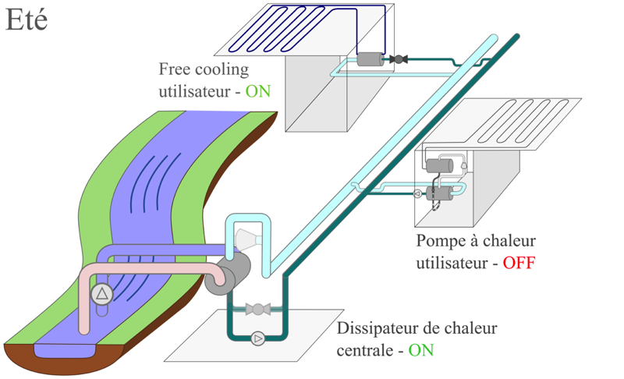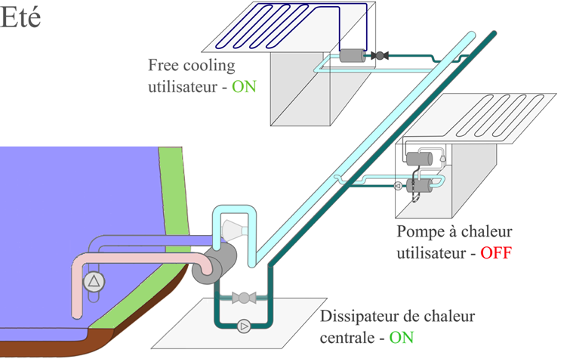

Free cooling user ON
Heat pump user OFF
Heat dissipator ON
SUMMER
Fig. 1a. Central plant and first users in summer of a CO₂ based DHC (light blue pipe=vapor pipe and dark green pipe =liquid pipe)
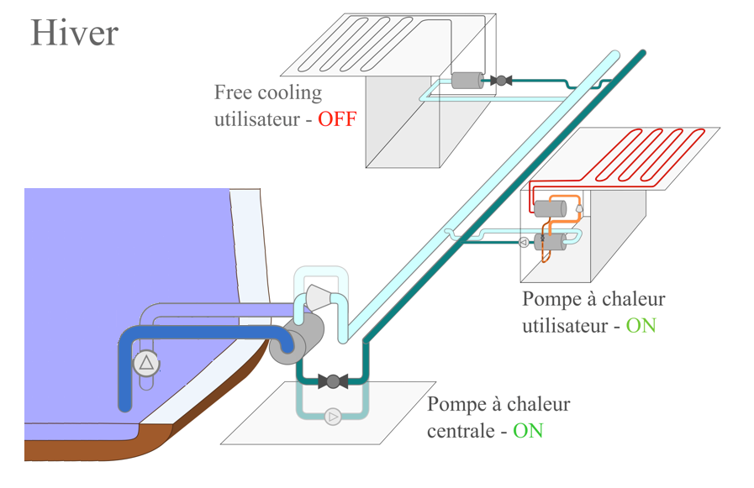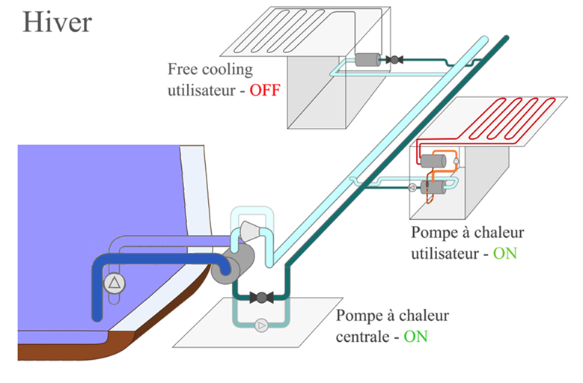

WINTER
Free cooling user OFF
Heat pump user ON
Central heat pump ON
Fig. 1b. Central plant and first users in winter of a CO₂ based DHC

Fig. 2. Size comparison between a water-based and a CO₂-based very low temperature DHC

Experimental proof of concept
A scaled down lab facility [Fig 3] was built to have a proof of concept to demonstrate the feasibility using only existing components, with scalable results and in which the potential hydro-acoustic phenomena could be observed and measured. Furthermore, the test rig has been used for the experimentation of various control schemes. The tests run so far did not indicate major operational difficulties like strong pressure surges or two-phase flow instabilities in the main network.
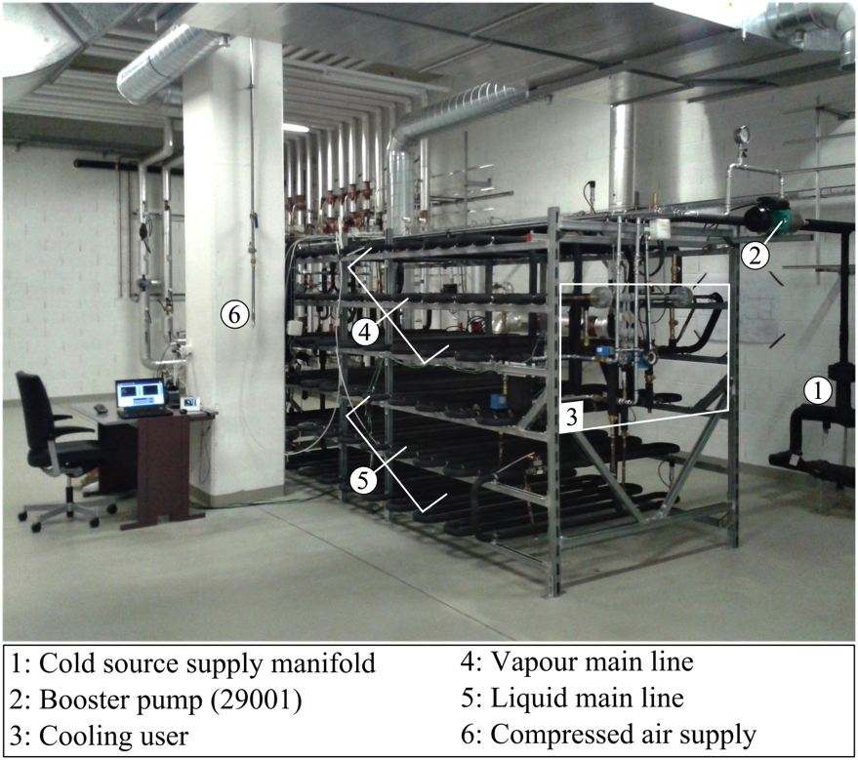
Fig. 3. Picture of the test rig installed at the industrial energy services in Geneva

Further extension of the concept
The proposed 2 pipe CO₂ energy network does not only allow for cold and warm energy supply via decentralized heat pumps when required, but it can also be a real umbilical cord in the city for further duties and improved synergies. Other uses include:
- Supply of an extinguishing agent in case of fire, either directly in non-occupied rooms or indirectly using mixing ejectors to reduce the excessive concentration of CO₂.
- Supply of a cold source for Organic Rankine Cycles or other waste heat conversion or cogeneration devices.
- Integration with daily electricity storage scheme using, at the central plant, like the reversible trans-critical CO₂ heat pump-power cycle shown in [10].
4) Integration with photovoltaics that allows to drive the heat-pumps with renewable energy. In addition the excess of PV electricity can be converted into methane by electrolysis and the Sabatier reaction. The resulting methane can be stored in summer in the form of liquid methane that can be converted into heat and electricity in winter. The use of combined cycles with CO₂ capture or fuel cells that separates the CO₂ such as SOFC [9] allows to collect CO2 in the network and store it to recycle it as methane in summer Studies have demonstrated that cities can by this way become self-sufficient in energy [11].

Conclusion
5th generation district heating and cooling networks based on the use of the latent heat of a natural fluid like CO₂ represent an interesting option to develop high efficiency city district by providing a very compact energy network allowing to use the synergies between the needs of the various users. Based on existing technologies, we have demonstrated that this technology can save more than 80% of the final energy consumed in a city center while being cheaper than conventional solutions. Combined with solar PV, it allows to design districts with nearly zero emissions In spite of the relatively high pressures required by a CO₂ DHC network, experiments, at reduced scale, have, so far, not shown any major pressure surge concerns.
References
[1] Lorentzen G., 1990. “Heat pumps for district heating applications” 3rd IEA heat pump conference Tokyo, Japan
[2] Pelet X, Favrat D., “Performance of a 3.9 MW Ammonia Heat Pump in a District Heating Cogeneration Plant: Status after eleven years of operation”, 1997, IEA Annex 22 Workshop, Gatlinburg, TN, USA
[3] Curti V., Favrat D., von Spakovsky M.. An environomic approach for the modeling and optimization of a district heating network based on centralized and decentralized heat pumps, cogeneration and/or gas furnace. Part II: Results. Int. J. of thermal sciences 2000;39:731-741.
[4] Henchoz S., Weber C., Marechal F.,Favrat D. Performance and profitability perspectives of a CO₂ based district energy network in Geneva’s city center.. Energy 2015;85:221-235
[5] Henchoz S., Chatelan P, Marechal F.,Favrat D. Key energy and technological aspects of three innovative district energy networks.. Energy 2016;117 part 2: 465-477
[6] Henchoz S., Favrat D., Marechal F.,Girardin L. Novel district heating and cooling energy network using CO₂ as a heat and mass transfer fluid. IEA heat pump conference, Rotterdam, May 2017
[7] Lund H.,Werner S.,Wiltshire R.,Svendsen S.,Thorsen J, Hvelplund F.,Mathiesen B.,4th generation District Heating (4GDH): Integrating smart thermal grids into future sustainable energy systems. Energy 2014;68:1-11
[8] Masson N. 2014 Natural refrigerants in Europe: The drivers and challenges for food retailers
[9] Facchinetti E,Favrat D.,Marechal F.,Innovative hybrid cycle solid oxide fuel cell-inverted gas turbine with CO₂ separation, Fuel cells 2011;11:565-572
[10] Morandin M.,Mercangoez M., Hemrle J.,Marechal F., Favrat D., Thermoeconomic design optimization of a thermo-electric energy storage system based on transcritical CO₂ cycles, Energy 2013;58:571-587
[11] Suciu, R. A., Girardin, L., & Maréchal, F. (2017). Energy integration of CO₂ networks and Power to Gas for emerging energy autonomous cities in Europe. In Proceedings of ECOS 2017

* Corresponding author. Tel.: +41793349785; fax: +41216930000. E-mail address: Daniel.favrat@epfl.ch

